Unmanaged Google Account Prevention Guidance
Enterprise controls to prevent new unmanaged accounts and prepare for SSO enforcement
Document Position
This document is written as implementation guidance. It provides controls, browser/admin steps, operating scenarios, and decision points. It does not replace Google Workspace, Microsoft 365, privacy, legal, or security policy review.

Executive Summary
Unmanaged Google accounts can be created when a user verifies an organizational email address during Google consumer account signup. To reduce this risk, the organization should combine managed Google identity provisioning, remediation of existing unmanaged accounts, mail-flow controls, service restrictions, and SSO enforcement.
- Create a managed Google identity for every person who has an active organizational mailbox where Google access may be required.
- Use the Transfer Tool for unmanaged users to remediate accounts that already exist.
- Configure Microsoft 365 / Exchange Online mail-flow controls to block Google sign-up verification messages for users who should not create unmanaged Google accounts.
- Disable Google productivity services by default when Microsoft 365 is the approved email and productivity platform.
- Use approved exception groups for Google Drive, Docs, Sheets, Slides, Gemini, YouTube, Google Cloud, or third-party OAuth access.
- Move validated users toward Microsoft Entra ID SSO enforcement as the end-state control.
End Goal
The end goal is not only to remove unmanaged accounts. The end goal is to make Google identities managed, governed, provisioned from the enterprise identity source, and authenticated through Microsoft Entra ID SSO with appropriate MFA and lifecycle controls.

1. Control Objectives
Control Objective | Enterprise Outcome
Prevent new unmanaged account creation | Users should not be able to independently create personal Google accounts using organizational email addresses.
Remediate existing unmanaged accounts | Existing accounts are transferred, renamed, or handled through an approved exception/remediation workflow.
Maintain Microsoft 365 as productivity authority | Gmail, Google Drive, Docs, Sheets, Slides, and Gemini remain disabled unless an exception is approved.
Prepare for SSO enforcement | Managed Google accounts are placed in OUs/groups where Microsoft Entra ID SAML SSO and MFA can be enforced.
Protect data and privacy | Users receive clear guidance before transfer, and services are enabled only after business/security/privacy review.

2. Google-Supported Prevention Options
Guidance Summary
Google identifies three practical controls: create managed users for people with domain email addresses, use the Transfer Tool for unmanaged accounts that already exist, and configure the mail server to block Google sign-up verification emails.

Option | What to Do | When to Use | Important Notes
Option 1 - Create managed users | Create a Google Workspace or Cloud Identity user account for every person who has an email address in the domain. | Use this for active employees, contractors, and service identities that may require Google sign-in under organizational governance. | This prevents the user from independently creating a new unmanaged account with that address because the managed identity already exists.
Option 2 - Transfer existing unmanaged users | Use the Transfer Tool for unmanaged users to invite existing accounts to become managed accounts. | Use this when unmanaged accounts already exist and need to be brought under governance or renamed/remediated. | Users must understand what transfer means before accepting. Backup and personal-data separation may be required.
Option 3 - Block verification emails | Configure the mail server to block Google sign-up verification emails. | Use this when Microsoft 365 is authoritative for email and users should not create personal Google accounts using work email. | Subject-based controls are language-specific. Prefer sender/header-based controls where possible.

3. Microsoft 365 / Exchange Online Mail-Flow Rule
For a Microsoft 365 / Exchange Online environment, create a mail-flow rule that blocks or quarantines Google sign-up verification emails. This prevents users from completing the email verification step required to create a new unmanaged Google account.
Google Verification Signal | Recommended Match
Envelope From / Sender | *@idverification.bounces.google.com
Header From | noreply@google.com
Subject | Verify your email address
Action | Reject, quarantine, or route to administrative review according to policy

Language-Specific Subject Warning
The subject text can vary by browser/user language. If the rule only blocks the English subject, users with another language setting may still receive the verification message. Use sender/header controls and test multilingual scenarios.

3.1 Admin UI Steps - Exchange Admin Center
Step 1: Open the Exchange Admin Center.
Step 2: Go to Mail flow -> Rules.
Step 3: Create a new rule.
Step 4: Name the rule: Block Google Unmanaged Account Verification.
Step 5: Add a condition for sender/envelope sender matching *@idverification.bounces.google.com.
Step 6: Add a condition for message header From matching noreply@google.com.
Step 7: Optionally add subject matching Verify your email address if language coverage is confirmed.
Step 8: Set the action to reject, quarantine, or redirect to an admin review mailbox based on policy.
Step 9: Add exceptions for approved Cloud Identity or Workspace users if the organization wants managed users to receive verification messages.
Step 10: Test with pilot accounts before enforcing broadly.
Recommended Action | Use Case | Operational Consideration
Reject | Strict prevention model | User receives non-delivery response. Useful when policy clearly prohibits unmanaged signups.
Quarantine | Controlled rollout | Security or messaging team can review message hits before full rejection.
Redirect to admin review | Pilot/testing phase | Good for collecting evidence and confirming the rule does not block legitimate business mail.
Allow by exception | Approved Cloud Identity users only | Use when active managed users may need to receive Google verification emails for approved services.

4. Prevention and SSO Control Flow
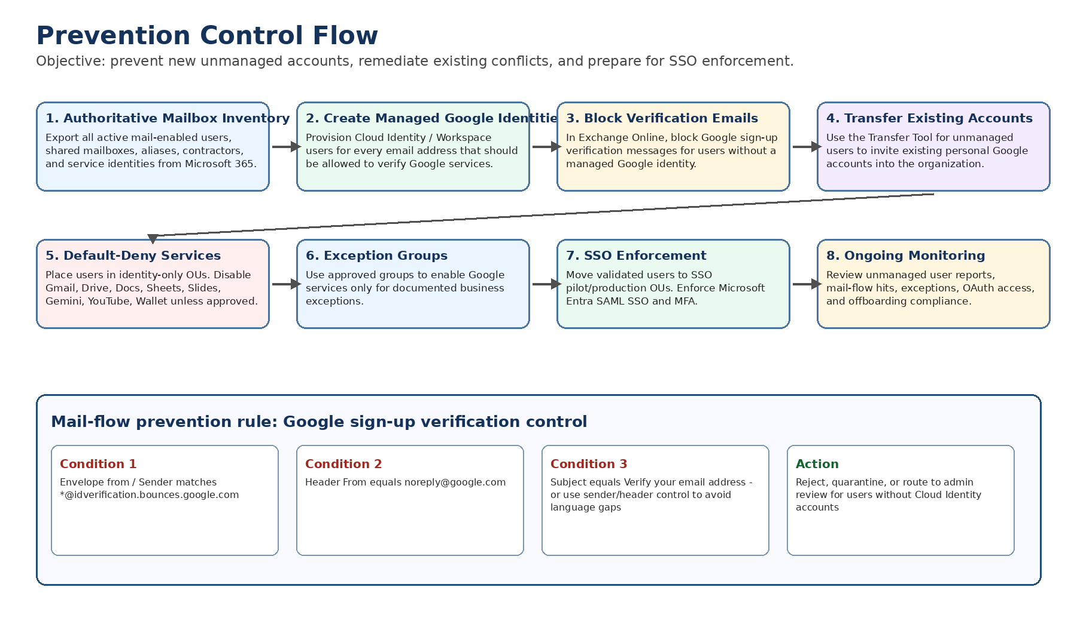

5. Recommended OU and Group Structure
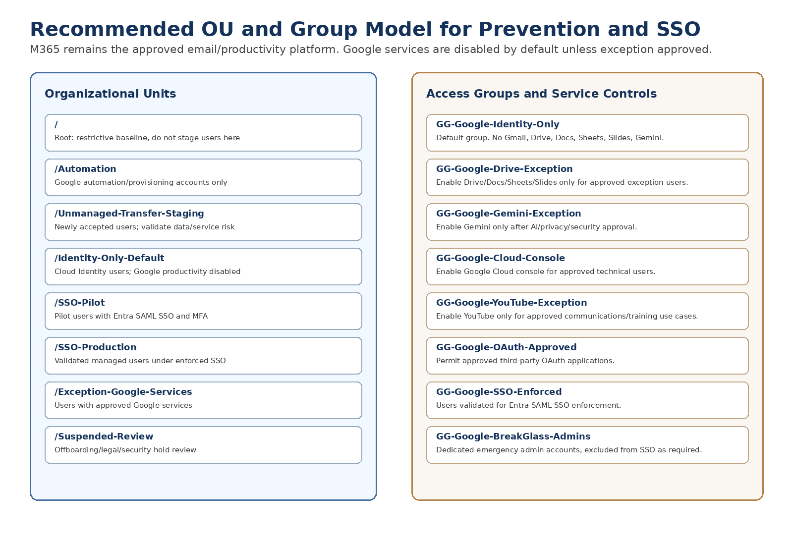
OU / Group | Purpose | Default Service Posture
/Identity-Only-Default | Default landing zone for managed users when Microsoft 365 is the approved productivity platform. | Gmail Off; Drive/Docs/Sheets/Slides Off; Gemini Off; YouTube Off unless exception.
/Unmanaged-Transfer-Staging | Temporary OU for users who accepted transfer and require validation before SSO production. | Restrictive baseline; service access reviewed before enabling.
/SSO-Pilot | Pilot group for Microsoft Entra SAML SSO enforcement. | Only approved services enabled; SSO/MFA tested.
/SSO-Production | Production OU after validation. | SSO enforced; service access controlled by group/OU.
GG-Google-Drive-Exception | Approved access to Drive/Docs/Sheets/Slides. | Enabled only with business approval.
GG-Google-Gemini-Exception | Approved access to Gemini or Google AI services. | Enabled only after AI/privacy/security review.
GG-Google-Cloud-Console | Approved access to Google Cloud resources. | Enabled only for technical roles requiring GCP access.

6. Operating Model: Microsoft 365 Only by Default
Policy Baseline
Microsoft 365 remains the approved platform for email and productivity. Google identity may be used for governance, SSO, and controlled Google service access. Google productivity tools are disabled by default unless a documented exception is approved.

Service Area | Default Posture | Exception Path
Email | Microsoft 365 / Exchange Online only. Gmail disabled. | Exception requires mail-routing, legal, privacy, and operational approval.
Files and productivity | OneDrive, SharePoint, Teams, Office apps are default. Google Drive/Docs/Sheets/Slides disabled. | Exception group for approved Google Drive/Docs use cases.
AI services | Microsoft-approved AI services by default. Google Gemini disabled. | Gemini exception group after AI governance review.
YouTube / Photos / Wallet | Disabled or restricted for general users. | Exception only for documented business role.
Google Cloud Console | Disabled for general users. | Enabled for approved technical users through Google Cloud exception group.
OAuth / third-party apps | Restricted by default. | Allowlist approved apps only.

7. Edge Cases and Failure Scenarios
Scenario | What Can Happen | Control / Response
User has mailbox but no managed Google identity | User may receive Google verification email and create an unmanaged account. | Create Cloud Identity account or block verification email.
Subject-only blocking | Non-English verification emails may bypass the rule. | Use sender/header controls and test browser-language variations.
Existing unmanaged account already exists | Mail blocking does not remove the existing account. | Use Transfer Tool, rename path, or remediation workflow.
Shared mailbox or service mailbox receives verification email | Someone with mailbox access could complete verification. | Include shared/service mailboxes in inventory and block verification.
Alias addresses | Verification may be attempted against email aliases. | Inventory aliases and configure Cloud Identity/provisioning or blocking rules accordingly.
External forwarding | Verification email may forward outside the organization. | Review forwarding controls and mail-flow rules.
Cloud Identity user exists but services are disabled | User may sign in but not access Drive/Docs/Gemini. | Communicate identity-only model and exception process.
Future Workspace licenses purchased | Users may accidentally receive Google productivity access if auto-licensing is enabled. | Disable broad auto-licensing; use group-based exceptions.
SSO enforced too early | Users may be locked out if provisioning/mapping is wrong. | Pilot first; maintain break-glass admin accounts.
Personal data in unmanaged account | Transfer may bring personal content under organizational management. | Require user backup and data separation guidance before transfer.

8. Validation Checklist
Test Case | Expected Result | Evidence to Capture
Attempt Google signup for user without Cloud Identity account | Verification email is blocked/quarantined or redirected. | Mail trace, quarantine result, rule hit.
Attempt Google signup for user with approved Cloud Identity account | Verification behavior follows approved exception design. | Mail trace and account state.
Attempt signup using non-English browser language | Rule still blocks based on sender/header or exception logic. | Mail trace and message headers.
Existing unmanaged user appears in Transfer Tool | Admin can initiate transfer/remediation process. | Transfer Tool screenshot and status.
Transferred user placed in staging OU | User is not left in root OU; restrictive baseline applies. | Admin Console user OU screenshot.
SSO pilot user signs in | User authenticates through Microsoft Entra ID SSO with MFA. | Sign-in logs and user validation notes.

9. Implementation Plan

Phase 1 - Inventory
- Export all active mail-enabled users from Microsoft 365.
- Include shared mailboxes, aliases, service accounts, contractors, and distribution/shared access scenarios.
- Compare with Google Admin Console users and unmanaged user list.

Phase 2 - Provision
- Create Cloud Identity / Workspace users for identities that require managed Google sign-in.
- Place users in Identity-Only-Default OU unless exception approved.
- Disable broad auto-licensing for Google productivity services.

Phase 3 - Prevent
- Create Exchange Online mail-flow rule for Google verification emails.
- Pilot the rule with test accounts.
- Review mail trace/quarantine results.
- Move to enforcement after validation.

Phase 4 - Remediate
- Use the Transfer Tool for unmanaged users that already exist.
- Send user communication and backup guidance before transfer.
- Place accepted users into Transfer-Staging OU.

Phase 5 - Enforce SSO
- Configure Microsoft Entra ID as SAML identity provider.
- Pilot SSO in SSO-Pilot OU.
- Validate MFA, attribute mapping, and break-glass accounts.
- Move validated users to SSO-Production.

10. Recommended Document Wording
Use this wording
Google Workspace / Cloud Identity domain ownership establishes organizational governance capabilities, but prevention of new unmanaged Google account creation should be implemented through managed account provisioning, unmanaged-user remediation, and mail-flow controls that block Google sign-up verification messages for users who should not create personal Google accounts with organizational email addresses.

Avoid this wording
Avoid stating that domain ownership alone fully blocks unmanaged account creation. Use the control-based language above so the guidance remains accurate and implementation-focused.

11. Official Google References
- Prevent creation of unmanaged user accounts: https://knowledge.workspace.google.com/admin/users/prevent-creation-of-unmanaged-user-accounts
- Before using the Transfer Tool: https://knowledge.workspace.google.com/admin/users/before-using-the-transfer-tool
- Use the Transfer Tool to migrate unmanaged users: https://knowledge.workspace.google.com/admin/users/use-the-transfer-tool-to-migrate-unmanaged-users
- Find and add unmanaged users: https://knowledge.workspace.google.com/admin/users/find-and-add-unmanaged-users
- Google Cloud identity federation best practices: https://docs.cloud.google.com/architecture/identity/best-practices-for-federating

Appendix A - Source Mapping for Controls
Guidance Item | Official Source Basis
Create managed accounts for every person with an email address in the domain | Google prevention guidance identifies this as a prevention option.
Use Transfer Tool for accounts already created | Google prevention and transfer guidance identify the Transfer Tool as the remediation option for unmanaged users.
Block sign-up verification emails | Google prevention guidance provides sender/header/subject details for mail server controls.
Do not rely only on subject | Google prevention guidance states the subject is language-specific.
Allow Cloud Identity users to receive verification emails | Google prevention guidance describes allowing Cloud Identity users while blocking employees without Cloud Identity accounts.
SSO and lifecycle alignment | Google Cloud identity federation best practices recommend aligning Google user lifecycle with the external IdP lifecycle.

