Unmanaged Google Account Transfer Invitation
Acceptance and Backup Guide
User-facing guidance for employees receiving a Google account transfer invitation

Audience: unmanaged Google account users who receive a transfer invitation in Outlook / corporate email. This guide explains how to review the invite, back up data, decide whether to accept, and complete the transfer safely.
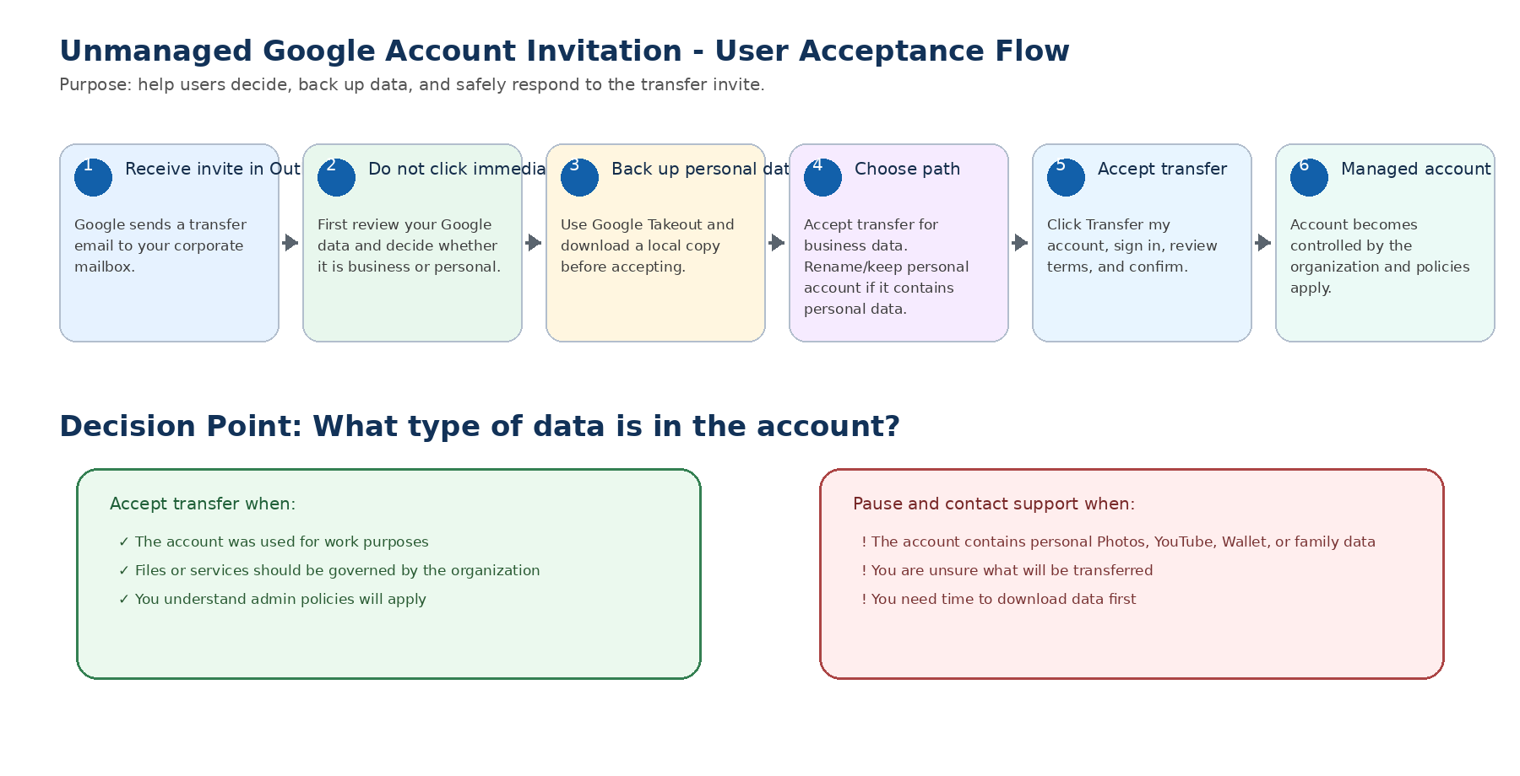
Document status: Draft guidance for validation and pilot use. Replace placeholder support contacts and policy decisions with approved organizational wording before broad distribution.

1. Purpose and Scope
This guide is written for users who receive a Google transfer invitation for a personal, unmanaged Google account that uses their organizational email address, such as john.smith@calgary.ca. The goal is to help users make an informed decision before accepting the invite and to reduce the risk of accidental loss of personal data, confusion, or support escalations.
The guide is intended to support a City of Calgary style identity transition where the corporate mailbox is hosted in Microsoft Office 365 / Exchange Online, users receive the Google invitation in Outlook, and the organization is moving unmanaged Google accounts into a managed Google Workspace or Cloud Identity environment.
Important: Accepting the transfer changes the account from a personal Google account into an organization-managed account. Users should review and back up personal information before accepting the invitation.

2. Official Google Basis for This Guide
This guidance is based on Google Workspace documentation for unmanaged users, the transfer tool, and Google Account data export. Key Google points used in this guide are summarized below:
- Users receive an email after an administrator sends a transfer request. In the email, users can click Transfer my account, sign in to their personal Google account, and agree to transfer terms.
- If a user accepts the transfer, the organization can manage the account, access and delete data in the account, and restrict access to Google services.
- If a user ignores the request, the organization can create a managed account with the same email address and the user will be prompted to rename the personal account the next time they sign in.
- Transferred personal accounts cannot be changed back to personal accounts. They are added to the root organizational unit and assigned a Cloud Identity Free license.
- Google notes that transferred personal accounts may lose data or content for some services; users may want to review and download personal account information before transferring.
- Google Takeout allows users to select Google products, choose a delivery method, create an export, and download an archive.

Official Google references
Use the transfer tool to migrate unmanaged users: https://knowledge.workspace.google.com/admin/users/use-the-transfer-tool-to-migrate-unmanaged-users
Before using the transfer tool: https://knowledge.workspace.google.com/admin/users/before-using-the-transfer-tool
Find and add unmanaged users: https://knowledge.workspace.google.com/admin/users/find-and-add-unmanaged-users
Download your Google data: https://support.google.com/accounts/answer/3024190
Google Workspace Updates - UserInvitation API / unmanaged accounts: https://workspaceupdates.googleblog.com/2022/07/userinvitation-api-unmanaged-accounts.html

3. What Is Happening When You Receive the Invite?
You are receiving the invitation because Google has identified that your organizational email address is associated with a personal Google account that is not currently managed by the organization. This can happen when a user previously used their work email address to access Google services such as Google Drive, YouTube, Google Photos, Google Maps, or Gemini.
The transfer invitation is the organization’s request to bring that account under enterprise governance. After the transfer, the account is no longer a personal Google account. It becomes part of the organization’s managed Google environment and organizational policies may apply.

4. User Acceptance Flow


5. Before You Accept: Review Your Account
Do not accept the transfer invitation immediately if you are unsure what data exists in the account. First, sign in to the Google account using the same organizational email address referenced in the invitation and review the data and services connected to the account.

Step-by-step review
- Open a private/incognito browser window to avoid signing into the wrong Google account.
- Go to https://myaccount.google.com/ and sign in using the organizational email address shown in the invitation.
- Confirm the profile name and email address match the invitation.
- Open Data & privacy and review activity controls, YouTube history, search personalization, location history, and connected services.
- Open Security and review devices, third-party apps, and recovery information.
- Open Payments & subscriptions / Wallet and check whether payment methods, subscriptions, or Google Pay data are present.
- Open Google Drive, Google Photos, YouTube, Google Docs, Sheets, and Slides to understand whether the account contains business, personal, or mixed data.
Decision rule: If the account contains only work-related data, accepting the transfer is usually appropriate after backup. If the account contains personal photos, YouTube data, payment methods, family data, subscriptions, or other personal content, pause and contact support before accepting.

6. Backup Guidance Before Accepting
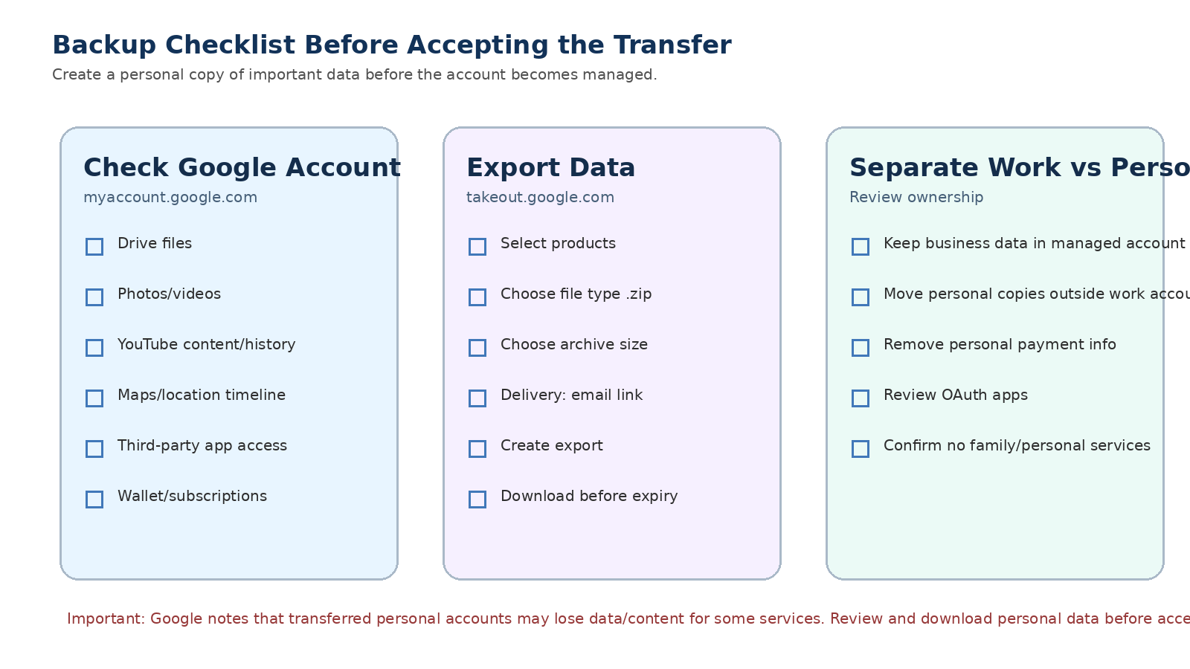
Google recommends that users may want to review and download personal account information before transferring because some services may behave differently during or after the transfer, and some personal account data or content may be affected. A backup also gives the user a reference copy before administrative controls apply.

Recommended backup steps using Google Takeout
- Open a private/incognito browser window.
- Sign in to the unmanaged Google account using the organizational email address receiving the invitation.
- Go to https://takeout.google.com/ or open myaccount.google.com and select Download your data.
- Review the list of Google products selected for export. Google products that contain data are typically selected automatically.
- Keep selected any products that may contain personal or important data, such as Drive, Photos, YouTube, Maps, Chrome, Contacts, Calendar, and Google Account data.
- If you do not need a product, uncheck it. If a product has options such as All data included, review the details before continuing.
- Click Next step.
- Choose Delivery method: Send download link via email. This is usually easiest for most users.
- Choose file type .zip unless instructed otherwise.
- Choose archive size based on available storage and download capability. Smaller archive sizes may create multiple files but are easier to download.
- Click Create export.
- Wait for Google to prepare the archive. This may take hours or days depending on the size of the account.
- When the email arrives, click Download archive and save the files to an approved location.
- Do not store personal backup files on shared corporate locations unless approved by policy.

What to check before accepting the transfer
Area | What to check | Suggested action
Google Drive | Work files, personal files, public links, files shared externally | Keep business files for transfer; export or move personal items if appropriate.
Google Photos | Personal photos, videos, albums, shared libraries | Export personal content or contact support before accepting.
YouTube | Channels, videos, subscriptions, comments, playlists, history | Pause if the YouTube identity is personal or important.
Wallet / Payments | Payment cards, subscriptions, purchase history | Remove or document personal payment methods before transfer.
Third-party apps | OAuth apps connected to the Google account | Revoke apps that are personal or not approved.
Security settings | Recovery phone/email, devices, saved passwords | Review and remove personal recovery details if required by policy.
Family / personal services | Google Family, Nest, Fit, personal memberships | Pause and contact support if present.

7. How to Accept the Transfer Invitation
Complete these steps only after you have reviewed the account, completed any required backup, and confirmed that accepting the transfer is appropriate.

Browser UI steps
- Open Outlook and locate the Google transfer invitation email. The message may come from Google or Google Workspace and may reference transferring your account to the organization.
- Read the message carefully and verify that the email address in the message matches your organizational email address.
- Click Transfer my account in the email.
- If prompted, sign in to the personal Google account that uses your organizational email address. Do not sign in with a different Gmail account.
- Review Google’s transfer terms and any information shown about what will happen to the account and data.
- Confirm that you understand the organization will be able to manage the account after transfer.
- Click the final confirmation button to accept the transfer.
- Wait for the confirmation screen or email indicating the transfer was accepted.
- Sign out of Google and close the browser window.
- Open a new browser window and sign in again using your organizational email address. If SSO is enabled, you may be redirected to the organization’s identity provider.
Important: Use a private/incognito window when accepting if you have multiple Google accounts open. This reduces the risk of accepting the invite while signed into the wrong account.

8. What Changes After Acceptance?
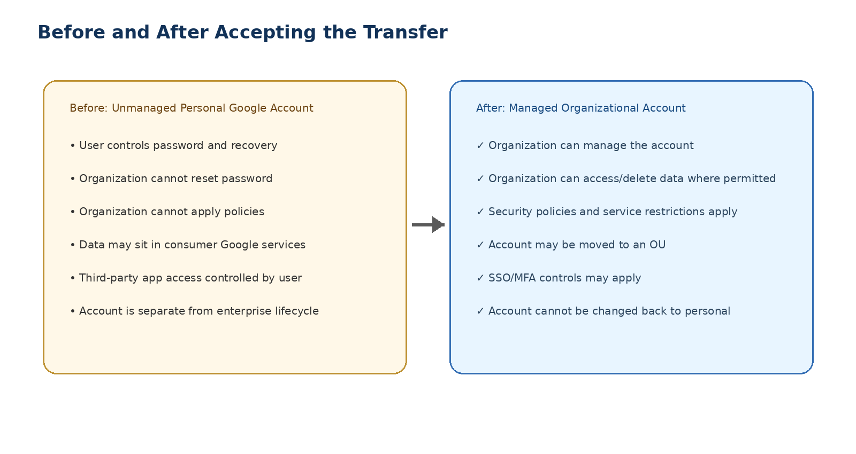
After acceptance, the account becomes a managed account under the organization’s Google Workspace or Cloud Identity environment. This changes the governance model of the account.
Topic | Before transfer | After transfer
Account ownership | Personal Google account controlled by the user | Managed by the organization
Password / sign-in | User controls account sign-in settings | Organization SSO/MFA policies may apply
Data access | User controls data and sharing | Organization may access/delete data and restrict services
Google services | Consumer services available based on Google account settings | Services may be restricted by organizational policy
Reversal | Personal account can be managed by user | Google states transferred personal accounts cannot be changed back to personal
OU placement | Not in organization | Added to root OU first; admin may later move to correct OU

9. What If You Should Not Accept Yet?
If the account contains personal data, subscriptions, family services, personal YouTube content, personal Google Photos, payment information, or any data you do not want to become managed by the organization, do not accept the transfer until you receive guidance from the support team.
Google documentation states that users cannot directly decline a transfer request, but they can ignore it. If the organization later creates a managed account with the same email address, the personal account may be prompted to rename the next time the user signs in. When a user renames the personal account, Google states that the data stays in the personal account and remains accessible only to the user.

When to contact support before accepting
- You do not recognize the Google account.
- You used the account for personal Google Photos, YouTube, Maps, Nest, Fit, Wallet, or subscriptions.
- You are part of a family group or are unsure whether family services are connected.
- The account contains personal documents or payment methods.
- You cannot complete Google Takeout.
- You see an error during the transfer.
- You are not sure whether the account is work-related or personal.

10. Decision Tree for Users
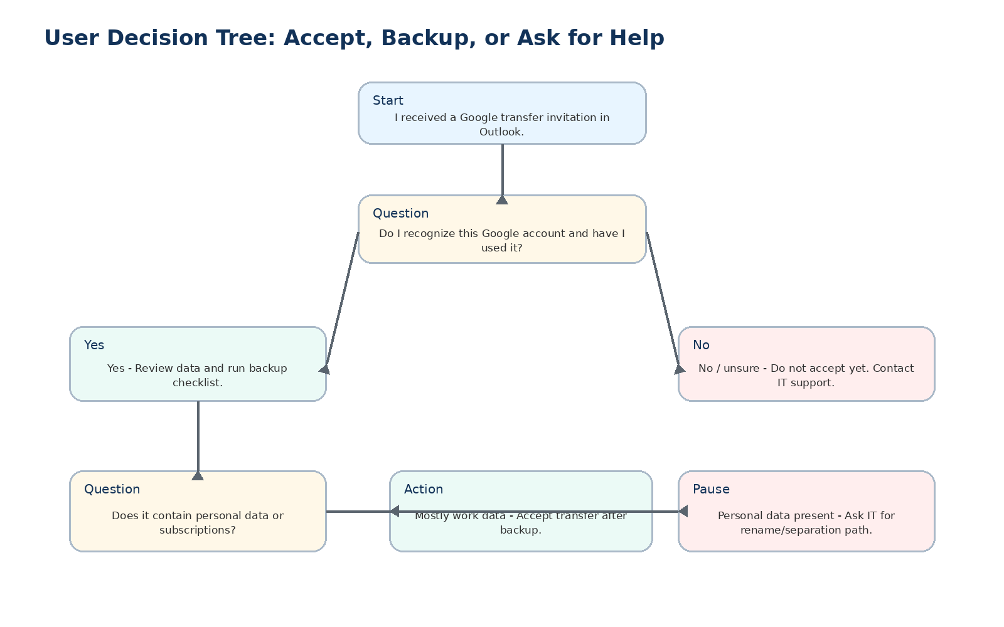

11. Post-Acceptance Checklist
After accepting the transfer, complete the following checks to confirm that access is working and that the account is now operating under the expected organizational model.
- Sign in again using your organizational email address.
- Confirm whether you are redirected to the organization’s sign-in page or SSO provider.
- Open Google Drive and confirm required work files are present.
- Open Google Docs, Sheets, and Slides and confirm access to required files.
- Check Google Calendar and contacts if used previously.
- Confirm that approved Google services are available and restricted services are blocked as expected.
- Report any missing files, sign-in problems, or unexpected restrictions to the support team.
- Do not reconnect personal third-party apps unless they are approved by policy.

12. Troubleshooting and Support
Issue | Likely cause | User action
I did not receive the invitation. | Email may be delayed, filtered, or in Junk/Quarantine. | Check Outlook Junk, Focused/Other, and contact support.
The link opens the wrong Google account. | Browser is already signed into another Google account. | Use private/incognito mode and sign in with the invited organizational email.
I do not recognize the account. | The Google account may have been created historically or by mistake. | Do not accept. Contact support.
Google Takeout takes too long. | Large data volume such as Drive or Photos. | Wait for export email; contact support if timing is urgent.
I see personal data. | Account has mixed work and personal use. | Pause. Export personal data and ask support for rename/separation guidance.
I accepted and now a service is blocked. | Managed account policies are now applying. | Contact support if access is business required.
I cannot sign in after accepting. | SSO, MFA, OU placement, or policy issue. | Contact IT support with screenshot and timestamp.

13. Sample User Communication
The following communication can be adapted for email or internal knowledge base publishing.
You may receive a Google email asking you to transfer a Google account that uses your organizational email address. Before accepting, please review the account and back up any personal data using Google Takeout. If the account contains only work-related data, you may proceed with the transfer. If the account contains personal photos, YouTube content, payment methods, family services, subscriptions, or data you are unsure about, do not accept yet and contact IT support.

14. Support Information
Replace the placeholders below before distribution.
- IT Service Desk: [insert contact]
- Project mailbox: [insert mailbox]
- Support hours: [insert hours]
- Escalation path: [insert team or manager]
- Pilot group: [insert OU/group name]
- Effective date: [insert date]

Appendix A - One Page Quick Guide
Do | Do Not
Use a private/incognito browser window. | Do not accept the invite while signed into another Google account.
Review Google Drive, Photos, YouTube, Wallet, and third-party apps. | Do not accept if you see personal data and have not backed it up.
Use Google Takeout to export important data before accepting. | Do not assume the transfer can be reversed.
Contact support if the account is mixed personal/work. | Do not ignore errors or continue if the invite looks suspicious.
Accept only after reviewing the impact. | Do not reconnect personal apps after transfer unless approved.

