EXPERIMENT-1
Aim:Design an application to demonstrate the temperature conversion in Andriod.
Source code:
Activity_main.xml
<?xml version="1.0" encoding="utf-8"?>
<LinearLayout
xmlns:android="http://schemas.android.com/apk/res/android"
android:layout_width="match_parent"
android:layout_height="match_parent"
android:orientation="vertical"
android:padding="24dp"
android:gravity="center">
<EditText
android:id="@+id/inputTemp"
android:layout_width="match_parent"
android:layout_height="wrap_content"
android:hint="Enter Temperature"
android:inputType="numberDecimal"
android:padding="12dp"/>
<RadioGroup
android:id="@+id/radioGroup"
android:layout_width="match_parent"
android:layout_height="wrap_content"
android:orientation="horizontal"
android:layout_marginTop="16dp">
<RadioButton
android:id="@+id/toCelsius"
android:layout_width="wrap_content"
android:layout_height="wrap_content"
android:text="To Celsius"/>
<RadioButton
android:id="@+id/toFahrenheit"
android:layout_width="wrap_content"
android:layout_height="wrap_content"
android:text="To Fahrenheit"/>
</RadioGroup>
<Button
android:id="@+id/convertButton"
android:layout_width="wrap_content"
android:layout_height="wrap_content"
android:text="Convert"
android:layout_marginTop="16dp"/>
<TextView
android:id="@+id/resultText"
android:layout_width="wrap_content"
android:layout_height="wrap_content"
android:text="Result"
android:textSize="18sp"
android:layout_marginTop="24dp"/>
</LinearLayout>
MainActivity.java
package com.example.temperatureconversion;
import androidx.appcompat.app.AppCompatActivity;
import android.os.Bundle;
import android.view.View;
import android.widget.*;
public class MainActivity extends AppCompatActivity {
EditText inputTemp;
RadioGroup radioGroup;
RadioButton toCelsius, toFahrenheit;
Button convertButton;
TextView resultText;
@Override
protected void onCreate(Bundle savedInstanceState) {
super.onCreate(savedInstanceState);
setContentView(R.layout.activity_main);
inputTemp = findViewById(R.id.inputTemp);
radioGroup = findViewById(R.id.radioGroup);
toCelsius = findViewById(R.id.toCelsius);
toFahrenheit = findViewById(R.id.toFahrenheit);
convertButton = findViewById(R.id.convertButton);
resultText = findViewById(R.id.resultText);
convertButton.setOnClickListener(new View.OnClickListener() {
@Override
public void onClick(View view) {
String input = inputTemp.getText().toString();
if (input.isEmpty()) {
resultText.setText("Please enter a temperature.");
return;
}
double temp = Double.parseDouble(input);
double converted;
String result;
if (toCelsius.isChecked()) {
converted = (temp - 32) * 5 / 9;
result = String.format("%.2f °C", converted);
} else if (toFahrenheit.isChecked()) {
converted = (temp * 9 / 5) + 32;
result = String.format("%.2f °F", converted);
} else {
result = "Please select a conversion option.";
}
resultText.setText(result);
}
});
}
}

Output:
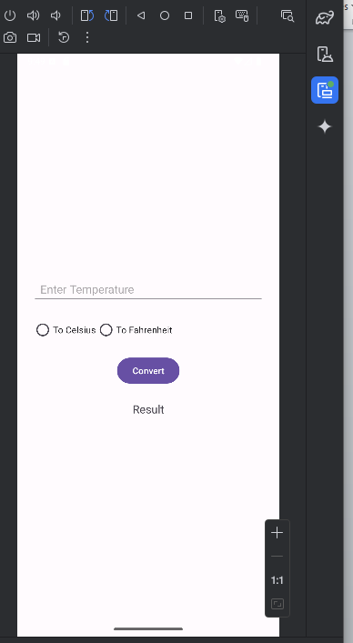
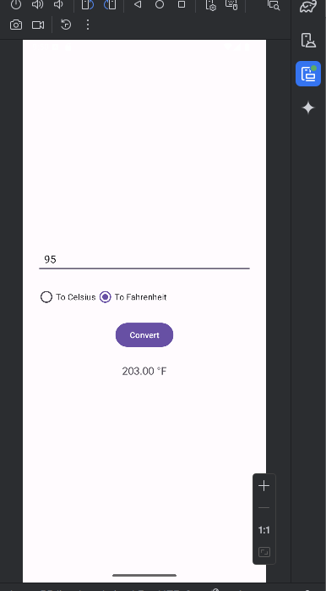
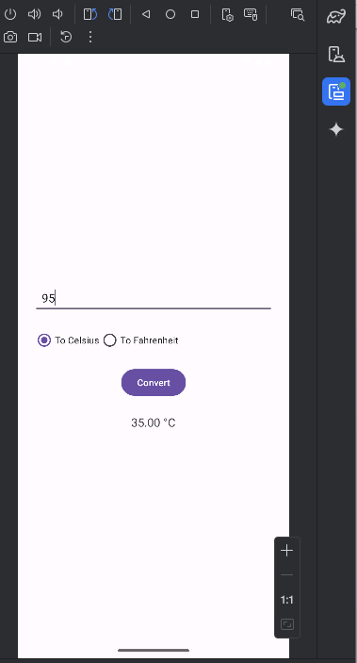

EXPERIMENT-2

Aim:Design an application to demonstrate student registration form using event handling.
Source code:
Activity_main.xml
<?xml version="1.0" encoding="utf-8"?>
<ScrollView xmlns:android="http://schemas.android.com/apk/res/android"
android:layout_width="match_parent"
android:layout_height="match_parent">
<LinearLayout
android:orientation="vertical"
android:padding="20dp"
android:layout_width="match_parent"
android:layout_height="wrap_content">
<EditText
android:id="@+id/nameInput"
android:layout_width="match_parent"
android:layout_height="wrap_content"
android:autofillHints=""
android:hint="enter_full_name"
android:inputType="textPersonName"/>
<EditText
android:id="@+id/rollInput"
android:layout_width="match_parent"
android:layout_height="wrap_content"
android:autofillHints=""
android:hint="enter_roll_number"
android:inputType="text"/>
<EditText
android:id="@+id/emailInput"
android:layout_width="match_parent"
android:layout_height="wrap_content"
android:autofillHints=""
android:hint="enter_email"
android:inputType="textEmailAddress"/>
<RadioGroup
android:id="@+id/genderGroup"
android:layout_width="match_parent"
android:layout_height="wrap_content"
android:orientation="horizontal">
<RadioButton
android:id="@+id/male"
android:layout_width="wrap_content"
android:layout_height="wrap_content"
android:text="male" />
<RadioButton
android:id="@+id/female"
android:layout_width="wrap_content"
android:layout_height="wrap_content"
android:text="female" />
</RadioGroup>
<CheckBox
android:id="@+id/agreeCheckbox"
android:layout_width="wrap_content"
android:layout_height="wrap_content"
android:text="i_agree_to_the_terms_and_conditions"/>
<Button
android:id="@+id/registerBtn"
android:layout_width="match_parent"
android:layout_height="wrap_content"
android:text="register" />
</LinearLayout>
</ScrollView>

MainActivity.java
package com.example.studentform;
import android.os.Bundle;
import android.view.View;
import android.widget.*;
import androidx.appcompat.app.AlertDialog;
import androidx.appcompat.app.AppCompatActivity;
public class MainActivity extends AppCompatActivity {
EditText nameInput, rollInput, emailInput;
RadioGroup genderGroup;
CheckBox agreeCheckbox;
Button registerBtn;
@Override
protected void onCreate(Bundle savedInstanceState) {
super.onCreate(savedInstanceState);
setContentView(R.layout.activity_main);
nameInput = findViewById(R.id.nameInput);
rollInput = findViewById(R.id.rollInput);
emailInput = findViewById(R.id.emailInput);
genderGroup = findViewById(R.id.genderGroup);
agreeCheckbox = findViewById(R.id.agreeCheckbox);
registerBtn = findViewById(R.id.registerBtn);
// Event Handling: Button Click
registerBtn.setOnClickListener(new View.OnClickListener() {
@Override
public void onClick(View view) {
handleRegistration();
}
});
}
private void handleRegistration() {
String name = nameInput.getText().toString().trim();
String roll = rollInput.getText().toString().trim();
String email = emailInput.getText().toString().trim();
int selectedGenderId = genderGroup.getCheckedRadioButtonId();
if (name.isEmpty() || roll.isEmpty() || email.isEmpty() || selectedGenderId == -1 || !agreeCheckbox.isChecked()) {
Toast.makeText(this, "Please fill all fields and agree to terms", Toast.LENGTH_SHORT).show();
return;
}
RadioButton selectedGender = findViewById(selectedGenderId);
String gender = selectedGender.getText().toString();
String message = "Name: " + name + "\nRoll: " + roll + "\nEmail: " + email + "\nGender: " + gender;
new AlertDialog.Builder(this)
.setTitle("Registration Successful")
.setMessage(message)
.setPositiveButton("OK", null)
.show();
}
}

Output:
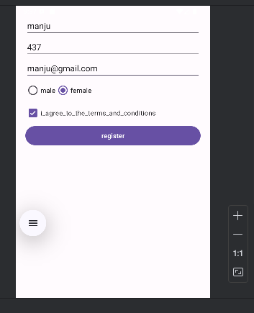

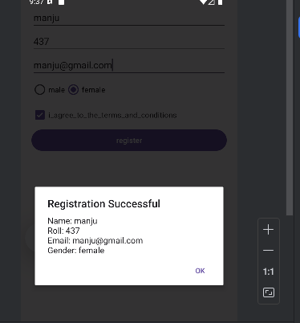

EXPERIMENT-6
Aim:design an application to demonstrate implicit intent in android using java.
Source code:
MainActivity.java
package com.example.implicitintentdemo;
import androidx.appcompat.app.AppCompatActivity;
import android.content.Intent;
import android.net.Uri;
import android.os.Bundle;
import android.view.View;
import android.widget.Button;
public class MainActivity extends AppCompatActivity {
Button btnOpenWebsite;
@Override
protected void onCreate(Bundle savedInstanceState) {
super.onCreate(savedInstanceState);
setContentView(R.layout.activity_main);
btnOpenWebsite = findViewById(R.id.btnOpenWebsite);
btnOpenWebsite.setOnClickListener(new View.OnClickListener() {
@Override
public void onClick(View v) {
// Create an implicit intent
Intent intent = new Intent(Intent.ACTION_VIEW);
intent.setData(Uri.parse("https://www.google.com"));
// Start activity that can handle this intent
startActivity(intent);
}
});
}
}
activity_main.xml
<?xml version="1.0" encoding="utf-8"?>
<LinearLayout xmlns:android="http://schemas.android.com/apk/res/android"
android:layout_width="match_parent"
android:layout_height="match_parent"
android:gravity="center"
android:orientation="vertical"
android:padding="20dp">
<Button
android:id="@+id/btnOpenWebsite"
android:layout_width="wrap_content"
android:layout_height="wrap_content"
android:text="Open Website" />
</LinearLayout>
Output:

