How to Choose the Right Wholesale Hotel Bedroom Furniture?
Selecting the right furniture for your hotel is essential for guest comfort, as well as enhancing the overall aesthetic of the property. Here are some key considerations when choosing your wholesale bedroom furniture:

1. Hotel Type and Design Theme
The type of hotel you run and the overall design theme should guide your furniture choices. Here are some popular styles and their furniture recommendations:
- Modern & Minimalist: Ideal for boutique hotels and urban accommodations. Opt for sleek, clean-lined bed frames, minimalist nightstands, and functional storage units.
- Luxury & Traditional: For upscale hotels or resorts, choose rich, elegant furniture like upholstered headboards, dark wood dressers, and soft, plush beds.
- Coastal or Resort Style: For beachfront properties or resorts, light wood and natural fabrics are ideal. A mix of modern and rustic furniture can create a welcoming, laid-back atmosphere.

2. Comfort and Functionality
While aesthetics are important, comfort and functionality should always be top priorities. Look for furniture that promotes relaxation, such as high-quality mattresses and ergonomic chairs. Consider these essential items for every hotel bedroom:
- Comfortable Bed and Mattress: The bed is the centerpiece of any hotel room. Invest in high-quality, comfortable mattresses and bed frames that cater to a wide range of guest preferences.
- Storage Solutions: Adequate storage, like wardrobes and dressers, is necessary for guest convenience. Include a mix of storage options, such as bedside tables with drawers and luggage racks.
- Lighting Fixtures: Proper lighting is essential for creating the right ambiance. Consider adjustable lighting options that allow guests to customize their room’s atmosphere.

3. Materials and Durability
Hotel furniture must endure heavy use, so the materials you select should be both durable and easy to maintain. Here are some commonly used materials for wholesale hotel bedroom furniture:
- Solid Wood: Perfect for high-end hotels, solid wood offers a luxurious look and durability. Opt for oak, mahogany, or cherry for a classic aesthetic.
- Engineered Wood: More affordable than solid wood, engineered wood (like MDF) is still a sturdy option and offers a range of finishes.
- Upholstered Fabrics: Fabrics like faux leather or high-grade polyester are commonly used for bed frames, headboards, and lounge chairs. They are durable and easy to clean.
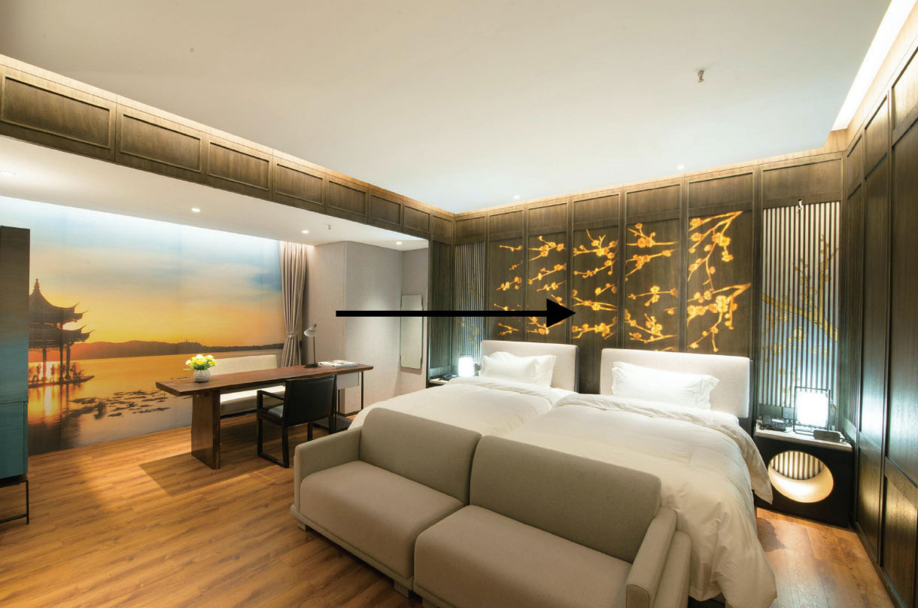

4. Consider Customization
Sometimes your hotel may need unique pieces to match a specific theme or branding vision. Many wholesale furniture suppliers offer customization options, allowing you to tailor the design, colors, and materials to your exact requirements.

5. Eco-Friendly Options
As sustainability becomes more important to consumers, investing in eco-friendly furniture can boost your hotel's appeal. Look for suppliers who offer environmentally friendly materials like reclaimed wood, low-VOC finishes, and sustainable fabrics.

