Gavin Lopes

Game Design

Robot Funk

(Rated E-10+)

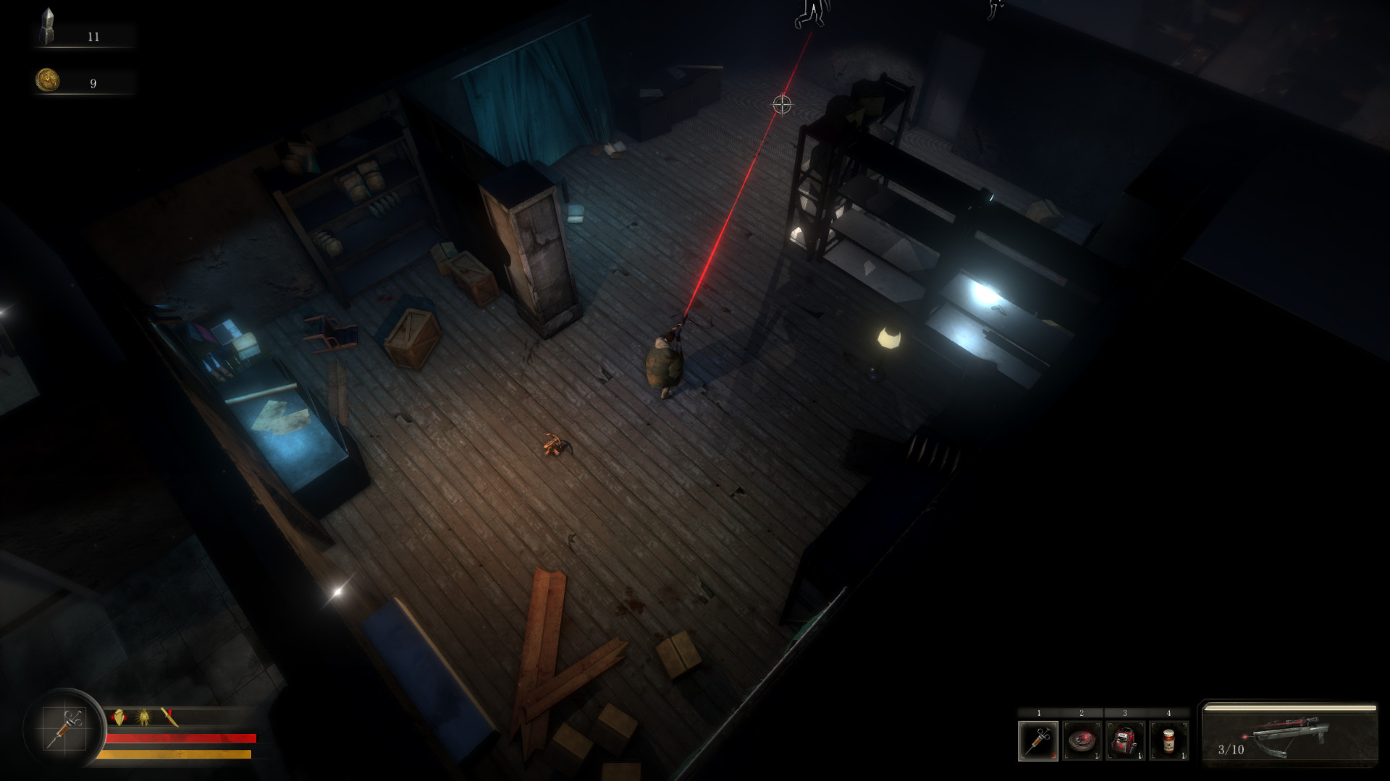

(example for look)

Robot Funk is a top down RPG that based in a post apocalyptic Universe. In this Universe, evil robots have taken over the world. You as our hero Troy, must use your handy dandy slingshot to sneak past and take out this robot menace.

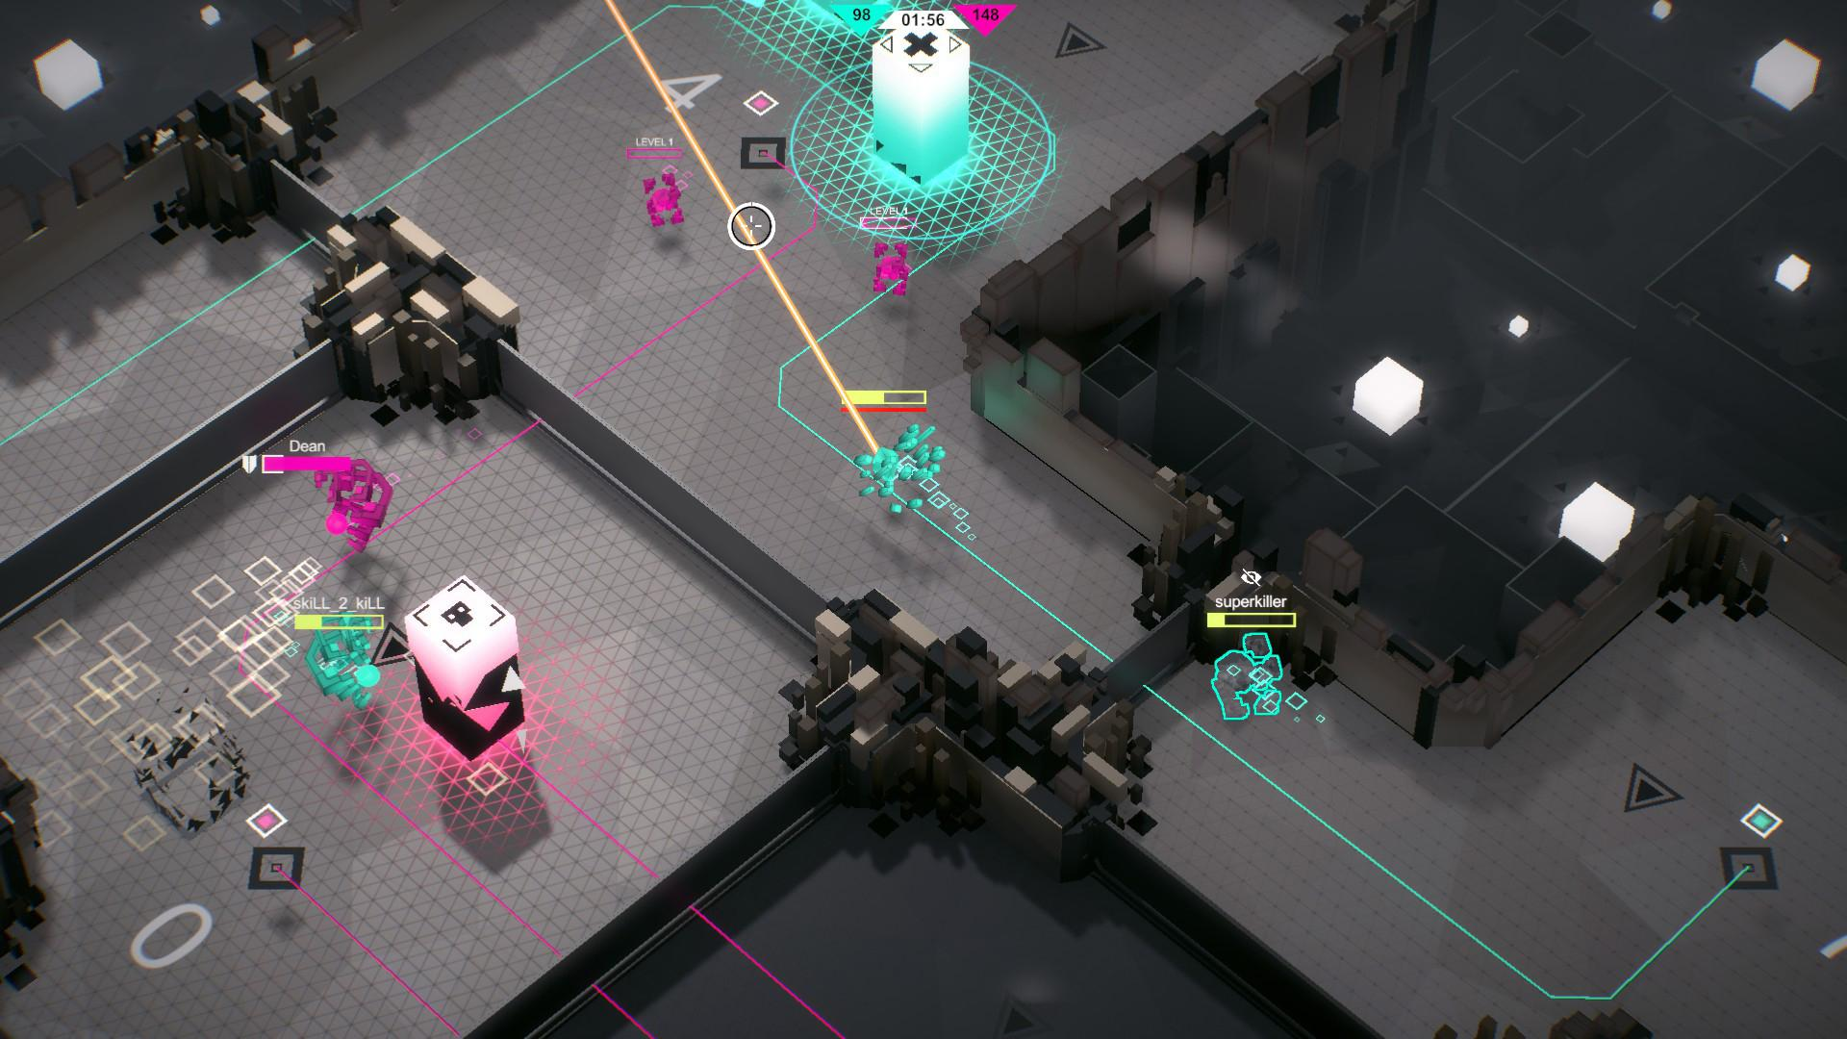

(example for look)

Game Look: Keeping with the robotic, futuristic look the environment of Robot Funk will have a metallic and neon to make it stand out. Things like floors, walls, rock shots, will have a glowing effect to them.

Target Audience: will be aimed at any game lover that enjoys the occasional shooter/stealth game. (All ages)

Gameplay: The player will have to maneuver through the levels while being stealth and ammo conscious. Some enemies will be too strong for the player to fight and will have to hide/sneak their way pass them.

Sound: machine sounds, slingshot, mechanics,footsteps, lasers