**Instructions** 26 November 2011

The TS package (V1.0) is a Graphic User Interface (GUI) based MATLAB software to compute the Target Strength (TS) of a solid elastic sphere. It is a self-contained and self-explanatory and easy to use.

**Installation**

To be completed…

**Operation**

Run the code by typing ComputeSolidElasticSphereTS in the Matlab window.

There are four groups of parameter options selectable by user.

1. **Target Properties:**

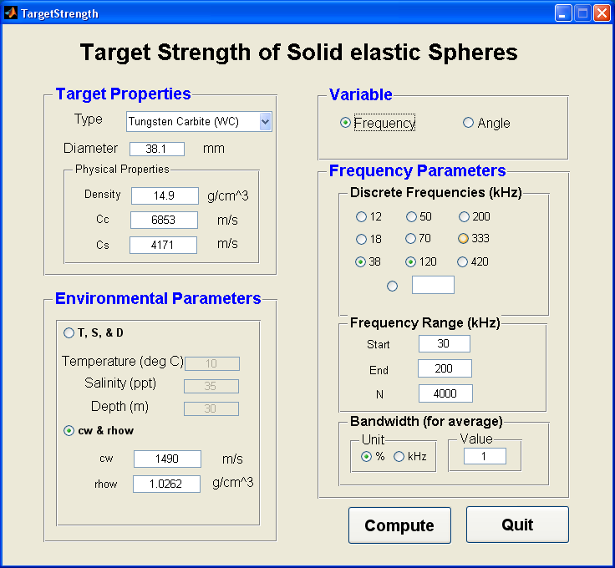

* Type (dropdown list):
  + Tungsten Carbide with 6% cobalt
  + Copper
  + Aluminum
  + Stainless steel
  + Other

The default material properties are shown but they can be changed by the user.

* Diameter: Diameter of the sphere in mm
* Physical Properties

Density of the sphere in 

Cc = compressional wave speed in the sphere in m/s

Cs = shear wave speed in the sphere in m/s

1. **Environmental Parameters:**

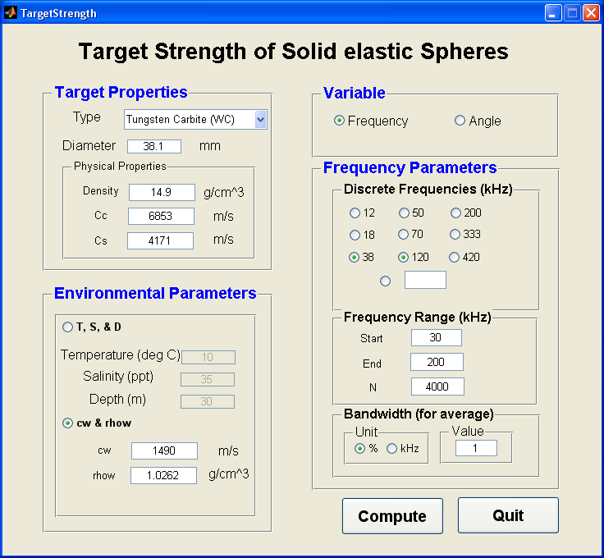

User can choose to provide either

* Temperature (deg C) , Salinity (ppt), and Depth (m)

by clicking on the radio option next to “T, S, & D)” or provide

* Cw (sound speed in water in m/s) and rhow (water density in )

by clicking on the radio option next to “cw & rhow”.

1. **Variable:**



* Either compute the TS as a function of frequency or scattering angle (bi-static scattering)
* If chooing “Angle”, the TS will be computed at the lowest frequency of the chosen discrete frequwncy and the start frequency defined in “Frequency Range”. The output is from 0 to 360 degree.

1. **Frequency Parameters:**



* Discrete frequencies:
  + Multiple selection either selecting the given frequency or frequencies or specifying a frequency other than those shown.
* Frequency Range:
  + Start frequency of the specified continuous frequency range
  + End frequency of the specified continuous frequency range
  + Number of output points of the TS over the specified frequency range
* Bandwidth (for average over the specified bandwidth):
  + Unit: percentage of the frequency range over which the average is taken
  + kHz: specific frequency range in kHz over which the average is taken

Example 1. TS of an elastic sphere as a function of frequency:

10-mm Tunsten Carbite (WC10) with the following parameters:



* TS of the sphere is shown as a specified continuous *frequency* range from 9.6 kHz to 361.9 kHz, with 4000 data points between the specified frequency range.
* Six chosen discrete frequencies at which the TS are explicitly given in the MATLAB command window.
* At each of the output frequencies, the average is taken over abandwidth of 1% around that frequency.

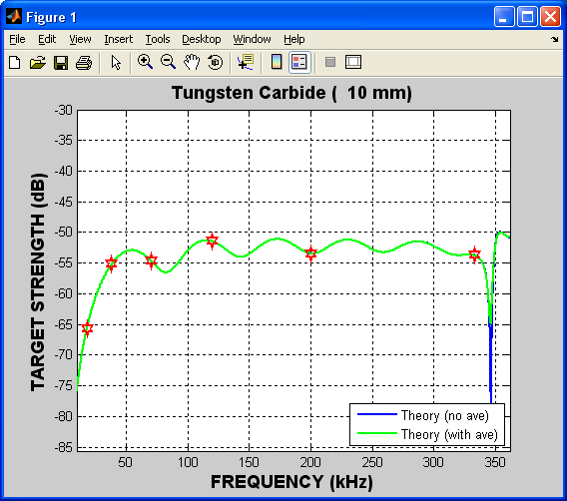

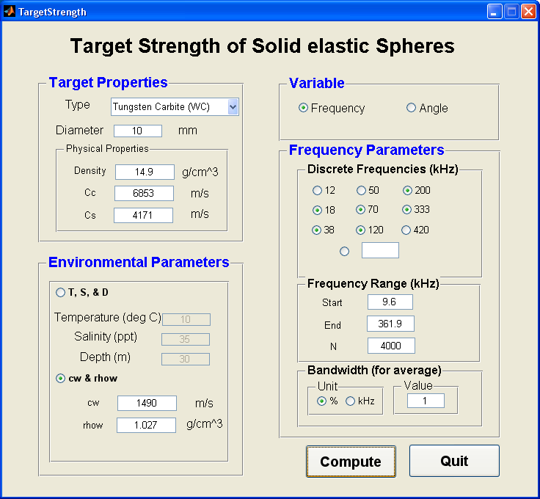

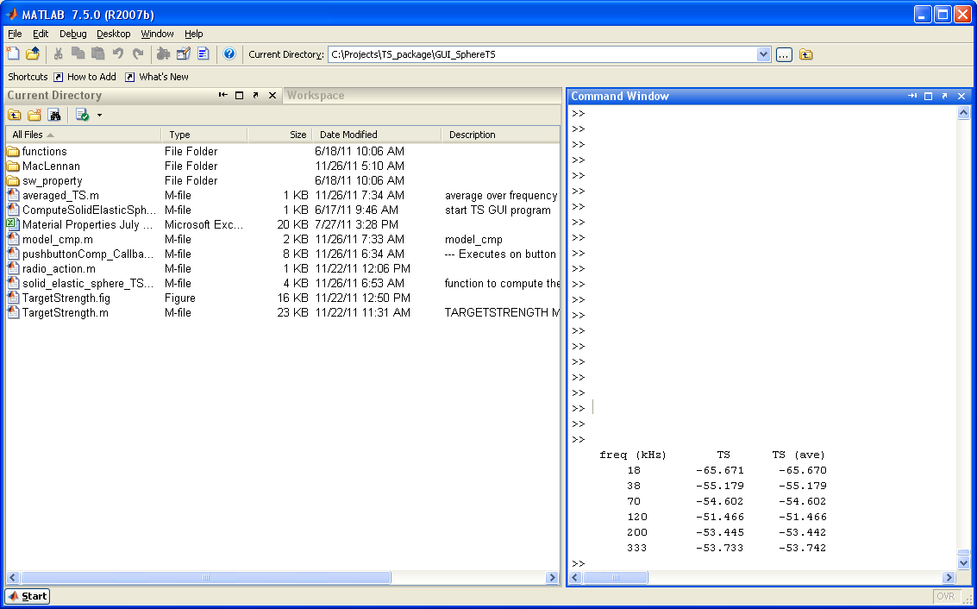

Example 2. TS of an elastic sphere is shown as a function of *angle*:

38.1-mm Tunsten Carbite (WC10) with the following parameters:



* Six chosen discrete frequencies at which the TS are explicitly given in the MATLAB command window.
* At each of the output frequencies, the average is taken over abandwidth of 1% around that frequency.
* Specify temperature (10 oC), salinity (35 ppt), and the corresponding depth (30m) where the sphere is located.
* The frequency is the lowest frequency of 18 kHz, 38 kHz, 120 kHz, and 40 kHz, which is 18 kHz. However, After the TS computation the freqeuncy range will change automatically to , where BW is the bandwidth (10 kHz).

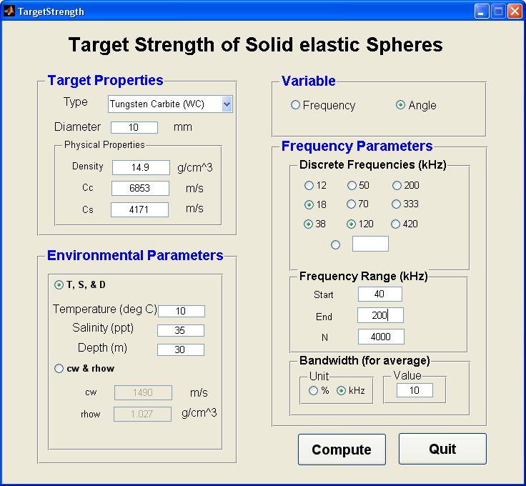

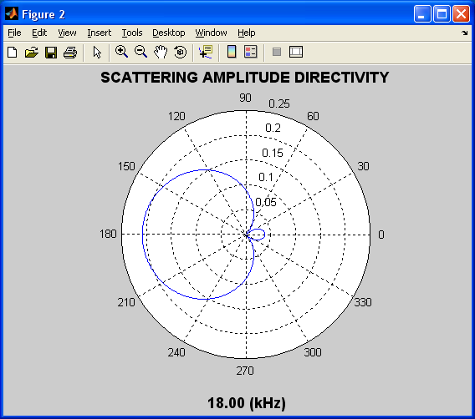

**Backscatter**

Bi-static scattering directivity by a 38.1-mm Tungsten Carbide sphere in linear scale.

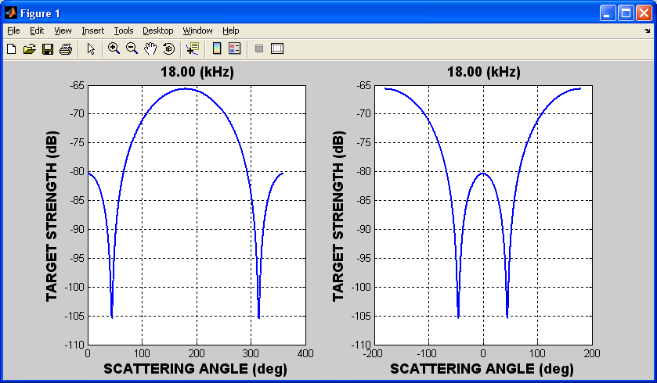

Bi-static scattering directivity by a 38.1-mm Tungsten Carbide sphere in logarithmic domain. One is the backscattering direction (180o) at the center, when is the forward scattering (0o) at the center.

All the parameters can be found in “para” (a struct class):

>> para

para =

rho: 14.900000000000000

cc: 6853

cs: 4171

ave_value: 10

ave_unit: 0

n: 4000

out_flag: 1

a: 0.005000000000000

cw: 1.490316174900207e+003

rhow: 1.027088118666203

freq_range: [13 205]

freq_spec: [18 38 120]

ave_BW: 10

scale: 1

target_index: 1

proc_flag: 2

D: 10

T: 10

P: 30

S: 35

and all output variables can be found in “out” (a struct class):

>> out

out =

fm: [1x4000 double]

TS: [1x4000 double]

freq: 18

t_str: 'Tungsten Carbide'

theta: [1x4000 double]

para_elastic: [1x7 double]

You can save, manipulate, and draw the output data (curves) in any way you want.