Description of the first algorithm developed to assess predator-prey interaction

Two are the main steps of the algorithm. For each frame of an attack sequence and having the position and direction of the predator in the image pre-labeled the algorithm performs a first step of image processing and filtering that follows the next scheme:

* Background subtraction: As the algorithm works in an offline fashion, a background model is computed for each video (HOW). Thus, the current frame of the video is subtracted to the reference background in order to eliminate noise specifically related to the acquisition device. Figure XX shows an example of how the background obtained from a sequence in which some noise-related issues can be observed, such as the appearance of shadows corresponding to the sonar beams.
* Image thresholding: Despite of the elimination of the device noise, there is still some contained in the images that must be reduced. For this reason, thresholding is applied to the subtracted image in order to eliminate those regions of the image with lower intensity whilst keeping the ones with the highest values. This gives as a result the image shown in (figure), in which spots corresponding to the fish school appears as unconnected blobs.
* Morphological filtering: The next step is to eliminate isolated pixels and to enhance the detected spots in order to get connected regions that correspond to the instantaneous shape of the school of fish.

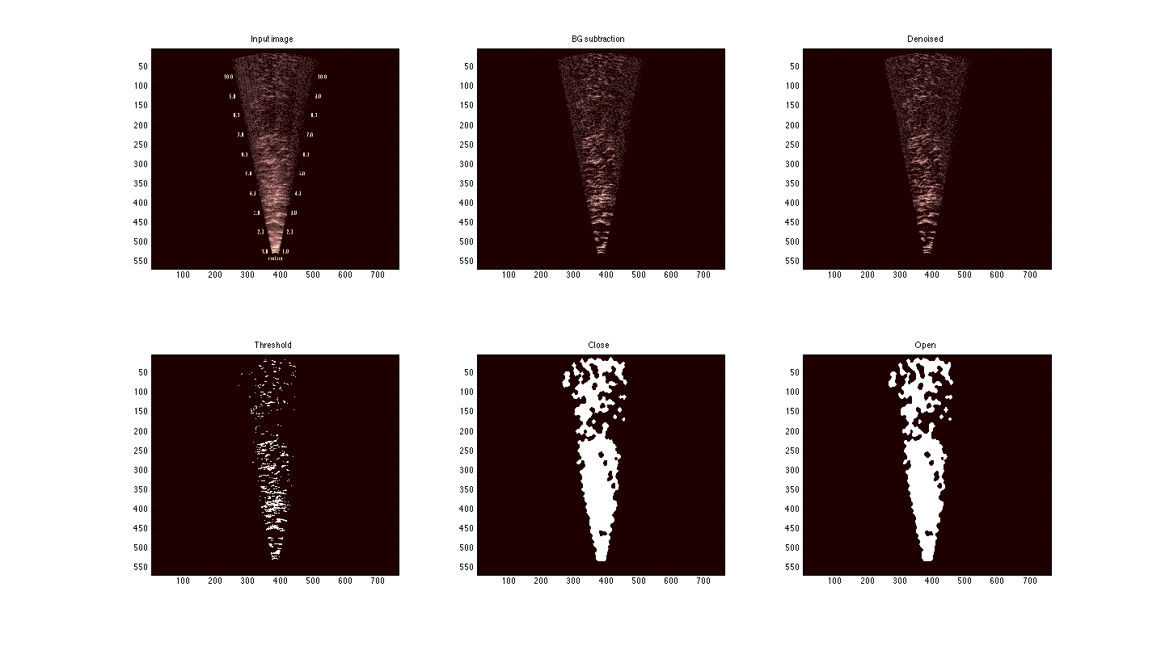

After the noise in the image has been reduced and the spots corresponding to fish are isolated, the detection of the interaction between the predator and the school takes place. The algorithm needs the position and direction of the predator (labelled in advance) and searches the positions of fish in front of it through an angle of 180º in front of the predator and a specified range:

* Split the angle into a series of vectors with range length.
* A ray tracing-like approach is used to detect collisions between each vector and pixels in the image, being the first non-zero pixel considered as belonging to the boundary.

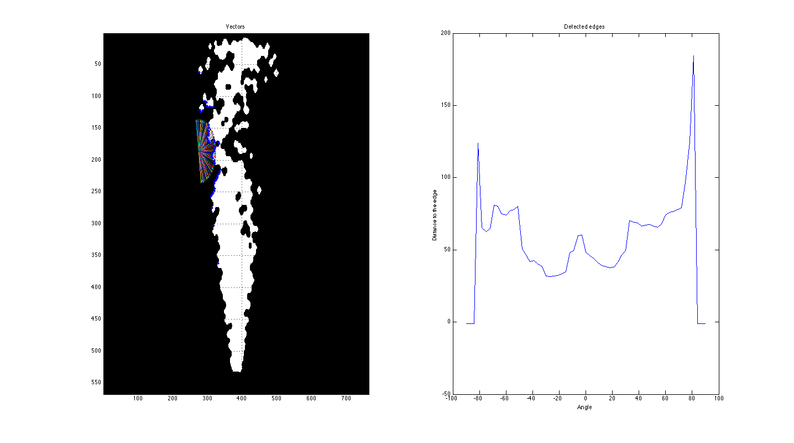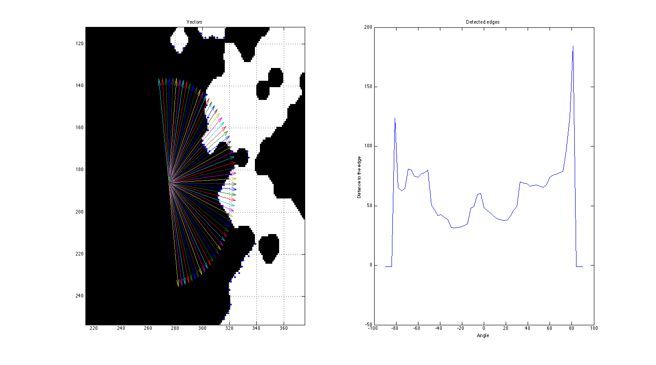

The result is shown in the image below and in the graph on the right

