05/29/16

ARCHSPARK spec

# PURPOSE

Archspark is a place for architects to discover, search, and save inspiration. It’s a live-updating collection of posts from the most popular and trusted architecture blogs & curators of content.

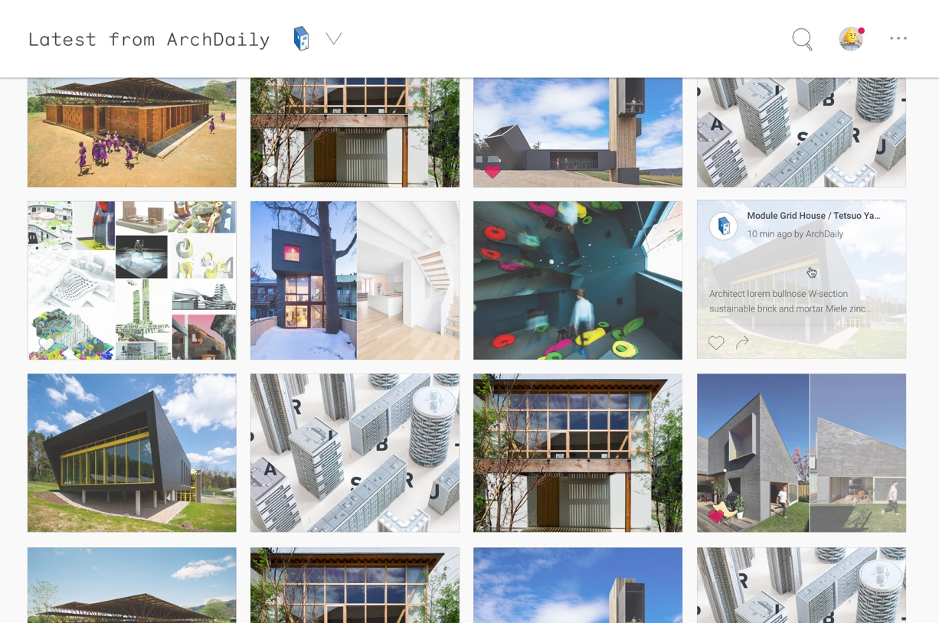

# PRECEDENTS / EXAMPLES

Archspark is inspired by tools that exist for UX, UI, Visual & product designers:

## <https://muz.li/>

## <http://usepanda.com/>

# DELIVERABLE

By building this app in React & React native, the goal is to launch a web app, iOS app, and Android app simultaneously.

## Web app

### URL is [www.archspark.com](http://www.archspark.com)

### Custom Responsive Design

#### Desktop resolution

#### Tablet resolution

#### Mobile resolution

## iOS app

### Standard iOS components

### Get into App store (free app)

## Android app

### Standard Material Design components

### Get into Google Play (free app)

# WEBAPP REQUIREMENTS

## Card (Main/Default view)

Continuously scrape a dozen websites and blogs to keep up-to-date information:

### Source

#### ArchDaily [www.archdaily.com](http://www.archdaily.com)

#### Dezeen [www.dezeen.com/architecture](http://www.dezeen.com/architecture)

#### Domus <http://www.domusweb.it/en/architecture.html>

#### Dwell <https://www.dwell.com/homes>

#### Design Boom [www.designboom.com/architecture/](http://www.designboom.com/architecture/)

#### Design Milk [www.design-milk.com/category/architecture](http://www.design-milk.com/category/architecture)

#### Architizer <http://architizer.com/>

#### BLDG BLOG <http://www.bldgblog.com/>

#### Archinect <http://archinect.com/news>

#### Wallpaper <http://www.wallpaper.com/architecture>

#### anArchitecture <http://www.an-architecture.com/>

#### Arcspace <http://www.arcspace.com/>

#### Cereal <http://readcereal.com/journal/>

#### Bustler <http://bustler.net/>

### Title of post

### Image(s)

### Time / Date posted

### Link (used in share state)

### First ~80 characters in story

### Ability to save / favorite

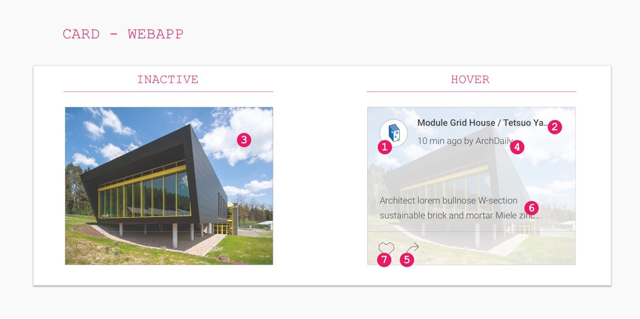

## Share

### Post to Facebook

#### Card View information with an overlay over the image that says “posted via Archspark”

### Post to Instagram

#### Image with an overlay that says “posted via Archspark” @archsparkit

### Post to Twitter

#### Same as Facebook, but also reference @archsparkit

### Post to LinkedIn

#### Same as Facebook

### Email link

### Text link

## Login

### Allow users to discover and search stories without logging-in

### Saving a post initiates a login/signup flow

### Ability to save, reference, and search favorites

### Single sign-on with Facebook, Twitter, Google+

## Search

### Ability to search for keywords in posts

### Display past searches

### Suggested searches while typing

### Search within:

#### Selected blog/source

#### All blogs/sources

#### Favorites

## Favorites

## Source Dropdown

## Menu

### Profile

#### Logout

#### Login/Signup

### Settings

#### Layout

##### Square

##### Masonry

#### Display

##### Day

##### Night

### About Archspark

### Archspark links

#### Stay inspired

##### Chrome extension download link

##### iOS download link

##### Android download link

#### More at…

##### @medium account link

##### @facebook page link

##### @twitter account link

### Contact us

#### Form & button

#### Confirmation screen

### Archspark links

#### Stay inspired

##### Chrome extension download link

##### iOS download link

##### Android download link

#### More at…

##### @medium account link

##### @facebook page link

##### @twitter account link

# android requirements

# IOS Requirements

# ACCOUNTS

## Medium - @archspark

## Facebook - /archsparkit

## Twitter - @archsparkit

## Instagram - @archsparkit

## Email – [info@archspark.com](mailto:info@archspark.com), [contact@archspark.com](mailto:contact@archspark.com), [gavin@archspark.com](mailto:gavin@archspark.com), [archsparkit@gmail.com](mailto:archsparkit@gmail.com)

## Domain redirect – [www.archsparkit.com](http://www.archsparkit.com) to [www.archspark.com](http://www.archspark.com)

# UI consideratioNS

## Typography

### Size

#### All size should be created in dp & sp units to ensure responsive clarity. If specs declare px, please convert to sp. sp=1.5(px)

# WORKING SCHEDULE

## Milestones

## Weekly Check-in

## Source Code & help with running it on my machine

## Hosting

## App Store

## Google Play