[https://regexper.com](https://regexper.com/)

**Expression:**

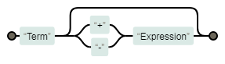

**Term(?:(?:\+|-)Expression)?**

**Term:**

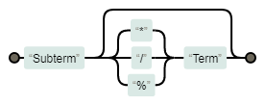

**Subterm(?:(?:\*|\/|%)Term)?**

**Subterm:**

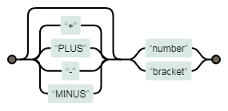

**(?:\+|PLUS|-|MINUS)?(?:number|bracket)**

**Bracket:**

**(?:\()Expression(?:\))**

D:\Users\gapollit\Downloads\image (2).png

**Number:**

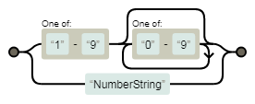

**(?:[1-9][0-9]*|NumberString)**

**NumberString:**

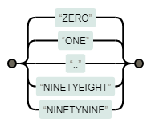

**(?:ZERO|ONE|\.\.|NINETYEIGHT|NINETYNINE)**

Expression : TEN * NINE + NINE

+

*

10

9

9

Expression: -(EIGHTY EIGHT/11 - SEVEN)

-

/

88

7

11

-1

*