Journey Assistant

Project Development Plan

Version <1.0>

Change Log

|  |  |  |  |
| --- | --- | --- | --- |
| **Date** | **Version** | **Change Note** | **Author** |
| 2019-04-02 | <1.0> | <The first version of this document> | Yiwen Song |
|  |  |  |  |
|  |  |  |  |
|  |  |  |  |

**1引言 1**

1.1编写目的 1

1.2 背景 1

1.3定义 1

1.4参考资料 1

**2项目概述 1**

2.1项目目标与工作内容 1

2.2团队组织结构 1

2.3产品 2

*2.3.1程序 2*

*2.3.2文件 2*

*2.3.3服务 2*

*2.3.4非移交的产品 2*

2.4验收标准 2

2.5项目的计划完成时间和最迟期限 2

**3实施计划 2**

3.1工作任务的分解与人员分工 2

3.2 阶段计划 3

3.3预算 3

3.4关键问题 3

**4技术流程计划 3**

4.1方法、工具和技巧 3

4.2技术标准 3

**5外部支持条件 3**

5.1需由用户承担的工作 4

5.2由外单位提供的条件 4

**6专题计划要点 4**

**Project Development Plan**

# 1Introduction

## 1.1Document Purpose

The purpose of this project development plan is to help the project developers clarify their jobs, deadlines and technical outlooks of this project. We expect all the project developers (or anyone who are involved in the development of this project) to know the development plan of our project.

## 1.2 Background

There are some statement we need to make before entering the main part.

1. The NAME of our software system is Journey Assistant.
2. The project is our final project of Software Engineering course, developed by Song Yiwen, Xie Zhihui, Chen Haoping, Wang Weizhe and Jiang Huangfei of SEIEE, Shanghai Jiaotong University. The target user of our system is the travellers who are making their jouney plans.
3. Our software system is an upgrade of the trip-recommendation system of Xiecheng, Tuyou, etc. We use automation algorithms to give journey plan recommendations, distinguished from the companies' manual recommendations.

## 1.3Definition

Here we list some terms or abbreviations we will use in this file.

|  |  |  |
| --- | --- | --- |
| Abbreviations | Terms | Implications |
| JAS | Journey Assistant | The name of our Project |
| / | Android | OS developed by Google |
| OS | Operating System | / |
| TCP/IP | / | Network Protocol |

## 1.4Bibliography

《面向对象软件工程（第三版）》 清华大学出版社

《代码整洁之道/*Clean Code*》人民邮电出版社

*Learning Java* O'Reilly

《机器学习》清华大学出版社

《面向对象软件工程实践指南》上海交通大学出版社

# 2Project Outlook

## 2.1Project Target and Job Contents

The purpose of our project is to develop a software system that can automatically recommend journey plans and do simulated journeys given a plan, and give feedback according to the experience of the simulated journey. The main jobs involved in this projects are:

1. Design a friendly user interface.
2. Design a good recommendation algorithm.
3. Implement the algorithm in a fast way in our software.
4. Design an port for the users to give advice.

## 2.2Team Organization Pattern

The organization pattern of our project team are listed as follows.

1. Song Yiwen is the team leader. Organizes all the jobs, and will participate in algorithm designing and implementation and UI designing.
2. Xie Zhihui is in charge of technical works, including algorithm designing and implementation, API ports, etc.
3. Chen Haoping will be in charge of the desgning works including art, texts and interface design.
4. Jiang Huangfei will be in charge of the database construction works, who will be responsible for acquiring data from other companies' APIs, and maintaining our database.
5. Wang Weizhe will be in charge of the optimization works, who gives advice to all aspects of jobs and help make our software become more efficient and user-friendly.

## 2.3Product

### 2.3.1Programs

The programs that will be delivered to the users are listed as follows.

1. The user-interface module. Coded with Java (complied to binary). Pakced in the main software program. This module is the manager of the user-interface, including login interface, destination-choosing interface, requirement-choosing interface and other display interfaces.
2. The display-data module. Coded with C++ and Java (complied to binary). Packed in the main software program. The maps and figures needed are packed in folders and saved in the user's flash drive. This module receives the data from our server and display it to the user.
3. The save-data module. Coded with Java (complied to binary). Packed in the main software program. This module saves key data to the user's device to enable offline-request.

### 2.3.2Files

The files that will be delivered to the users are listed as follows.

1. The Operation Manual. It tells the operations of our software.
2. The Service Agreement. It orders the user to agree the protocols in order to use our software.
3. Essential figures and videos. Some essential figures and videos are kept in the user's device. Therefore, the user does not need to query the essential data every time they use the software.

### 2.3.3Services

The services that will be delivered to the users are listed as follows.

1. Application Maintainence. Starts from installation, ends by uninstallation. Priority Level: Medium. Service due date: None.
2. User guide. Given at the first time the user uses the application. Priority Level: Low. Service due date: After the first use.
3. Bug reporting. Starts from installation. Priority Level: High. Service due date: None.
4. Advice port. Starts from first use. Priority Level: Low. Service due date: None.

### 2.3.4Non-delivered products

The products that will NOT be delivered to the users are listed as follows.

1. The user database. Using MySQL. Saving the username, user info, and password.
2. The recommendation and simulation algorithm. Coded by C++ and Python.
3. Unessential figures and data.

## 2.4Acceptance Certificate Standard

The whole system works well and stably, according to GB15532-2008, *Software Testing Standard*.

## 2.5Predicted Completion Time and Latest Delay

The project is predicted to be completed on 2019.6.23, and the delay will be no more than 1 week.

# 3Performance Plan

## 3.1Split of Jobs and Division of Labor

|  |  |  |
| --- | --- | --- |
| **Project** | **Leader** | **Participating Members** |
| Requirement Analysis | Wang Weizhe | Jiang Huangfei |
| Usecase | Jiang Huangfei | Song Yiwen, Wang Weizhe |
| Analysis | Chen Haoping | Xie Zhihui |
| System Design | Song Yiwen | All others |
| Module Design | Xie Zhihui | All others |
| Outer Port Design | Xie Zhihui | Wang Weizhe, Jiang Huangfei |
| Module Realization | Song Yiwen | All others |
| Module Test | Wang Weizhe | Xie Zhihui, Chen Haoping |
| System Integration | Chen Haoping | All others |
| System Test | Jiang Huangfei | Wang Weizhe, Xie Zhihui |
| System Deployment | Song Yiwen | All others |
| User Guide | Chen Haoping | Wang Weizhe, Jiang Huangfei |
| System Specification | Xie Zhihui | Song Yiwen, Chen Haoping |
| System Deployment Specification | Song Yiwen | Chen Haoping, Wang Weizhe |
| System Maintainence | Wang Weizhe | All others |

## 3.2 Phase Plans

|  |  |
| --- | --- |
| Phase Plan | |
| Milestone Event | Predicted Time |
| Requirement Definition | 2019.4.7 |
| Software Architecture | 2019.4.28 |
| Module Development | 2019.5.19 |
| System Integration | 2019.6.1 |
| System Display | 2019.6.9 |
| System Deployment | 2019.6.21 |
| Project Completion | 2019.6.23 |

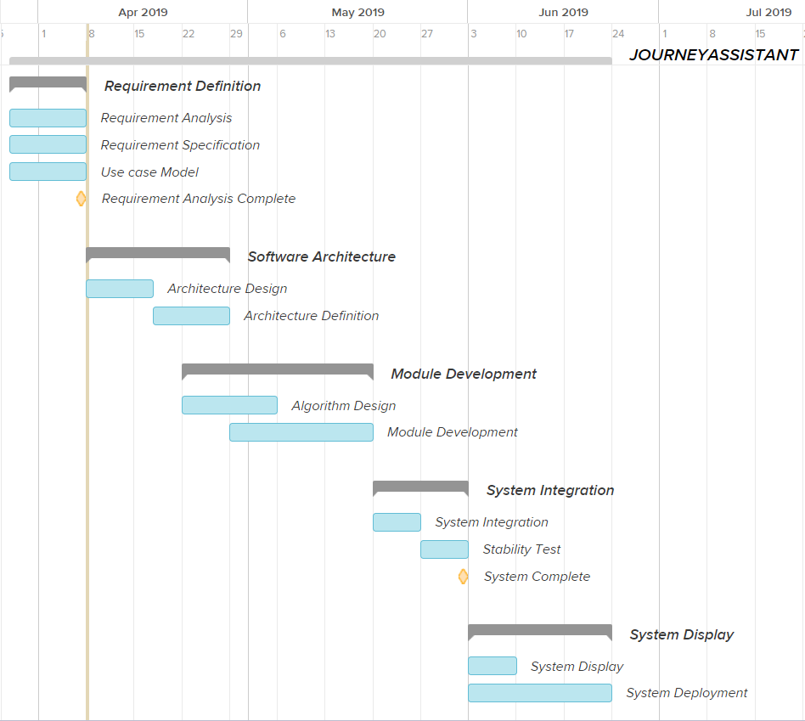

## 3.3Budget

We don't need any budget to complete the project, as our labor needs no salary.

## 3.4Key Problem

1. The safety of users' information. If the users' information were lost or stolen, it will cause greate economical loss and privacy cost.
2. The capability and stability of databse. If the stability or capability of database is not enough, the system may fail at unpredictable time.
3. Friendliness of user interface. A friendly user interface will attract more users.
4. Easiness of using. A easy-using software will keep more users.
5. The plan, communications, and technical restricts during our development. Our development progress may be delayed, prolonged or we may not be able to complete planned tasks.

# 4Technological Process Plan

## 4.1Methodology, Tools and Techniques

Our project is maily developed by Java, C++ and Python, use IDE Eclipse/IntelliJ, CLion, and PyCharm.

The database is maily developed by the open-source database MySQL.

We use structural development to split our whole system into several modules and develop them individually.

We use fountain model for the life cycle of our project.

## 4.2Technical Standards

The technical standards we will use in our development include:

1. Business Modeling Guide: 《业务建模指南》
2. UI Guide: Google Material Design
3. Use case Modeling Guide: 《用例建模指南》
4. Design Guide: Google Material Design
5. Programming Guide: *Object Oriented Software Engineering*
6. Testing Guide: GB15532-2008, *Software Testing Standard, Pearson*.
7. Coding Scheme Guide: *Clean Code, Robert C. Martin*.

# 5External Support Conditions

## 5.1Jobs Performed by Users

We need to users to create their account (sign up) the first time they use our software. Then their account will be saved in our database and they aren't required to do any further jobs. Other non-required jobs include bug reporting and giving advice.

## 5.2Jobs Performed by Other Companies

We may use some API developed by other companies in our project. They include:

1. Map API supported by Gaode or Baidu Inc.
2. Scenary information API supported by MeituanDianping Inc.
3. Tensorflow, a deep learning development kit, developed by Google Inc.
4. Anaconda, a multi-functional kit for Python, developed by Anaconda Inc.
5. Open-source web frameworks such as bootstrap.
6. Other open-source codes developed by personal developers or small teams.

# 6Plan Keywords

In the requirement management plan we will mainly focus on the requirement analysis, and make plans according to our ability to satisfy as much need as possible.

In the progress control plan, the key point is to control the progress as planned during our development of our project.

The quality control plan is mainly about to improve our project quality in planned time.

The risk management plan is mainly about reducing the risk during and after our completion of our project, and make plans before the accidents happen.

The equipment management plan is mainly about reducing the cost of our equipments under the constraints of quality control.

The system testing plan is mainly about finding as much bugs and repair them as possible before our software finally goes into the application market.

The system acceptance plan is mainly about making a proper standard for our project. The standard should not be too hard to pass, but also not be too easy so that the software may not be friendly at last.

The developer training plan is mainly about training developers to complete the tasks they should do.

The system installation plan is mainly about finding a proper way to make a good sequence to install the system.