**Purpose**

This C++ program tracks the buying habits of customers at Corner Grocer. Given a record of items purchased in chronological order, this program generates an alphabetized list of each item’s name and the frequency that it is purchased. Additionally, the program allows a user to search for the frequency of a particular item and display the list it generates as either a table or a histogram. Corner Grocer can use this program to easily identify the most popular items and rearrange their produce section accordingly.

**Functionality**

Upon execution, the program reads from a text file containing the names of produce items and creates a special list, known as a map, to keep track of each item. C++ maps are a type of container that stores key-value pairs and automatically organizes keys in ascending order (Kartik, 2025). The map uses the item’s name as the key while the value is a Product object which stores the item’s name and frequency. To determine frequency, each item that is read from the input file is checked against the map list to see if the item’s name matches any existing key. If a match is found, the frequency of that Product is incremented by 1. Otherwise, a new element pair is created and is initialized with a frequency of 1. Once every item from the text file has been read, the program creates *frequency.dat* to store a backup of the organized information in the form of a table.

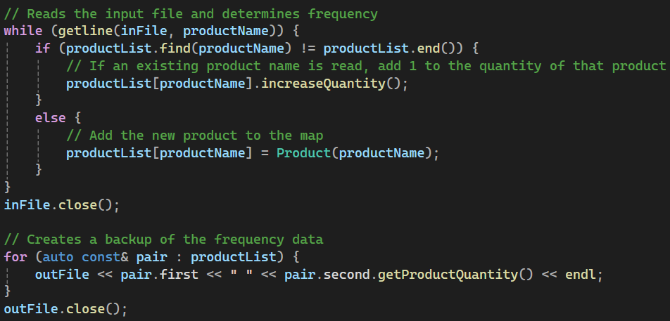

After item frequency has been determined, the user is provided with the following menu:

1. Item Quantity Search

The user is prompted to enter an item’s name. If the entered item exists, the program displays the item’s name and frequency. Otherwise, the program notifies the user that the item does not exist.

1. List of Items and Quantity

The program outputs a table that displays each item’s name alongside its associated frequency, represented with a number.

1. Chart of Items and Quantity

The program outputs a vertical histogram chart which displays each item’s name and its associated frequency, denoted with asterisks (*).

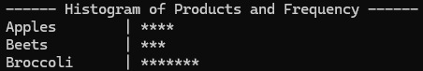

1. Quit the Program

Ends program execution and safely exits the program.

**Design**

This program utilizes a single class called *Product* to store information about each item’s name and frequency within the map list. While such a class was not necessary for the specific needs of Corner Grocer, the Product class allows for additional information to be stored about each item in the future without needing to modify the map list that it is organized within.

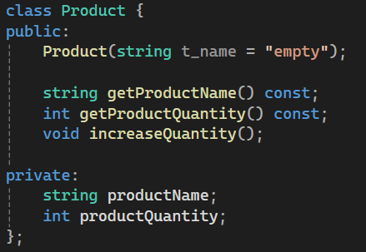

A map was chosen because of its use of key-value pairs. Keys make it quick and easy to search for a particular element within a list. Using iterators and the find() member function, a search term can quickly be tested to determine if there is a matching element pair in the map.

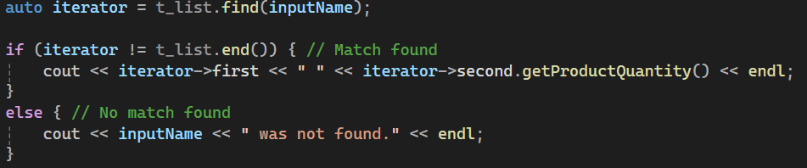

This program uses a single map list and passes it by **const**ant reference to each of the three main functions in main() to save on memory. Likewise, element pairs of the map list are passed by constant reference in for-loops within each of the print functions.





Self-documenting variable names are used throughout the program to improve readability, and comments are provided to explain the operations of each function. Input validation is used to prevent errors and ensure that the program works correctly.

**References**

Kartik. (2025, September 19). *Map in C++ STL*. GeeksforGeeks. <https://www.geeksforgeeks.org/cpp/map-associative-containers-the-c-standard-template-library-stl>