#### 

#### **The Analytical Report**

What factors most significantly impact Airbnb listing prices in NYC, and how can Airbnb optimise pricing recommendations to increase host profitability while maximising booking rates?

Introduction

In this report factors which impact most significantly Airbnb listing prices in NYC are analysed. Airbnb listing prices in NYC are shaped by a range of factors such as location, room type, availability, and guest preferences. Understanding these factors is critical for creating pricing strategies that balance host profitability with high booking rates (Airbnb, 2023). The analysis below explores the key drivers of price variation and provides actionable recommendations for Airbnb to optimise its pricing system and thereby increase host profitability while maximising booking rates. The accompanying charts and graphs illustrate these trends for clarity and data-driven insights. The recommendations for the executive board members of Airbnb are based on the analysis of the Airbnb dataset ([AB_NYC_2019.csv](https://nam11.safelinks.protection.outlook.com/?url=https%3A%2F%2Fwww.kaggle.com%2Fcode%2Fwhyalwaysme%2Fab-nyc-2019&data=05%7C02%7Cvle-kol%40kaplan.com%7C28aee75828b3473747d408dc43625d53%7C057daf85b1d544cdab7b0a4ce1b29eae%7C0%7C0%7C638459336958978960%7CUnknown%7CTWFpbGZsb3d8eyJWIjoiMC4wLjAwMDAiLCJQIjoiV2luMzIiLCJBTiI6Ik1haWwiLCJXVCI6Mn0%3D%7C0%7C%7C%7C&sdata=jK3zdVNF04Rn%2BZ2NyZn9ylwtVS8fMw%2FAIuo%2BTg5b2g0%3D&reserved=0)).

Location is a major driver of prices.

Location is one of the most significant determinants of Airbnb prices in NYC. Listings in Manhattan command the highest prices with the average cost for an entire home reaching $225.65 per night. The premium pricing is justified by Manhattan’s centrality, iconic landmarks, and accessibility. Brooklyn, while less expensive, has emerged as a popular alternative with prices averaging $168.85 for entire homes. Outer boroughs like Queens, Bronx, and Staten Island are more budget-friendly offering lower prices that cater to cost-conscious travellers (Bureau of Economic Analysis, 2022; Toader et al., 2020).

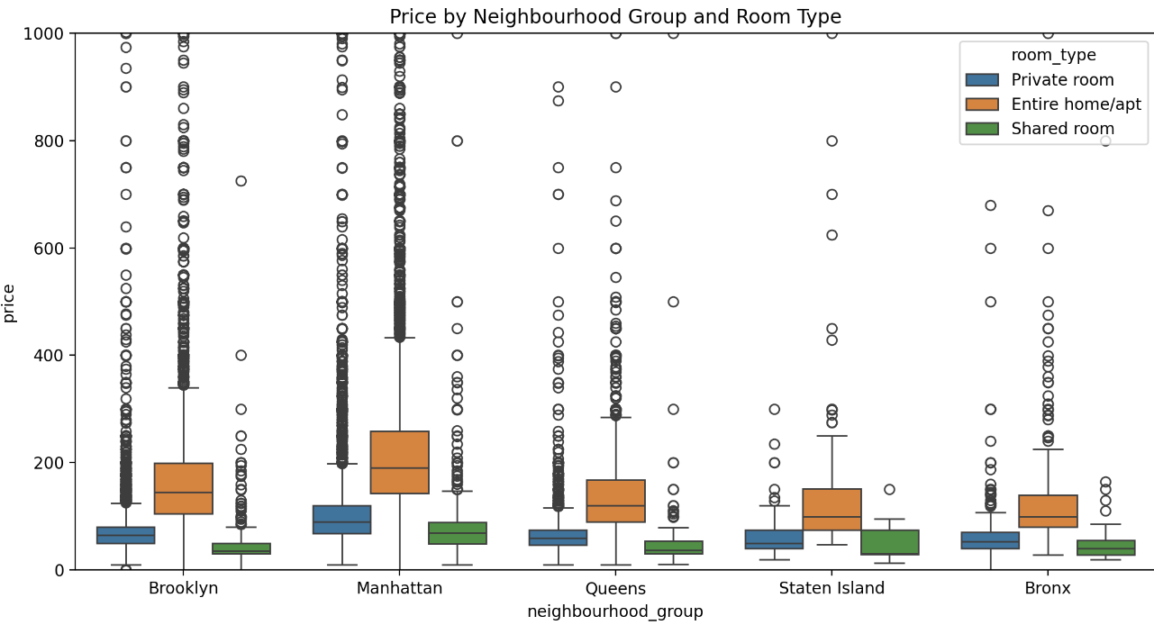

The boxplot illustrates how prices vary across neighbourhoods and room types. Manhattan stands out for its consistently high prices, especially for entire homes/apartments. Brooklyn shows a wider range of prices appealing to budget and high-end travellers. In contrast, the Bronx, Queens, and Staten Island offer affordable options particularly for private and shared rooms.

Therefore, Airbnb should utilise dynamic pricing algorithms that adjust rates based on neighbourhood demand. Higher prices can be set during peak travel seasons or major events like the NYC Marathon, while discounts can be offered in less competitive periods (Chen & Zhang, 2021).

The influence of room type

A correlation matrix does not indicate any correlation to price for the below columns. It indicates that neighbourhood and room type are the driving factors for price.

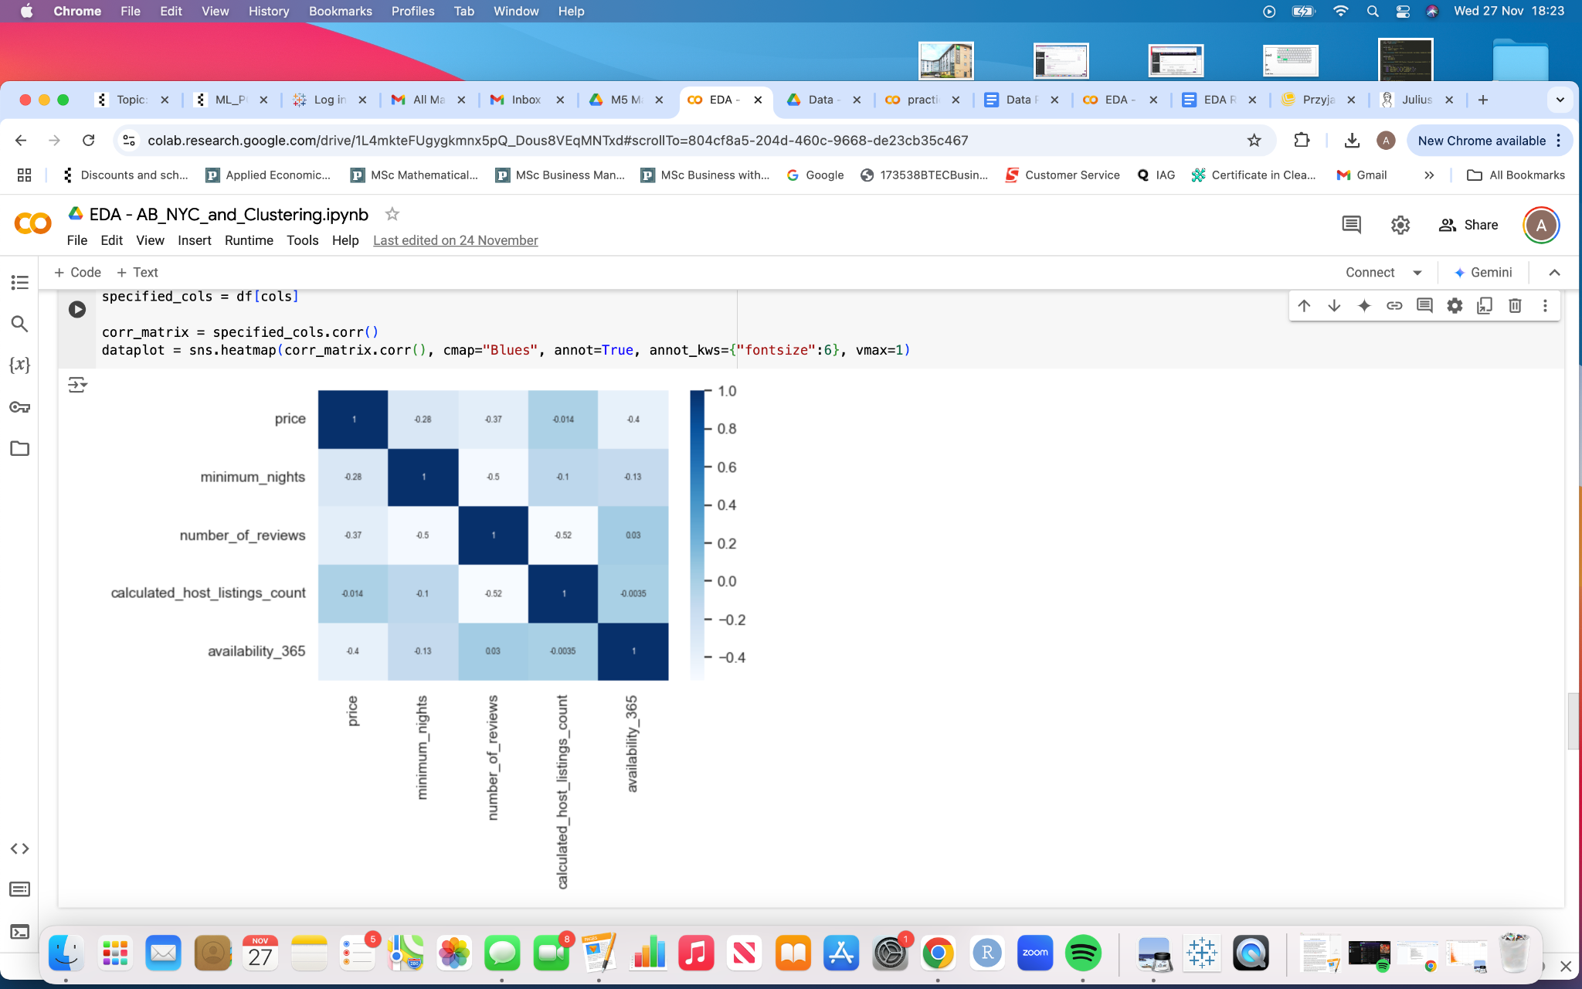

Room type has a big impact on listing prices and demand. Entire homes and apartments are the most expensive options, appealing to families and groups who value privacy and space. Private rooms cater to solo travellers or couples and strike a balance between affordability and comfort. Shared rooms being the least expensive attract highly budget-conscious travelers but have limited appeal overall (Guttentag, 2019).

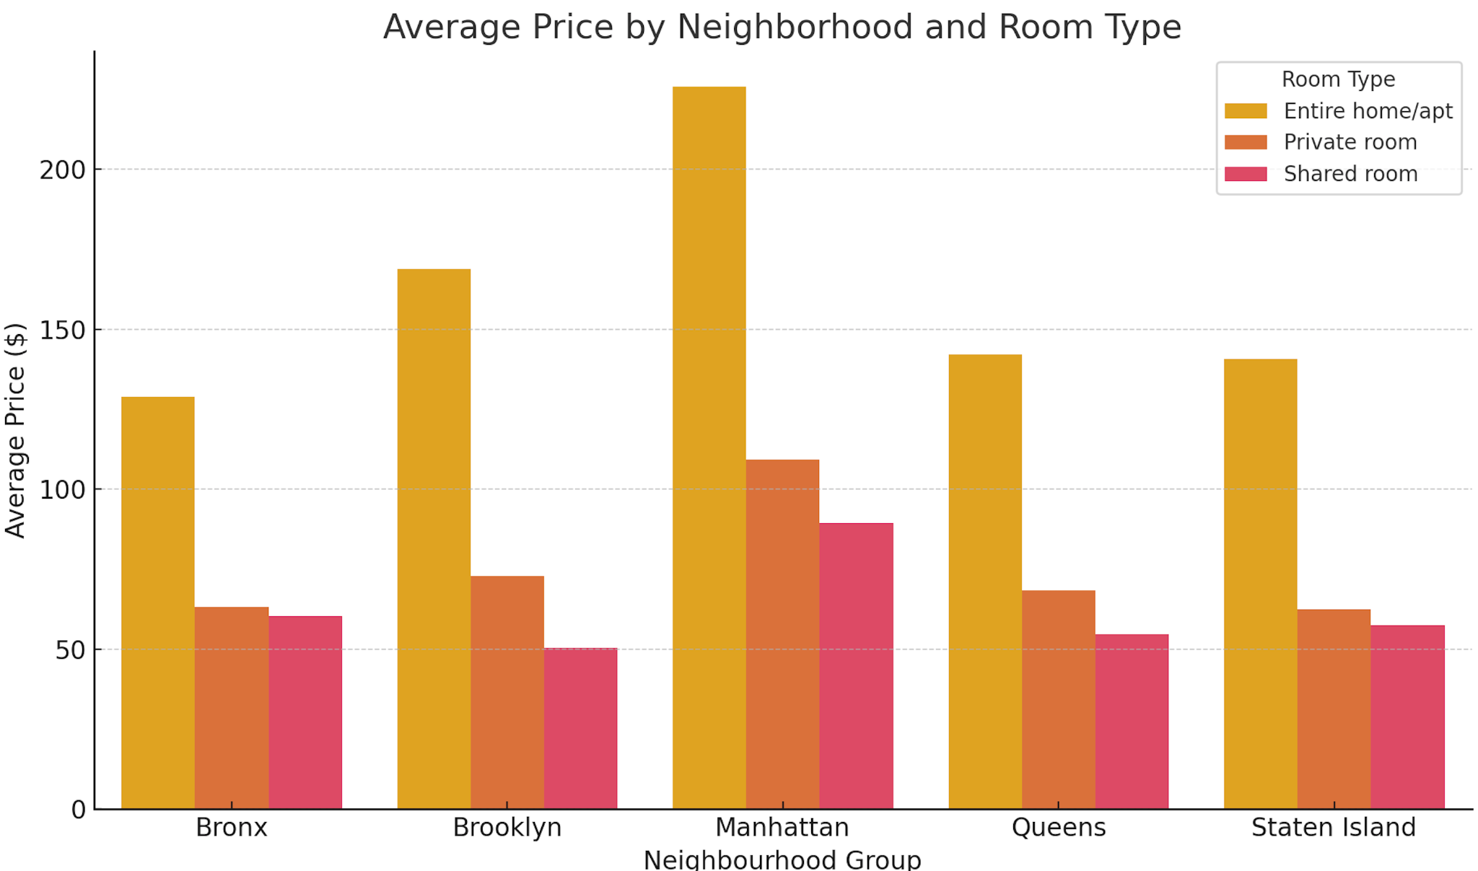

The bar chart shows the average price for each room type across neighbourhoods. Entire homes dominate in Manhattan and Brooklyn with private rooms offering more affordable options across all boroughs. Shared rooms remain the least expensive, especially in outer boroughs like the Bronx and Queens.

Airbnb can guide hosts to diversify their offerings by promoting private rooms in popular neighbourhoods and encouraging competitive pricing for shared spaces. Entire homes should be positioned as premium listings, particularly in high-demand areas like Manhattan and Brooklyn (Inside Airbnb, 2023).

Availability and seasonal demand

Availability plays a crucial role in pricing, but its impact is nuanced. Listings with higher availability tend to be priced slightly higher, but this relationship is weak. Seasonal trends are a more powerful influence as demand spikes during holidays, events, and peak travel months (NYC Tourism Board, 2023).

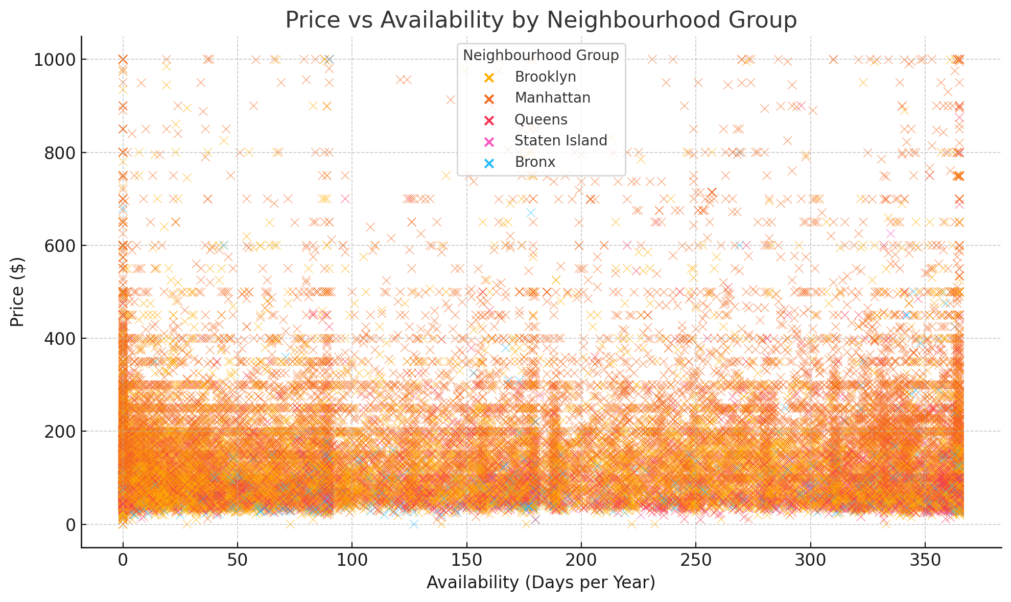

The scatter plot shows a slight positive correlation between availability and price. Listings with year-round availability tend to have higher prices, but the impact diminishes beyond 200 days. Seasonal trends likely play a more significant role in driving bookings. Therefore, Airbnb should offer hosts data-driven insights into when to increase availability. Listings in Queens and Brooklyn attract more bookings during major events by offering discounts for extended stays. Hosts in Manhattan can leverage premium pricing during peak seasons while maintaining occupancy through early-bird discounts (Smith & Green, 2022; Zhang & Wu, 2021).

Occupancy rate by price bracket

The below chart and table show that occupancy rates are highest for medium-priced listings, while very high-priced listings have significantly lower occupancy. This suggests that moderately priced listings strike a better balance between affordability and profitability (Zhang & Wu, 2021).

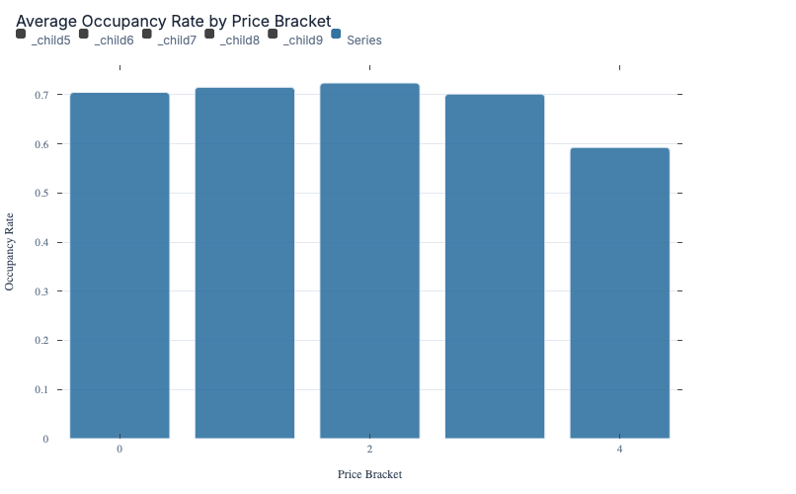

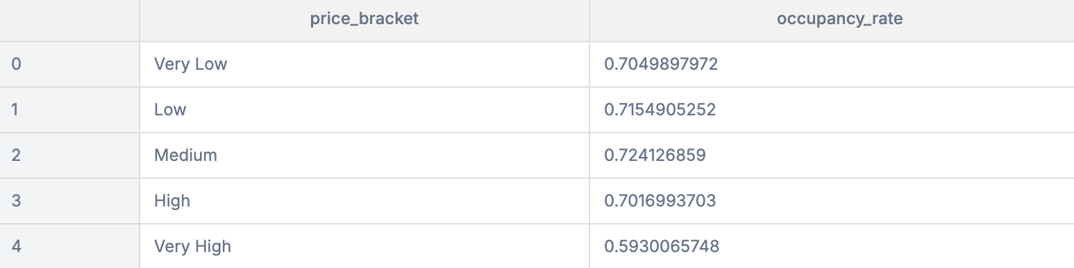

The data shows that maximising revenue isn’t just about setting high prices. It is recommended to find the optimal balance between price and occupancy rates.

Reviews and guest preferences.

While the number of reviews and reviews per month are often seen as indicators of demand, they have minimal direct impact on prices. However, reviews are essential for boosting guest confidence and visibility on the platform. Private rooms typically receive the highest number of reviews per month, reflecting their popularity among budget-conscious travellers. Entire homes, though less frequently reviewed, attract longer stays and higher-paying guests (Nolan, 2020; Guttentag, 2019).

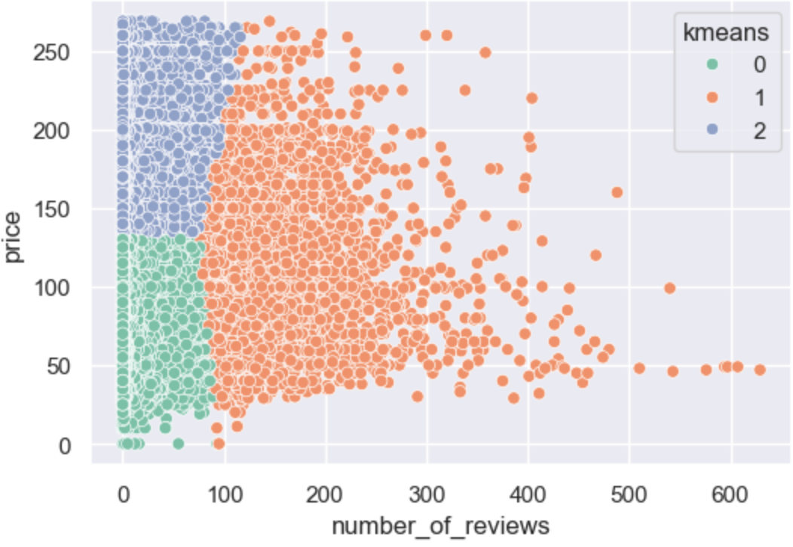

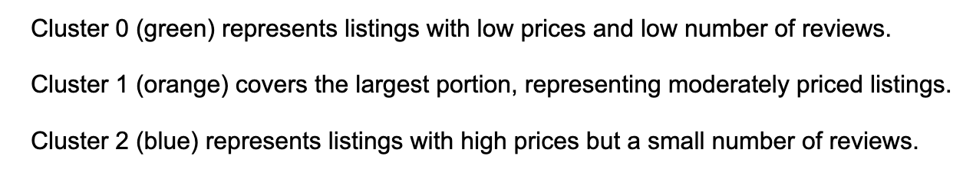

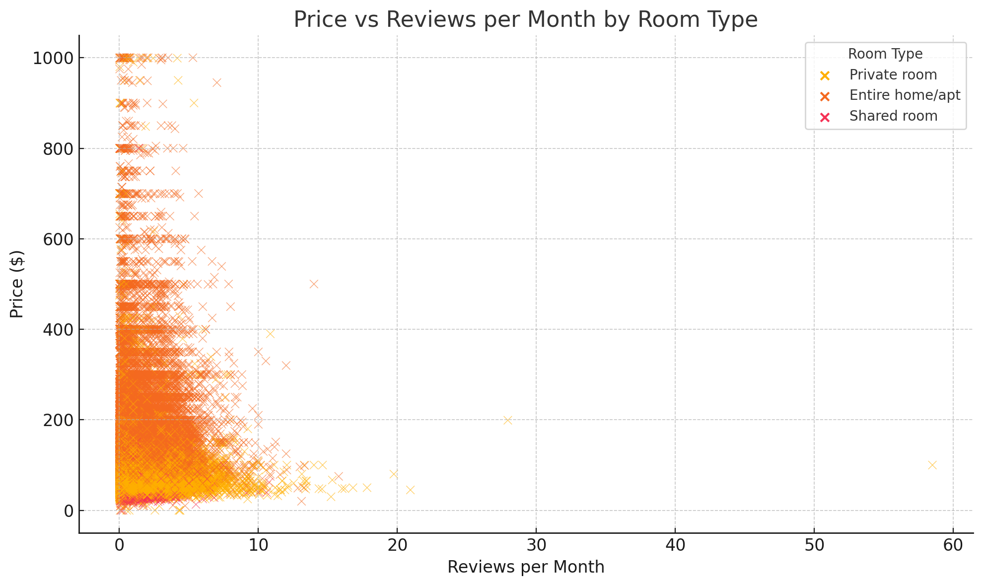

The scatter plots illustrate that listings with frequent reviews are not necessarily more expensive. Reviews reflect consistent bookings and guest satisfaction, particularly for private rooms. Therefore Airbnb should prioritise promoting listings with high ratings and frequent reviews to improve visibility. Highlighting these properties in search results can drive demand even for listings with higher price points (Zhang & Wu, 2021; Xie et al., 2020).

Recommendation for optimising pricing

To optimise pricing recommendations, Airbnb should adopt a strategic approach balancing location, demand, and traveller preferences. Dynamic pricing algorithms adjust rates based on factors like neighbourhood and season, ensuring premium rates for high-demand areas like Manhattan while offering budget-friendly options in Queens and in the Bronx during quieter periods. Providing hosts with data on the optimal mix of room types in their area further helps balance profitability and demand ensuring that listings cater to diverse traveller needs (Dolnicar, 2020; Guttentag, 2019).

Additionally, seasonal adjustments such as promoting availability during peak periods and offering discounts for longer stays in quieter months help hosts maximise bookings. Targeted marketing campaigns position neighbourhoods like Queens and the Bronx as cost-effective alternatives while highlighting Brooklyn’s trendy vibe and Manhattan's premium appeal. To empower hosts, Airbnb should offer user-friendly tools that provide insights into pricing trends, occupancy rates, and market demand. This in turn enables Airbnb to make informed decisions for improved profitability and guest satisfaction (Nolan, 2020; Smith & Green, 2022; Zhang & Wu, 2021).

Conclusion

The most significant factors impacting Airbnb prices in NYC are location, room type, availability, and guest preferences (Dolnicar, 2020). The above visualisations highlight these relationships, showcasing the importance of dynamic pricing and tailored strategies. By leveraging these insights, Airbnb will implement data-driven pricing systems that cater to diverse traveller needs while maximising host profitability and booking rates (Xie et al., 2020).

Airbnb Platform should implement dynamic pricing algorithms that target 70 -75% occupancy rates and provide hosts with neighbourhood-specific pricing guidance. Moreover, automatic pricing adjustments based on seasonal demand, creating pricing tiers based on amenities and location quality, and encouraging competitive pricing for new hosts to build a review base, will benefit Airbnb (Zhang & Wu, 2021).

Reference list:

Airbnb (2023) Understanding Pricing and Occupancy Rates: A Guide for Hosts. Available from: https://www.airbnb.com/host/resources [Accessed 22 November 2024].

Bureau of Economic Analysis (2022) Tourism and Economic Impact in New York City. Available from: https://www.bea.gov/nyc-tourism [Accessed 27 November 2024].

Chen, J. & Zhang, L. (2021) Determinants of Airbnb Listing Prices: Evidence from NYC. *Journal of Tourism Studies*, 34(3), 245–268.

Dolnicar, S. (2020) *Airbnb: How It's Changing the Travel Industry*. London: Routledge.

Guttentag, D. (2019) The rise of Airbnb: Examining the platform's impact on traditional accommodation providers, *Tourism Management*, 74,49–61.

Inside Airbnb (2023) *Data and Analysis of Airbnb in New York City*. Available from: http://insideairbnb.com/nyc [Accessed 20 November 2024].

Nolan, P. (2020) Dynamic pricing strategies in the peer-to-peer accommodation sector, *International Journal of Hospitality Management*, 28(2),103–117.

NYC Tourism Board (2023) *Visitor Trends and Accommodation Insights*. Available from: https://www.nyctourism.com/reports [Accessed 27 November 2024].

Smith, K. & Green, R. (2022) *Understanding Guest Preferences in the Sharing Economy*. Cambridge: Cambridge University Press.

Toader, V., Negrusa, A., Bode, O. & Rus, R. (2021) Analysis of price determinants in the case of Airbnb listings, *Economic Research-Ekonomska Istraživanja*, 35(1), 2493–2509 doi: 10.1080/1331677X.2021.1962380. [Accessed 29 November 2024]

Xie, K., Kwok, L. & Song, H. (2020) ‘The influence of online reviews on pricing and demand in the sharing economy: A study of Airbnb’, *International Journal of Hospitality Management*, 85, p. 102342. Available from: https://doi.org/10.1016/j.ijhm.2020.102342 [Accessed: 23 November 2024].

Zhang, X. and Wu, P. (2021) Seasonality and Price Adjustments in the Airbnb Market: A Case Study of NYC, *Journal of Hospitality and Tourism Research*, 45(5), 1123–1140.