**DT265 Systems Analysis and Testing Phase I Submission**

**Semester 2 2015/2016**

**Gavin O’Neill - D15127205**

**The Happy Sumo Japanese Restaurant**

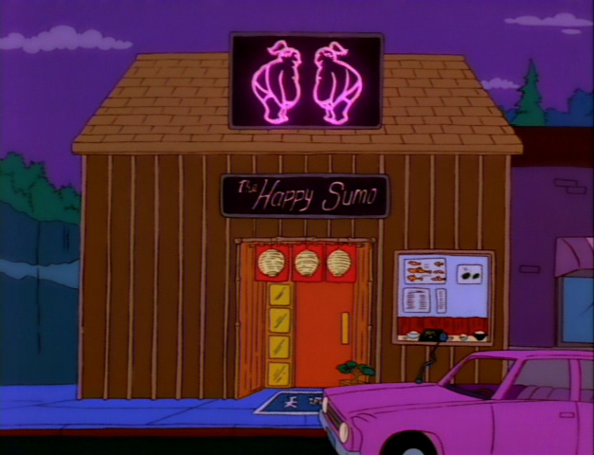

Table of Contents

1. General Project Information 3

2. Research Conducted 5

3. Model Developed 7

3.1 Use Case Diagram 7

3.2 Use Case Narratives 8

3.3 Activity Diagrams 10

4. Entity Classes 12

5. Guidelines for developing required artefacts 13

# 1. General Project Information

**1.1 Team Details**

My group has a total of five members, the others being:

* Zheer Zhang – D15126205 – DT8265
* Kevin Walsh – C07393946 – DT8265
* Godwin Otite – D13126293 – DT8265
* Niall Thompson – D15127211 – DT8265

**1.2 Project Description**

**The Happy Sumo Japanese Restaurant**

As a group we decided to develop an online system for a Japanese restaurant, located in Dublin, which would allow its customers to place orders online for either delivery or collection and also give users the facility to book a table in the restaurant.

The system being developed will start off on the customer side with a homepage that gives the option to either view the menu, order online, book a table or contact the restaurant. One of the main aims of the project will be to allow a customer to complete an order in as few clicks as possible and also gather customer information in the form of registration details which will be valuable to restaurant management in the form of aiding business decisions.

How it is envisaged the system will work is that a customer will place an order, restaurant staff will be alerted by the system when the order is received and must then manually accept the order before it can be finalised. This will allow the staff to reject any orders containing an item which is out of stock and the staff member can enter an explanation to assist the customer. The customer will receive a message advising him of the situation and will be prompted to update their selection by the system.

For delivery orders there will be a pre-defined delivery area served by the restaurant, designated by the relevant Dublin area codes. A customer will be required to enter their area code when making a delivery order and if they are not located within the pre-defined area then the order will not be processed.

The system will have a built-in function for handling table bookings which can be updated by the staff. The staff will decide how many 2, 4, 6 or 8 person tables the restaurant will have available and the system will allocate bookings automatically. For odd number bookings the system will assign that customer to a table of the next highest even number and the staff will organise the restaurant seating to their own liking. For bookings of more than 8 people the customer will be prompted to phone the restaurant.

For the project I made the assumption that this restaurant is already established in the city and the proprietors feel it is now essential to have an online presence to keep up with and hopefully ahead of their main competitors. The restaurant management thought about the idea of using a third party provider, such as Just-Eat.ie, to manage online orders but they would like more control of their content, to be able to connect the website to their social media accounts for marketing and promotional purposes and also have additional features available to their customers such as the booking of tables, contact forms, etc. The website must be optimised for mobile devices because customers at home ordering food are more likely to be using a smartphone or tablet as opposed to a laptop and the experience must be fluid from start to finish to ensure repeat business.

I also made the assumption that the restaurant has the staff and infrastructure to handle the additional business that will be generated by the new website including delivery drivers, vehicles and training for staff on how to use the system.

I decided that at this time the restaurant staff would not be able to manage the website content themselves but this would be a viable option for future development.

With regard to restaurant stock, I contemplated including an automated stock ordering function within the system, however, unlike other businesses such as retail, the restaurant doesn’t scan items in and out as they are used in the kitchen so it is almost impossible to manage stock in this manner. The restaurant also orders a lot of their ingredients fresh on a daily basis from local suppliers who are not set up for business to business e-commerce.

# 2. Research Conducted

**The Competition**

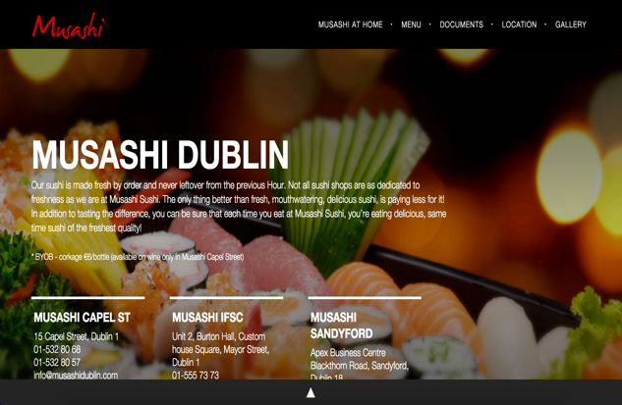To begin my research into the main competitors of the restaurant, I tried a simple Google search for Japanese food delivery which yielded surprisingly few results. It seems that most places either use the third party provider Just-Eat.ie for their online orders or if they do have a website, it only has the functionality to book a table. In the end I found two competitors with their own stand-alone food ordering websites which I will discuss in more detail below.

First, we’ll look at Musashi which has three restaurants in Dublin and a contemporary looking website. What immediately strikes me as unusual is that on the main website (<http://musashidublin.com/)> you can view the menu, details of the restaurants and book a table, however, when you click the option for “Musashi at Home” you are re-directed to another website (<http://www.musashiathome.ie/>) designed with the sole purpose of taking your food order.

Main website

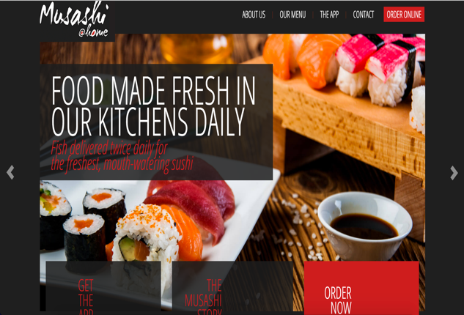Both of Musashi’s websites are well laid out, very minimalistic with only the essential information displayed. They are easy both to navigate and to use for experienced and novice users alike. The websites are optimised for mobile devices too and they even have an app which can be downloaded. I think this is smart as a well designed app would lead to repeated use by customers.

Food ordering website

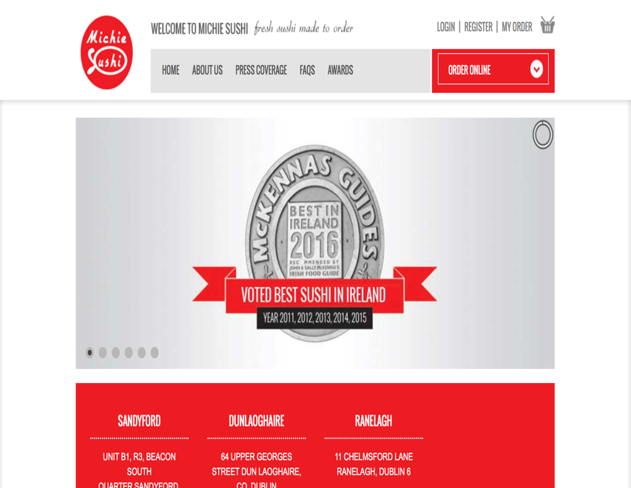The second competitor website I looked at belongs to a restaurant named Michie Sushi, which also has three locations around Dublin city. What I noticed first off is that the homepage (<https://www.michiesushi.com/>) doesn’t have any link in the navigation bar to either the food menu or contact details and in fact to see the menu you must click the “Order Online” button. The restaurant appears to have won lots of awards for it’s food and the website shows this through large images and graphics on every page. I understand why they wanted to do this but it’s a bit too much in my opinion and distracts from the main purpose of the website.

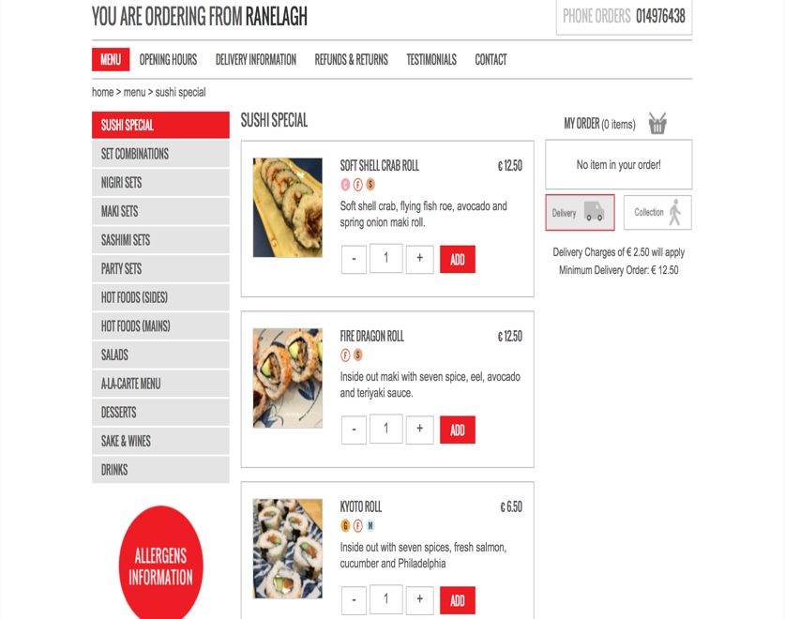From their ordering page, you first need to select your nearest store location, you then add items to your basket and continue from there to the checkout. Next you are presented with an option to login or continue as guest which is how I plan to design the website for ‘The Happy Sumo’. I noticed that some links on this website lead to an unfinished page, such as when clicking on ‘Delivery Information’, with just some text displaying ‘Coming Soon’. This seems a little unprofessional to me and as a user I would be unimpressed that a website didn’t provide this seemingly important piece of information.

There is no function to book a table on the website so this is an area that ‘The Happy Sumo’ can take a step ahead of its competitor. I checked the website on mobile devices and was surprised to find that it was not optimised for mobile and instead is a squeezed down version of the desktop site. It’s difficult to navigate and click on the buttons and is definitely not a user friendly experience.

# 3. Model Developed

## 3.1 Use Case Diagram

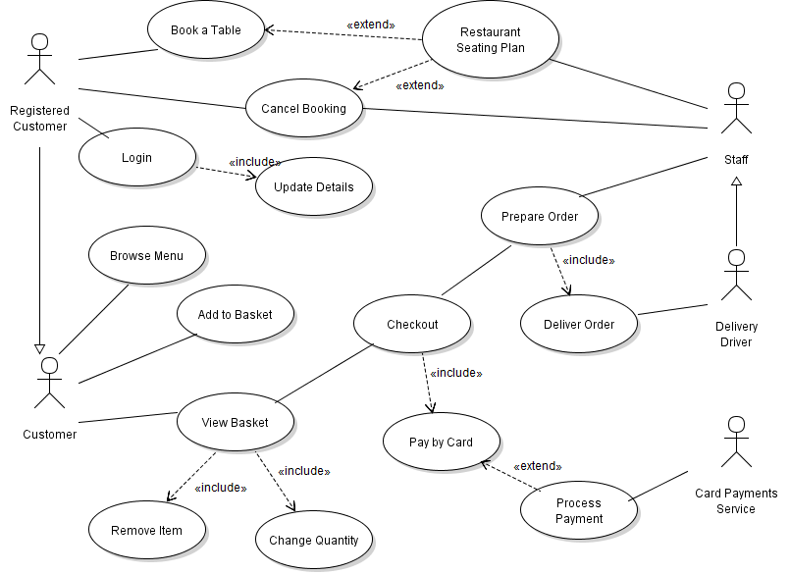In the above Use Case diagram I have two different actors that are specialisations of another actor. First off ‘Registered Customer’ is a specialisation of ‘Customer’ because I wanted it to inherit all of the base actor’s use cases while making it clear that only a ‘Registered Customer’ can manage table bookings. Secondly ‘Delivery Driver’ is a specialisation of ‘Staff’ because only this person can deliver an order and they share all use cases of ‘Staff’ too.

The ‘View Basket’ use case has two includes relationships with the abstract use cases ‘Remove Item’ and ‘Change Quantity’. These abstract use cases are only seen in conjunction with ‘View Basket’. The same can be said for the ‘Login’ use case which has an includes relationship with the abstract use case ‘Update Details’.

‘Process Payment’ has an extends relationship with ‘Pay by Card’ and this is because it will only come into effect if ‘Pay by Card’ is enacted. It extends the functional capabilities of the original use case. The same can be said about ‘Restaurant Seating Plan’ which is only used when the ‘Book a Table’ or ‘Cancel Booking’ use cases have been initiated.

## **3.2 Use Case Narratives**

|  |
| --- |
| **Use Case Name:** Checkout |
| **Intent:** Complete transaction and process order through the system |
| **Pre-condition:** User has added their desired items to the basket |
| **Use Case Initiation:** User clicks ‘Checkout’ option from ‘View Basket’ screen |
| **Dialog:**   1. User is viewing their basket and clicks ‘Proceed to Checkout’. 2. System asks user to select delivery or collection. 3. System then asks user to login or continue as guest. 4. User logs in and is presented by the system with their saved payment and delivery information. 5. User confirms or edits their information and then confirms the order. 6. System processes order. 7. Upon completion user is shown on-screen confirmation message by system and restaurant staff receive notification of new order from the system.   **Alternate Flow:**   1. User hasn’t selected any items so system displays “Your Basket is empty, please add an item(s) to continue”.   4. User has chosen to continue as guest so is required to enter delivery address and payment details if paying with card.  5. User cancels the order, system returns to menu screen with items remaining in the basket.  6. If user has opted to pay by card then system passes the payment information to the payments partner for validation and processing. If this process doesn’t complete then system displays this message to the user and requests the customer to try again. |
| **Use Case Termination:** The use case is finished once the transaction is completed. The user can exit back to the website by closing the last window which the system will have displayed. |
| **Post-condition:** Normal termination results with the order being processed through the system for the restaurant staff to fulfil.  If the order is cancelled at any stage nothing will pass through the system. |

|  |
| --- |
| **Use Case Name:** Booking a table |
| **Intent:** Reserve a table in the restaurant |
| **Pre-condition:** User is on the website homepage. User must be registered to use this feature |
| **Use Case Initiation:** User clicks the button to “Book a Table” |
| **Dialog:**   1. System presents the user with a login screen. 2. User enters their login details which are verified by the system. 3. System displays the user’s saved contact information and requests booking date, time and number of people for table reservation. 4. User must confirm or update their contact info and choose their desired reservation details. 5. System validates the user’s input and checks the seating plan for availability. 6. The seating plan for that date is updated in the system with the user’s request. 7. The system then displays a confirmation message on-screen for the user and informs that an email has been sent to their registered email address. 8. The staff will be able to view the updated seating plan whenever they need.   **Alternate Flow:**   1. If the user is not already registered they will not be able to continue and are re-directed to the registration page.   5a. Data received by the user is in an incorrect format so user is asked for details to be re-entered.  5b. There is no availability at the chosen date/time so system displays this message to the user and requests an alternate selection. |
| **Use Case Termination:** Normal termination occurs when the system is updated with the reservation and user is notified.  If the user has never registered and is unwilling to do so then this use case is aborted.  If the user exits the booking page before the system displays a confirmation message then the use case is aborted. |
| **Post-condition:** The user receives a confirmation email regarding his reservation. The restaurant seating plan is updated within the system and can be viewed by the staff at any time. |

## **3.3 Activity Diagrams**

## **Checkout**

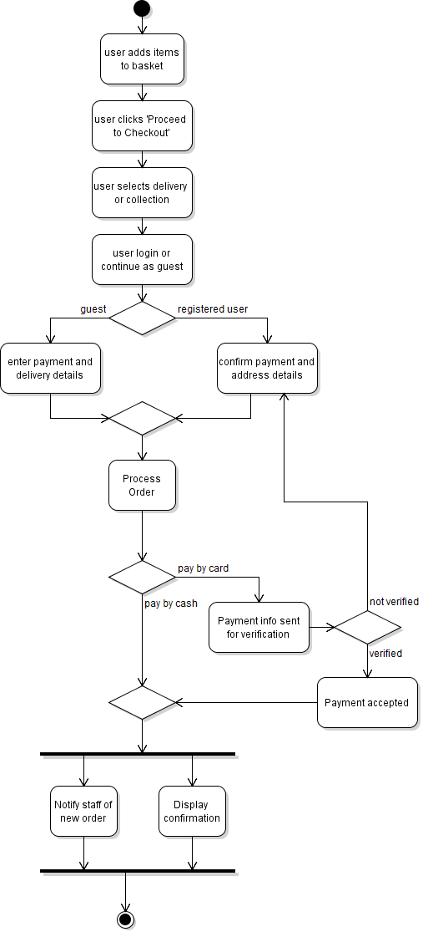

**Booking a Table**

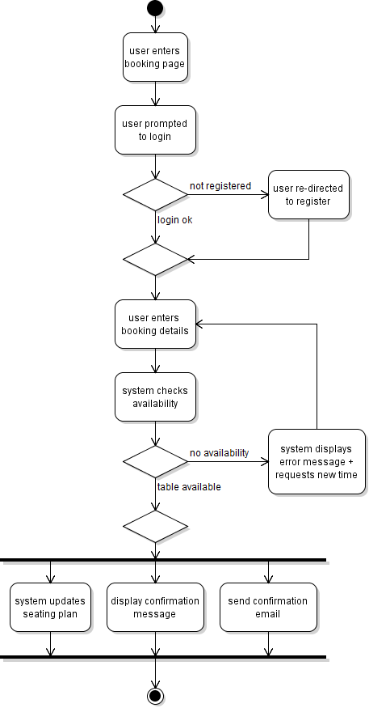

# Entity Classes

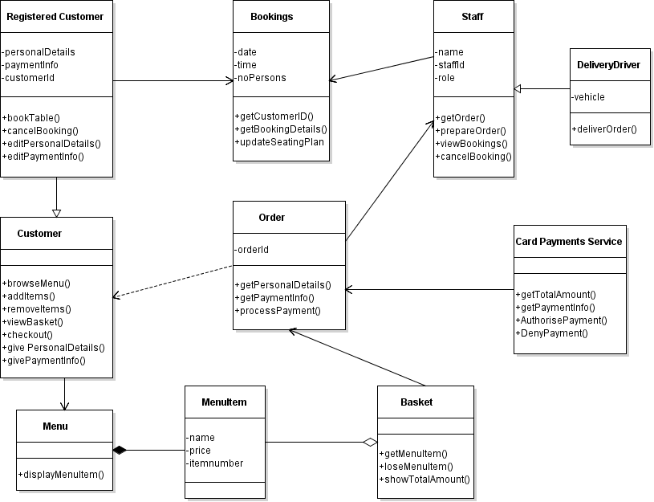

For my first cut class diagram above I used both my use case diagram and narratives to guide me in deriving the classes involved. I tried to break down the requirements and identify the nouns as these are usually the entity classes. Typically entity classes would be described as modelling the key concepts of the system, they hold long lasting information and can be used in multiple use cases. In my own diagram this would apply to ‘Registered Customer’ whose info will always be kept, ‘Order’ as these are stored for accounting purposes, ‘Staff’ whose information will be kept long term and ‘MenuItem’ which once created can be stored long term and added/removed from the menu as desired.

In placing operations into each of my classes I first tried to make a list of all action or doing verbs from my narratives and used these to figure out what I needed in my diagram. The operations describe the relationships between the different classes and objects in the system.

# Guidelines for developing required artefacts

**Use Case diagram**

This diagram is used to display the main functions of the system being developed and shows us who the users of the system will be. It needs to allow someone to quickly come to terms with what the system is about but it shouldn’t go into too much detail regarding the exact requirements or how processes work. It is best to start off by working out who the main actors of the system are going to be and what functions will need to be in place to accommodate interaction between these actors. You should be able to think of how each actor will use the system and list each step one by one. You can easily come back to add/edit the diagram as needed so don’t worry about not having it perfect after the first draft.

**Use Case Narratives**

These are developed with every use case diagram. They are a written description of the sequence of events of a use case from your diagram and tell how a user will interact with the system from the beginning to the end of a task. You should try to imagine yourself using the system, picture different scenarios that may occur due to either user or system errors, making different selections during the task, etc. Each narrative describes one feature of the system used by one actor. It’s easier to write your narrative by first stating the main goal of the task and then branching off to alternate scenarios as they arise. The language you use in your narrative needs to be geared towards your target audience and you should have a good level of detail but don’t include too many low level steps from the task.

**Activity Diagrams**

These diagrams are used to show the flow from activity to activity in the system. You need to be sure to show what triggers an activity, which activities are done in parallel and where there are alternate paths. You should use your narratives as a basis for your diagram, clearly marking different actions and objects within the task. In my diagrams above you can see where a decision needs to be made when you reach a diamond and these options merge back into another diamond to continue. The thick, bold black bar (Fork) displays the beginning of parallel actions and merges into a similar style bar (Join) before continuing. There are two black nodes at each end of the diagram to show the beginning and end of the task.

**Entity Classes**

The entity class diagram is used to model long lasting information and can be used in a variety of use cases. The entity classes are displayed in a box broken into 3 parts, the top being the Name, the middle shows the information being stored and the final part shows different functions related to the entity. One of the most effective ways to distinguish an entity class is to find all nouns and noun phrases from your use case narratives.