ALIVE Classmate
ALIVE Classmate is an online virtual classroom environment which brings on-campus and off-campus students together in the one area. The classroom is complete with whiteboard, slide projector, streaming video and webcam and voice-over-ip (VoIP).
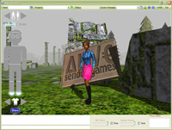 | 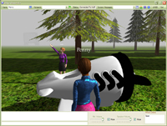 | 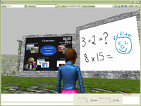 | 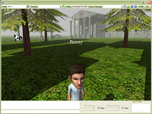

Download Classmate Beta Version 0.4 Here
Features
- User represented in 3D world environment as a humanoid character.
- Real time voice over the internet (VoIP) conferencing.
- Real time text chat.
- Avatar Editor for personalising your character.
- Broadcast Slide Project for giving real time, multi-user slide presentations.
- Multi-user synchronous whiteboard.
- Streaming and broadcast video.
- Live web cam displaying.
- Auto gesticulation of avatar when talking; this means your avatar moves and gestures with its hands automatically when it detects you are talking into the microphone while using VoIP.
Video Tutorials
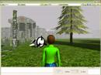 | - Getting Started: How to log in and navigate.  (WATCH ON YOUTUBE)
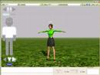 | - Dressing for Success: Using the Avatar Editor to customise the look of your character.  (WATCH ON YOUTUBE)
- Slide Projector Use: How to hold multi-user, real time, slide presentations.
(WATCH ON YOUTUBE)

Requirements
1Ghz Pentium III processor
Microsoft Windows 2000/XP/Vista
256Mb RAM
64Mb graphics card
20Mb free hard disk space
Internet Connection

