ALIVE DXEditor
The ALIVE DXEditor is being developed as an easy-to-use 3d multi-user/single-user immersive environment and serious game creator. The goal is to provide educators with tools to drag and drop their way to a high-quality 3D environment for distributing on the web or on CDROM.
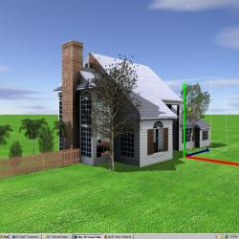 | 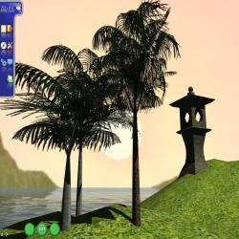 | 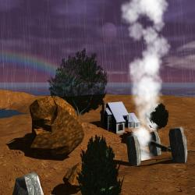 | 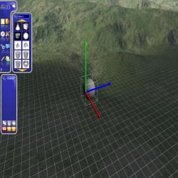

Download ALIVE DXEditor Beta 1.0 Here
Full Version | Lite-Version
System Requirements
Lite-Version Requirements  1Ghz Pentium III processor  Microsoft Windows 2000/XP/Vista  256Mb RAM  64Mb graphics card  20Mb free hard disk space | Full Version Requirements  2Ghz Pentium IV processor  Microsoft Windows XP/Vista  256Mb RAM  256Mb graphics card, Pixel/Vertex Shader 2.0+  20Mb free hard disk space

