ALIVE: Advanced Learning and Immersive Virtual Environments

One of the biggest challenges facing educators today is the integration of rich and immersive Serious Games and 3D Environments with existing teaching and learning materials. To empower educators with the ability to embrace emerging Web3D technologies, the ALIVE research and development laboratory is developing easy-to-use drag and drop e-Learning tools built upon game engine technology. The goal of ALIVE is to reduce the need for technological experts in the creation of online immersive multi-student e-Learning environments and provide simple tools which allow educators to teach in prefabricated or customised embedded games and 3D applications. |  |  |  | 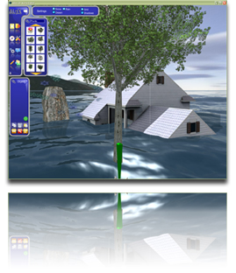
  ALIVE Classmate |  |   ALIVE DXEditor
 |  |  |  |  | 

