The Phoenix Challenge
The Phoenix Challenge is a small game developed entirely with X3D. It uses the Flux Player to deliver the 3D environment. Users can login with their USQConnect username and password. If you are not a USQ affiliate you can try it out with the username: guest and password: guest.

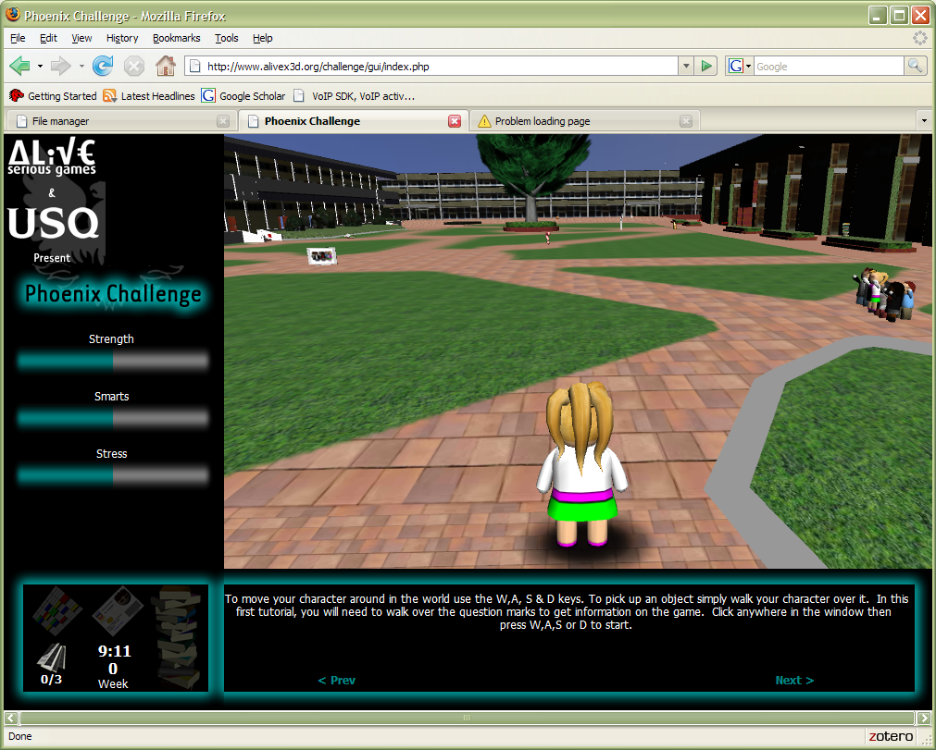
Try it Now

