2D/3D Hybrids
In most cases there is no point in converting things that work fine in 2D to 3D. Books, newspapers, movies and much of what we have on our computer screens are 2D and will continue to be presented in 2D. Text is a typical case for 2D. You will very seldom need 3D for text. It is better to keep 3D for cases that really need it and where it can lead to real enhancements. To this end, we also produce 2D/3D hybrid e-Learning content through the implementation of dollylinking in online content.

These examples require Internet Explorer and the DXStudio Player Plugin.

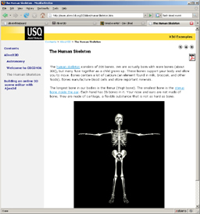 | This Skeleton example places a live 3D model of a skeleton into an embedded window. The camera can be focused on specific bones in the model through the use of hyperlinks in the document.  View Here
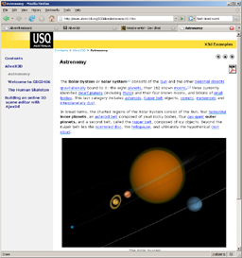 | This example includes a fully functioning scale model of the solar system. The user can fly around in the system and watch the planets as they spin on their axes and orbit the sun.  View Here
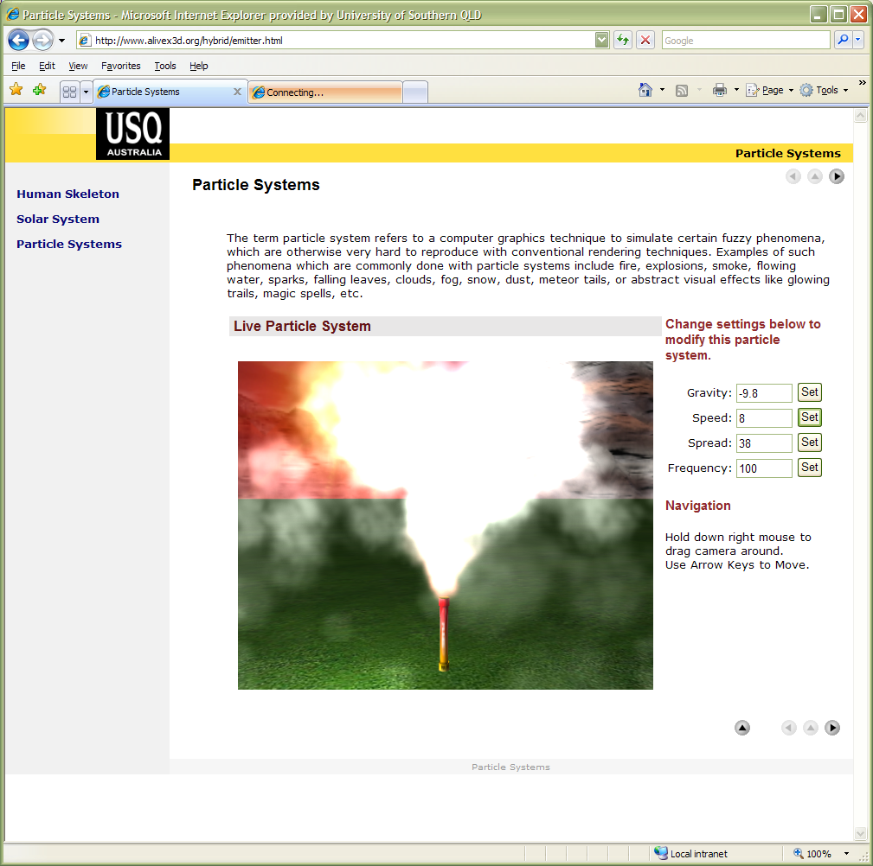 | In this 2D/3D hybrid students can learnt about the parameters of particle systems and set the physics constraints in real time to control the particle flow.  View Here

