Projects
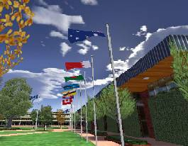 | USQAlive  Our first version of a virtual campus modelled on the Toowoomba University of Southern Queensland campus.  This version used Quake BSP maps and the Apocalyx Game Engine.
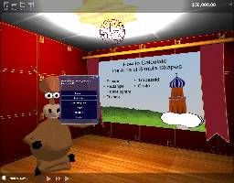 | Foundation Mathematics  This project was designed for first year mathematics students to problem solve about the areas of polygons. The polygons were represented on a map in the form of paddocks which the students have to calculate the area of accurately in order to plant the best crop they can buying the correct amount of seed and fertiliser.
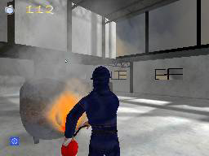 | Spotfire  This is a prototype Serious Game for fire-extinguisher training. The student learns about different extinguishing chemicals and their effects of different fire accelerants. The fire extinguishers are colour coded to Australian standards.
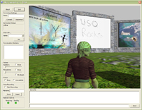 | ALIVE Classmate  Our virtual classroom with slide projector, streaming video, webcam viewer, synchronous multi-user whiteboard, text chat and voice-over-IP.
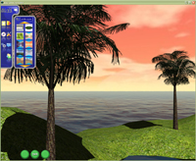 | ALIVE DXEditor  An online easy-to-use 3D world editor created for technical novices to build their own high-quality multi-user environments.  The editor can be used for creating Serious Games for Learning and Teaching applications and will soon be able to embed new worlds into the ALIVE Classmate application.

