Train Animation-Project

By Gavriel arbov

Link: https://github.com/gabroelA/Train_Animation

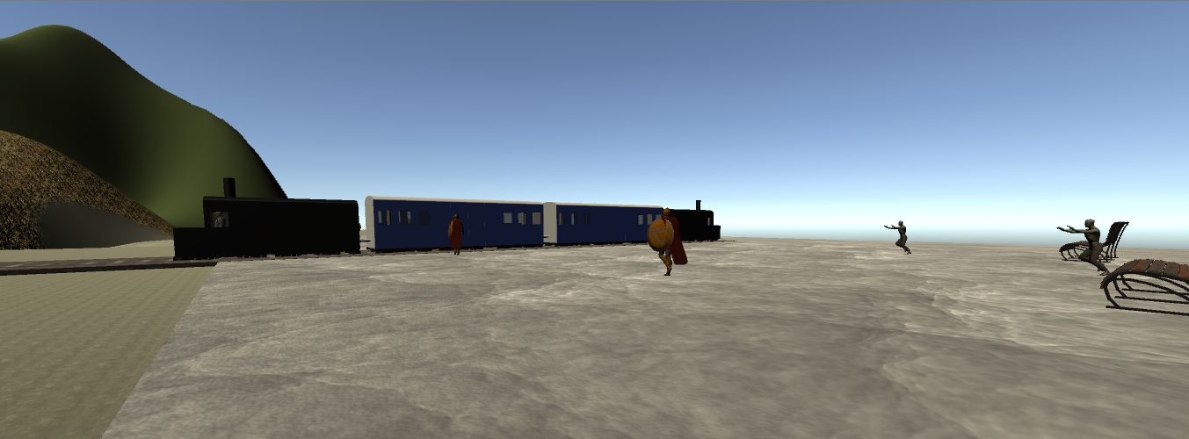

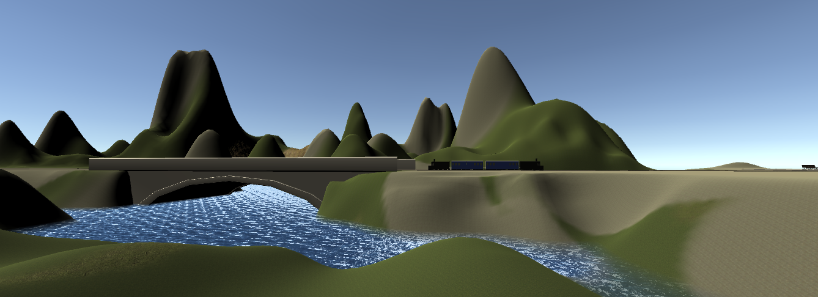

The train will appear at the start of the game, the passengers will enter the train, the player can also enter the train by holding to poll

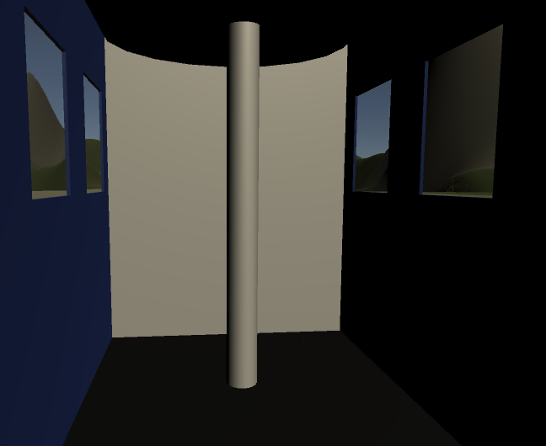

To hold the poll in the train get near by it

To release the hold press x

When the train will get to his destination the passengers will exit and the train will go on, the passengers will wait in the station for the train to come back