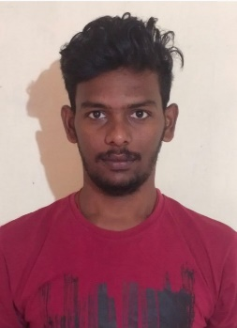

**ATLA KRISHNA REDDY**

**Email: atla.krishnareddy[@mphasis.com](mailto:gavvala.nikhil@mphasis.com)**

**Mobile:9573125883**

Career Objective

A versatile, hard-working person with practical knowledge, “gets the thing done” attitude and ability to develop effective and efficient solutions with zero tolerance for errors. Seeking an opportunity to work with a client where I can wholly utilize my learning’s and enhances my skills in the field of development and succeeding in a challenging environment.

Academic Profile

|  |  |  |  |
| --- | --- | --- | --- |
| ACADEMY / EDUCATION BACKGROUND | INSTITUTION NAME | YEAR OF PASSING | PERCENTAGE/CGPA |
| B. TECH (CSE) | SASTRA DEEMED TO BE UNIVERSITY | 2022 | 7.58 |
| 12TH (BIE - AP) | SRI NARAYANA JUNIOIR COLLEGE, VIJAYAWADA | 2018 | 96.3% |
| 10TH (SSC- AP) | SREE GURUDHATTA HIGH SCHOOL, ONGOLE | 2016 | 9.8 |

*SHANMUGHA ARTS, SCIENCE, TECHNOLOGY & RESEARCH ACADEMY – SASTRA

Technical Skills

|  |  |
| --- | --- |
| Technical Skills | Java,  SQL,  HTML & CSS,  Angular. |
| Area of Interest | Software development using Java. |

Projects Done

* Major project- Face Emotion recognition using haars cascade and Machine learning by CNN approach.
* Capstone Project-E-MEDICARE APP.

Extracurricular Activities

* Volunteered in Green initiatives taken in our campus.
* Participated in NSS activities conducted by our college.
* Participated as a volunteer in “Theta” event conducted in our campus.
* Been a part of cisco networking workshop conducted by Azure Skynet Solutions Pvt.Ltd.

Personality Skills

* Active listener
* Optimist by Nature & Self-Motivative.
* Very flexible and can adjust to any environment.
* Cool and calm by nature.

Declaration

I hereby declare that all the details furnished above are true to the best of my knowledge and belief.

**ATLA KRISHNA REDDY**