Internal and Surface Temperature Profiles of Spherical Biosolids Particles During Convective Drying
Julian Nylen¹, Madoc Sheehan¹, Anna Whelan², Elsa Antunes¹*
¹College of Science & Engineering, James Cook University, Townsville, QLD 4811, Australia
²Townsville City Council, Wastewater Operations, Townsville, QLD, 4810, Australia
*Corresponding author: Elsa Antunes (elsa.antunes1@jcu.edu.au)

Supplementary Information/Appendix

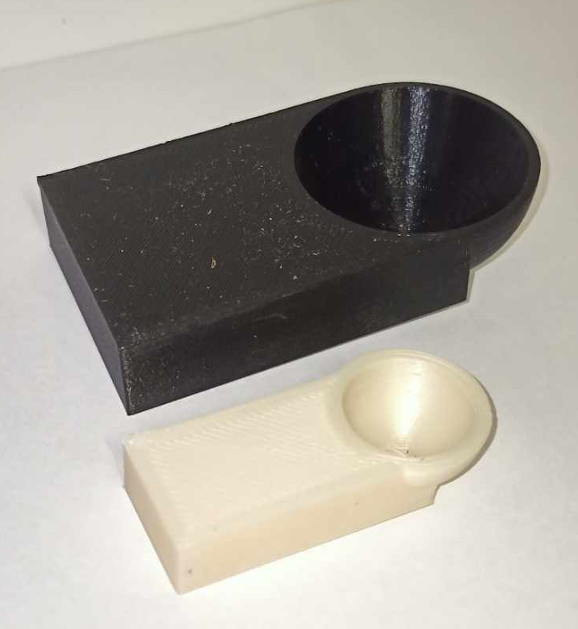
Figure A1: 3D printed spherical molds for shaping biosolids particles.

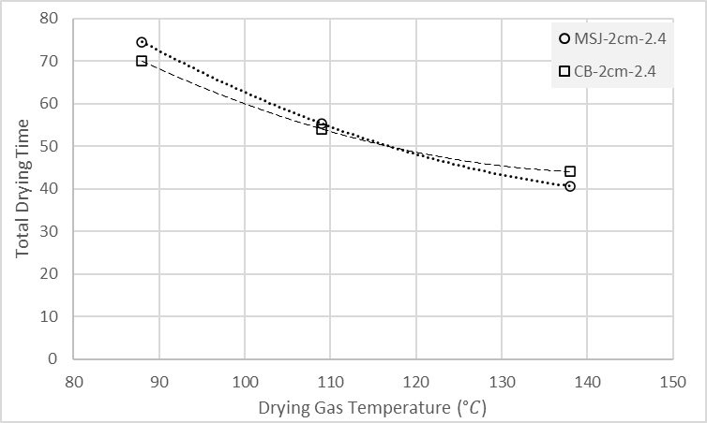
Figure S2: Total drying times for MSJ and CB 2 cm particles at different drying gas temperatures.

