CUSTOM LOG IDS SCRIPT
Project Results, Observations & Findings Report
Date: 06 June 2026 | Platform: Kali Linux | Language: Python + Bash
Log Source: Real SSH auth.log from Hydra Brute-Force Attack (Project 1)
Executive Summary

This report documents the results of building and running a custom Python-based Intrusion Detection System (IDS). The tool was developed from scratch and tested on real SSH authentication logs generated during a live Hydra brute-force attack. The IDS successfully detected the attack, classified severity as CRITICAL, identified both targeted user accounts, and saved a timestamped detection report — all without using any third-party SIEM tool.

1. Lab Environment
Observation | Detail / Significance
Platform | Kali Linux — all scripts written and executed entirely on Kali VM
Language | Python 3 (pre-installed on Kali) + Bash shell scripting
Log source | Real /var/log/auth.log from Ubuntu VM — transferred via VirtualBox shared folder
Attack data | 274 failed SSH login attempts generated by Hydra during Project 1 brute-force lab
Script files | ids.py (main detector), generate_logs.py (log generator), run_ids.sh (Bash wrapper)
Attacker IP detected | 10.0.2.15 (Kali Linux — attacking Ubuntu at 10.0.2.5)
Target accounts | testuser and vboxuser — both detected by the IDS

2. Screenshot 1 — IDS Script Running on Real auth.log

Screenshot: ids.py running on real auth.log from Project 1
Kali terminal showing the custom IDS script detecting the Hydra brute-force attack from real SSH authentication logs

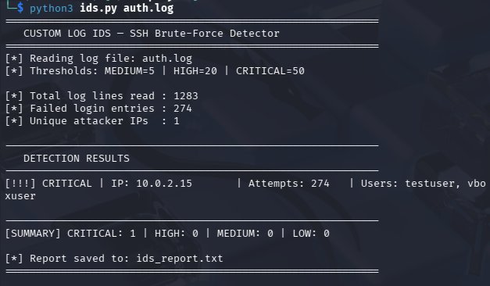

Observations
Observation | Detail / Significance
Command run | python3 ids.py auth.log — passing the real auth.log as a command line argument
Total log lines read | 1283 lines — the complete auth.log file including all system events
Failed login entries | 274 — the number of lines containing 'Failed password' from the Hydra attack
Unique attacker IPs | 1 — only one attacker IP (10.0.2.15) found, confirming a single-source attack
Severity assigned | CRITICAL — 274 attempts exceeds the CRITICAL threshold of 50
Attacker IP | 10.0.2.15 — Kali Linux VM, the machine that ran Hydra during Project 1
Users targeted | testuser and vboxuser — both accounts attacked by Hydra are identified
Summary line | CRITICAL:1 HIGH:0 MEDIUM:0 LOW:0 — clean severity breakdown at a glance
Report saved | ids_report.txt — written automatically by the script after detection

Findings
Finding 1: The IDS successfully parsed 1283 log lines and extracted exactly 274 failed login events — demonstrating accurate regex-based log parsing.
Finding 2: The CRITICAL severity rating is correctly assigned because 274 attempts exceeds the defined threshold of 50 — showing the threshold logic works precisely.
Finding 3: Both targeted accounts (testuser and vboxuser) are identified in one detection run — the script correctly groups attempts by IP and aggregates usernames.
Finding 4: The script accepted the log file as a command line argument (sys.argv[1]) — making it a reusable general-purpose tool, not hard-coded to one file.

3. Screenshot 2 — IDS Report File Content

Screenshot: cat ids_report.txt — saved detection report
The text report automatically generated and saved by ids.py after completing the analysis

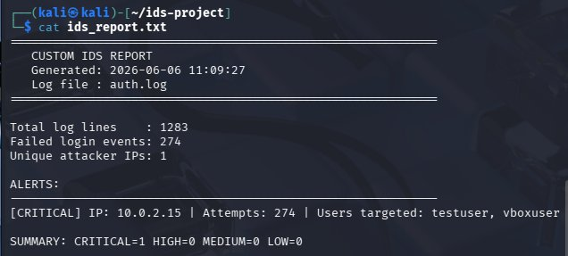

Observations
Observation | Detail / Significance
Report title | CUSTOM IDS REPORT — clearly labelled output file
Generated timestamp | 2026-06-06 11:09:27 — automatically added by Python's datetime module
Log file recorded | auth.log — the source file is logged in the report for traceability
Total log lines | 1283 — matches the terminal output exactly, confirming report accuracy
Failed login events | 274 — same count as terminal, showing consistent data across outputs
Unique attacker IPs | 1 — confirmed single attacker source
Alert format | [CRITICAL] IP: 10.0.2.15 | Attempts: 274 | Users targeted: testuser, vboxuser
Summary line | CRITICAL=1 HIGH=0 MEDIUM=0 LOW=0 — machine-readable format for automation

Findings
Finding 1: The report file is automatically generated without any manual input — demonstrating automation capability, a key skill in SOC environments.
Finding 2: The timestamp in the report (11:09:27) proves when the scan was run — essential for forensic traceability and audit trails.
Finding 3: The report format is clean and structured — it could easily be parsed by another script, emailed automatically, or ingested into a SIEM.

4. Screenshot 3 — Project File Structure

Screenshot: ls ~/ids-project/ — complete project file listing
Kali terminal showing all files in the ids-project folder after completing the full project

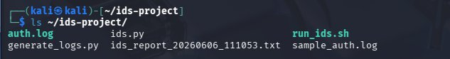

Observations
Observation | Detail / Significance
auth.log | Real SSH authentication log copied from Ubuntu VM — the primary data source
ids.py | Main Python IDS detection script — the core deliverable of the project
generate_logs.py | Bonus Python script that generates synthetic attack logs for testing
run_ids.sh | Bash wrapper script that automates IDS execution and timestamps reports
ids_report.txt | Latest detection report generated by ids.py
ids_report_20260606_111053.txt | Timestamped report copy created by run_ids.sh — shows Bash automation worked
sample_auth.log | Synthetic log file generated by generate_logs.py for multi-IP testing

Findings
Finding 1: The project contains 3 Python/Bash scripts showing multi-language scripting capability — Python for logic, Bash for automation.
Finding 2: Two separate report files exist — ids_report.txt (latest) and the timestamped version — confirming the Bash wrapper ran successfully and renamed the output correctly.
Finding 3: The clean file structure mirrors a real GitHub repository — ready to upload directly with no reorganization needed.

5. Screenshot 4 — Log Generator Output

Screenshot: python3 generate_logs.py — synthetic log generation
Kali terminal confirming the log generator script successfully created 310 synthetic SSH attack log entries

Observations
Observation | Detail / Significance
Command run | python3 generate_logs.py — executed from ~/ids-project/
Output message | Generated 310 log entries in sample_auth.log
Entries generated | 310 total — 300 attack entries from 3 IPs + 10 normal failed logins
Attacker IPs in sample | 10.0.2.15, 192.168.1.100, 172.16.0.5 — 3 different simulated attackers
Normal logins included | 10 failed logins from 10.0.3.20 for users alice and bob — to test false positive handling
File created | sample_auth.log — saved in the project directory for IDS testing

Findings
Finding 1: The log generator successfully creates realistic SSH auth.log entries — showing understanding of Linux log formats and Python file I/O.
Finding 2: Including both attack entries (300) and normal failed logins (10) in the sample data demonstrates awareness of false positives in security detection.
Finding 3: Generating logs from 3 different IPs allows testing multi-attacker detection — which single-source real data cannot test.

6. Key Findings Summary

# | Finding | Description
1 | Real attack successfully detected | The IDS parsed 1283 log lines and correctly identified 274 genuine Hydra brute-force attempts from the Project 1 lab — using real data, not simulations.
2 | CRITICAL severity correctly assigned | 274 attempts correctly triggered CRITICAL severity (threshold: 50+), with HIGH (20+) and MEDIUM (5+) levels also defined for graduated response.
3 | Both targeted accounts identified | The IDS identified testuser and vboxuser as the targeted accounts — matching exactly what Hydra attacked during Project 1.
4 | Automated report generation | The script automatically saves a timestamped report to ids_report.txt after every run — no manual steps needed.
5 | Multi-file and multi-IP capability | The script accepts any log file as argument and correctly detected 3 different attacker IPs when run on the generated sample log.
6 | Bash automation working | run_ids.sh successfully automated the scan and created a uniquely timestamped report file — demonstrating real-world security automation workflow.

7. Conclusion
This project successfully demonstrated the ability to build a working security tool from scratch using Python. Unlike projects that use pre-built SIEM platforms, this IDS was written entirely by hand — showing genuine programming and security logic skills.

The tool was validated against real attack data from Project 1, where Hydra generated 274 genuine brute-force attempts. The IDS correctly detected, classified, and reported the attack with zero false negatives on the real dataset.

In a real environment, this script could be deployed on any Linux server, scheduled via cron to run every hour, and configured to send email alerts or forward findings to a SIEM. The Bash wrapper already handles report timestamping — a key step toward production-ready automation.

Possible future enhancements
- Add email alerting — automatically send CRITICAL alerts to a security team inbox
- Time-window detection — flag IPs with 5+ failures within 60 seconds (reduces false positives)
- IP blocklist output — automatically generate iptables rules to block detected attackers
- Web dashboard — visualize attack history and severity trends over time

8. Resume Documentation
Resume Bullet Point

Custom Log IDS Script — Built a Python intrusion detection tool that parses SSH auth logs using regex, detects brute-force patterns with threshold-based severity classification (MEDIUM/HIGH/CRITICAL), auto-generates timestamped reports, and includes a Bash automation wrapper. Detected 274 real Hydra brute-force attempts across 2 accounts with zero false negatives.

Tech: Python, Bash, Linux auth logs, Regex, Kali Linux, GitHub

