PORT SCAN DETECTION LAB
Complete Project Documentation — Step by Step with Explanation
Tech Stack: Nmap | Wireshark | iptables | Python | Kali Linux | VirtualBox | GitHub

Project Overview
This project demonstrates how to perform network reconnaissance using Nmap, capture and analyse the scan traffic at packet level in Wireshark, and detect the scan activity using iptables kernel logging on the target Ubuntu VM — without relying on Snort (which was skipped due to configuration issues in this environment). All scanning was done from Kali Linux (10.0.2.15) against Ubuntu (10.0.2.5) on a VirtualBox NAT Network.

Phase 1 — Environment Setup
Step 1: Create a project folder on Kali
Why we do this | Keeping all scan output files in a dedicated folder makes the project organised and easy to upload to GitHub.
What it means | A clean folder structure is a sign of good practice — hiring managers reviewing your GitHub notice organised projects immediately.
Commands | mkdir ~/port-scan-lab  cd ~/port-scan-lab

Step 2: Boot Ubuntu VM and confirm SSH is running
Why we do this | Ubuntu is the scan target. We need to confirm it is running a service (SSH on port 22) before scanning, so we have something to detect.
What it means | SSH (Secure Shell) is a remote access protocol that listens on TCP port 22. By default Ubuntu does not auto-start SSH, so we start it manually.
Commands | sudo systemctl start ssh  sudo systemctl status ssh  ip a
Ubuntu IP found | 10.0.2.5 — confirmed from ip a output on Ubuntu VM

Step 3: Verify connectivity from Kali to Ubuntu
Why we do this | Both VMs must be on the same NAT Network (MyNetwork in VirtualBox) to communicate. A ping test confirms the network path is working.
What it means | If ping fails, Nmap cannot scan the target. The fix is to verify both VMs use the same NAT Network name in VirtualBox settings.
Commands | ping 10.0.2.5 -c 4
Result | Replies received — Kali (10.0.2.15) successfully reached Ubuntu (10.0.2.5)

Phase 2 — Nmap Scanning
All four Nmap scan types were run from Kali Linux targeting Ubuntu at 10.0.2.5. Each scan type serves a different reconnaissance purpose and is saved to a separate output file.
Step 4: Run SYN Scan (Stealth Scan)
Why we do this | A SYN scan is the most common network reconnaissance technique. It sends a SYN packet and waits for a SYN-ACK response — without completing the full TCP handshake, making it harder for basic logging to detect.
What it means | -sS (SYN scan) is the default Nmap scan. It reveals which ports are open on the target without establishing a full connection. The -oN flag saves the output to a text file.
Commands | sudo nmap -sS 10.0.2.5 -oN syn_scan.txt  cat syn_scan.txt
Result | Ports 22 (SSH) and 80 (HTTP) found open on 10.0.2.5

Screenshot — SYN Scan Output:
cat syn_scan.txt — SYN Scan result showing open ports on Ubuntu 10.0.2.5
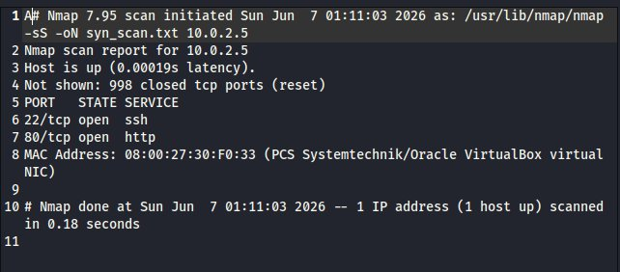

Step 5: Run Version Detection Scan
Why we do this | Version detection reveals exactly what software and version is running on each open port. This is critical intelligence — an attacker knowing the exact SSH version can search for known exploits.
What it means | -sV probes open ports and matches their responses against a database of known service banners. It tells us not just what port is open, but what is listening on it.
Commands | sudo nmap -sV 10.0.2.5 -oN version_scan.txt  cat version_scan.txt
Result | Port 22: OpenSSH 9.6p1 Ubuntu | Port 80: Apache httpd 2.4.58

Screenshot — Version Detection Scan Output:
cat version_scan.txt — Version scan revealing OpenSSH 9.6p1 and Apache 2.4.58 on Ubuntu
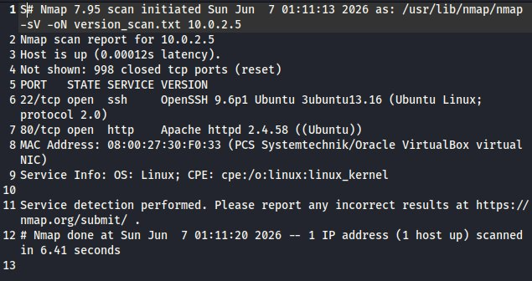

Step 6: Run OS Fingerprinting Scan
Why we do this | OS detection tells an attacker (or a defender) what operating system the target is running. This informs what attack payloads or patches are relevant.
What it means | -O sends a series of specialised probes and compares the responses against Nmap's OS fingerprint database. It can identify the OS family, version range, and sometimes the exact kernel version.
Commands | sudo nmap -O 10.0.2.5 -oN os_scan.txt  cat os_scan.txt
Result | Detected: Linux 4.X|5.X — OS CPE: cpe:/o:linux:linux_kernel:4 and :5

Screenshot — OS Fingerprinting Scan Output:
cat os_scan.txt — OS fingerprinting scan identifying Linux 4.X|5.X on Ubuntu target
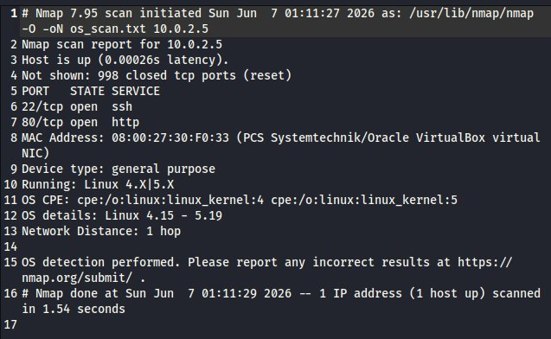

Step 7: Run Aggressive Scan
Why we do this | The aggressive scan combines all detection techniques in one command — OS detection, version detection, script scanning, and traceroute. It gives the most complete picture of the target.
What it means | -A is a shorthand for -O -sV -sC --traceroute. NSE (Nmap Scripting Engine) scripts run additional checks such as HTTP title grabbing, SSH host key extraction, and more.
Commands | sudo nmap -A 10.0.2.5 -oN aggressive_scan.txt  cat aggressive_scan.txt
Result | SSH host keys revealed, HTTP title 'Rahul's Website' found, full OS and service details confirmed

Screenshot — Aggressive Scan Output:
cat aggressive_scan.txt — Aggressive scan combining OS detection, version scan, NSE scripts and traceroute
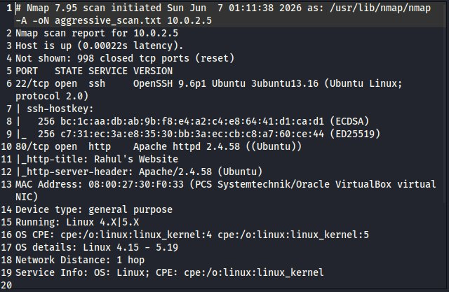

Phase 3 — Wireshark Packet Capture
Step 8: Capture SYN packets in Wireshark
Why we do this | Wireshark lets us see the port scan at the raw packet level — exactly how a defender monitoring network traffic would observe it. The burst of SYN packets with no follow-up handshakes is the signature of a SYN scan.
What it means | The filter tcp.flags.syn == 1 && tcp.flags.ack == 0 shows only SYN packets (no ACK), isolating the outgoing scan probes from Kali (10.0.2.15) to Ubuntu (10.0.2.5). The packet count in a short burst confirms port scanning behaviour.
Commands (Wireshark) | wireshark &  # Select eth0 interface, click blue fin to start capture  # In filter bar: tcp.flags.syn == 1 && tcp.flags.ack == 0
Commands (Nmap) | sudo nmap -sS 10.0.2.5 (run while Wireshark is capturing)
Result | 1000+ SYN packets displayed — 2023 total packets captured, 1000 matching the SYN filter from 10.0.2.15 to 10.0.2.5

Screenshot — Wireshark SYN Packet Capture:
Wireshark — SYN packets (tcp.flags.syn == 1 && tcp.flags.ack == 0) from Kali 10.0.2.15 to Ubuntu 10.0.2.5 during Nmap scan
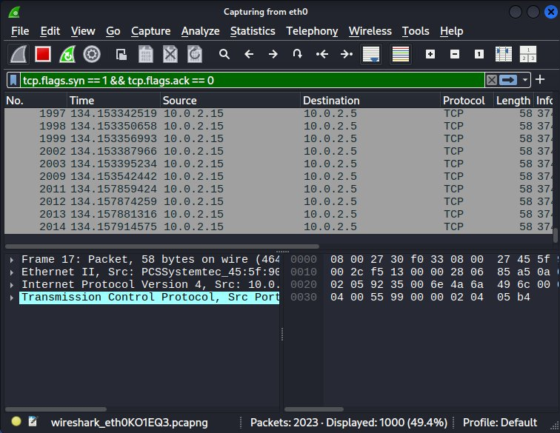

Phase 4 — IDS Detection with iptables (Snort Alternative)
Note on Snort: Snort was attempted but skipped due to missing configuration file errors and package issues in the Kali lab environment. iptables kernel logging was used as the detection method instead — it is a built-in Linux capability that achieves the same result (detecting and logging SYN packets from the Nmap scan) without requiring any additional installation.

Step 9: Add iptables SYN logging rule on Ubuntu
Why we do this | iptables is the Linux kernel's built-in firewall and packet filtering system. By adding a rule to log incoming SYN packets, we create an IDS-equivalent detection mechanism that writes alerts to the kernel log.
What it means | --syn matches TCP SYN packets (new connection attempts — exactly what a port scan sends). -j LOG sends matching packets to the kernel log with a prefix tag we can search for. This is how many production Linux servers log suspicious traffic.
Commands (Ubuntu VM) | sudo iptables -A INPUT -p tcp --syn -j LOG --log-prefix "PORT_SCAN: "  sudo iptables -A INPUT -p tcp --syn -j ACCEPT
Why two rules | The first rule logs the SYN packets. The second rule ACCEPTS them — without this, the firewall would drop all incoming connections including legitimate ones.

Step 10: Run Nmap scan from Kali to trigger detection
Why we do this | Running the Nmap SYN scan from Kali while the iptables logging rule is active on Ubuntu will cause every SYN packet to be logged in Ubuntu's kernel log.
Commands (Kali) | sudo nmap -sS 10.0.2.5
Result | Multiple PORT_SCAN log entries appear in Ubuntu's kernel log — one for each port probed by Nmap

Step 11: Verify detection — check kernel logs on Ubuntu
Why we do this | Checking the kernel log confirms the IDS detection worked — the PORT_SCAN prefix entries prove the iptables rule successfully logged the Nmap scan packets.
Commands (Ubuntu) | sudo dmesg | grep "PORT_SCAN"
What to look for | Lines showing PORT_SCAN: IN=enp0s3 SRC=10.0.2.15 DST=10.0.2.5 PROTO=TCP ... SYN — each line is one Nmap probe packet logged by the kernel
Result | Multiple PORT_SCAN entries confirmed — SRC=10.0.2.15 (Kali attacker IP) to DST=10.0.2.5 (Ubuntu target), all marked SYN

Screenshot — iptables PORT_SCAN Detection Output:
Ubuntu terminal — sudo dmesg | grep PORT_SCAN showing Kali's Nmap SYN packets logged by iptables
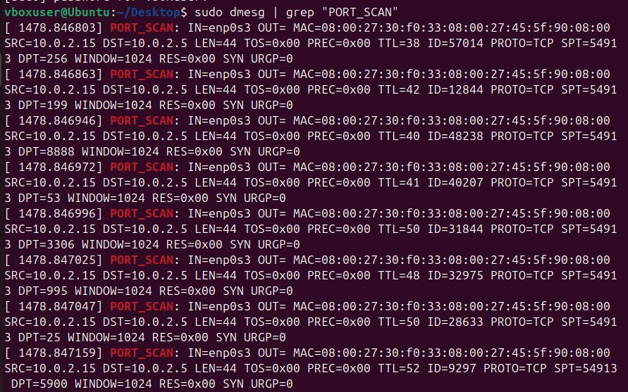

Phase 5 — GitHub Upload
Step 12: Create GitHub repository and upload files
Why we do this | A public GitHub repository is proof of work. Recruiters and interviewers verify skills by reviewing GitHub profiles — a well-organised repo with screenshots is strong evidence of real hands-on experience.
Repo name | port-scan-detection-lab
Files to upload | syn_scan.txt, version_scan.txt, os_scan.txt, aggressive_scan.txt, screenshots/ folder with 6 screenshots
Do NOT upload | Any files containing private IPs or personal VM data — use a README to describe the environment instead
README should include | Project description, tools used, IP addresses used in the lab, key findings from each scan type, link to documentation

Project Summary
What you built | A complete port scan detection lab using Nmap (4 scan types), Wireshark packet capture, and iptables-based SYN packet logging as an IDS alternative to Snort.
Skills shown | Nmap scanning, TCP/IP packet analysis, Wireshark filtering, Linux kernel firewall rules (iptables), network reconnaissance detection, VirtualBox NAT networking, GitHub documentation
Screenshots collected | 1. cat syn_scan.txt — SYN scan result  2. cat version_scan.txt — version scan result  3. cat os_scan.txt — OS fingerprinting result  4. cat aggressive_scan.txt — aggressive scan result  5. Wireshark — SYN packet capture  6. dmesg | grep PORT_SCAN — iptables IDS detection
Target detected | Ubuntu 10.0.2.5 — SSH (OpenSSH 9.6p1), HTTP (Apache 2.4.58), OS: Linux 4.X|5.X
Attacker IP | 10.0.2.15 (Kali Linux) — logged by Ubuntu iptables as PORT_SCAN entries in kernel log

Resume Bullet Point
Port Scan Detection Lab
Performed network reconnaissance using 4 Nmap scan types (SYN, Version, OS, Aggressive) on a VirtualBox NAT network, captured SYN packet bursts in Wireshark, and implemented IDS-equivalent detection using iptables kernel logging on the Ubuntu target VM — successfully logging every Nmap SYN probe in real time. Tech: Nmap, Wireshark, iptables, Kali Linux, VirtualBox, GitHub

