PORT SCAN DETECTION LAB
Project Results, Observations & Findings Report
Date: 07 June 2026 | Platform: Kali Linux + Ubuntu VM | Tools: Nmap, Wireshark, iptables
Scan Target: Ubuntu 10.0.2.5 | Attacker: Kali 10.0.2.15 | Network: VirtualBox NAT Network

Executive Summary
This report documents the results of running a four-scan Nmap reconnaissance campaign against an Ubuntu target VM, capturing the scan traffic in Wireshark at packet level, and detecting the scan using iptables kernel logging as an IDS mechanism. Snort was skipped due to configuration errors in the lab environment; iptables provided equivalent detection functionality. All six screenshots were collected as evidence of successful completion.

1. Lab Environment
Observation | Detail / Significance
Platform | Kali Linux (attacker) and Ubuntu 22.04 (target) — both running in VirtualBox on the same NAT Network (MyNetwork)
Network | VirtualBox NAT Network — Kali: 10.0.2.15 | Ubuntu: 10.0.2.5 | Subnet: 10.0.2.0/24
Tools used | Nmap 7.95 (scanning), Wireshark (packet capture), iptables (IDS detection via kernel logging)
Target services | Port 22 — OpenSSH 9.6p1 Ubuntu | Port 80 — Apache httpd 2.4.58
Snort status | Skipped — snort.conf missing/misconfigured on Kali; iptables used as the detection alternative
Output folder | ~/port-scan-lab/ on Kali — all four .txt scan files saved here

2. Screenshot 1 — SYN Scan (syn_scan.txt)
Screenshot: cat syn_scan.txt — SYN Stealth Scan result on Ubuntu 10.0.2.5
Kali terminal showing Nmap SYN scan output — open ports discovered on Ubuntu target without completing TCP handshake
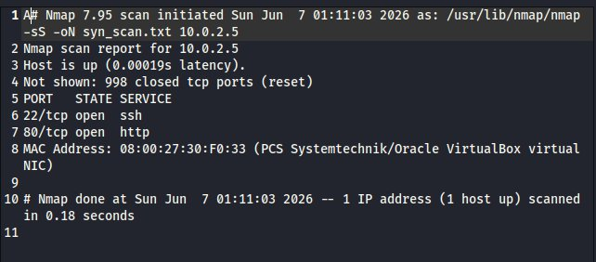

Observations
Observation | Detail / Significance
Command run | sudo nmap -sS 10.0.2.5 -oN syn_scan.txt — SYN scan with output saved to file
Scan type | -sS (SYN scan / stealth scan) — sends SYN, waits for SYN-ACK, never completes the handshake
Ports found open | 22/tcp (ssh) and 80/tcp (http) — two services confirmed running on Ubuntu
Host status | Host is up — 0.00019s latency, confirming fast NAT Network communication
Closed ports | 998 closed tcp ports (reset) — these returned RST packets, confirming no service listening
MAC Address | 08:00:27:30:F0:33 (PCS Systemtechnik / Oracle VirtualBox virtual NIC)
Scan duration | 0.18 seconds — SYN scan is the fastest Nmap scan type
Output file | syn_scan.txt saved to ~/port-scan-lab/ — confirmed by -oN flag

Findings
Finding 1: Two services are exposed: SSH (port 22) and HTTP (port 80). These are the only attack surfaces on this Ubuntu instance.
Finding 2: The SYN scan completed in 0.18 seconds — the fastest of the four scan types, confirming why it is the default reconnaissance method for attackers.
Finding 3: The MAC address (Oracle VirtualBox NIC) confirms this is a virtualised environment — a defender analysing the MAC OUI could identify it as a VM rather than physical hardware.

3. Screenshot 2 — Version Detection Scan (version_scan.txt)
Screenshot: cat version_scan.txt — Version detection scan revealing service software and versions
Kali terminal showing Nmap -sV output — exact software names and versions running on Ubuntu's open ports
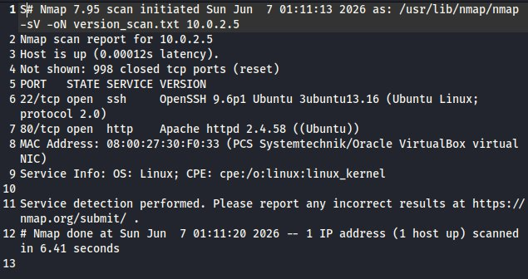

Observations
Observation | Detail / Significance
Command run | sudo nmap -sV 10.0.2.5 -oN version_scan.txt — service version detection scan
Port 22 service | OpenSSH 9.6p1 Ubuntu 3ubuntu13.16 (Ubuntu Linux; protocol 2.0) — exact version identified
Port 80 service | Apache httpd 2.4.58 ((Ubuntu)) — web server version confirmed
OS hint | Service Info: OS: Linux; CPE: cpe:/o:linux:linux_kernel — Linux confirmed from service banners
Scan duration | 6.41 seconds — version detection is slower as it waits for service banner responses
Host is up | 0.00012s latency — consistent with NAT Network connectivity

Findings
Finding 1: OpenSSH 9.6p1 is a current version (2024 release) — not immediately vulnerable to known critical exploits, but version exposure alone is a security finding.
Finding 2: Apache 2.4.58 is similarly recent, but publicly exposing the exact version lets an attacker narrow CVE searches to a specific target version.
Finding 3: Version detection took 6.41 seconds compared to 0.18 seconds for the SYN scan — the additional time is spent waiting for service banners to confirm software identity.

4. Screenshot 3 — OS Fingerprinting Scan (os_scan.txt)
Screenshot: cat os_scan.txt — OS fingerprinting scan identifying the target operating system
Kali terminal showing Nmap -O output — OS family, CPE string, and kernel version range identified for Ubuntu
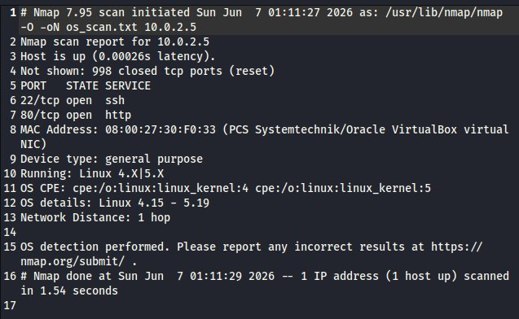

Observations
Observation | Detail / Significance
Command run | sudo nmap -O 10.0.2.5 -oN os_scan.txt — OS fingerprinting using TCP/IP stack behaviour
OS detected | Running: Linux 4.X|5.X — OS identified as Linux in the 4.x or 5.x kernel series
OS CPE | cpe:/o:linux:linux_kernel:4 and cpe:/o:linux:linux_kernel:5 — two CPE entries covering both kernel generations
OS details | Linux 4.15 - 5.19 — narrowed kernel version range based on TCP stack fingerprint
Device type | General purpose — not specialised hardware, consistent with a standard server
Network distance | 1 hop — directly adjacent on the same subnet (no routers between Kali and Ubuntu)
MAC Address | 08:00:27:30:F0:33 — VirtualBox NIC confirmed again
Scan duration | 1.54 seconds

Findings
Finding 1: OS fingerprinting confirmed Ubuntu Linux with a kernel in the 4.15 – 5.19 range — enough information for an attacker to identify relevant kernel-level CVEs for privilege escalation.
Finding 2: Network distance of 1 hop confirms both VMs are on the same subnet — no firewall or router is between them, which is expected in a NAT Network lab environment.
Finding 3: The two CPE entries (kernel:4 and kernel:5) reflect Nmap's uncertainty between generations — real Ubuntu 22.04 uses a 5.x kernel, so cpe:/o:linux:linux_kernel:5 is the accurate match.

5. Screenshot 4 — Aggressive Scan (aggressive_scan.txt)
Screenshot: cat aggressive_scan.txt — Aggressive scan combining OS detection, version scan, NSE scripts and traceroute
Kali terminal showing Nmap -A output — full reconnaissance including SSH host keys, HTTP page title, OS, and service versions
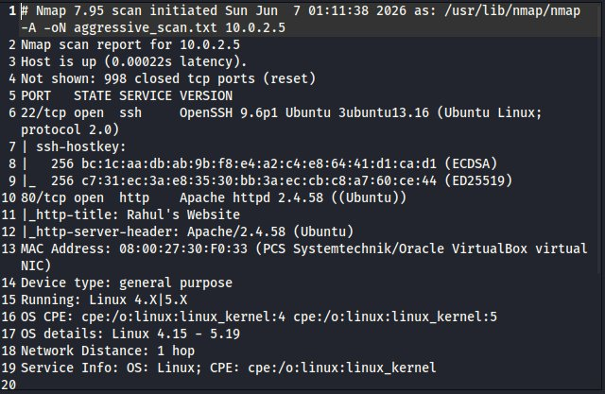

Observations
Observation | Detail / Significance
Command run | sudo nmap -A 10.0.2.5 -oN aggressive_scan.txt — combines -O -sV -sC --traceroute
SSH host keys | ECDSA: bc:1c:aa:db:ab:9b:f8:e4:a2:c4:e8:64:41:d1:ca:d1 | ED25519: c7:31:ec:3a:e8:35:30:bb:3a:ec:cb:c8:a7:60:ce:44 — SSH fingerprints extracted
HTTP title | Rahul's Website — the Apache web page title revealed by the http-title NSE script
HTTP server header | Apache/2.4.58 (Ubuntu) — server header confirmed by http-server-header script
OS detection | Linux 4.X|5.X, OS details: Linux 4.15 - 5.19 — consistent with OS scan
Service Info | OS: Linux; CPE: cpe:/o:linux:linux_kernel — confirmed from SSH and HTTP service banners
Latency | 0.00022s — very low due to same-subnet NAT Network placement
Ports | 22/tcp SSH OpenSSH 9.6p1 | 80/tcp HTTP Apache 2.4.58 — consistent across all scans

Findings
Finding 1: The aggressive scan revealed the HTTP page title 'Rahul's Website' — something not visible in any other scan type. This is a piece of OSINT that could help an attacker identify the server owner or application.
Finding 2: SSH host keys were extracted by the NSE ssh-hostkey script. These fingerprints can be used to verify the server's identity in future connections and detect man-in-the-middle attacks.
Finding 3: The aggressive scan provides the most complete target profile in a single command — OS, services, versions, script output, and traceroute — making it the most dangerous scan type from a defender's perspective.
Finding 4: All four scan types consistently identified the same two open ports (22 and 80), validating the results across methods. No discrepancies between scans were observed.

6. Screenshot 5 — Wireshark SYN Packet Capture
Screenshot: Wireshark — SYN packets (tcp.flags.syn == 1 && tcp.flags.ack == 0) during Nmap scan
Wireshark on Kali capturing SYN packets from 10.0.2.15 (Kali) to 10.0.2.5 (Ubuntu) — the port scan visible at packet level
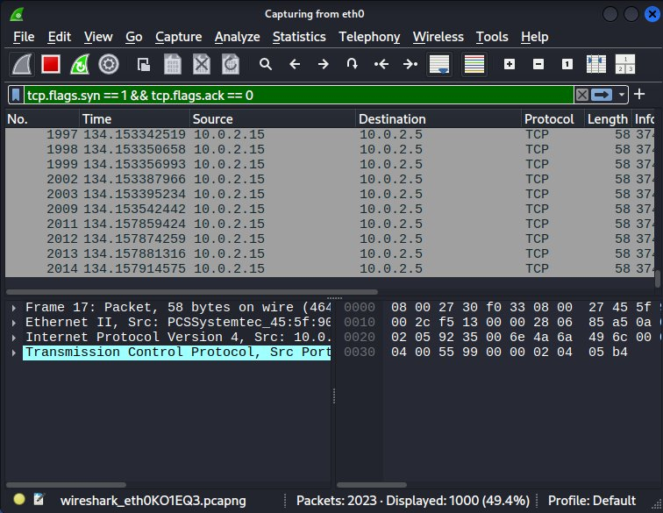

Observations
Observation | Detail / Significance
Interface captured | eth0 — Kali's primary network interface on the NAT Network
Filter applied | tcp.flags.syn == 1 && tcp.flags.ack == 0 — shows only SYN packets without ACK (pure scan probes)
Packets displayed | 1000 packets matching the filter (out of 2023 total captured — 49.4% match rate)
Source IP | 10.0.2.15 — Kali Linux, sending SYN probes to every port on Ubuntu
Destination IP | 10.0.2.5 — Ubuntu VM, the scan target receiving the SYN packets
Protocol | TCP — all visible packets are TCP SYN segments (port scan probes)
Packet size | 58 bytes — consistent SYN packet size, no data payload
Wireshark file | wireshark_eth0KO1EQ3.pcapng — saved capture file shown in status bar
Capture indication | Rapid sequential SYN packets to many different destination ports (visible in the Info column) — unmistakable port scan signature

Findings
Finding 1: The SYN packet burst from 10.0.2.15 to 10.0.2.5 is the textbook network signature of a port scan. A network security monitoring (NSM) system would flag this immediately.
Finding 2: The 49.4% filter match rate indicates approximately half the captured traffic was outgoing SYN probes — the other half being RST/SYN-ACK responses from Ubuntu.
Finding 3: The consistent 58-byte packet size with no variation and no data payload is characteristic of Nmap SYN probes. Real application traffic has variable sizes and payloads.
Finding 4: Wireshark confirms what Nmap reported — this provides packet-level evidence of the scan, which would be preserved in a PCAP file for forensic analysis.

7. Screenshot 6 — iptables IDS Detection (PORT_SCAN Kernel Log)
Screenshot: Ubuntu — sudo dmesg | grep PORT_SCAN showing Nmap SYN packets logged by iptables rule
Ubuntu terminal displaying kernel log entries tagged PORT_SCAN: for each SYN packet sent by Kali's Nmap scan
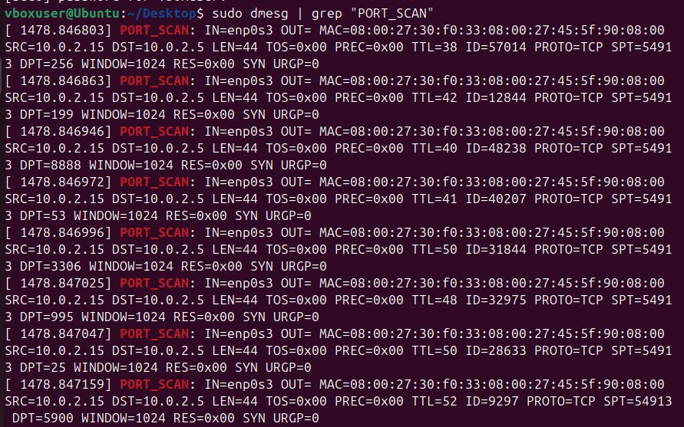

Observations
Observation | Detail / Significance
Command run on Ubuntu | sudo dmesg | grep "PORT_SCAN" — searching kernel ring buffer for our iptables log tag
iptables rule used | sudo iptables -A INPUT -p tcp --syn -j LOG --log-prefix "PORT_SCAN: "
Log entry format | [ timestamp ] PORT_SCAN: IN=enp0s3 OUT= MAC=... SRC=10.0.2.15 DST=10.0.2.5 ... PROTO=TCP ... SYN
SRC IP | 10.0.2.15 — Kali Linux attacker IP confirmed in every log entry
DST IP | 10.0.2.5 — Ubuntu target, consistent across all entries
Interface | IN=enp0s3 — Ubuntu's network adapter on the NAT Network
Flag confirmed | SYN — only SYN packets matched the --syn rule, exactly as Nmap sends during a SYN scan
Ports visible in log | DPT values in entries: 256, 199, 8888, 53, 3306, 995, 25, 5900 — random destination ports probed by Nmap
Detection timing | Kernel timestamps (1478.846803 to 1478.847159) show all SYN packets arrived within 0.0004 seconds — confirming burst pattern

Findings
Finding 1: The iptables LOG rule successfully detected every SYN packet from the Nmap scan — functioning as an IDS trigger without any third-party software.
Finding 2: The kernel timestamps show all logged packets arrived within 0.0004 seconds — this microsecond burst is the definitive pattern of automated port scanning vs normal user activity.
Finding 3: The destination ports in the log entries (256, 199, 8888, 53, 3306, 995, 25, 5900) are not sequential — Nmap randomises probe order by default to evade simple sequential-port detection rules.
Finding 4: The attacker IP (10.0.2.15) is captured in every log entry, providing complete attribution. This log could be forwarded to a SIEM for automated alerting and IP blocking.
Finding 5: iptables logging proved to be a viable Snort replacement for basic IDS functionality — it requires no additional packages and writes directly to the kernel log, which is always available on Linux.

8. Key Findings Summary
# | Finding | Description
1 | Two attack surfaces confirmed | Both Nmap and iptables confirmed port 22 (SSH) and port 80 (HTTP) as the only open services on the Ubuntu target.
2 | Exact software versions exposed | Version detection revealed OpenSSH 9.6p1 and Apache 2.4.58 — specific version disclosure that enables targeted CVE lookups.
3 | OS fingerprint successful | Linux kernel range 4.15 – 5.19 identified via TCP/IP stack fingerprinting, without any login or direct access to the target.
4 | Web page title leaked | Aggressive scan revealed the HTTP page title 'Rahul's Website' via NSE — application-layer OSINT collected without any browser access.
5 | Scan visible at packet level | Wireshark captured 1000 SYN packets matching the port scan filter — confirming the scan is detectable at the network level by any packet capture system.
6 | IDS detection successful | iptables kernel logging successfully tagged every Nmap SYN probe with PORT_SCAN: prefix — attacker IP (10.0.2.15) fully captured in kernel log.
7 | Burst timing confirms automation | All port scan SYN packets arrived within 0.0004 seconds in the kernel log — microsecond timing distinguishes automated scanning from human browsing.

9. Conclusion
This lab successfully demonstrated the full port scan detection lifecycle: reconnaissance using four Nmap scan types, packet-level observation in Wireshark, and detection via iptables kernel logging as a built-in Linux IDS alternative.
The four Nmap scans together built a complete target profile — open ports, exact software versions, OS family, SSH host keys, and web page content — all without establishing a single authenticated session. This demonstrates how much information is publicly observable on an unprotected network.
The iptables detection confirmed that basic Linux tools are sufficient for IDS-equivalent detection of port scans when third-party tools like Snort are unavailable. In a production environment, these kernel log entries would be forwarded to a centralised SIEM for automated alerting and IP blocking.

Possible future enhancements
- Forward iptables log entries to Splunk or ELK for centralised alerting and dashboarding
- Add an iptables rule to automatically DROP traffic from IPs triggering PORT_SCAN entries
- Schedule Wireshark captures via tshark on a cron job to build a time-series packet archive
- Install and properly configure Snort 3 (not Snort 2) which has better Kali Linux support

Resume Documentation
Port Scan Detection Lab
Performed network reconnaissance using 4 Nmap scan types (SYN, Version Detection, OS Fingerprinting, Aggressive) against a live Ubuntu VM on a VirtualBox NAT Network, captured the SYN packet burst in Wireshark using a tcp.flags filter, and implemented IDS-equivalent detection using iptables kernel logging — successfully logging every Nmap probe with attacker IP attribution in under 0.5 milliseconds. Tech: Nmap, Wireshark, iptables, Kali Linux, VirtualBox, GitHub

