Three Dimensional Convolutional Neural Network for Video Saliency

Jiawen Xu
Supervised by Mikahil Starsev

This Project is to search for saliency points in videos. In the previous work the coordinates of the saliency points as training data are labeled. The main work of this project is the preprocessing of training data and to construct the convolutional neural network. In the end, the saliency maps of the test video is generated to verify the performance of the training results. The Network is built and trained on the basis of the library Keras.

The saliency searching processing is actually a binary classification problem. The videos are firstly preprocessed to generate 9 sub-channels of gray-scaled video, RGB coded horizontal gradients and vertical gradients , horizontal and vertical optical flow. In another words, the raw video is converted to 9 videos , which contain different visual information.

The next stage is to extract video volumes from the nine videos, which will be fed into the neural network. The spatial and temporal size are defined as 60,40, 14. It means that every volume is of size 60 * 40 and 14 frames videos. For Gazecom videos , the volumes with their labels are stored in the hard disk in format of .h5 files.
For Hollywood datasets, it is firstly converted to 9 videos and then stored in the .h5 files with its respective labels.

Because of the large size of the training data and the limited memory of the graphic card the training data are divided as batches to be fed into the network. For Gazecom and Hollywood the ways to generate batches are different. For Gazecom, each batch is consist of randomly chosen .h5 files , which we mentioned before. And then the volumes and labels in the files are concatenated. For each epoch, every file are chosen once. For Hollywood , since the limit of the hard disk space and memory, it is impossible to store preprocessed volumes in hard disk as Gazecom. A Pointlist is firstly defined. It is a list of all the interest points and their coordinates and video names. The order of the points on the list is shuffled. Each time to generate one batch of dataset, it is firstly to choose the interest points from the list and then open the pre-saved .h5 files to extract volumes. This method is slow but saves space.

The structure of the network can be shown as in fig. 1. Three dimensional convolution are used twice for each channel. The outputs of the convolution are fed into a two layer fully connected network . The final outputs are the possibilities of the two classes.

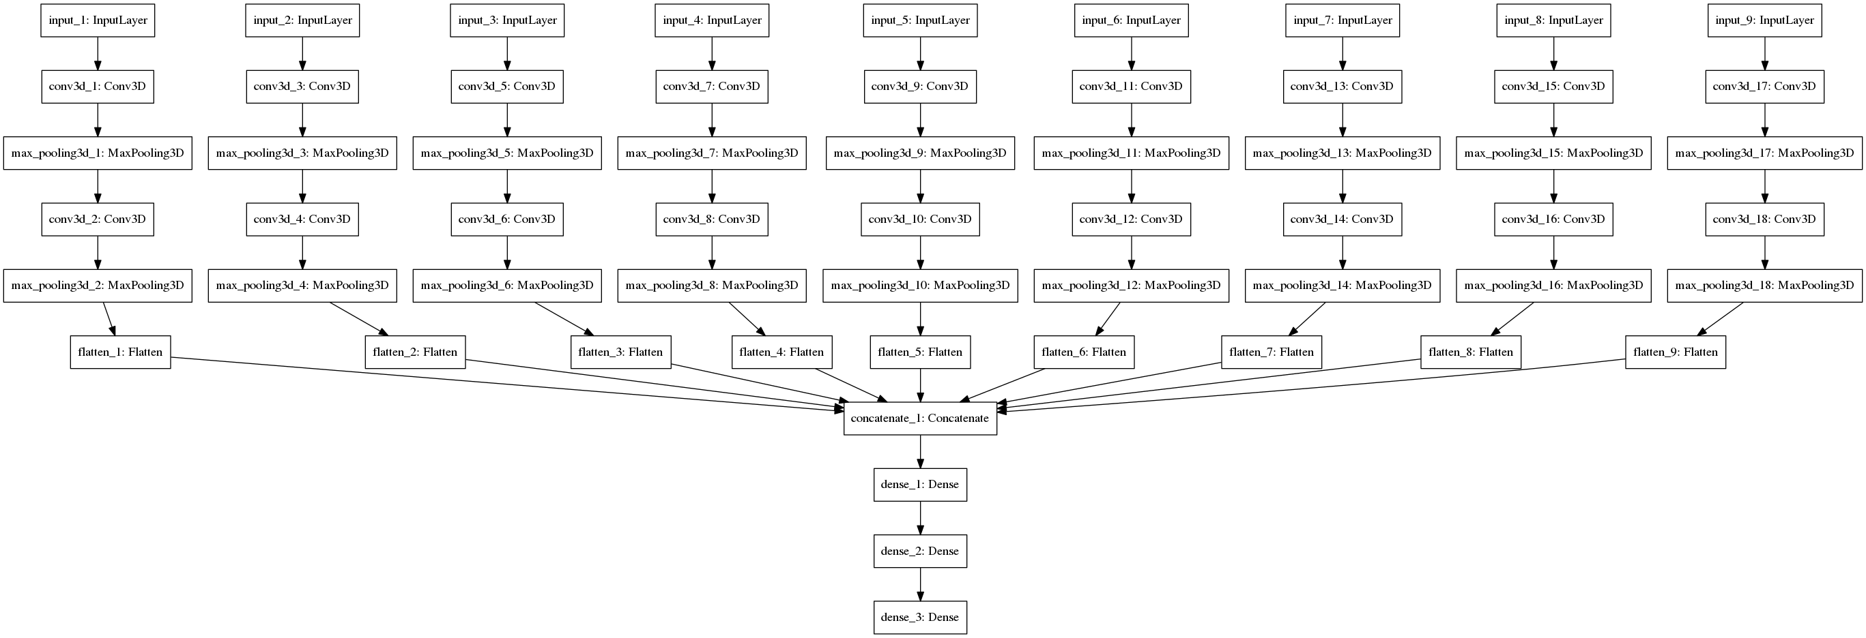
Figure 1. structure of the neural network

