##### **Application for Booking Appointments for Diagnostics**

ER Diagram:

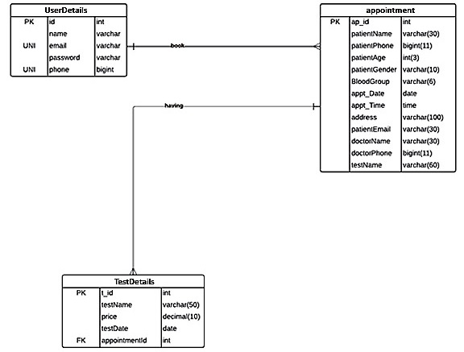

**SQL code of Database:**

create database protocoanpc7698gaurav;

use protocoanpc7698gaurav;

**# create table UserDetails**

create table UserDetails(

id int primary key auto_increment,

name varchar(30) not null,

email varchar(30) not null unique,

password varchar(10) not null,

phone bigint(10) not null unique

);

**#describing userdetails Table**

desc UserDetails;

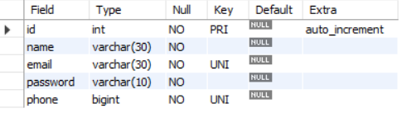

**#create table appointment**

create table appointment(

aid int primary key auto_increment,

patientName varchar(30) not null,

patientPhone bigint(11) not null,

patientAge int(3) not null,

patientGender varchar(10) not null,

BloodGroup varchar(10),

appointmentdate date not null,

appointmenttime time,

addr varchar(50) not null,

patientEmail varchar(30) not null

);

alter table appointment add Column doctorName varchar(30) not null;

alter table appointment add Column doctorPhone bigint(11);

alter table appointment add Column testName varchar(30) not null;

**#describing appointment Table**

desc appointment;

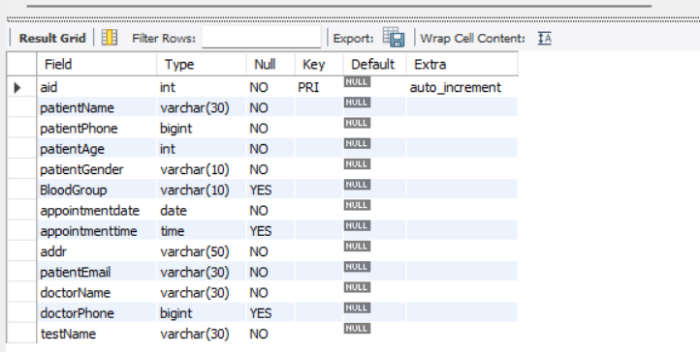

**#create table TestDetails**

create table TestDetails(

tid int primary key auto_increment,

testName varchar(30) not null,

price decimal not null,

testdate date not null,

appointmentId int,

foreign key(appointmentId) references appointment(aid)

);

**#describing TestDetails Table**

desc TestDetails;

