Q1

Code

package Q01;  
  
public class Temperature {  
 private double celcious;  
  
 public Temperature() {  
 this.celcious = 0.0;  
 }  
  
 public Temperature(double celcious) {  
 this.celcious = celcious;  
 }  
  
 public double toCelsius() {  
 return celcious;  
 }  
  
 public double toFahrenheit() {  
 return (celcious \* 9/5) + 32;  
 }  
  
 public double getCelsius() {  
 return celcious;  
 }  
  
 public void setCelsius(double celcious) {  
 this.celcious = celcious;  
 }  
  
 public void setFahrenheit(double farenheit) {  
 this.celcious = (farenheit - 32) \* 5 / 9;  
 }  
}

package Q01;  
  
import java.util.Scanner;  
  
public class Main {  
 public static void main(String[] args) {  
 Scanner scanner = new Scanner(System.*in*);  
  
 System.*out*.print("Enter temperature value in Celsius: ");  
 double input = scanner.nextDouble();  
  
 Temperature temperature = new Temperature(input);  
  
 System.*out*.println(" Fahrenheit value: " + temperature.toFahrenheit());  
  
 scanner.close();  
 }  
}

Output

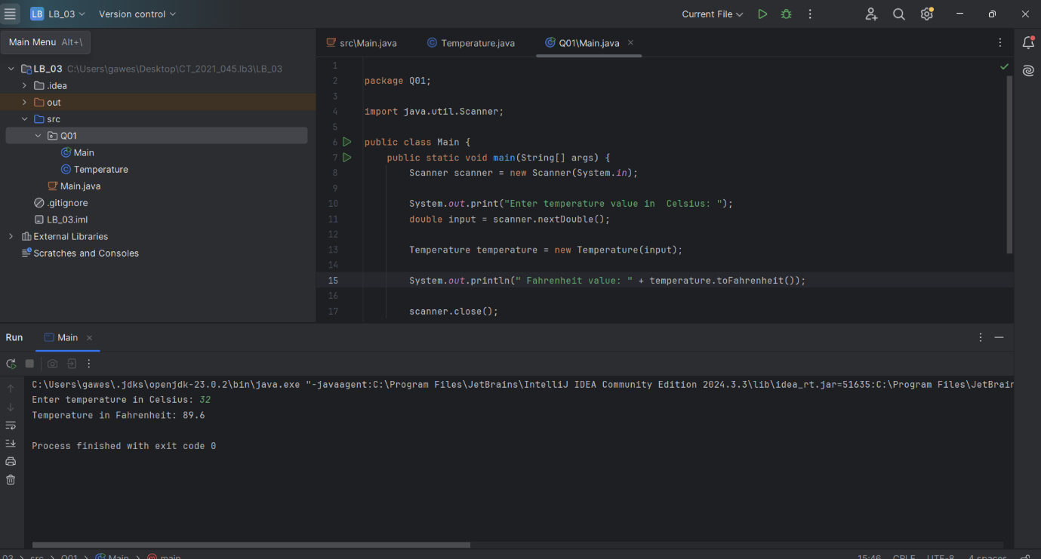

Q2

Code

package Q02;  
  
public class Temperature{  
 private double celcious;  
  
 public Temperature() {  
 this.celcious = 0.0;  
 }  
  
 public Temperature(double celcious) {  
 this.celcious = celcious;  
 }  
  
 public double toCelsius() {  
 return celcious;  
 }  
  
 public double toFahrenheit() {  
 return (celcious \* 9/5) + 32;  
 }  
  
 public double getCelsius() {  
 return celcious;  
 }  
  
 public void setCelsius(double celcious) {  
 this.celcious = celcious;  
 }  
  
 public void setFahrenheit(double farenheit) {  
 this.celcious = (farenheit - 32) \* 5 / 9;  
 }  
}

package Q02;  
  
import java.util.Scanner;  
  
public class Mainq02 {  
 public static void main(String[] args) {  
 Scanner scanner = new Scanner(System.*in*);  
  
 System.*out*.print("Enter temperature in Fahrenheit: ");  
 double farenheit = scanner.nextDouble();  
  
 Temperature temperature = new Temperature();  
 temperature.setFahrenheit(farenheit);  
  
 System.*out*.println("Temperature in Celsius: " + temperature.toCelsius());  
  
 scanner.close();  
 }  
}

output:

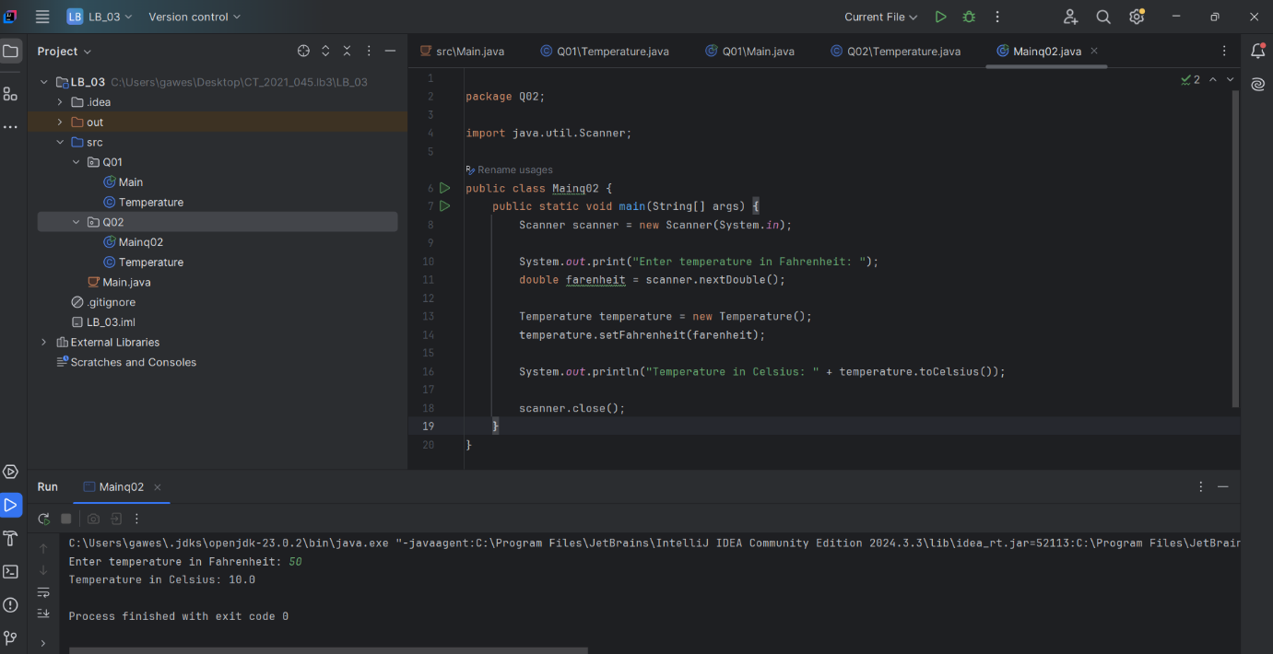

Q3

Code:

class Circle {  
 private double radius;  
  
   
 public Circle(double radius) {  
 this.radius = radius;  
 }  
  
   
 public double computeArea() {  
 return Math.*PI* \* radius \* radius;  
 }  
}

import java.util.Scanner;  
  
public class CircularRegion {  
 public static void main(String[] args) {  
 Scanner scanner = new Scanner(System.*in*);  
  
   
 System.*out*.print("Enter inner radius : ");  
 double ri = scanner.nextDouble();  
  
 System.*out*.print("Enter outer radius : ");  
 double ro = scanner.nextDouble();  
  
   
 Circle innerCircle = new Circle(ri);  
 Circle outerCircle = new Circle(ro);  
  
   
 double shadedArea = outerCircle.computeArea() - innerCircle.computeArea();  
  
   
 System.*out*.println("Shaded Area: " + shadedArea);  
  
 scanner.close();  
 }  
}

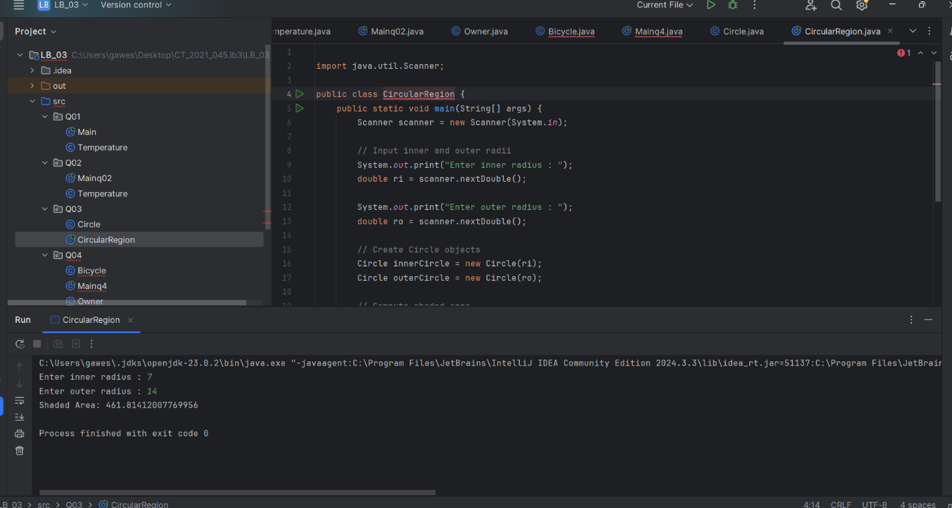

Q4

Code

public class Bicycle {  
 private Owner owner;  
  
 public Bicycle() {  
 this.owner = new Owner();  
 }  
  
 public Bicycle(String name, String num) {  
 this.owner = new Owner(name, num);  
 }  
  
 public String getOwnerName() {  
 return owner.getOwnerName();  
 }  
  
 public void setOwnerName(String name) {  
 owner.setOwnerName(name);  
 }  
  
 public String getPhoneNo() {  
 return owner.getPhoneNo();  
 }  
  
 public void setPhoneNo(String num) {  
 owner.setPhoneNo(num);  
 }  
}

public class Owner {  
 private String ownerName;  
 private String phoneNo;  
  
 public Owner() {  
 this.ownerName = "Unknown";  
 this.phoneNo = null;  
 }  
  
 public Owner(String ownerName, String phoneNo) {  
 this.ownerName = ownerName;  
 this.phoneNo = phoneNo;  
 }  
  
 public String getOwnerName() {  
 return ownerName;  
 }  
  
 public String getPhoneNo() {  
 return phoneNo;  
 }  
  
 public void setOwnerName(String ownerName) {  
 this.ownerName = ownerName;  
 }  
  
 public void setPhoneNo(String phoneNo) {  
 this.phoneNo = phoneNo;  
 }  
}

public class Mainq4 {  
 public static void main(String[] args) {  
 Bicycle bike = new Bicycle("Nimal", "0716789678");  
  
 System.*out*.println("Owner Name: " + bike.getOwnerName());  
 System.*out*.println("Phone Number: " + bike.getPhoneNo());  
  
 bike.setOwnerName("Kamal");  
 bike.setPhoneNo("0704567890");  
  
 System.*out*.println("Updated Owner Name: " + bike.getOwnerName());  
 System.*out*.println("Updated Phone Number: " + bike.getPhoneNo());  
 }  
}

