INSTALLATION

Our modular software library is easily installed on top of any search engine, database, or other content source, which may be under your control or only accessible to you via HTTP – no matter. Customers have reported successful installation in as little as 15 minutes! Here is how the Clustering Engine is installed (together with the optional Content Integrator at Step 3):
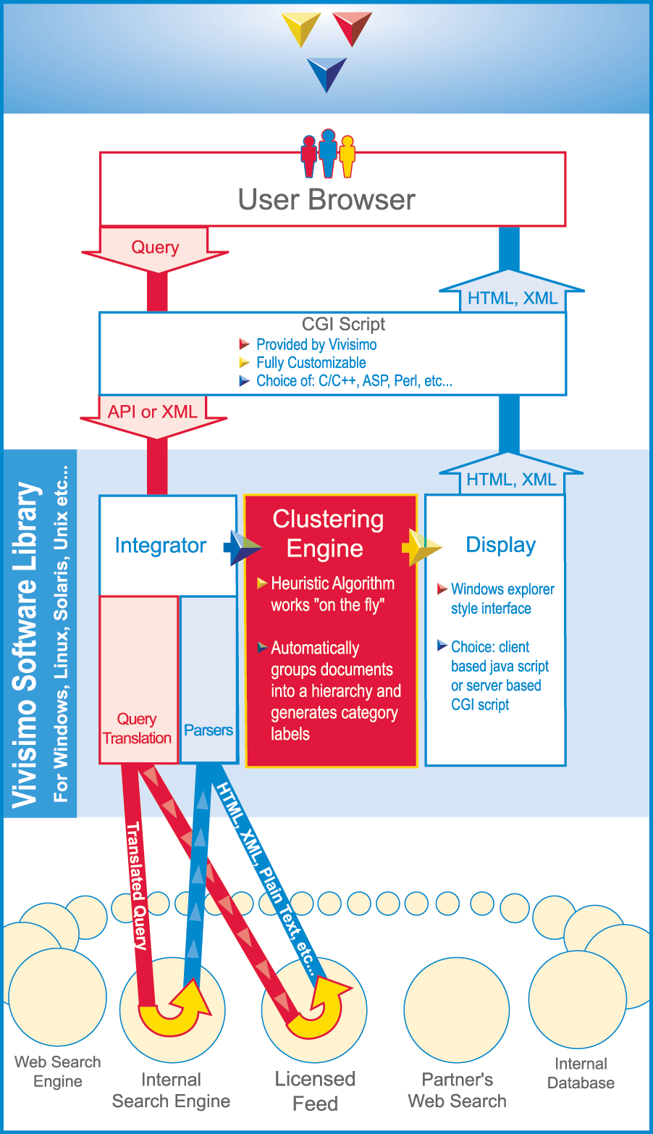
- The search engines and other content sources interact with the Vivisimo software library through a CGI script running on your server.
- The user types a query which triggers a Vivísimo CGI script running on your server. This CGI script creates a Vivisimo object which is forwarded to the Content Integrator.
- The Vivisimo Content Integrator translates the query, sends it to various content sources, and retrieves results in parallel. It parses these search results, converting them to valid XML if needed.
- The Vivísimo Clustering Engine takes the XML output and automatically groups the search results “on-the-fly” into hierarchical folders, whose structure and labels are inferred spontaneously from the returned search results.
- The Display component produces a windows explorer style interface that can be presented with either client-side JavaScript or server-side HTML.

Specs:
- Written in portable C, for maximum speed and flexibility.
- Distributed with wrappers for the most common scripting languages (Perl, ASP, JSP, C, C++ etc).
- API is based on the XML standard.
- Available for Windows, Linux, Solaris, and other Unix systems.
- Never accesses the index or the source search engines or source databases.
- Interacts with any search engine through HTTP connections.
- Uses XML search engine output, or parses its default HTML/Text output.
- Does not need to run on the same platform/server as the search engine.
- Integrates with any server and with the most common scripting languages.
- Requires a search engine (or other source) that returns 50-500 results relatively fast (an ordinary Pentium IV server can handle up to 1M queries a day).
- The only requirement on the client side is a browser.
The Vivísimo release comes with hooks for the most commonly used search engines (Verity, Inktomi, IIS, etc.) and seamlessly integrates with them. If your search engine vendor is not included in our current release then some minor customization will complete the integration process.

