Exhibit A: Search Results Data
http://download.com.com/3120-20-0.html?qt=google&tg=dl-2001&search.x=0&search.y=0

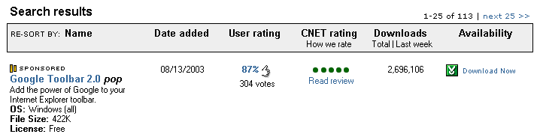

Exhibit B: Product Detail Page:
http://download.com.com/3000-2379-10220032.html

