

NUCLEAR ENERGY INSTITUTE

Discussion Paper
Analytical Approaches to
Calculating Avoided Emissions
June 27, 2003

Introduction

Avoided emissions are those emissions that are not produced, or are avoided, by using non-emitting technologies instead of emitting technologies to produce electricity. Every megawatt-hour of electricity produced by an emission-free generating unit—such as a nuclear plant, a hydroelectric facility or a wind farm—is a megawatt hour that a fossil-fueled plant, which produces various emissions, does not produce.

As programs designed to reduce emissions of air pollutants evolve, regulators and government officials working to reduce air pollution and greenhouse gas emissions generally recognize the importance of non-emitting technologies. This is appropriate: Simple equity demands that non-emitting sources that contribute to air quality goals by increasing production and avoiding additional emissions receive recognition. A ton of any pollutant avoided has the same value as a ton reduced. Such recognition is best achieved by granting fungible credits or allowances to participating non-emitting sources for their emissions avoided.

But how many credits should a non-emission source receive?

This discussion paper presents three analytical approaches to calculating avoided emissions.

Three Analytical Approaches to Calculating Avoided Emissions

Avoided emissions can be calculated in several ways. Some require considerable data and modeling. Others are simpler and more straightforward. In fact, all methods for calculating avoided emissions are projections, as the emissions avoided never existed and cannot be directly measured. The most accurate estimates are based on past experience, like measuring emissions avoided last month.

Approach #1:
Using Dispatch Order and Demand Curves to Calculate Avoided Emissions

A very precise method for determining tons of emissions avoided by a specific non-emitting electric generator for a period of time in the past would use (1) the demand curve for the period of time in question, (2) the dispatch order for all the generating units in the region, and (3) the emission rates of all generating units in that dispatch order.

The dispatch order is determined primarily by the variable operating and maintenance (O&M) cost of the unit. Units that are least expensive to run are dispatched first.

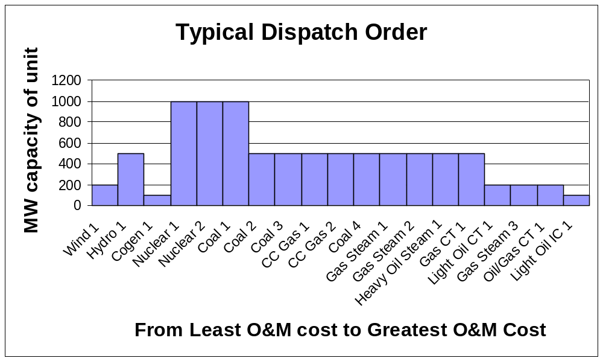
Exhibit 1

Fuel cost represents a large part of a fossil-fired unit’s variable O&M cost. Units with “free” fuel, like wind and hydro units, have the least cost. Compared to fossil-fueled plants, fuel costs for a typical nuclear power plant are a relatively small percentage of O&M costs and are relatively stable. Units that run on fuels, like natural gas, that have significant price volatility will move up or down the dispatch order as the price of that fuel moves up and down. As gas prices rise, the gas-fired units will migrate later in the dispatch order (or further to the right in Exhibit 1 above). Other components of O&M costs are typically environmental compliance allowances, labor, direct materials, etc.

Combining the demand for a given period of time, typically one hour, with the dispatch order shows which units were running. In the example shown in Exhibit 2 (below), a demand of 5,500 MW is met by the 11 least expensive units to run.

Sometimes a unit cannot operate, or cannot operate at full capacity, because of maintenance, river conditions or wind speeds. This is demonstrated by Hydro 1 contributing only 100 MW of its 500 MW nameplate capacity. Renewable generators in particular tend to be limited resources: When they are available, they always run, but they are not always available.

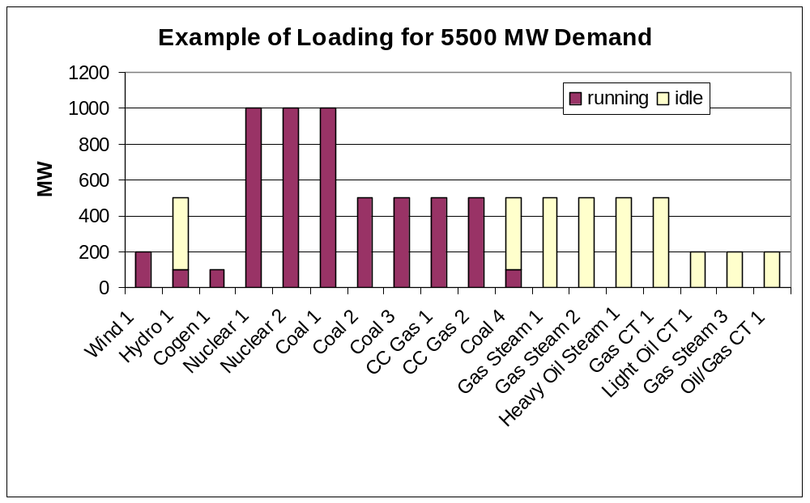

Exhibit 2

To calculate the emissions avoided by any of the non-emitting generators, it is necessary to predict what the dispatch order would have been for that hour if the non-emitting generator were not running. For example, Coal 4 is the marginal unit running in Exhibit 2 (above). If more non-emitting generation is added to the region, like the 20% uprate of Nuclear 2 in Exhibit 3 (below), the margin would shift to Combined Cycle Gas 2 (CC Gas 2). One less fossil unit would run to cover the 5500 MW load. The emissions avoided by the uprate are the emissions that otherwise would come from generating those 200 MW at CC Gas 2 and Coal 4. Those emissions could be calculated by using plant specific emission data that EPA collects.

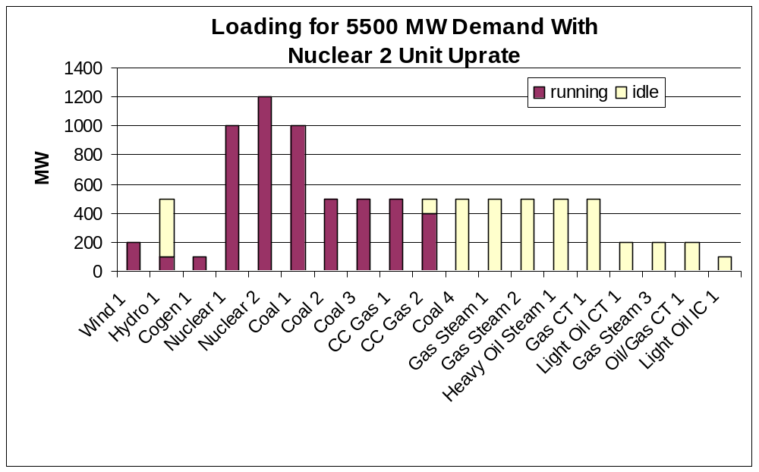
Exhibit 3

Theoretically, a similar calculation could be done for each non-emitting unit for each hour of the year, and this would yield rather precise estimates for emissions avoided. There are, however, a number of drawbacks. Gaining access to regional dispatch order and load data for such calculations may be difficult, if not impossible. In addition, this approach is labor-intensive, and would entail significant cost and resources.

Approach #2:
Using An Average Emission Rate

The Average Emission Rate method calculates avoided emissions by multiplying the increased output (kWh) by the average fossil plant emission rate in the region or power pool.

Using an average emission rate to compute avoided emissions significantly reduces the complexity of the analysis relative to the Dispatch Order/Demand Curve method discussed in Approach #1 above. The average emission rate method also provides a reasonably good estimate of avoided emissions.

The average emission rate method is basically the method used by companies reporting avoided emissions into the existing 1605(b) voluntary greenhouse gas registry, and endorsed by the Energy Information Administration (EIA), but with one major difference. In the existing 1605(b) registry, the average emission rate supplied by EIA is a regional average computed for all generating plants in the region, and includes emitting and non-emitting generators. Using an average “fossil-only” emission rate would increase the accuracy of the calculation in most, if not all, regions.

As noted earlier, the non-emitting generating sources are dispatched before the emitting generation sources due to fuel costs. In most (if not all) regions of the United States, the fossil-fired power plants will always be on the margin. (The margin is the demand at any given moment. The marginal unit is the most expensive unit running to meet that demand.) This means that if a non-emitting unit does not run, no matter the season or time of day, the power would be replaced by emitting plants. Changes in demand with season and time of day would, however, mean a continuously changing mix of fossil “replacement” plants. Thus, an average fossil emission rate provides a good factor to use in computing avoided emissions. Exhibits 4 and 5 demonstrate this concept.

The same dispatch order from the previous example is represented in Exhibit 4, with least cost generation appearing on the left of the chart. The curved line is a demand line that shows the percentage of a given year various demand levels in the region exist. For example, 75% of the year the demand is approximately 5,500 MW or greater. This curve, overlaid with the dispatch order, shows which units were always called to service, which units were used to adjust the load, and which units were used in peak demand times. So, Combined Cycle Gas 1 was called to service 75% of the year, because the demand was at least 5,500 MW 75% of the year.

Exhibit 5 shows the same demand curve and the same dispatch order, but additional capacity has been added to both nuclear units. (Capacity additions are possible at most operating nuclear power plants and are commonly referred to as “uprates”.) The additional non-emission capacity clearly reduces the load on fossil plants. In fact, all plants that reside on the margin will run less because there is more non-emission generation earlier in the dispatch order. Because the fossil plants are the plants that primarily reside along the margin throughout the year, using an average fossil emission rate to calculate avoided emissions provides a good estimate.

Using this method, EIA would supply an average fossil emission rate factor with which companies could calculate avoided emissions in each region. This factor would change continuously if based on past generation and emissions. A weighted three-year rolling average fossil emission rate would both allow for smoothing (reducing large variations from an unusual season) and for trends (reduced or increased use of fossil plants by the market).

Load Curve Shows Marginal Units Are Fossil Plants

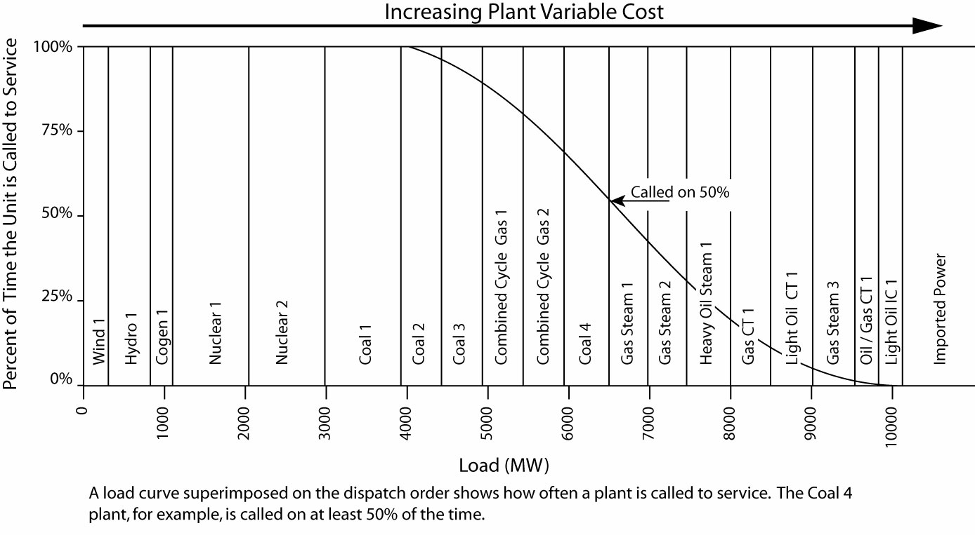
Exhibit 4

Additional Non-Emission Generation Reduces Use of Fossil Plants

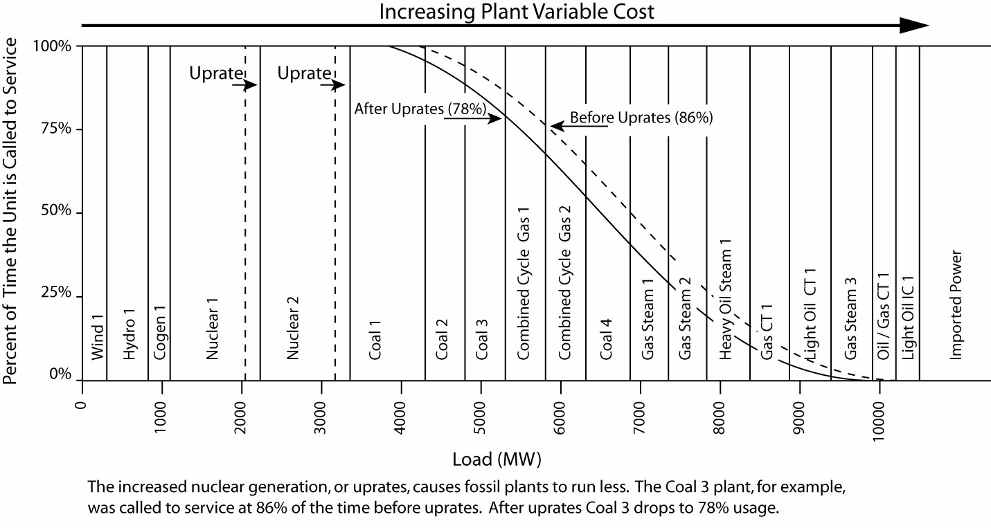
Exhibit 5

Approach #3:
Using a State-of-the-Art Combined Cycle Emission Factor

Some analysts might argue that an emission-free generator, such as a hydroelectric facility or a nuclear unit, avoids the emissions associated with a state-of-the-art gas-fired combined cycle generating unit, the plants commonly being built today. Using the emissions rate of a combined cycle gas unit to calculate avoided emissions clearly underestimates the avoided emissions today, but this would be the most simple (and the least accurate) way to calculate avoided emissions.

Using the State-of-The-Art Combined Cycle Method, emissions avoided would be calculated simply by multiplying the generation of the non-emitting source (kWh) by the emission rate of the latest combined-cycle gas-fired unit.

Conclusion

The most accurate method of calculating emissions avoided is also the most resource-intensive and burdensome analytically: the Dispatch Order/Demand Curve method. In addition, most operators of transmission systems, with whom the dispatch order and demand curve reside, do not currently perform detailed tracking of emissions and, as a result, this approach may not be feasible. Finally, this method would likely discourage voluntary reporting due to the cost of report preparation. Having Regional Transmission Organizations (RTOs) produce emissions data in real time based on the dispatch order may be an option for the future, however.

At the other extreme, the least accurate method for calculating avoided emissions is the State-of-the-Art Combined Cycle Emission Factor method.

The Nuclear Energy Institute believes the most reasonable method is the Average Emission Rate method, which uses the average fossil emission rate by region. The advantages are many and the disadvantages are few.

The major disadvantage: Modestly less accuracy compared to the Dispatch Order/Demand Curve method.

The major advantages: Ease of use and continuity with methods currently employed in the 1605(b) program. In addition, this method provides reasonably robust and defensible estimates of avoided emissions. The factor would be supplied by EIA, and updated regularly by region to best reflect the generation mix and thus the marginal “replacement” units used to calculate avoidance emissions. In most regions, use of an average fossil emissions rate is appropriate. If a region had non-emitting generating units among its marginal units, now or in the future, a more appropriate factor could be supplied by EIA.

Sound public policy depends on complete, accurate data. Recognizing the emissions avoided by non-emitting sources of electricity is vital to supplying the public and decision-makers with accurate data. Without accurate representation of all technologies that degrade and improve air quality, policy-makers cannot develop workable plans to improve air quality.

