**Problem Statement**

Docker is an open platform for developers and sysadmins to build, ship, and run distributed applications. The engineer need to learn the below topics and experiment the same.

* Overview of Docker
* Installing the Docker Engine
* Creating our first Docker container
* Building Docker images
* Storing and retrieving Docker images from Docker Hub
* Building containers from images
* Using Docker for sandboxing and testing
* Deploying BroadLeaf Application with Docker

Installing virtual machine in EC2 instances to deploy the Docker engine

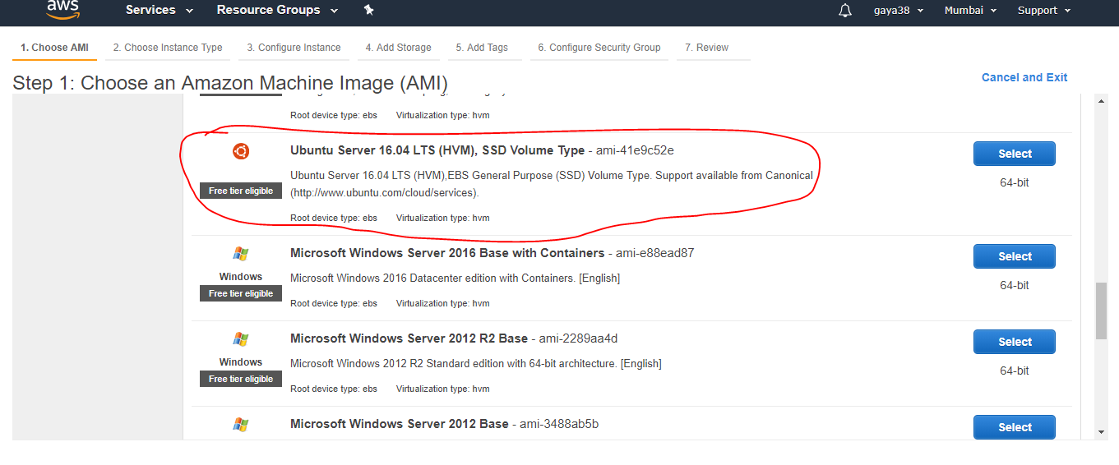

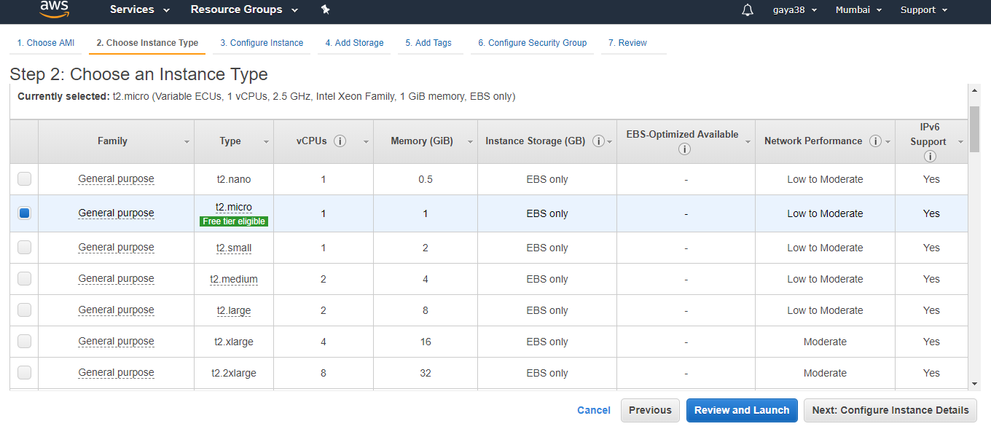

1.Installing the Docker engine in virtual machine

Adding path

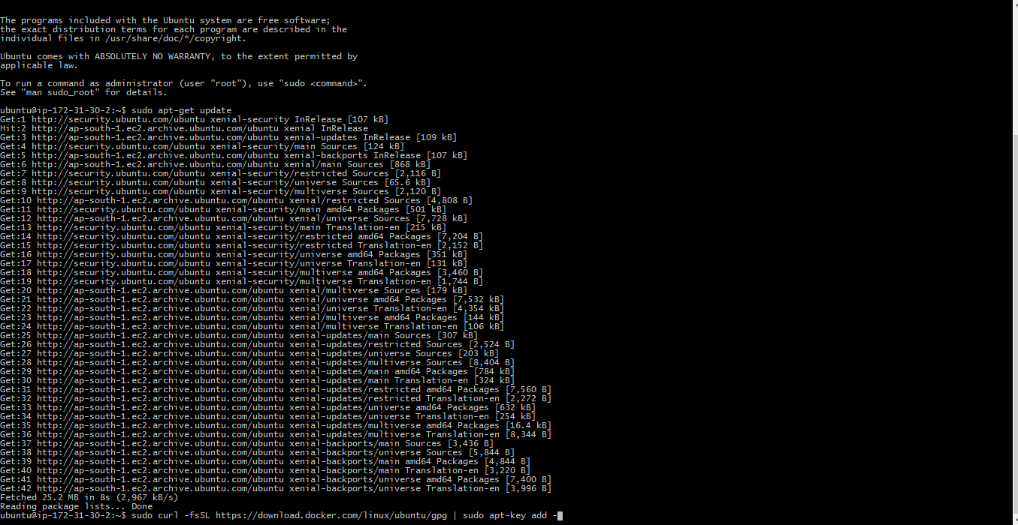

Installing docker



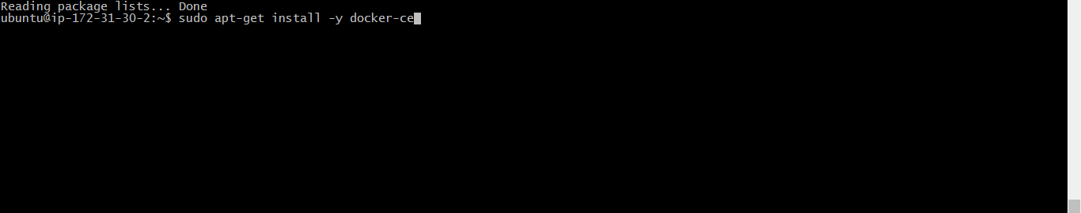

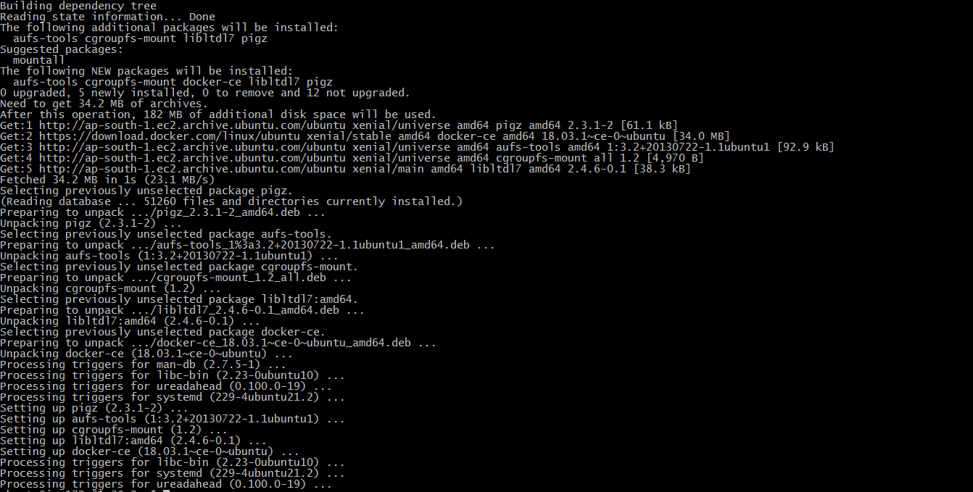

Checking Docker status : it is up and running

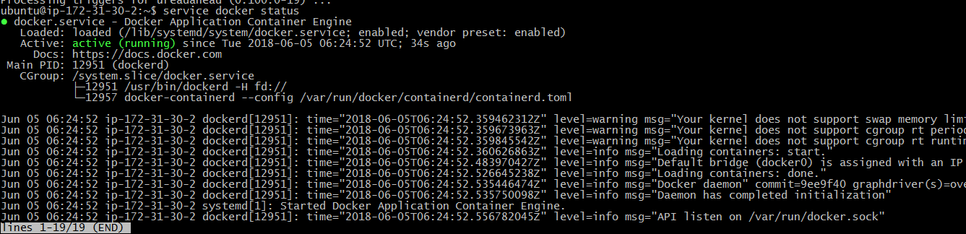

Checking version of Docker



2. Creating First Docker Container

To create the container needs to download the image

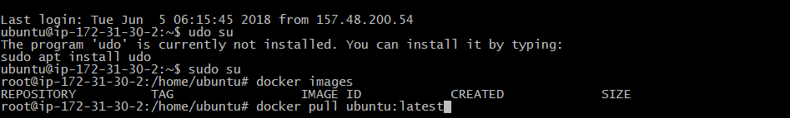

Check for the status



Creating the container from the downloaded image



Container list



Second Container



Container list



3.Building Docker images

Created Docker file to build an image



Created an image by using docker build command

Before run the command

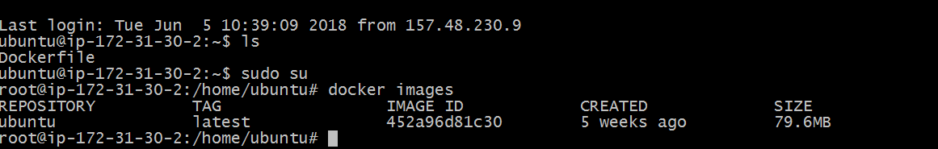

After run the command

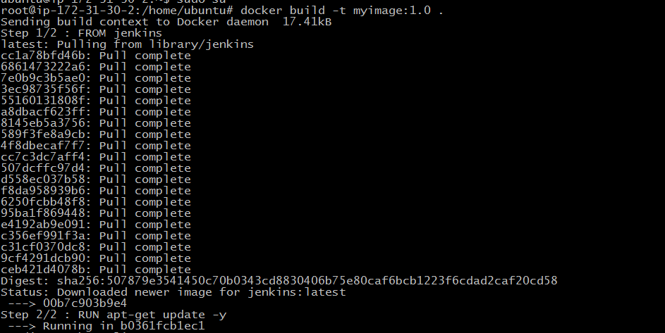



4. Storing and retrieving Docker images from Docker Hub

Login into Docker hub

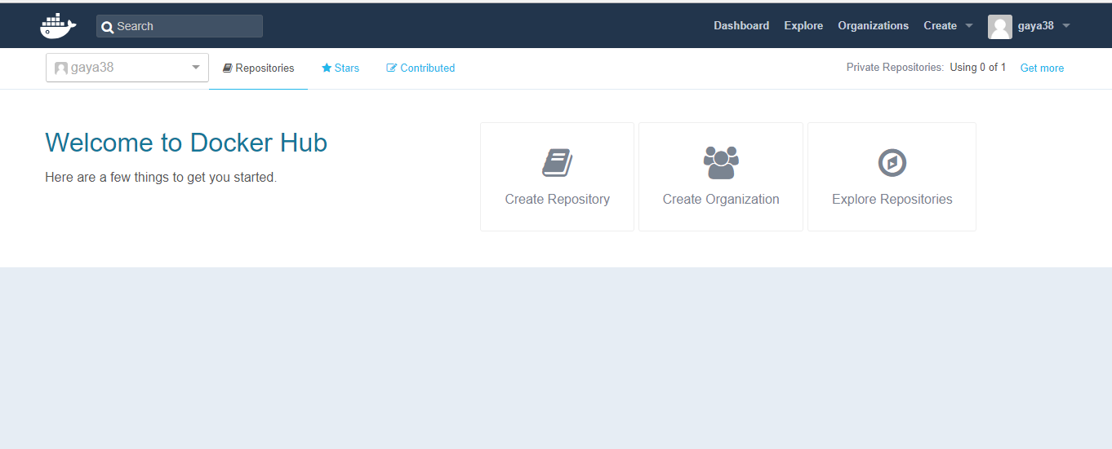

Creating Repository in Docker hub

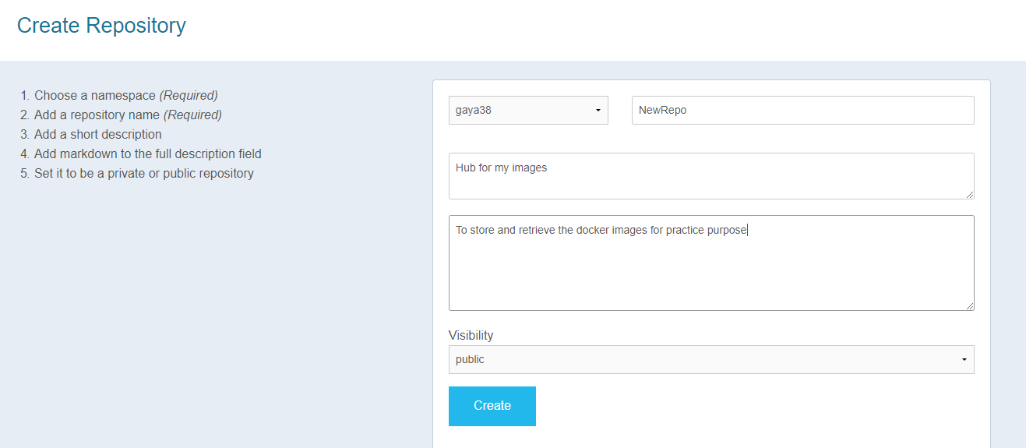

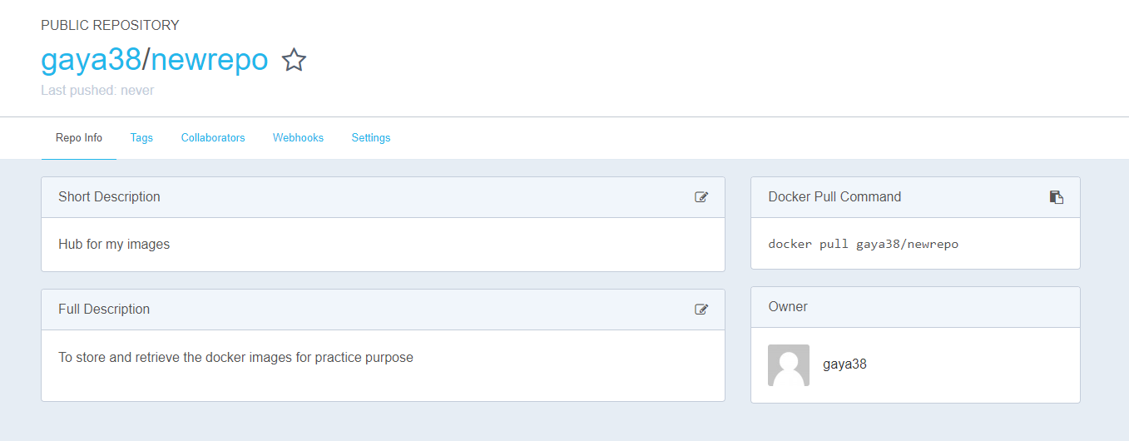

Log in to the Docker hub

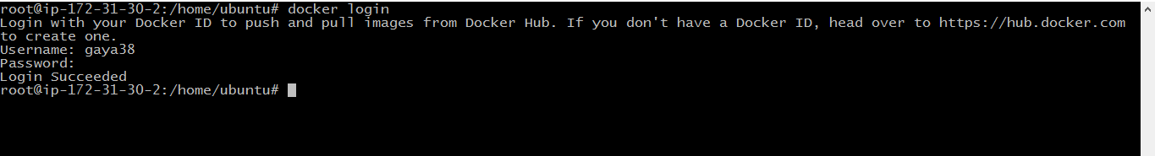

Tag the image

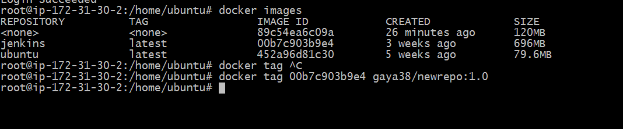

Pushing to Docker hub

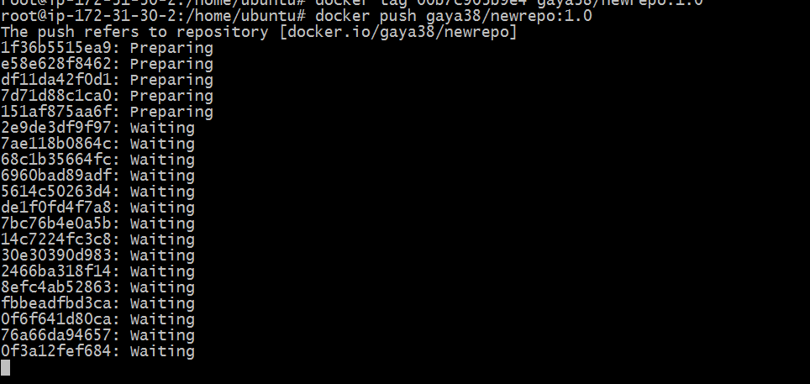

Uploaded into my Docker hub

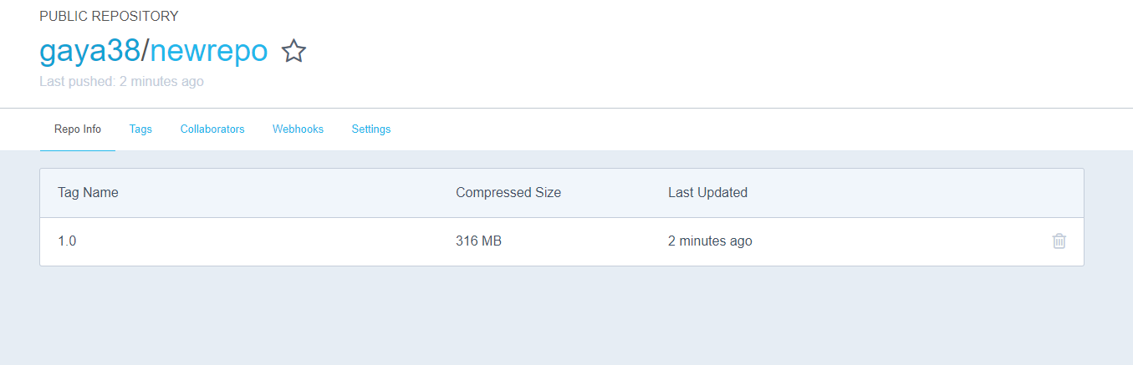

Pulling from Docker hub



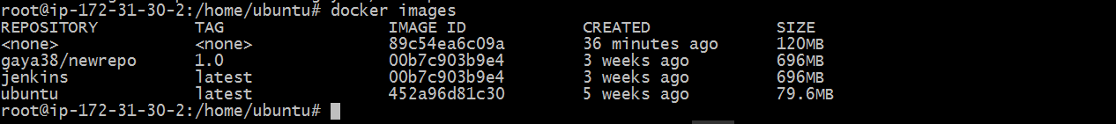

5. Building Containers from Images





6. Using Docker for sandboxing and testing

Pulling Docker image from docker hub

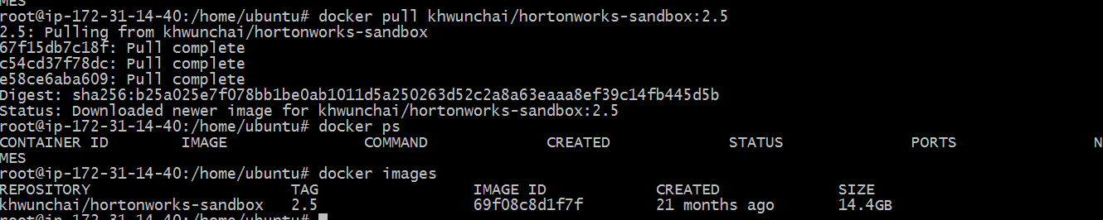

Container in Docker

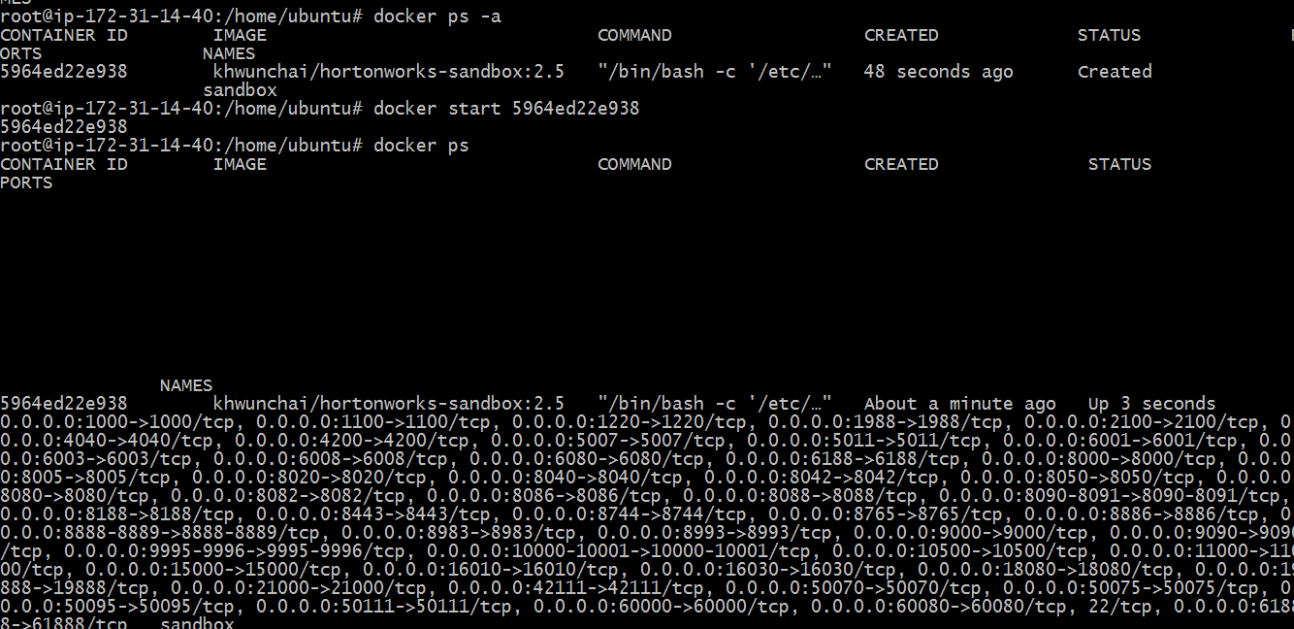

Opening sandbox in host

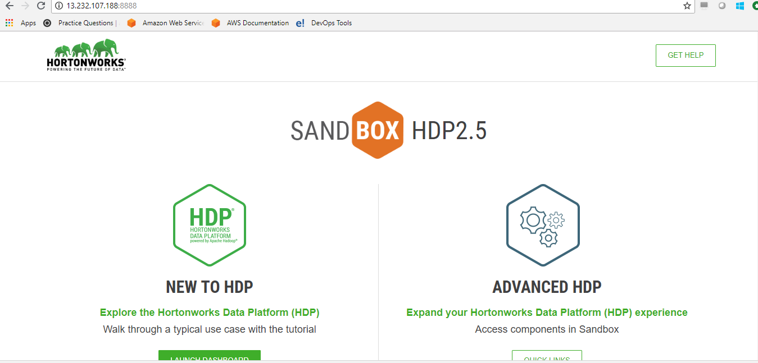

7.Deploying Broad Leaf Application

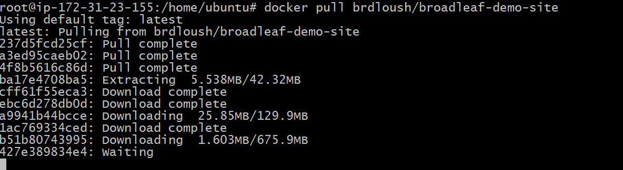

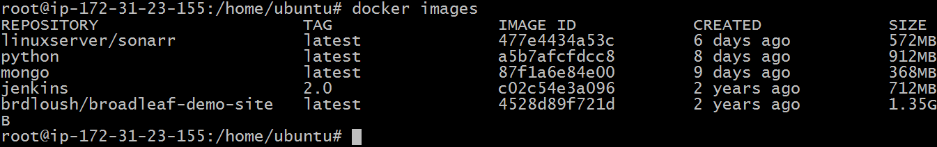

Running a container

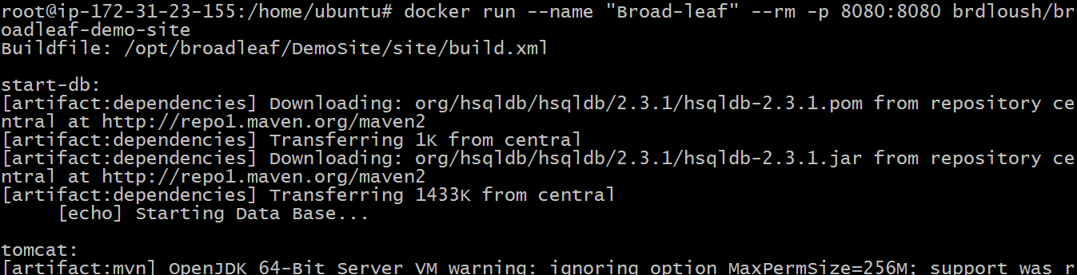

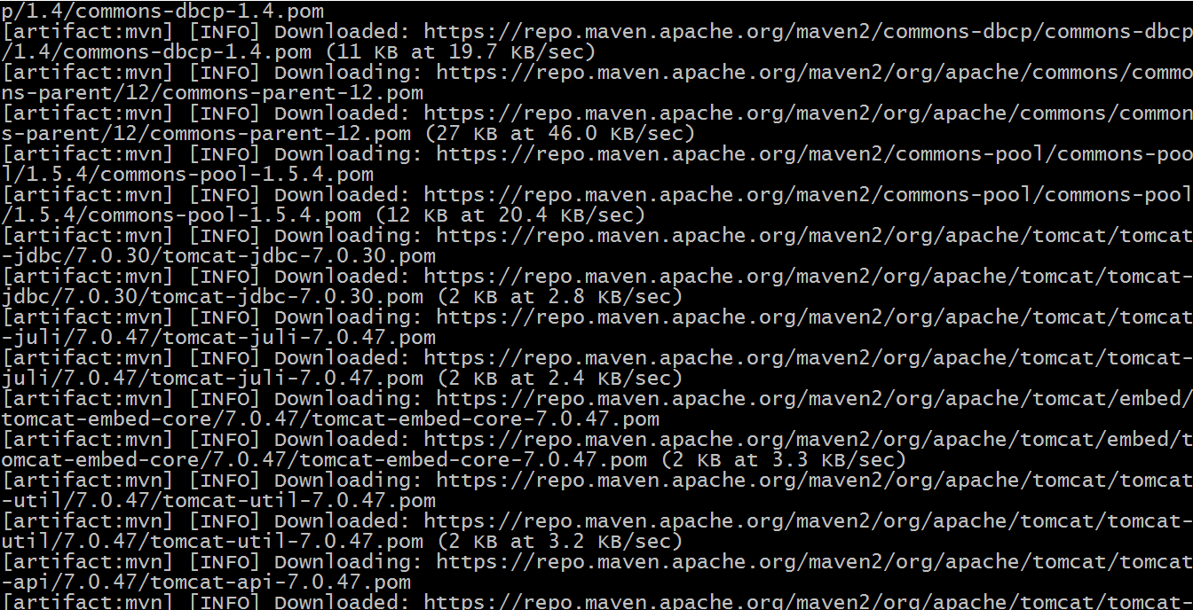

Docker container:



Broad-leaf application on port:8080

