Installed Docker in first instance

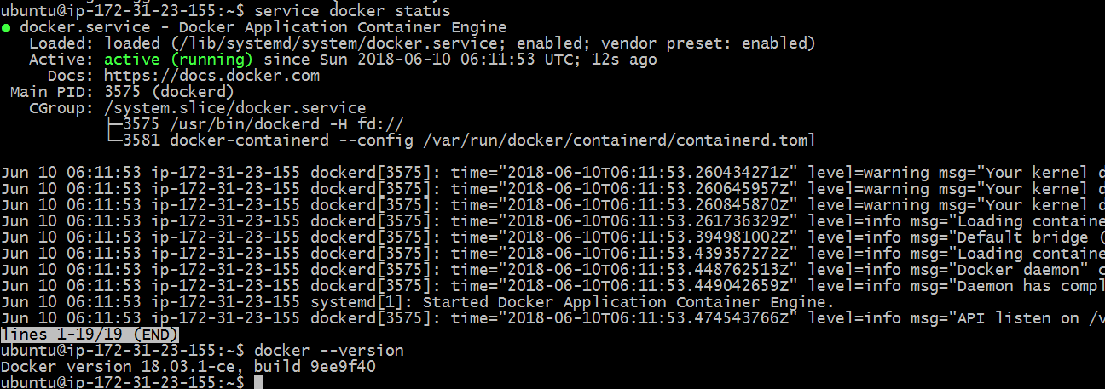

Installed Docker compose

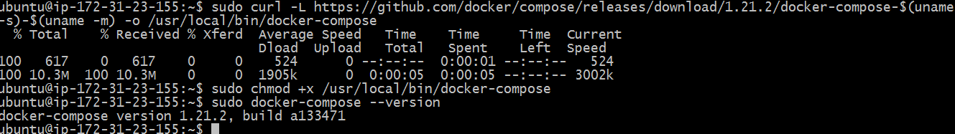

Creating docker-compose.yml file

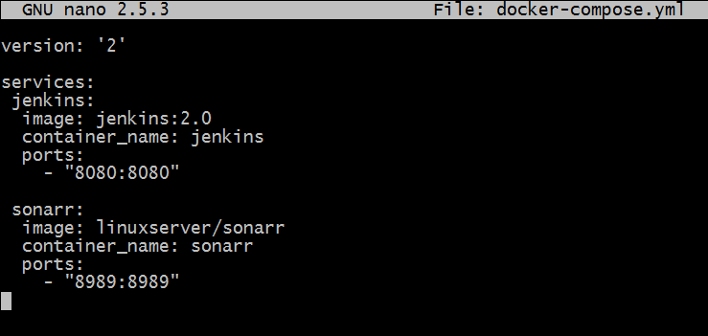

Running docker compose to download Jenkins 2.0 and sonar

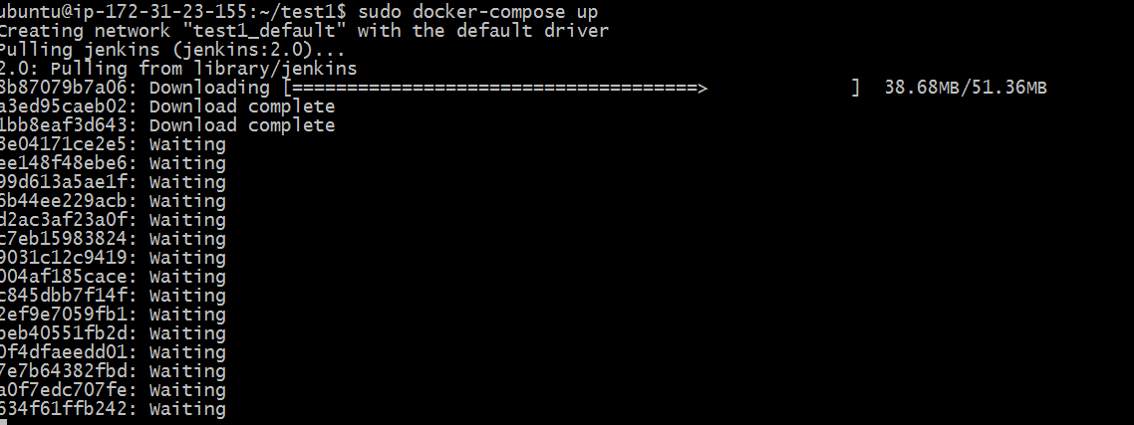

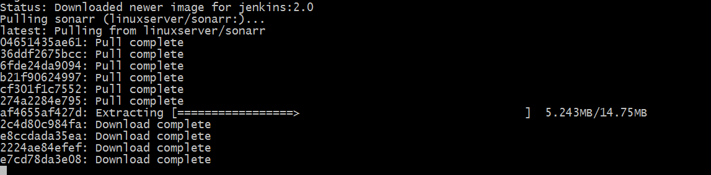

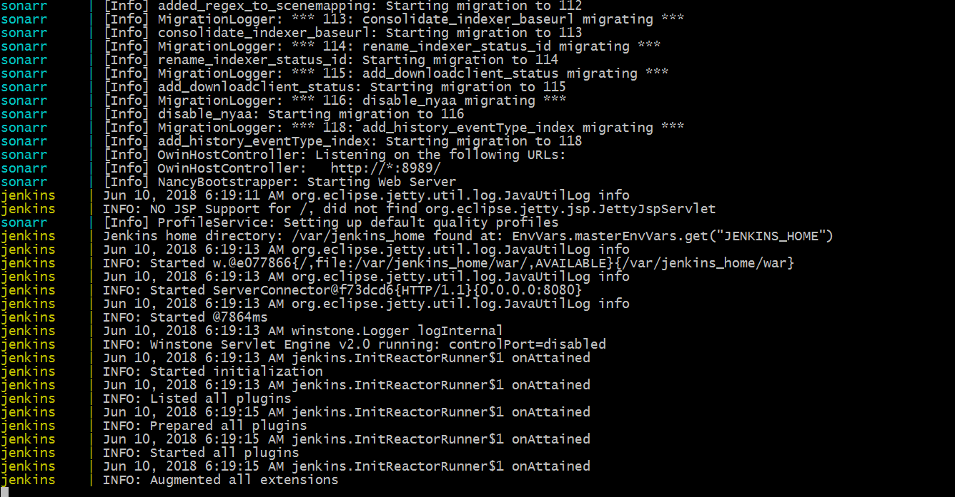

Docker images of Jenkins 2.0 and sonar

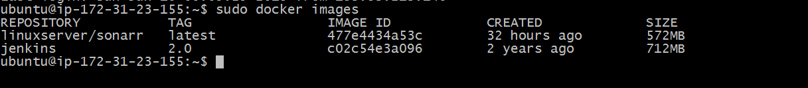

Containers of Jenkins 2.0 and sonar

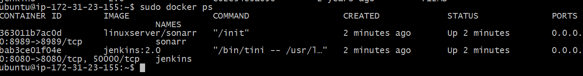

Jenkins 2.0 on port:8080

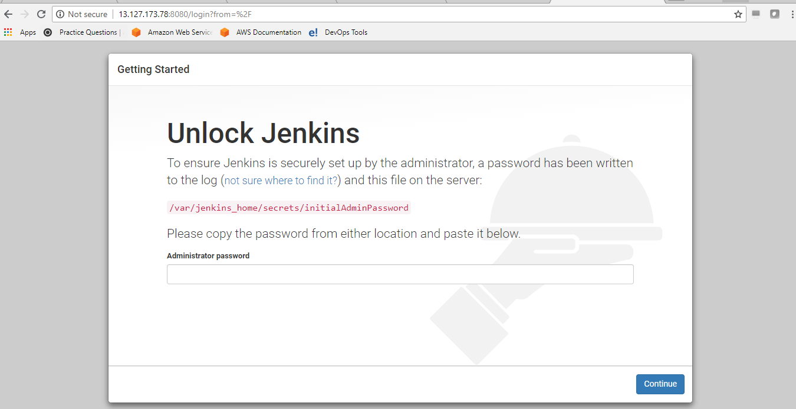

Sonar on port: 8989

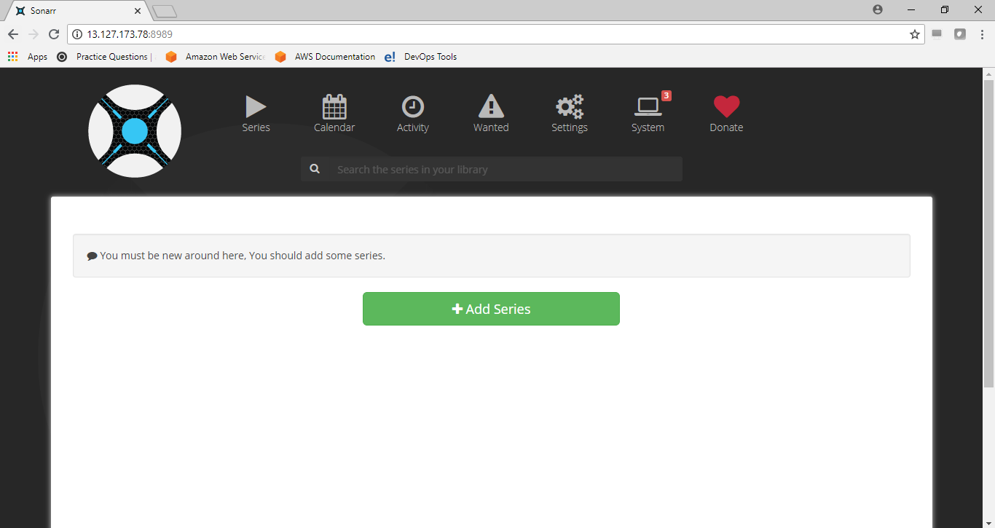

Pushed docker-compose.yml file to git repository

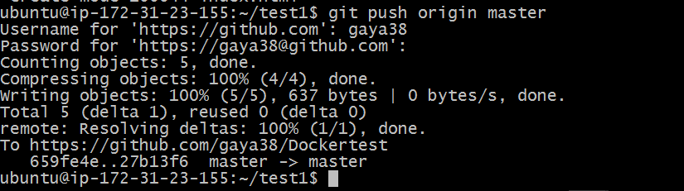

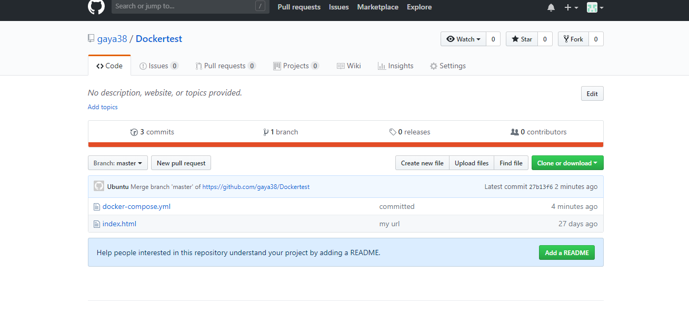

Installed Docker and Docker-compose on second instance

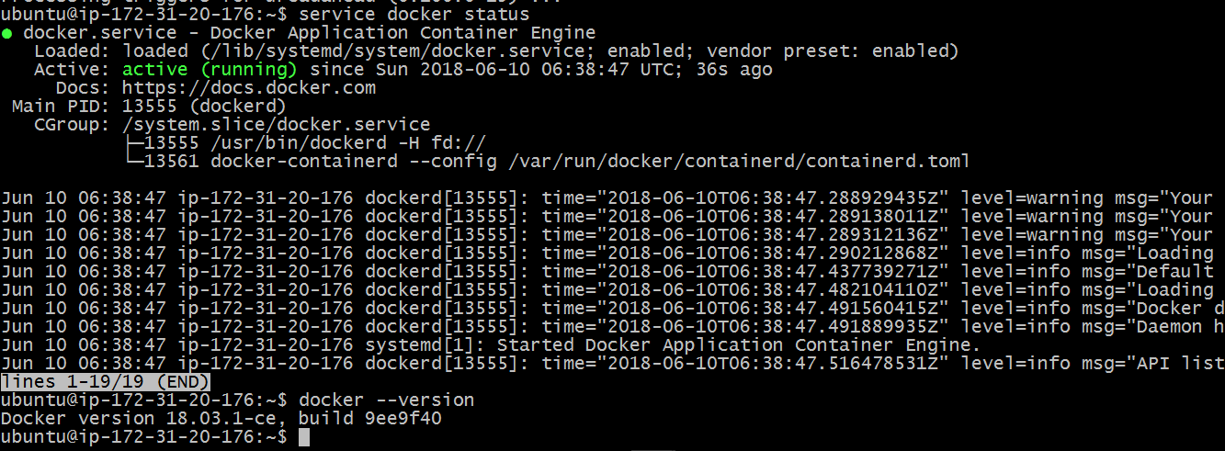

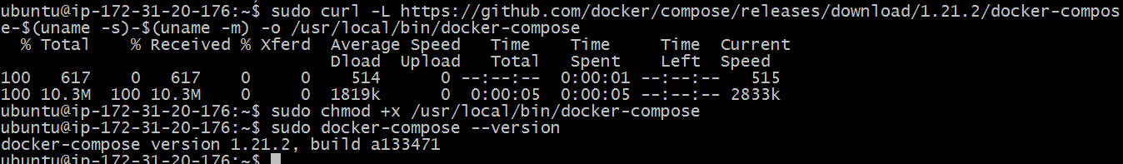

Pulling the Docker compose file from git repository

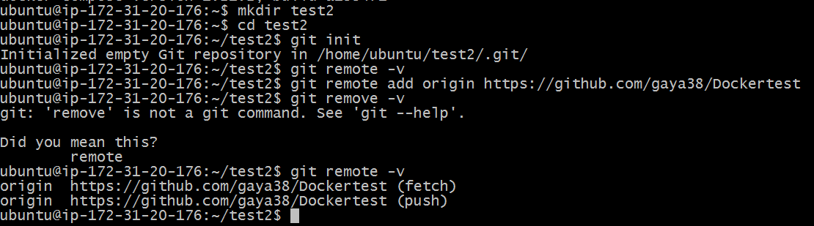

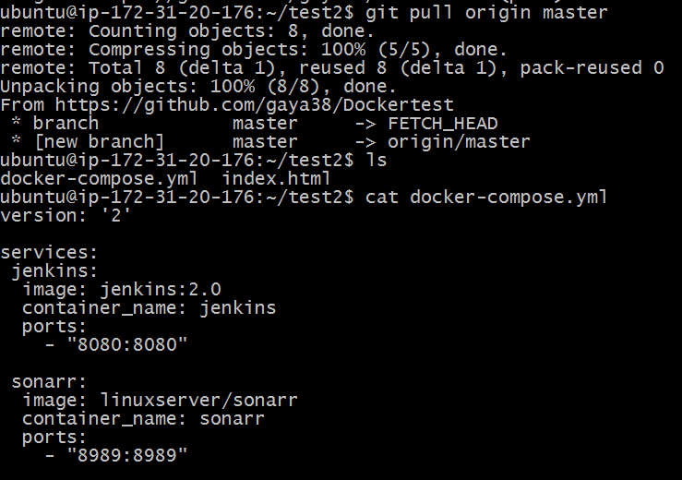

Running the docker-compose.yml

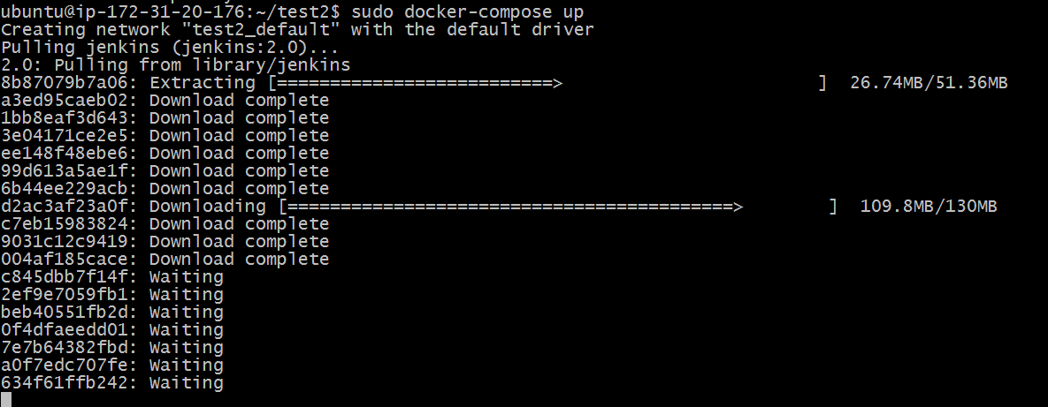

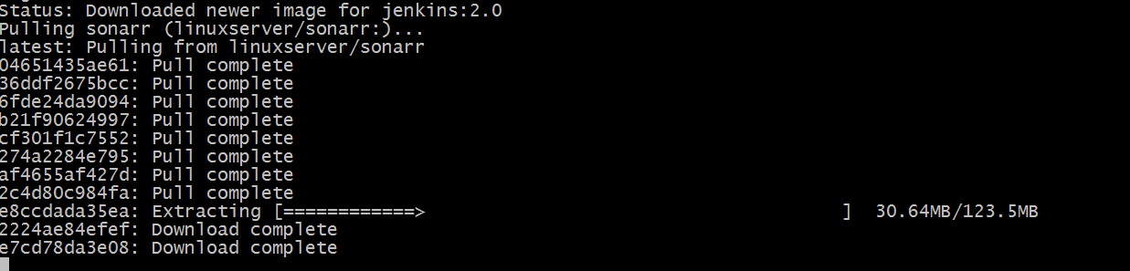

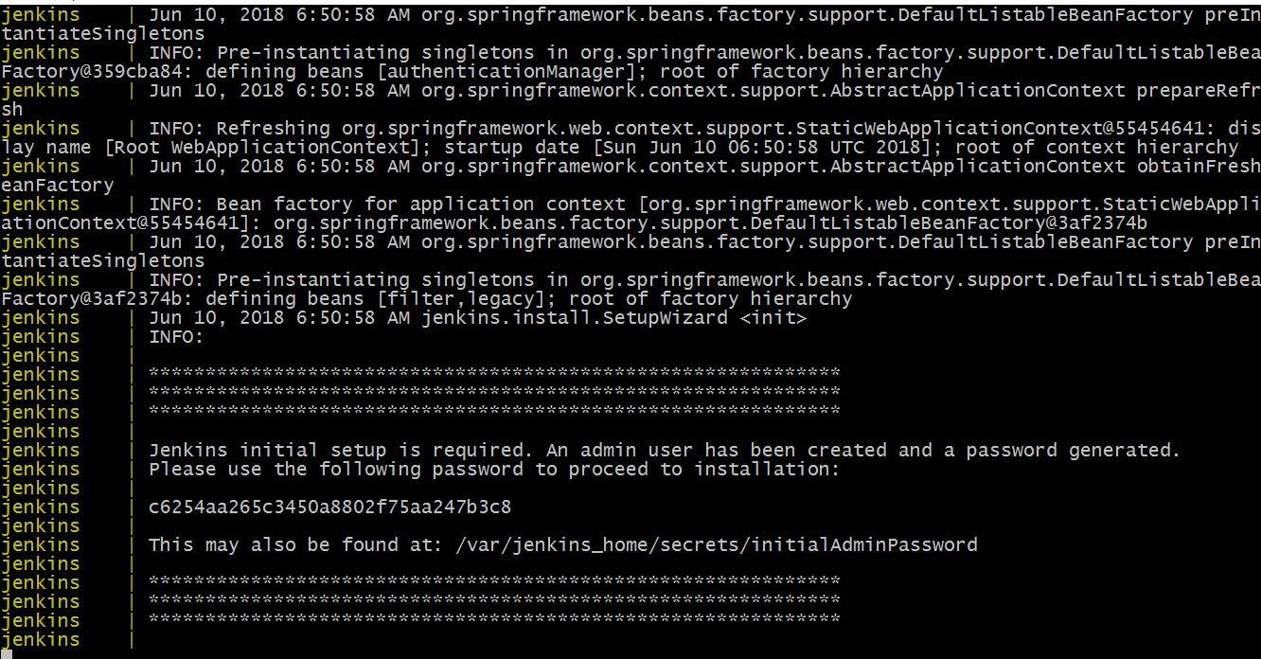

Images

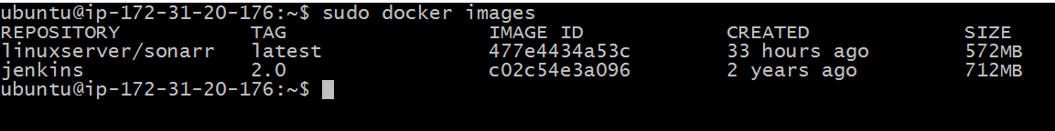

Containers

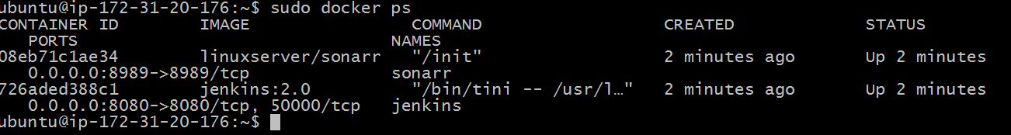

Jenkins 2.0 on port :8080

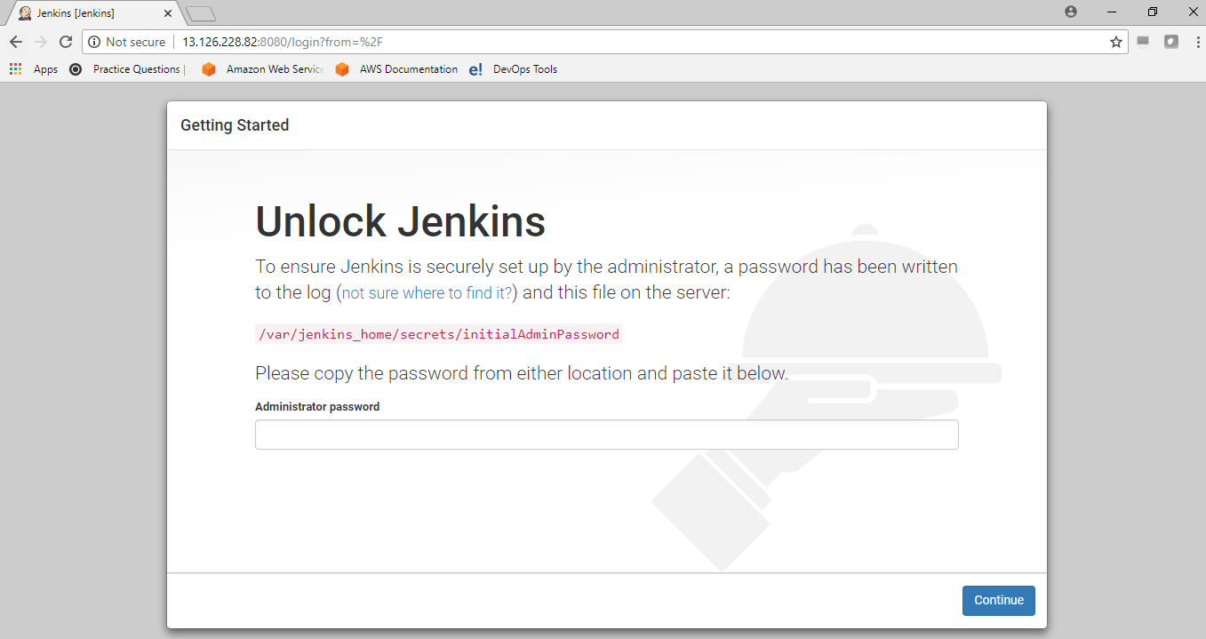

Sonar on port:8989

