PROJECT REPORT TEMPLATE

1 INTODUCTION

* 1. Over view

The project aim is to provide real-time knowledge for all students who have basic knowledge of sales force and looking for a real-time project. This will also help to those professionals who are in cross- technology and wanted to switch to sales force with the help of this project they will gain knowledge and include into their resume as well.

1.2 Purpose

The main role of an even organizer is to plan and organize events in the most efficient way possible. To be successful in this profession, you will need certain skill so you can easily perform your responsibilities.

1. PROBLEM DEFINTION &DESIGN THINKING
   1. Empathy Map
   2. IDEATION & BRAINSTORMING MAP

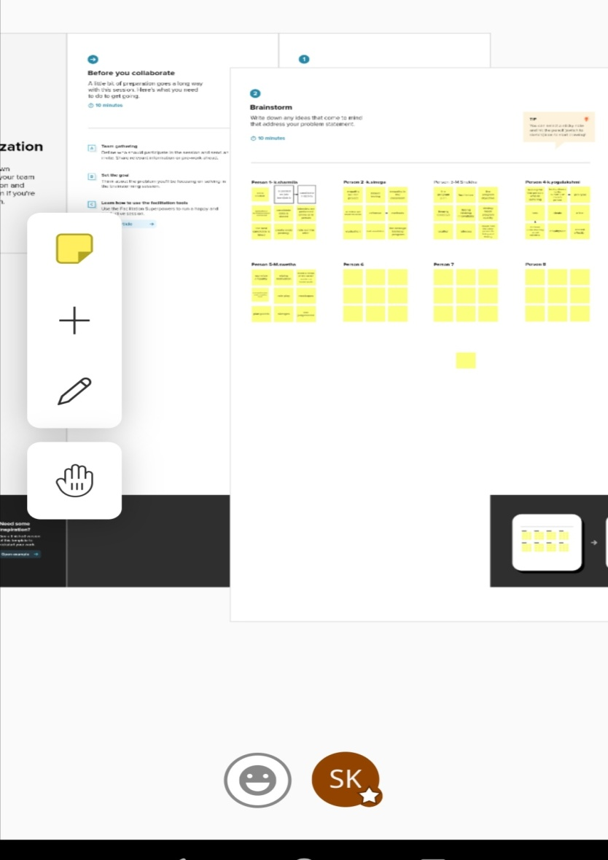

1. RESULT
   1. Data Model:

|  |  |  |
| --- | --- | --- |
| Object Name | Fields in the object | |
| Object-1 | Field label | Data type |
| Event | Phone |
| Events | Phone |
| Object-2 | Field label | Data type |
| Attendee | Mail |
| Attendees | Mail |
| Object-3 | Field label | Data type |
| Speaker | Students |
| Speakers | Students |
| Object-4 | Field label | Data type |
| Vendor | Profile |
| Vendors | Profile |

* 1. ACTIVITY & Screenshot

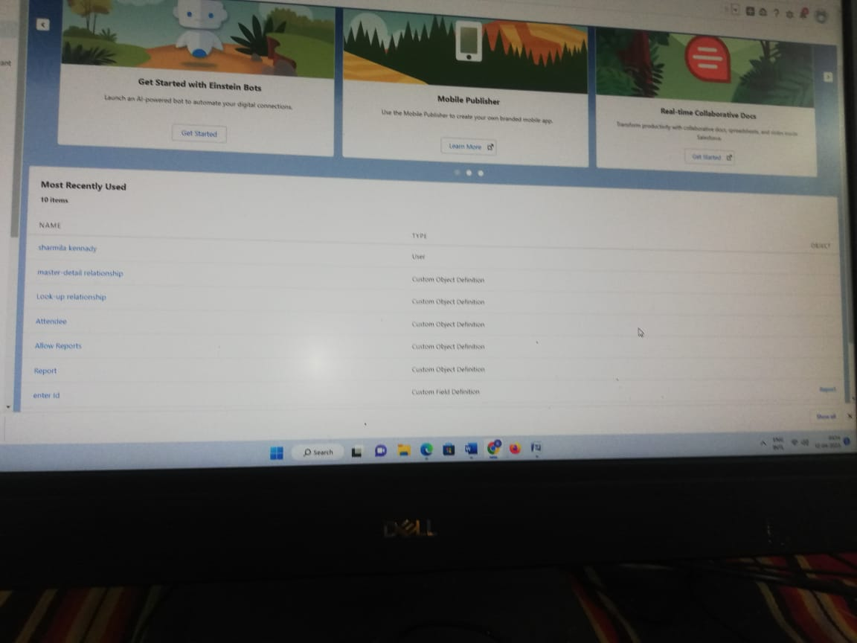

1. Trailhead Profile Public URL

Team Lead- K. SHARMILA trailblazer.me/id/hgahlot3

Team Member 1- M. SINEHA trailblazer.me/id/smurugesan56

Team Member 2- K.SINEGA https://trailblazer.me/id/hgahlot3

Team Member 3- K. YOGALAKSHMI https://trailblazer.me/id/ykasinathan

5 ADVANTAGES

* + - Reduction in the cost of expenses.
    - Improving the quality of service/product.
    - History of work with business.

Disadvantage:

* It may not suit every business.
* Security concerns associated with centralised data.
* Staff over reliance on CRM may diminish customer loyalty through a bad experience.

6 APPLICATIONS

Tracking customers, collecting data for marketing, improving interactions and communications, streamlining internal sales processes.

7 CONCLUSION

Customer relationship management enables a company to align its strategy with the needs of the customer in order to best meet those needs and thus ensure long term customer loyalty.

8 FUTURE SCOPE

Customers will become a company best sales reps through superior products and services as well as customer oriented messing. The future of CRM is more than just the future of customer relationship management software. It is really the future .