NOSQL DATABASE
NoSQL (Not Only SQL) has various non-relational database types, including document, key-value, graph, and wide-column stores.
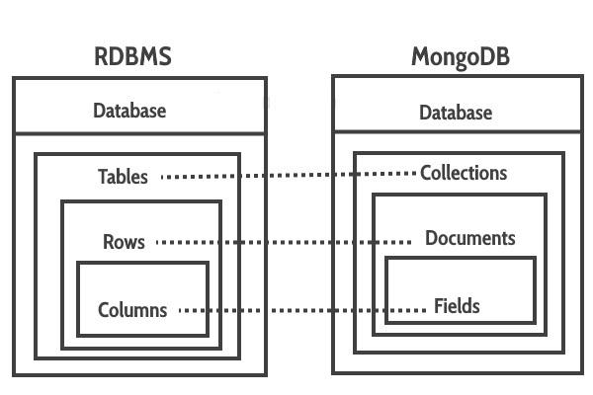
Fig 1. DB comparison (source: website)

Emergence of NoSQL
The many options for a distributed storage system were examined in a Google paper on BigTable, the wide-column database, published in the early 2000s. With the introduction of two important document-oriented databases, MongoDB and CouchDB in 2009, NoSQL was starting to get popular.

By the 2010s, businesses were becoming increasingly data-driven, and various NoSQL database types had evolved.

Software engineers were also reconsidering how they built software, and the Agile Manifesto was gaining traction. They had to fast iterate, make adjustments throughout their software stack, all the way down to the database. This flexibility was made possible by NoSQL databases.
(source: mongodb docs)

We are discussing mongodb in today’s class. Mongodb is a document type NoSQL.

MONGODB ADVANTAGES

1. Flexible Schema Design
One of the most important advantages of MongoDB is its schema-less nature. Unlike relational databases, MongoDB does not require a predefined structure for storing data. Each document in a collection can have a different structure, allowing developers to modify the schema as needed. This flexibility is especially useful in applications where requirements change frequently, as it eliminates the need for complex migrations.


Fig 2. Database scheme sample (source: mongodb docs)

2. High Scalability
MongoDB is designed to scale horizontally using a technique called sharding. In this approach, data is distributed across multiple servers, which allows the system to handle large datasets and high traffic efficiently. This makes MongoDB highly suitable for big data applications and systems that require continuous growth without performance degradation.

3. High Performance
MongoDB offers high performance for both read and write operations. It uses indexing to speed up queries and stores frequently accessed data in memory, which improves response time. Additionally, its document-based structure reduces the need for complex joins, resulting in faster data retrieval compared to traditional relational databases.

4. Document-Oriented Storage
MongoDB stores data in BSON (Binary JSON) format, which is similar to JSON. This format allows developers to store complex data structures, including arrays and nested objects, within a single document. It closely matches the way data is represented in programming languages, making it easier to develop and maintain applications.

5. Ease of Use and Developer Productivity
MongoDB provides a simple and intuitive query language that is easy to learn and use. Developers can perform basic operations such as create, read, update, and delete (CRUD) without writing complex queries. This reduces development time and improves productivity, especially for beginners.

6. High Availability and Reliability
MongoDB ensures high availability through replication. It uses replica sets, where multiple copies of data are maintained across different servers. In case of a server failure, MongoDB automatically switches to another server without interrupting the application. This ensures data reliability and continuous system operation.

7. Support for Unstructured and Semi-Structured Data
MongoDB is capable of handling different types of data, including structured, semi-structured, and unstructured data. This makes it ideal for modern applications such as social media platforms, content management systems, and Internet of Things (IoT) applications, where data formats are diverse and constantly evolving.

8. Powerful Querying and Indexing
MongoDB provides powerful query capabilities, allowing users to filter, sort, and aggregate data efficiently. It supports secondary indexes, text search, and geospatial queries. These features help improve the speed and accuracy of data retrieval, making it suitable for analytical and real-time applications.

9. Cost-Effective Solution
MongoDB is available as an open-source database, which reduces licensing costs. Organizations can use the community edition for free, making it an economical choice for startups and educational purposes. Its ability to scale horizontally using commodity hardware also reduces infrastructure costs.

10. Strong Ecosystem and Community Support

MongoDB has a large and active community along with extensive documentation and official support. It also provides tools such as MongoDB Atlas (cloud service), Compass (GUI), and integration libraries, which make development, deployment, and management easier.

11. Aggregation Framework
MongoDB includes a powerful aggregation framework that allows developers to perform complex data processing and analysis directly within the database. This reduces the need for external tools and improves overall efficiency.

12. GridFS for File Storage
MongoDB provides a feature called GridFS, which allows storage and retrieval of large files such as images, videos, and documents. This makes it suitable for applications that require handling of multimedia data.

REAL-TIME USECASES

1. E-Commerce Platforms (eBay)
eBay operates at a massive scale, handling millions of product listings and user interactions every day. MongoDB has been used in parts of its platform to manage large and dynamic datasets efficiently.
- Stores product catalogs where each item may have different attributes such as price, category, seller details, and specifications
- Handles high read and write traffic generated by users browsing, searching, and purchasing products
- Supports personalization features such as recommendations and user-specific listings
- Enables rapid updates to product information without requiring schema changes
Its flexible schema and horizontal scalability allow efficient handling of diverse and high-volume e-commerce data.
(Source: MongoDB case studies and developer discussions (mongodb.com/customers))

2. Ride-Sharing Applications (Uber)
Ride-sharing platforms require real-time data processing and location tracking. MongoDB has been used in certain backend services. Its support for geospatial queries and high write throughput makes it effective for real-time, location-based systems.
- Manages real-time location data of drivers and riders
- Handles high-frequency updates and queries during ride matching
- Supports geospatial indexing for route optimization and tracking
- Stores trip history and operational data

3.Beauty and Cosmetics Industry (L'Oréal)
L’Oréal operates globally with large-scale digital applications that require high performance and scalability. MongoDB is used to manage complex and rapidly evolving data across its platforms.
- Handles large volumes of product, customer, and application data efficiently
- Supports AI-driven features such as virtual try-on and personalized recommendations
- Enables real-time data processing for enhanced customer experience
- Allows flexible data modeling for diverse product information and formulations
- Improves developer productivity by simplifying application development
Its flexible schema, high performance, and scalability enable L’Oréal to build modern, data-intensive applications and accelerate digital innovation.
Source: MongoDB Customer Case Study – L’Oréal (mongodb.com/solutions/customer-case-studies/loreal)

4. Digital Experience Management (Adobe)
Adobe uses MongoDB as part of its Adobe Experience Manager (AEM) platform to manage large-scale digital content and customer experiences.
- Stores and manages massive volumes of digital assets such as images, videos, and web content
- Supports high read and write operations required for delivering content across web, mobile, and other channels
- Enables scalable content repositories that can grow to petabytes of data
- Supports real-time content delivery and personalization for global users
- Provides high availability and distributed architecture for mission-critical applications
Its horizontal scalability and ability to handle large, complex datasets allow Adobe to efficiently manage and deliver digital experiences at scale.
Source: MongoDB–Adobe case study and Adobe Experience Manager documentation (mongodb.com / Adobe Experience Manager docs)

5. Device Management Platforms (Applivery)
Applivery uses MongoDB to manage large amounts of device and application data.
- Handles data from many devices like mobile phones and computers
- Supports changing data structures due to different devices and updates
- Enables real-time monitoring and management of devices
- Scales easily as the number of devices increases
Its flexible schema and scalability help Applivery efficiently manage large and constantly changing data.
Source: MongoDB Customer Case Study – Applivery (mongodb.com/solutions/customer-case-studies/applivery)

Therefore ,MongoDB is a powerful and flexible database solution that is widely used in modern applications across various industries. Its schema-less design, high scalability, and strong performance make it suitable for handling large volumes of dynamic and unstructured data. MongoDB provides a reliable, scalable, and efficient platform for building data-driven applications, making it a preferred choice in today’s tech landscape.

