**Summary of Data Fields**

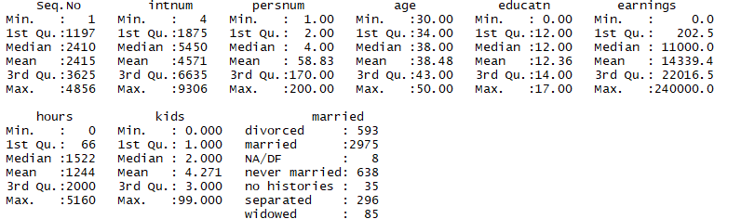

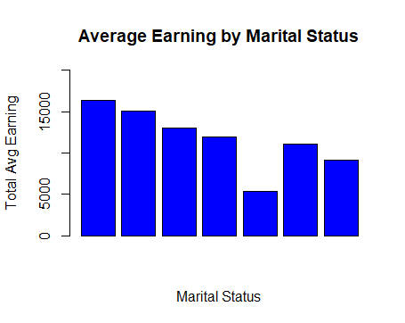

**Marital Status earnings**

1 divorced 16404.963

2 married 15040.008

3 NA/DF 13025.000

4 never married 11893.643

5 no histories 5337.343

6 separated 11026.493

7 widowed 9132.341

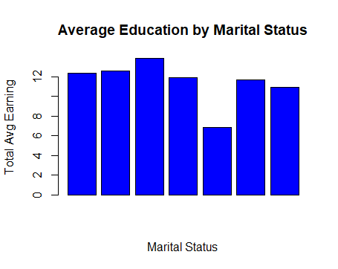

married education

1 divorced 12.355818

2 married 12.631933

3 NA/DF 13.875000

4 never married 11.901254

5 no histories 6.857143

6 separated 11.712838

7 widowed 10.905882

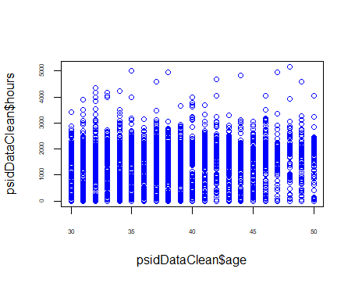

Above figure shows how working hours varies with age

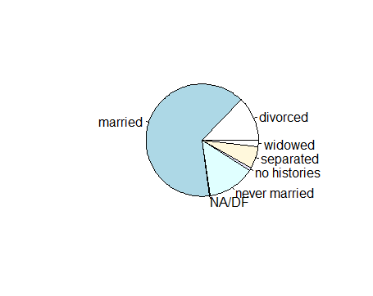

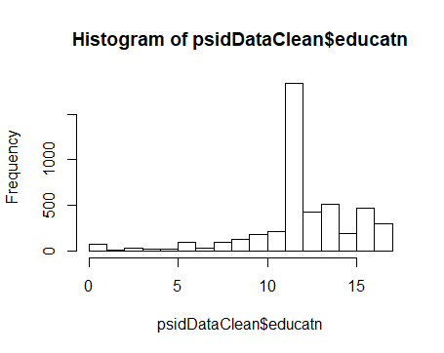

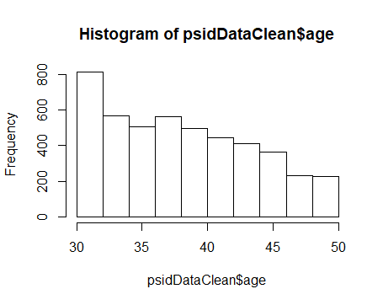

**Age vs Education / Education vs Earnings**

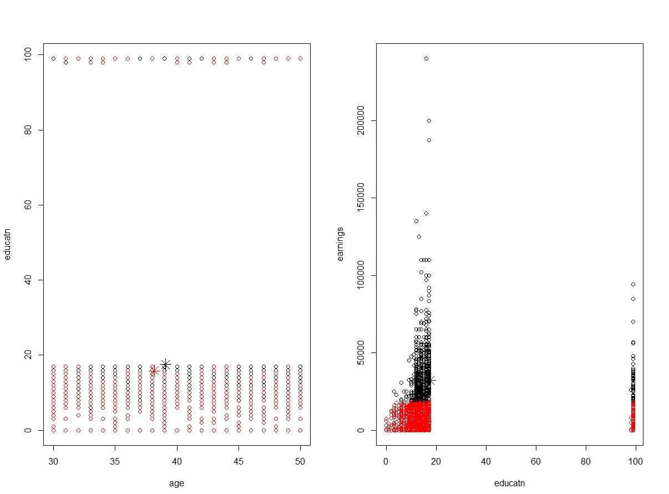

**Age vs Education vs Earnings vs Working hours vs No of kids**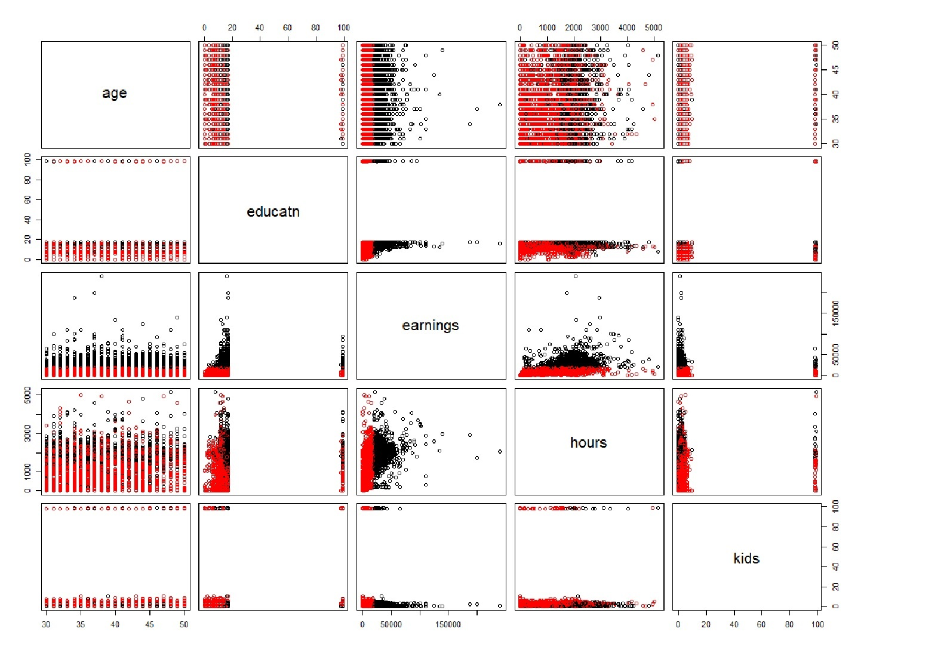

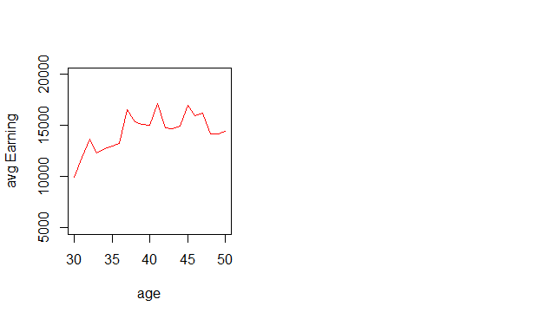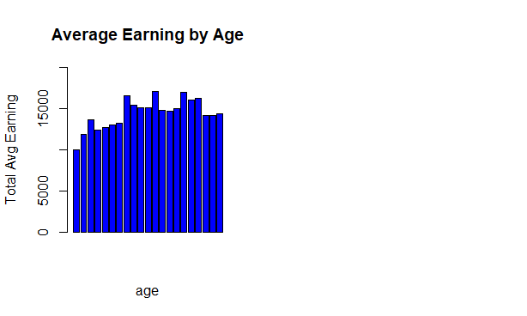

Using the given data set, first we analysed if there are null or missing values and removed them.

Then, we tried to check if there is any relationship between the age of a person and the total earnings.

But as shown in the above chart there is no significant pattern identified in the change of earnings of people by age. Difference in Education level is the reason for this behavior.