IT3051 – Fundamentals of Data Mining · Group Mini-Project 2026
DataCo Late Delivery Predictor
Dataset Proposal and Validation Evidence
Why the dataset was chosen and proof that it is fit for purpose
Required deliverable
Dataset proposal/validation evidence.

Part A – Dataset Proposal

A1. Scenario and problem
DataCo Global, a multinational retailer, ships orders to five markets using four shipping modes. More than half of order items arrive after their scheduled date. The proposal is to predict at checkout how many days an order will take to ship and whether it will be late, so that customers get realistic expectations and operations can act early.

A2. Proposed dataset
DataCo Smart Supply Chain for Big Data Analysis (Constante, Silva and Pereira, 2019), Mendeley Data, doi: 10.17632/8gx2fvg2k6.1 – 180,519 order items × 53 columns, 2015–2018.

A3. Proposed data-mining tasks
 | Primary | Secondary
Task type | Regression | Binary classification
Target | Days for shipping (real) (0–6) | Late_delivery_risk (0/1)
Main metric | MAE | ROC-AUC
Use | Estimated days → late if > scheduled days | Probability of late delivery

A4. Suitability criteria
Criterion | Assessment
Relevance to scenario | Contains real and scheduled shipping days, shipping mode and destination – directly relevant
Size | 172,765 clean rows, 62,897 orders – sufficient for CV and a hidden test set
Features available at prediction time | Shipping mode, market, country, category, quantity, segment, order timestamp
Quality | No missing values after removing 2 empty columns; business rules hold 100 %
Ethics / privacy | Customer names, street and zip codes present → removed before modelling; email/password already masked
Licence / citation | CC BY 4.0, DOI available

Part B – Validation Evidence
All checks were performed in 01_data_prep_m1.ipynb / c01_data_prep_m1.ipynb; EDA in 02_eda_features_m2.ipynb / c02_eda_features_m2.ipynb (training set only). These notebooks are included in this folder.

B1. Data quality checks
Table 1: Data quality validation
Check | Result | Action
Character encoding | UTF-8 corrupts Spanish names (Japón → JapÛn) | Read as Latin-1
Missing values | Product Description 100 %, Order Zipcode 86.2 % | Columns dropped
Masked / constant | Email & Password all ‘XXXXXXXXX’; Product Status constant | Dropped
Duplicate columns | 7 exact pairs found by pairwise comparison | One of each dropped
Business rules | Sales = Price × Qty; Sales per customer = Sales − Discount; 0 ≤ Discount Rate ≤ 1 | Hold for 100 % of rows
Order structure | All items of an order share real days and shipping mode (0 exceptions) | Split grouped by Order Id
Outliers | Benefit per order: 10.4 % IQR outliers, 18.7 % negative | Kept – genuine losses, consistent with other columns
Temporal drift | Monthly mean days 3.40–3.63 over 37 months | No drift
Final | 172,765 rows × 28 cols, 0 missing, 0 duplicate rows | Clean

B2. Leakage validation
Table 2: Leakage proof
Column | Evidence | Decision
Late_delivery_risk | = (real days > scheduled days) for 97.5 % of rows | Removed (regression); target (classification)
Delivery Status | Each value falls in exactly one real-vs-scheduled bucket | Removed
shipping date (DateOrders) | Shipping − order date = real days for 97.4 % of rows | Removed
Order Status | Describes how the order ended (COMPLETE, CLOSED …) | Used to filter, then removed
Days for shipment (scheduled) | One value per shipping mode | Redundant – removed

B3. Row filtering and split
CANCELED and SUSPECTED_FRAUD orders were never shipped and were removed per order (7,754 rows, 2,855 orders). The clean data was split with StratifiedGroupKFold(5, shuffle=True, random_state=42), grouped by Order Id and stratified on the target.
Table 3: Regression split
Set | Rows | Orders | Mean days | Std
Train | 138,098 | 50,318 | 3.500 | 1.626
Test | 34,667 | 12,579 | 3.494 | 1.614
Overlap | – | 0 | – | –

B4. Columns removed
25 columns were removed with a recorded reason – see drop_log_m1_reg.csv and drop_log_clf.csv in this folder: 5 leakage/redundant, 2 masked, 4 PII, 2 mostly missing, 2 constant/URL, 6 exact duplicates, 2 code↔name duplicates, 2 identifiers.

B5. Key EDA evidence
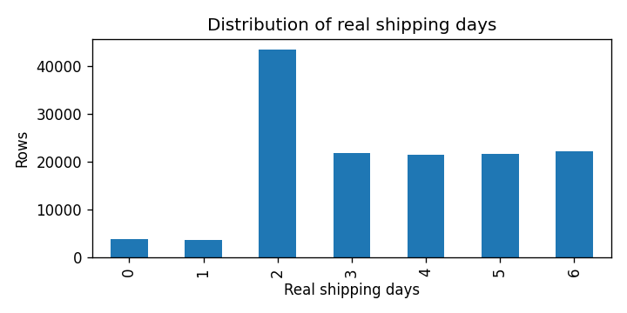
Figure 1: Distribution of real shipping days (training set)
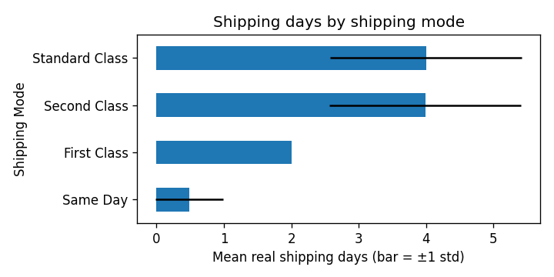
Figure 2: Shipping mode explains 38.9 % of variation (η² = 0.389)
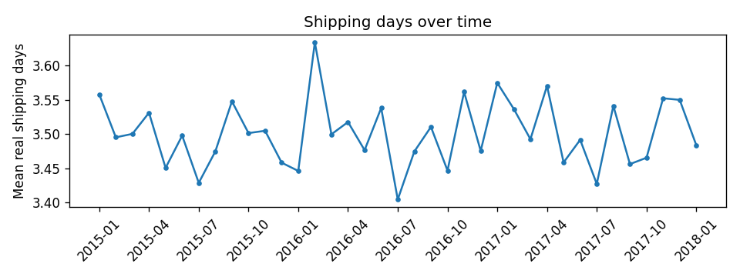
Figure 3: Monthly mean shipping days – no drift over 2015–2018
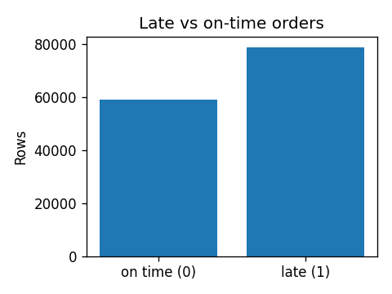
Figure 4: Class balance of Late_delivery_risk (training set)

B6. Files in this folder
File | Purpose
01_data_prep_m1.ipynb, c01_data_prep_m1.ipynb | Loading, validation, leakage proof, cleaning, split, baselines
02_eda_features_m2.ipynb, c02_eda_features_m2.ipynb | Exploratory data analysis and date features
drop_log_m1_reg.csv, drop_log_clf.csv | Every dropped column with its reason
split_meta_reg.json, split_meta_clf.json | Split method, seed, excluded rows
figures/eda_regression/, figures/eda_classification/ | All EDA charts

