IT3051 – Fundamentals of Data Mining · Group Mini-Project 2026
DataCo Late Delivery Predictor
Trained Final Model – Model Card
Description, performance and usage of the saved final models
Required deliverable
Trained final model.

1. Files
File | Description
final_pipeline.pkl | Final regression model – full scikit-learn pipeline (encoding + DecisionTreeRegressor)
model_info.json | Features, input fields, date-feature recipe, allowed values, CV and test scores, library versions
clf_final_pipeline.pkl | Final classification model – full pipeline (encoding + DecisionTreeClassifier)
clf_model_info.json | Same metadata for the classifier, plus decision threshold 0.65

2. Final regression model (primary)
Model summary
Algorithm: DecisionTreeRegressor(max_depth=3, min_samples_leaf=50, min_samples_split=2, random_state=42)
Target: Days for shipping (real) (0–6 days)
Trained on: 138,098 order items (50,318 orders)
Test result: MAE 0.937 days, RMSE 1.248, R² 0.402, bias +0.005 days

Metric | Cross-validation (5 grouped folds) | Hidden test set | Shipping-mode baseline (test)
MAE (days) | 0.9617 ± 0.0103 | 0.9366 | 0.9633
RMSE (days) | 1.2666 | 1.2482 | 1.2531
R² | 0.3930 | 0.4017 | 0.3970
Median AE | 0.9897 | 0.9998 | 0.9972
Within ±1 day | 52.2 % | 53.6 % | 53.6 %
Bias | −0.0000 | +0.0047 | +0.0066

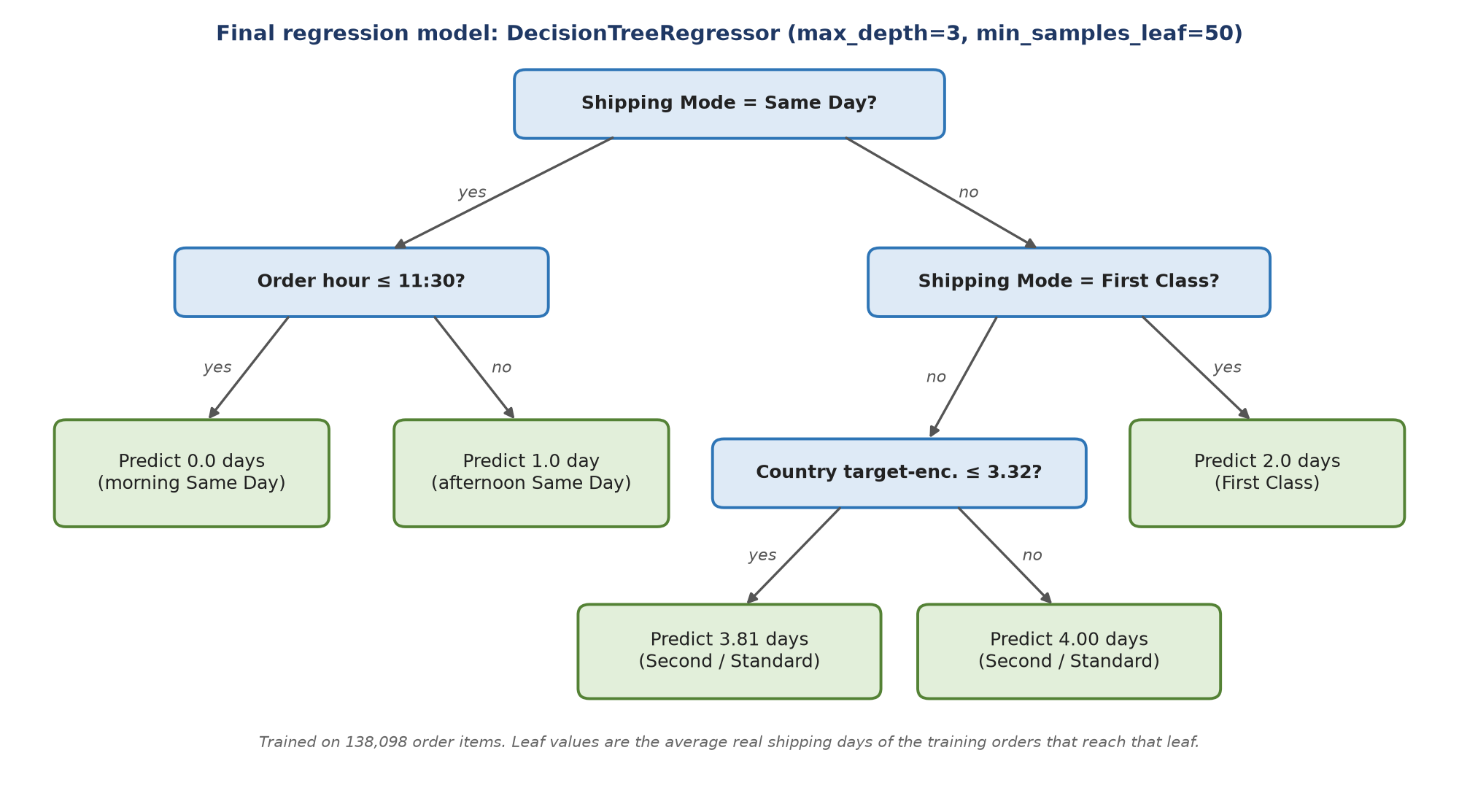
Figure 1: Complete structure of the final regression model

3. Final classification model (secondary)
Item | Value
Algorithm | DecisionTreeClassifier(max_depth=5, min_samples_leaf=20, min_samples_split=10, class_weight='balanced')
Target | Late_delivery_risk (1 = late)
Decision threshold | 0.65 (max Youden's J on out-of-fold training predictions)
CV ROC-AUC | 0.7761 ± 0.0033
Test | ROC-AUC 0.773 · accuracy 0.724 · precision 0.894 · recall 0.592 · F1 0.712

4. Inputs
Input field | Type / allowed values | Model feature(s)
Shipping Mode | Same Day, First Class, Second Class, Standard Class | One-hot (4)
Market | Africa, Europe, LATAM, Pacific Asia, USCA | One-hot (5)
Order Country | 161 countries (Spanish names, e.g. ‘Estados Unidos’) | Target-encoded (1)
Category Name | 50 product categories | Target-encoded (1)
Order Item Quantity | Integer 1–5 | Numeric (1)
Customer Segment | Consumer, Corporate, Home Office | One-hot (3)
order date (DateOrders) | Timestamp | weekday, month, hour, quarter, is_weekend (5)

5. How to load and use
import joblib, pandas as pd
model = joblib.load("final_pipeline.pkl")
X = pd.DataFrame([{"Shipping Mode": "Standard Class", "Market": "LATAM", "Order Country": "México", "Category Name": "Cleats", "Order Item Quantity": 2, "Customer Segment": "Consumer", "order_weekday": 0, "order_month": 10, "order_hour": 9, "order_quarter": 4, "is_weekend": 0}])
days = model.predict(X)[0] # → 4.0
Requires scikit-learn 1.7.2 and pandas 2.3.3 (versions used for training).

6. Intended use and limitations
- Intended for estimating shipping time and late risk at checkout for DataCo-style orders.
- Same Day and First Class are predicted exactly; Second/Standard Class have ≈ 1.2-day error because the data holds no order-time signal for their 2–6-day spread.
- Trained on 2015–2018 data; should be monitored and retrained before real-world use.
- Quantities above 5 and unseen countries are outside the training range (unseen countries fall back to the overall average).

