IT3051 – Fundamentals of Data Mining · Group Mini-Project 2026
DataCo Late Delivery Predictor
Integrated System – Source Code Guide
Structure, architecture and run instructions for the final system
Required deliverable
Source codes of the final integrated system.

1. Folder structure
Path | Contents
backend/app.py | FastAPI inference service (loads both models, 4 endpoints)
models/ | Final pipelines and model-info JSON loaded by the backend
frontend-web/ | React 18 + Vite + Tailwind web application (final UI)
frontend-web/src/components/ | Header, OrderForm, ResultPanel, ModeComparison, ModelInfo
frontend-web/src/api.js | API client (/predict, /classify, /predict/combined, /health)
frontend-streamlit-prototype/ | Early Streamlit prototype (superseded by the React UI)
tests/test_no_leakage.py | Anti-leakage test suite
Makefile, requirements.txt, conftest.py | Setup and run commands, Python dependencies, test config

2. Architecture
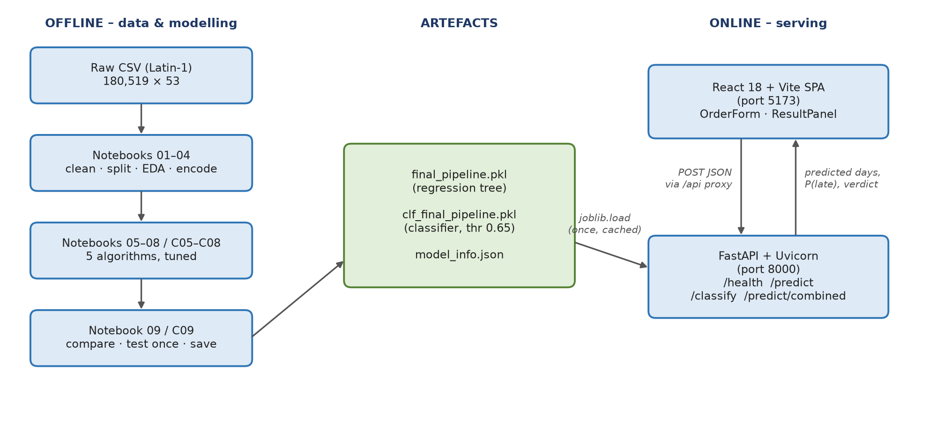
Figure 1: System architecture – offline modelling, saved artefacts, online serving

3. Backend API
Endpoint | Purpose | Response
GET /health | Liveness check | {"status": "ok"}
POST /predict | Regression | predicted_days, scheduled_days, is_late, late_by, shipping_mode
POST /classify | Classification | is_late, probability, threshold, shipping_mode
POST /predict/combined | Both models in one call | {regression, classification}

Request body: shipping_mode, market, order_country, category_name, quantity (1–10), customer_segment, order_date (YYYY-MM-DD). Inputs are validated with Pydantic; errors return HTTP 422 / 503 / 500 with a message.

4. Frontend
Single-page React application. The Vite dev server proxies /api/* to the backend on port 8000. The user fills in the order form and receives the predicted days vs scheduled days, a late-risk gauge, a comparison across shipping modes and the model metrics.

5. How to run
Step | Command (run inside this folder)
1. Python environment | python3.11 -m venv .venv && .venv/bin/pip install -r requirements.txt
2. Start backend (port 8000) | .venv/bin/uvicorn backend.app:app --reload --port 8000 (or make api)
3. Install frontend | cd frontend-web && npm install
4. Start frontend (port 5173) | npm run dev, then open http://localhost:5173
Check API | Open http://localhost:8000/docs for interactive API documentation

6. Example request
POST /predict/combined
{"shipping_mode": "Second Class", "market": "LATAM", "order_country": "México", "category_name": "Cleats", "quantity": 2, "customer_segment": "Consumer", "order_date": "2026-10-05"}
→ regression: predicted_days 4.0, scheduled_days 2, is_late true, late_by 2.0
→ classification: probability 0.7499, threshold 0.65, is_late true

7. Technology stack
Layer | Technology
Modelling | Python 3.11, pandas, scikit-learn, XGBoost, joblib
Backend | FastAPI, Pydantic, Uvicorn
Frontend | React 18, Vite, Tailwind CSS, Framer Motion

