IT3051 – Fundamentals of Data Mining
Group Mini-Project 2026 · Stage 11 Technical Report
DataCo Late Delivery Predictor
Predicting shipping time and late-delivery risk at the moment an order is placed
At a glance
Dataset: DataCo Smart Supply Chain (Mendeley Data, 180,519 order items × 53 columns)
Primary task – regression: predict Days for shipping (real); final model Decision Tree, test MAE 0.937 days, R² 0.402
Secondary task – classification: predict Late_delivery_risk; final model Decision Tree, test ROC-AUC 0.773
System: scikit-learn pipelines → FastAPI inference service → React (Vite) web application

Member | Role | Name / Student ID
M1 | Data preparation, leakage control, split, Ridge / Logistic Regression | [Name – IT number]
M2 | EDA, feature engineering, Random Forest | [Name – IT number]
M3 | Encoding, feature selection, XGBoost, model comparison, frontend | Primesh Marasingha – [IT number]
M4 | Scaling & validation, Decision Tree, KNN, backend | [Name – IT number]

Submission date: [dd/mm/2026] · Group ID: [ ]

Table of Contents
Executive Summary 4
1. Introduction and Problem Definition 4
1.1 Background 4
1.2 Problem statement 4
1.3 Data-mining task formulation 5
1.4 Objectives 5
2. Assigned Scenario and Stakeholder Requirements 5
2.1 Scenario 5
2.2 Stakeholders 6
2.3 Requirements 6
3. Dataset Identification, Source, Citation and Validation 7
3.1 Identification and source 7
3.2 Citation 7
3.3 Why this dataset fits the scenario 7
3.4 Validation of the data 7
4. Data Understanding and Exploratory Data Analysis 8
4.1 The regression target 8
4.2 Shipping mode dominates 8
4.3 Other categorical and numeric factors 9
4.4 Outliers and data quality 9
4.5 Time patterns 9
4.6 Classification view 10
5. Data Cleaning and Preprocessing 10
5.1 Leakage control 10
5.2 Row filtering 10
5.3 Column removal 10
5.4 Train/test split 11
5.5 Scaling 11
6. Feature Engineering and Feature Selection 12
6.1 Engineered date features 12
6.2 Final feature list 12
6.3 Encoding strategy 12
6.4 Feature selection 13
7. Algorithms Implemented and Their Rationale 13
8. Model Evaluation and Comparison 13
8.1 Evaluation protocol 13
8.2 Regression results (primary task) 14
8.3 Classification results (secondary task) 15
9. Hyperparameter Tuning and Optimisation 15
10. Final Model Selection and Justification 16
10.1 Selection rule 16
10.2 What the regression model learned 16
10.3 Final test-set results 18
10.4 Derived late-delivery verdict 18
10.5 Why a single tree rather than an ensemble 19
10.6 Final classification model 19
11. System Architecture and Implementation 19
11.1 Offline layer 20
11.2 Model artefacts 20
11.3 Technology stack 20
12. Backend and Frontend Development 20
12.1 Back end (FastAPI) 20
12.2 Front end (React + Vite) 21
13. System Testing and Results 21
13.1 Data and model tests 22
13.2 API functional tests 22
13.3 Validation, robustness and performance tests 22
13.4 Known issues found during testing 22
14. Limitations and Possible Future Improvements 23
14.1 Limitations 23
14.2 Future improvements 23
15. Conclusion 23
References 24
Appendix A – Project Repository Map 24
Appendix B – How to Run 25

Executive Summary
Late deliveries are the single most visible failure in an e-commerce supply chain. In the DataCo dataset, 54.8 % of order items arrive later than their scheduled shipping window. This project builds a decision-support system that, using only information available when the customer places the order, estimates how many days the order will take to ship and how likely it is to be late.
The team treated the problem as two linked supervised-learning tasks. The primary task is regression on the real number of shipping days (0–6); the predicted days are compared with the scheduled days for the chosen shipping mode to give a late/on-time verdict. A secondary classification model predicts Late_delivery_risk directly and returns a calibrated probability. Five algorithms (a linear model, Decision Tree, Random Forest, XGBoost and KNN) were trained for each task on an identical, leakage-free, order-grouped cross-validation scheme and tuned with randomised search.
A tuned, depth-3 Decision Tree Regressor was selected as the final regression model. It had the lowest cross-validated MAE (0.962 ± 0.010 days), was statistically tied with Random Forest and XGBoost, and won the tie on simplicity. On the untouched test set (34,667 items, 12,579 orders) it achieved MAE 0.937 days, RMSE 1.248, R² 0.402, with near-zero bias, and predicts Same Day and First Class orders exactly. Both models are served through a FastAPI back end and a React web front end.
The main finding is also the main limitation: shipping mode explains about 39 % of the variation in shipping time, and the remaining variation within Second and Standard Class (2–6 days, roughly uniform) is not explained by any order-time feature in the dataset. The model is therefore honest about what it can know, and the report closes with concrete ways to close that gap.

1. Introduction and Problem Definition

1.1 Background
Online retailers promise a delivery window at checkout. When that promise is broken, the cost is not only a refund or a complaint ticket but also lost repeat business. Most retailers only find out an order is late after it is late. If the risk could be estimated at the moment of purchase, the business could act early: set a realistic expectation, suggest a faster shipping mode, or prioritise the order in the warehouse.

1.2 Problem statement
Given the details an e-commerce customer enters at checkout (shipping mode, destination, product category, quantity, customer segment and order time), predict (a) how many days the order will take to ship and (b) whether it will miss its scheduled delivery window.

1.3 Data-mining task formulation
Table 1: How the problem was framed as two supervised-learning tasks
Aspect | Primary task (regression) | Secondary task (classification)
Target | Days for shipping (real) – integer 0–6 | Late_delivery_risk – 1 = late, 0 = on time
Output to user | Estimated days + derived late verdict | Probability of being late + verdict at threshold 0.65
Main metric | MAE (average days wrong) | ROC-AUC (ranking quality)
Supporting metrics | RMSE, R², Median AE, % within 1 day, bias | Accuracy, precision, recall, F1
Business priority | Small, unbiased errors in days | Catch late orders (recall) without many false alarms

Regression was chosen as the primary task (with the lecturer's approval) because it gives richer information than a yes/no label: a predicted number of days can always be turned into a late flag (predicted days > scheduled days), but the reverse is not possible. The error size also matters in this domain – predicting 5 days when the truth is 2 is worse than predicting 3 – which a regression loss captures and a classification loss does not.

1.4 Objectives
- Identify, validate and clean a real supply-chain dataset, and prove which columns would leak the answer.
- Explore the data to find which order-time factors drive shipping time.
- Engineer and select features that are genuinely available at checkout.
- Train, tune and fairly compare at least five algorithms for each task on the same grouped cross-validation folds.
- Select a final model with a transparent, pre-agreed rule and test it once on a hidden test set.
- Deploy the models behind a REST API and a web interface that a non-technical user can operate.

2. Assigned Scenario and Stakeholder Requirements

2.1 Scenario
The group was assigned a retail logistics / supply-chain scenario: DataCo Global, a multinational retailer of sporting goods, clothing and electronics, ships orders to five markets (LATAM, Europe, Pacific Asia, USCA, Africa) using four shipping modes. Management wants a tool that flags orders likely to be delivered late so that customer-service and operations teams can intervene before the customer is disappointed.

2.2 Stakeholders
Table 2: Stakeholders and their needs
Stakeholder | Interest | What the system gives them
Customer (at checkout) | A realistic delivery estimate | Predicted shipping days for the chosen mode; comparison across modes
Customer-service team | Fewer complaints, proactive contact | Late-risk probability per order; high-risk flag
Operations / warehouse manager | Prioritise risky orders | Late verdict and days late, driven by mode and timing
Business / product owner | Trustworthy, explainable tool | Simple tree model that can be drawn and explained; documented metrics
IT / development team | Easy to deploy and maintain | Single scikit-learn pipeline file, REST API with validation, health check

2.3 Requirements
Table 3: Functional requirements
ID | Functional requirement | How it is met
FR1 | Accept order details available at checkout only | Seven input fields; no post-shipment columns used anywhere
FR2 | Predict shipping days for an order | POST /predict – regression pipeline
FR3 | Predict the probability that the order is late | POST /classify – classification pipeline, threshold 0.65
FR4 | Give both answers in one request | POST /predict/combined
FR5 | Let the user compare shipping modes | Mode-comparison component in the web UI
FR6 | Validate inputs and report clear errors | Pydantic schema (types, quantity range), HTTP 422 on bad date

Table 4: Non-functional requirements
ID | Non-functional requirement | How it is met
NFR1 | No data leakage – honest performance | Leakage proven and removed; grouped split; encoders fitted inside pipelines
NFR2 | Explainability | Final models are shallow decision trees; permutation importance reported
NFR3 | Response time < 1 s per prediction | ≈ 3 ms per combined prediction after model load (Section 13)
NFR4 | Reproducibility | Fixed seed 42, shared split files, pinned library versions, logged experiments
NFR5 | Privacy | All customer PII columns removed before modelling

3. Dataset Identification, Source, Citation and Validation

3.1 Identification and source
Table 5: Dataset summary
Property | Value
Name | DataCo Smart Supply Chain for Big Data Analysis
Publisher | Mendeley Data (open access, CC BY 4.0)
DOI | 10.17632/8gx2fvg2k6.1
File used | DataCoSupplyChainDataset.csv (character encoding Latin-1)
Size | 180,519 rows × 53 columns; 65,752 unique orders
Grain | One row per order item; an order has 1–5 items (mean 2.75)
Time span | January 2015 – January 2018

3.2 Citation
Constante, F., Silva, F. and Pereira, A. (2019) DataCo SMART SUPPLY CHAIN FOR BIG DATA ANALYSIS. Mendeley Data, V1. doi: 10.17632/8gx2fvg2k6.1.

3.3 Why this dataset fits the scenario
- It is real-world-style transactional data from a retail supply chain with both the scheduled and the actual shipping days.
- It is large enough (172k usable rows) for reliable cross-validation and a meaningful hidden test set.
- It contains both a numeric target (real shipping days) and a binary target (late risk), which supports the two-task design.
- It is publicly citable, so results can be reproduced by the marker.

3.4 Validation of the data
Before any modelling, the team validated the file (notebook 01_data_prep_m1):
Table 6: Data validation checks and outcomes
Check | Result | Action
Character encoding | UTF-8 corrupts Spanish names (Japón → JapÛn) | Read as Latin-1; spot-checked accented country names
Missing values | Product Description 100 %, Order Zipcode 86.2 % missing | Columns dropped
Masked / constant columns | Customer Email & Password all ‘XXXXXXXXX’; Product Status constant | Dropped
Exact duplicate columns | 7 pairs found by pairwise comparison (e.g. Benefit per order = Order Profit Per Order) | One of each pair dropped
Business-rule consistency | Sales = Price × Quantity; Sales per customer = Sales − Discount; 0 ≤ Discount Rate ≤ 1 | All hold for 100 % of rows
Order structure | All items in an order share the same real days and shipping mode (0 exceptions) | Split must be grouped by Order Id
Target semantics | Late_delivery_risk = (real > scheduled) for 97.5 % of rows; exceptions are cancelled shipments | Confirms how the label is defined
Temporal stability | Monthly mean shipping days 3.40–3.63 over 37 months (std 0.05) | No drift; grouped random split acceptable

4. Data Understanding and Exploratory Data Analysis
All EDA was carried out on the training set only (138,098 rows, 50,318 orders) so that no decision was influenced by the test set. Key findings are summarised below; full output is in notebooks 02_eda_features_m2 and c02_eda_features_m2.

4.1 The regression target
Real shipping days take whole values 0–6, with mean 3.50, median 3, standard deviation 1.63 and skewness 0.09 – no long tail, so no log transform is needed. 2 days is the most common value (31.4 %); days 3–6 each hold about 16 %.
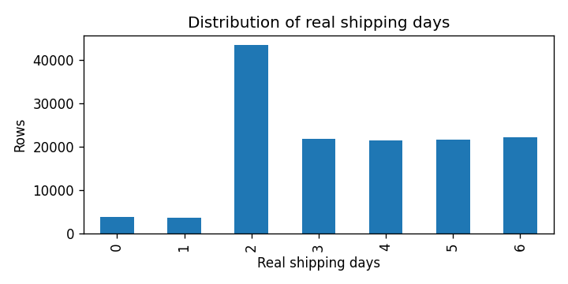
Figure 1: Distribution of real shipping days (training set)

4.2 Shipping mode dominates
Shipping mode is by far the strongest single factor (η² = 0.389, i.e. 38.9 % of variation explained). The pattern is very structured:
Table 7: Real shipping days by shipping mode (training set)
Shipping mode | Scheduled days | Mean real days | Std | Range | Training rows
Same Day | 0 | 0.49 | 0.50 | 0 – 1 | 7,431
First Class | 1 | 2.00 | 0.00 | 2 – 2 | 21,201
Second Class | 2 | 3.99 | 1.42 | 2 – 6 | 26,922
Standard Class | 4 | 4.00 | 1.42 | 2 – 6 | 82,544

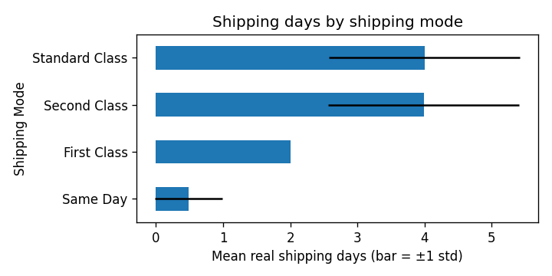
Figure 2: Mean real shipping days per mode, with ±1 standard deviation
Two important consequences follow. First, First Class always takes 2 days against a 1-day promise, so every First Class order is late by design. Second, Second and Standard Class have identical distributions spread uniformly from 2 to 6 days; the spread within these modes is the part of the problem any model must explain beyond shipping mode.

4.3 Other categorical and numeric factors
Table 8: Strength of categorical features (η², training set)
Feature | Categories | η² with real days
Shipping Mode | 4 | 0.3889
Order City | 3,494 | 0.0964 (inflated by many small groups)
Order State | 1,065 | 0.0295
Order Country | 161 | 0.0043
Product Name | 118 | 0.0010
Category Name | 50 | 0.0005
Market | 5 | 0.0001
Customer Segment | 3 | 0.0000

All eleven numeric columns (prices, discounts, profit, quantity, latitude/longitude) have |Pearson| and |Spearman| correlation with the target below 0.01. Market, customer segment and product category show almost identical mean shipping days across their values (about 3.5). The only highly correlated input pair was Sales ↔ Sales per customer (r = 0.99).

4.4 Outliers and data quality
Benefit per order has 10.4 % IQR outliers and 18.7 % negative values (minimum −4,274.98). These were investigated and kept: the money columns are internally consistent, and mean shipping days are the same for loss-making and profitable rows (3.51 vs 3.50), so they are genuine business losses rather than errors.

4.5 Time patterns
Shipping time is flat across weekdays and months and shows no trend from 2015 to 2018. The order hour has a small but real signal (η² = 0.0008), which later proved important for Same Day orders.
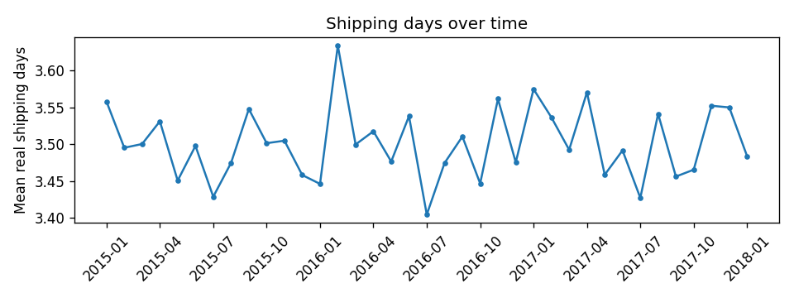
Figure 3: Monthly mean shipping days, 2015–2018 – no drift

4.6 Classification view
For the classification target the late rate is 57.2 % in the cleaned training data. The late rate by mode mirrors the regression findings: First Class is late 100 % of the time, Second Class about 80 %, Same Day about 45 % and Standard Class about 40 %.

5. Data Cleaning and Preprocessing

5.1 Leakage control
The model is used at checkout, so any column computed from the real shipping days or recorded after shipping would give away the answer. Each was proved to leak before it was removed:
Table 9: Leakage analysis
Column | Evidence | Decision
Late_delivery_risk | Equals (real days > scheduled days) for 97.5 % of rows | Leakage – removed (target of classification task only)
Delivery Status | ‘Advance’, ‘On time’, ‘Late’ each fall in exactly one real-vs-scheduled bucket | Leakage – removed
shipping date (DateOrders) | Shipping date − order date = real days for 97.4 % of rows | Leakage – removed
Order Status | COMPLETE / CLOSED etc. describe how the order ended | Used once to filter rows, then removed
Days for shipment (scheduled) | Exactly one value per shipping mode | Not leakage, but redundant – removed
Days for shipping (real) | Is the regression target | Removed from the classification features

5.2 Row filtering
Orders with Order Status CANCELED or SUSPECTED_FRAUD were never shipped, yet still carry a ‘real shipping days’ value. They were removed per order (7,754 rows, 2,855 orders), leaving 172,765 rows and 62,897 orders.

5.3 Column removal
A total of 25 columns were dropped, each with a recorded reason in reports/drop_log_m1_reg.csv:
Table 10: Columns removed during cleaning
Reason | Columns | Count
Leakage / redundant | Late_delivery_risk, Delivery Status, shipping date, Order Status, Days for shipment (scheduled) | 5
Masked | Customer Email, Customer Password | 2
Personal data (PII) | Customer Fname, Lname, Street, Zipcode | 4
Mostly / fully missing | Order Zipcode (86 %), Product Description (100 %) | 2
Constant / URL | Product Status, Product Image | 2
Exact duplicates | Order Profit Per Order, Order Item Total, Product Category Id, Order Customer Id, Order Item Cardprod Id, Order Item Product Price | 6
Code ↔ name 1-to-1 | Department Id, Product Card Id | 2
Identifiers | Order Item Id, Customer Id | 2

After cleaning: 172,765 rows × 28 columns, no missing values and no duplicate rows.

5.4 Train/test split
Because all items of an order share the same answer, a plain random split would place ‘sibling’ rows in both sets and inflate scores. The team used StratifiedGroupKFold(n_splits=5, shuffle=True, random_state=42) – grouped by Order Id and stratified on the target – and took one fold as the hidden test set. Every member loads the same files; nobody re-splits.
Table 11: Regression split (Order Id overlap between train and test: 0)
Set | Rows | Orders | Share | Mean days | Std days
Full (clean) | 172,765 | 62,897 | 100 % | 3.499 | 1.623
Train | 138,098 | 50,318 | 79.9 % | 3.500 | 1.626
Test | 34,667 | 12,579 | 20.1 % | 3.494 | 1.614

The classification task uses its own split with the same method, stratified on Late_delivery_risk (test set: 34,534 rows, 12,579 orders).

5.5 Scaling
Scaling was tested per model family on the grouped folds (notebook 04). Tree models need none. For Ridge the choice made no difference (MAE 0.9959–0.9960); for KNN it mattered a lot – no scaling gave MAE 1.301, MinMax gave 1.046 – so MinMax was used for both linear and KNN regression models, and StandardScaler for the classification equivalents.
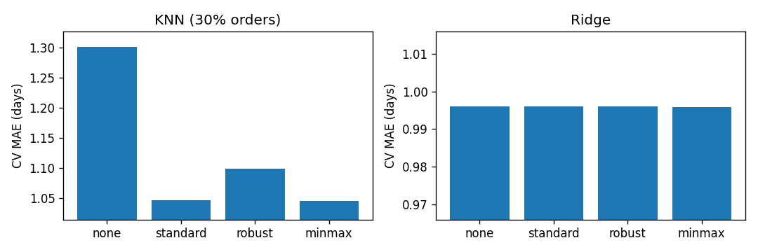
Figure 4: Effect of the scaler on each model family (regression)

6. Feature Engineering and Feature Selection

6.1 Engineered date features
Five features were derived from order date (DateOrders) – the only timestamp known at checkout: order_weekday (0 = Monday), order_month, order_hour, order_quarter and is_weekend. Each uses only the row's own timestamp, so applying the same function to training, test and live orders cannot leak information.
Order-level aggregates (items per order, order total) and an is_domestic flag were also prototyped, but were left out of the final feature list because they showed no measurable signal and would require the full basket at prediction time.

6.2 Final feature list
The team agreed on 11 features, all known at checkout and all collectable from a simple web form:
Table 12: Final features and encoding plan
Feature | Type | Distinct values | Encoding | Model columns
Shipping Mode | categorical | 4 | One-hot | 4
Market | categorical | 5 | One-hot | 5
Customer Segment | categorical | 3 | One-hot | 3
Order Country | categorical | 161 | Target encoding | 1
Category Name | categorical | 50 | Target encoding | 1
Order Item Quantity | numeric | 5 | As is | 1
order_weekday / month / hour / quarter / is_weekend | numeric (engineered) | 7 / 12 / 24 / 4 / 2 | As is | 5
Total |  |  |  | 20

6.3 Encoding strategy
Columns with ≤ 30 categories were one-hot encoded. For the high-cardinality columns four strategies were compared on the same grouped folds with both a linear (Ridge) and a tree model (HistGradientBoosting):
Table 13: High-cardinality encoding comparison (5-fold grouped CV)
Strategy | Ridge MAE | HistGB MAE | HistGB MAE std
Drop the columns (reference) | 0.9928 | 0.9859 | 0.0089
One-hot (all values) | 1.0027 | 0.9875 | 0.0081
One-hot, rare values grouped | 0.9962 | 0.9872 | 0.0083
Target encoding (chosen) | 0.9960 | 0.9836 | 0.0062

Target encoding gave the best tree-model score with the lowest fold-to-fold noise. It was implemented with scikit-learn's TargetEncoder inside the pipeline, which uses internal cross-fitting and smoothing. A deliberate experiment showed why this matters: encoding naively on all training rows before cross-validation produced an optimistic score (MAE 1.4220) compared with the honest in-pipeline version (1.4277) – that gap is leakage.

6.4 Feature selection
Drop-column importance (retrain without each feature, measure how much MAE rises) and alternative feature sets were evaluated:
Table 14: Drop-column importance (HistGB, one grouped validation fold)
Feature removed | MAE increase
Shipping Mode | +0.4442
Date features (group of 5) | +0.0049
Order Item Quantity | +0.0008
Category Name | −0.0007
Market | −0.0028
Order Country | −0.0044
Customer Segment | −0.0133

Shipping mode alone carries almost all of the signal; the date features add a small, real improvement. The other features are within noise. The team kept the full 11-feature list because (i) it was within one standard deviation of the best alternative (HistGB: 0.9836 with all features vs 0.9870 with Shipping Mode only), (ii) it lets the system respond to destination, product and timing, which stakeholders expect, and (iii) tree-based models simply ignore features that do not help.

7. Algorithms Implemented and Their Rationale
Each team member owned one algorithm family; every model used the same features, the same preprocessing pipeline, the same five grouped folds and the same metrics, so the comparison is fair.
Table 15: Algorithms and rationale (same five families for both tasks)
Algorithm | Owner | How it works | Why it was included
Ridge Regression / Logistic Regression | M1 | Linear combination of features with L2 penalty | Interpretable baseline; tests whether relationships are linear
Decision Tree | M4 | Sequence of yes/no splits; leaf = average (or class share) of training rows | Highly explainable; captures interactions such as mode × hour
Random Forest | M2 | Average of many decorrelated trees on bootstrap samples | Reduces variance of single trees; robust default
XGBoost | M3 | Gradient-boosted trees, each correcting the previous ensemble | State of the art for tabular data
K-Nearest Neighbours | M4 | Average target of the k most similar training orders | Non-parametric, instance-based contrast to the other families

Two baselines were set before any model was trained: predict the mean (MAE 1.4276) and mean per shipping mode (MAE 0.9867, R² 0.389). A model is only useful if it beats the shipping-mode baseline; otherwise it adds nothing beyond a lookup table.

8. Model Evaluation and Comparison

8.1 Evaluation protocol
- 5-fold StratifiedGroupKFold on the training set only, grouped by Order Id, seed 42; identical folds for every model.
- Each fold fits the full pipeline (encoders, scaler, model) on the training part only.
- Regression is ranked on MAE; classification on ROC-AUC. MAE_std / roc_auc_std (fold-to-fold noise) is reported so that small differences are not over-interpreted.
- The hidden test set is used once, only for the final chosen model.

8.2 Regression results (primary task)
Table 16: Regression – cross-validated results (training set, 5 grouped folds)
Model | Scaler | Default MAE | Tuned MAE ± std | RMSE | R² | Within 1 day | Beats baseline
Decision Tree | none | 1.3108 | 0.9617 ± 0.0103 | 1.2666 | 0.393 | 52.2 % | Yes
Random Forest | none | 0.9997 | 0.9650 ± 0.0103 | 1.2684 | 0.391 | 52.1 % | Yes
XGBoost | none | 1.0027 | 0.9692 ± 0.0100 | 1.2678 | 0.392 | 52.0 % | Yes
Ridge | MinMax | 0.9959 | 0.9933 ± 0.0088 | 1.2712 | 0.389 | 52.0 % | No
KNN | MinMax | 1.0383 | 1.0091 ± 0.0094 | 1.2962 | 0.364 | 52.2 % | No
Baseline: mean per mode | – | – | 0.9867 | 1.2710 | 0.389 | 52.1 % | –
Baseline: overall mean | – | – | 1.4276 | 1.6259 | 0.000 | 31.4 % | –

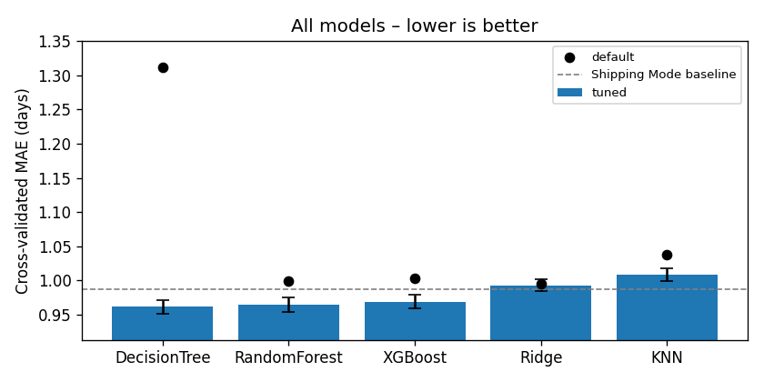
Figure 5: Tuned cross-validated MAE per model; error bars are fold noise, dots are default settings, dashed line is the shipping-mode baseline
The three tree-based models are the only ones that beat the shipping-mode baseline, and their error bars overlap – they are statistically tied. Ridge cannot beat the baseline because the useful structure is an interaction (e.g. hour matters only for Same Day orders) that a linear model cannot represent without hand-crafted terms. KNN suffers because most features carry little signal, so distances are dominated by noise.

8.3 Classification results (secondary task)
Table 17: Classification – cross-validated results (training set, 5 grouped folds)
Model | Default AUC | Tuned AUC ± std | Accuracy | Precision | Recall | F1
Decision Tree | 0.6411 | 0.7761 ± 0.0033 | 0.723 | 0.894 | 0.585 | 0.707
XGBoost | 0.7691 | 0.7738 ± 0.0026 | 0.722 | 0.891 | 0.587 | 0.707
Random Forest | 0.7664 | 0.7725 ± 0.0046 | 0.723 | 0.894 | 0.585 | 0.707
KNN | 0.7523 | 0.7602 ± 0.0040 | 0.706 | 0.826 | 0.617 | 0.706
Logistic Regression | 0.7450 | 0.7450 ± 0.0038 | 0.714 | 0.885 | 0.575 | 0.697
Baseline: shipping mode only | – | 0.7414 | 0.697 | 0.887 | 0.539 | 0.670
Baseline: always ‘late’ | – | 0.5000 | 0.572 | 0.572 | 1.000 | 0.728

9. Hyperparameter Tuning and Optimisation
Every model was tuned with RandomizedSearchCV on the same grouped folds (scoring: negative MAE for regression, ROC-AUC for classification). Random search was preferred over grid search because it finds equally good settings in a fraction of the time on a 138k-row dataset. For each candidate the gap between training and validation error was inspected to detect over-fitting.
Table 18: Regression hyperparameter tuning
Model | Search space (main parameters) | Best regression settings | CV MAE: default → tuned
Decision Tree | max_depth, min_samples_leaf, min_samples_split | max_depth = 3, min_samples_leaf = 50, min_samples_split = 2 | 1.3108 → 0.9617
Random Forest | n_estimators, max_depth, min_samples_leaf, max_features | 300 trees, max_depth = 8, min_samples_leaf = 20, max_features = 1.0 | 0.9997 → 0.9650
XGBoost | n_estimators, learning_rate, max_depth, subsample, colsample_bytree, min_child_weight | 200 trees, lr = 0.05, max_depth = 3, subsample = 1.0, colsample = 0.7, min_child_weight = 10 | 1.0027 → 0.9692
Ridge | alpha (log-uniform) | alpha = 157.4 | 0.9959 → 0.9933
KNN | n_neighbors, weights, p | k = 50, uniform weights, Euclidean (p = 2) | 1.0383 → 1.0091

Tuning had by far the largest effect on the Decision Tree. With default settings (unlimited depth) it memorised the training folds and scored worse than predicting the mean (R² −0.27). Limiting depth to 3 and requiring at least 50 rows per leaf cut the MAE by 0.349 days – 34 times the fold noise – and closed the train/validation gap to 0.001 days, i.e. no over-fitting.
Table 19: Classification hyperparameter tuning
Model | Best classification settings | CV ROC-AUC: default → tuned
Decision Tree | max_depth = 5, min_samples_leaf = 20, min_samples_split = 10, class_weight = balanced | 0.6411 → 0.7761
XGBoost | 200 trees, lr = 0.05, max_depth = 3, colsample = 0.7, min_child_weight = 10 | 0.7691 → 0.7738
Random Forest | 100 trees, max_depth = 8, min_samples_leaf = 50, max_features = 0.5, balanced | 0.7664 → 0.7725
KNN | k = 100, distance weights, Manhattan (p = 1) | 0.7523 → 0.7602
Logistic Regression | C = 0.216, no class weight | 0.7450 → 0.7450

Decision threshold (classification). The classifier outputs a probability; the alarm threshold was chosen on out-of-fold training predictions (never the test set) by maximising Youden's J (recall − false-alarm rate). The selected threshold of 0.65 keeps precision at 0.89 with a false-alarm rate of 9.3 %.

10. Final Model Selection and Justification
Highlight – Final regression model
Model: DecisionTreeRegressor(max_depth=3, min_samples_leaf=50, random_state=42) inside a scikit-learn pipeline with one-hot and target encoding.
Cross-validation: MAE 0.962 ± 0.010 days · RMSE 1.267 · R² 0.393
Hidden test set (used once): MAE 0.937 days · RMSE 1.248 · R² 0.402 · bias +0.005 days
Shipping-mode baseline on the same test set: MAE 0.963 · RMSE 1.253 · R² 0.397
Exact on two of four modes: Same Day and First Class orders have test MAE 0.000.

10.1 Selection rule
The rule was agreed before the results were seen, to avoid cherry-picking:
- Lowest cross-validated MAE wins.
- Any model within one MAE_std of the best counts as a tie (the difference is fold noise).
- Ties go to the simplest model (Ridge → Decision Tree → KNN → Random Forest → XGBoost).
- The winner must beat the shipping-mode baseline; otherwise the team reports that honestly.
Applying the rule: the lowest MAE was Decision Tree (0.9617 ± 0.0103). The tie zone (MAE ≤ 0.9720) contained Decision Tree, Random Forest and XGBoost. Decision Tree is the simplest of the three, and it beats the baseline – so it was selected. The same rule on ROC-AUC selected a Decision Tree classifier (tie with XGBoost).

10.2 What the regression model learned
Because the final model is only three levels deep, it can be drawn in full. This is the complete model used in production:
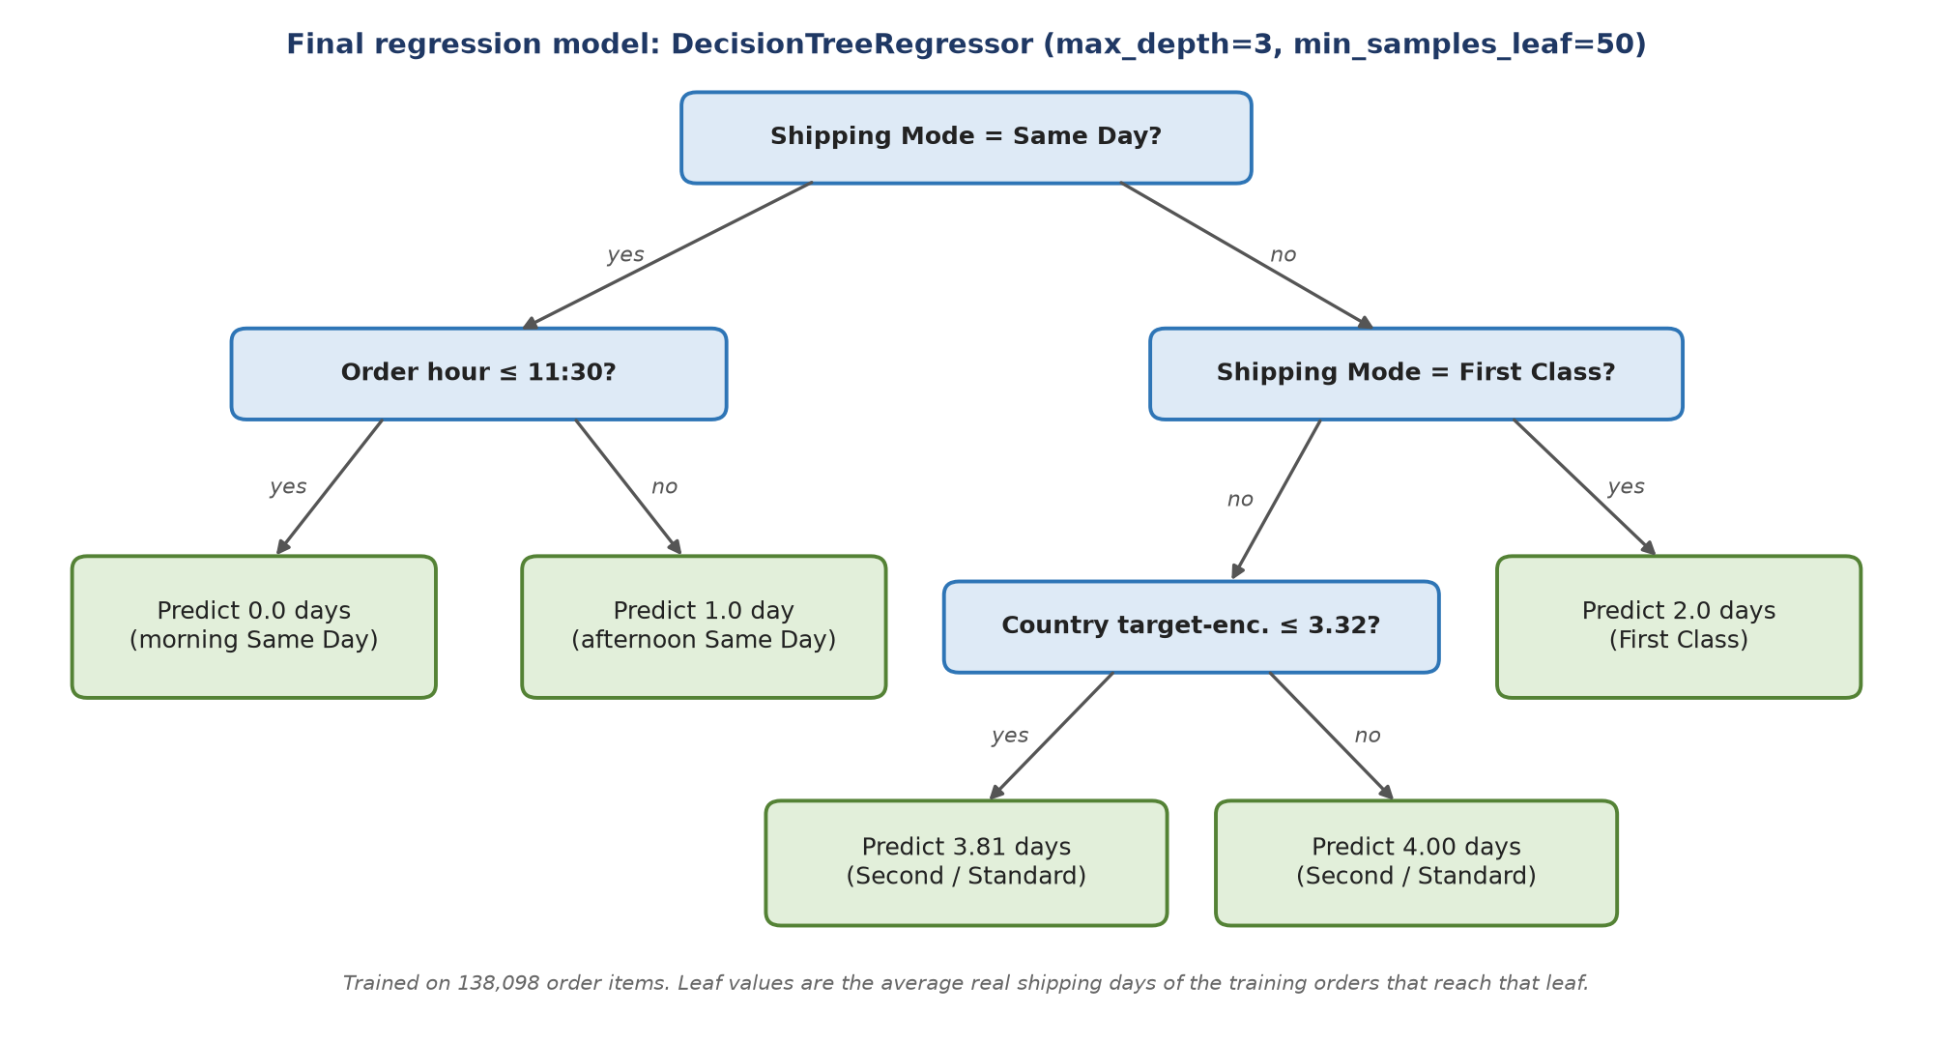
Figure 6: The complete final regression model
The tree reads like a business rule-book and matches the EDA exactly:
- Same Day orders placed before 11:30 ship the same day (0 days); later orders ship the next day (1 day). This explains why order_hour is the second most important feature.
- First Class orders always take 2 days – one day more than promised.
- Second and Standard Class orders are predicted at about 4 days, with a small adjustment for destination country.
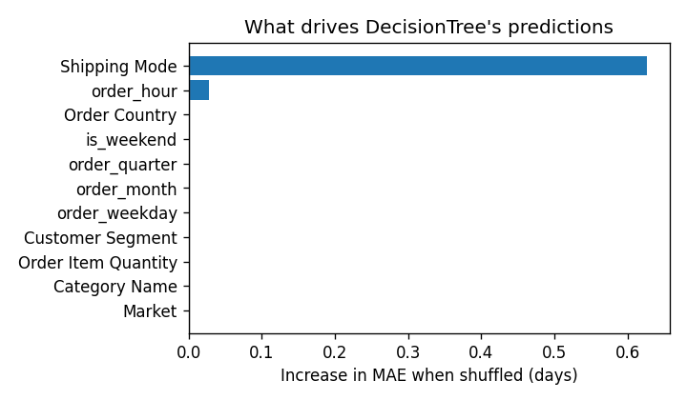
Figure 7: Permutation importance on the test set – increase in MAE when each feature is shuffled

10.3 Final test-set results
Table 20: Regression – cross-validation vs hidden test set
Metric | Decision Tree – CV | Decision Tree – TEST | Shipping-mode baseline – TEST
MAE (days) | 0.9617 | 0.9366 | 0.9633
RMSE (days) | 1.2666 | 1.2482 | 1.2531
R² | 0.3930 | 0.4017 | 0.3970
Median absolute error | 0.9897 | 0.9998 | 0.9972
Within ±1 day | 52.2 % | 53.6 % | 53.6 %
Bias (mean error) | −0.0000 | +0.0047 | +0.0066

The test MAE (0.937) is slightly better than the cross-validated MAE (0.962), which shows that the model generalises to unseen orders and is not over-fitted. Bias is essentially zero, so it does not systematically over- or under-promise.
Table 21: Regression test error by shipping mode
Shipping mode | Test rows | Actual mean days | Predicted mean days | MAE
Same Day | 1,862 | 0.450 | 0.450 | 0.000
First Class | 5,312 | 2.000 | 2.000 | 0.000
Second Class | 6,884 | 4.017 | 3.995 | 1.175
Standard Class | 20,609 | 3.980 | 3.995 | 1.183

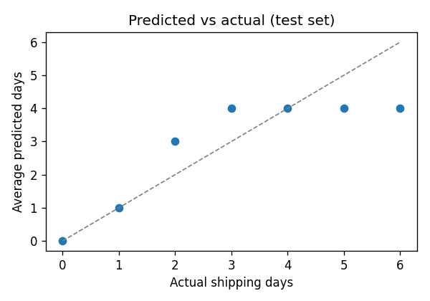
Figure 8: Average predicted vs actual shipping days on the test set
The per-mode breakdown shows exactly where the remaining error lies. Same Day and First Class are predicted perfectly. For Second and Standard Class the real time is spread evenly from 2 to 6 days and no order-time feature distinguishes a 2-day from a 6-day order, so the best any model can do is predict the centre (≈ 4 days), which gives an MAE of about 1.2. Random Forest and XGBoost could not find extra signal either – confirming this is a limit of the data, not of the algorithm.

10.4 Derived late-delivery verdict
Comparing predicted days with the scheduled days for the mode gives a late flag directly from the regression model. On the regression test set this derived verdict scores accuracy 0.733, precision 0.901, recall 0.596, F1 0.718 against the true Late_delivery_risk – practically the same quality as the dedicated classifier, which is evidence that the regression framing loses nothing.

10.5 Why a single tree rather than an ensemble
Table 22: Justification for the final regression model
Criterion | Decision Tree | Random Forest / XGBoost
Accuracy (CV MAE) | 0.9617 – best | 0.9650 / 0.9692 – statistically tied
Explainability | Whole model fits on one page (5 leaves) | Hundreds of trees; needs SHAP or similar
Inference cost | A few comparisons, ≈ 3 ms per API call | Hundreds of tree traversals
Model file / dependencies | Small; scikit-learn only | Larger; XGBoost adds a dependency
Over-fitting risk | Train–validation gap 0.001 days | Low after tuning, but harder to inspect

10.6 Final classification model
The secondary classifier is a DecisionTreeClassifier(max_depth=5, min_samples_leaf=20, min_samples_split=10, class_weight='balanced') with threshold 0.65. On its hidden test set (34,534 rows) it achieved ROC-AUC 0.773, accuracy 0.724, precision 0.894, recall 0.592, F1 0.712, beating the shipping-mode baseline (ROC-AUC 0.743, F1 0.678). Shipping mode (AUC drop 0.27) and order hour (0.05) are again the main drivers.
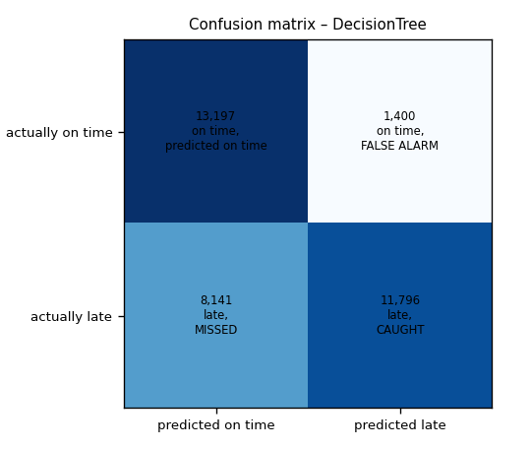
Figure 9: Classifier confusion matrix on the test set (threshold 0.65)

11. System Architecture and Implementation
The system is split into an offline modelling layer and an online serving layer, connected only by saved model artefacts. This keeps training code out of production and means retraining needs no change to the API or UI.
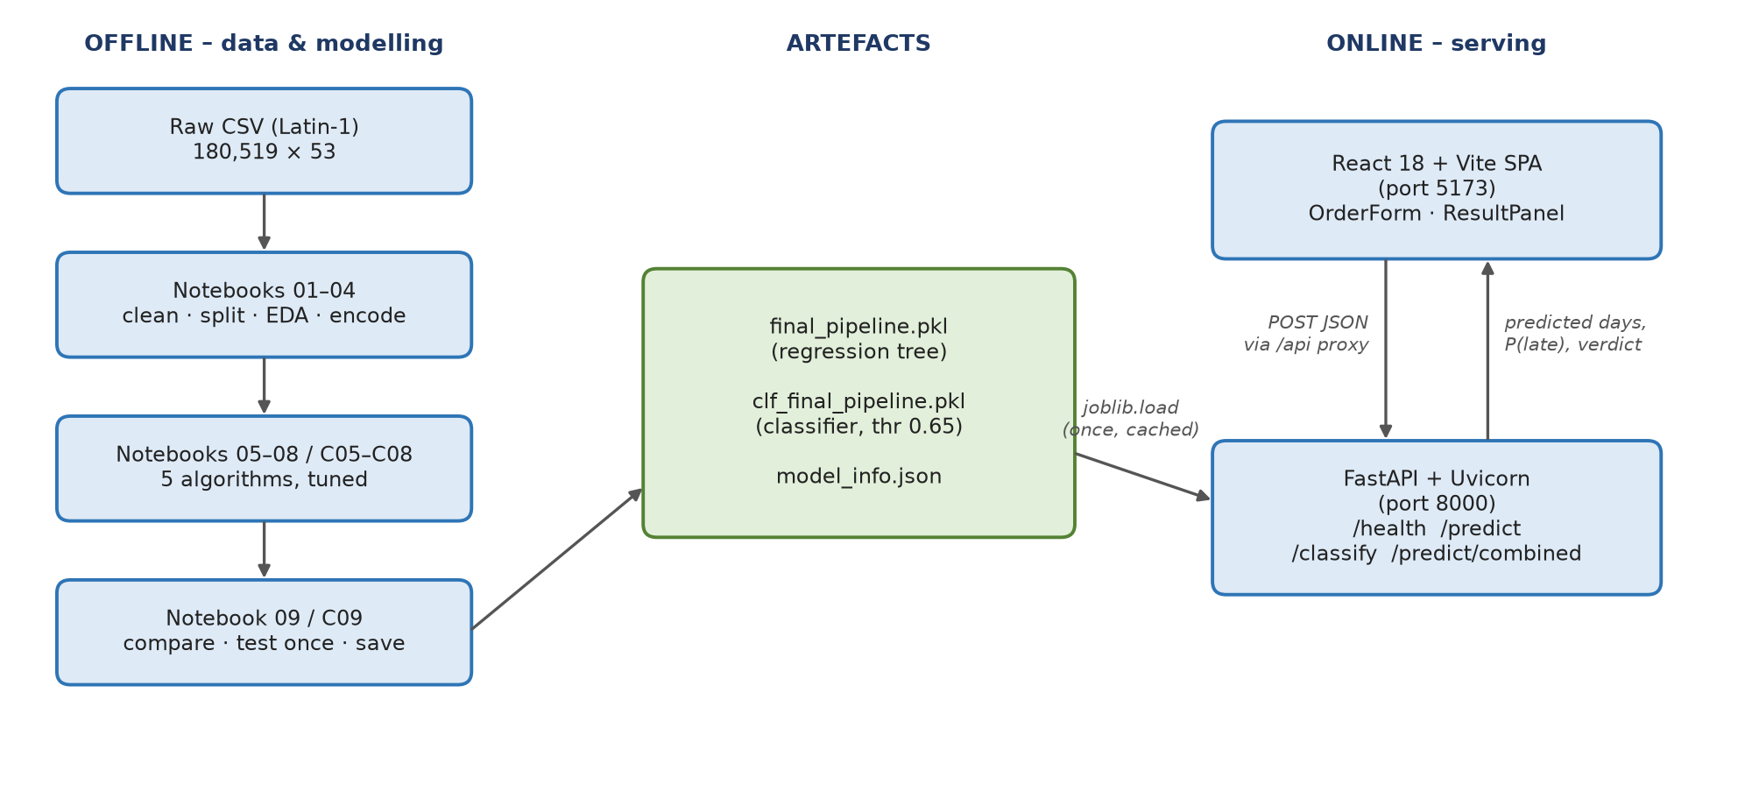
Figure 10: System architecture

11.1 Offline layer
- Notebooks 01–09 (regression) and c01–c09 (classification), one owner per stage, run in order.
- Shared, versioned outputs: train_reg.csv / test_reg.csv, split_meta_*.json, m3_selection.json (feature & encoding plan), m4_preprocessing.json (scaler choice), params_<model>.json and the experiment log results/experiments.csv.
- Notebook 09 / C09 rebuilds the winning pipeline, scores it once on the test set and saves it with joblib.

11.2 Model artefacts
- models/final_pipeline.pkl – the full regression pipeline (ColumnTransformer + DecisionTreeRegressor).
- models/clf_final_pipeline.pkl – the full classification pipeline.
- models/model_info.json, clf_model_info.json – features, date-feature recipe, allowed dropdown values, threshold, scores and library versions (scikit-learn 1.7.2, pandas 2.3.3).

11.3 Technology stack
Table 23: Technology stack
Layer | Technology
Data & modelling | Python 3.11, pandas, NumPy, scikit-learn, XGBoost, matplotlib, seaborn, Jupyter
Back end | FastAPI, Pydantic, Uvicorn, joblib
Front end | React 18, Vite, Tailwind CSS, Framer Motion
Tooling | Git / GitHub (feature branches + pull requests), Makefile, pytest, virtualenv

12. Backend and Frontend Development

12.1 Back end (FastAPI)
backend/app.py exposes a small REST API. Both pipelines are loaded lazily once and cached (lru_cache), so only the first request pays the loading cost. Each request is validated by a Pydantic model, converted to the same 11 features used in training (date features are derived on the server so the client cannot send inconsistent values), and passed to the pipeline.
Table 24: REST API endpoints
Method & path | Purpose | Response
GET /health | Liveness check used by the UI status badge | {"status": "ok"}
POST /predict | Regression | predicted_days, scheduled_days, is_late, late_by, shipping_mode
POST /classify | Classification | is_late, probability, threshold, shipping_mode
POST /predict/combined | Both models in one round trip | {regression: …, classification: …}

Request body (all endpoints): shipping_mode, market, order_country, category_name, quantity (integer, 1–10), customer_segment, order_date (YYYY-MM-DD). Errors are returned as HTTP 422 (invalid input), 503 (model file missing) or 500 (inference failure) with a readable message. CORS is enabled for the front end.

12.2 Front end (React + Vite)
The web application in frontend-web/ is a single-page React app. The Vite dev server proxies /api/* to the FastAPI service on port 8000, so the browser never needs to know the back-end address.
Table 25: Front-end components
Component | Responsibility
Header | Title and live API status indicator (polls /health)
OrderForm | Dropdowns for mode, market, country, category, segment; quantity and date inputs; shipping-mode preview
ResultPanel | Risk gauge with late probability, predicted vs scheduled days, late-by value, loading and error states
ModeComparison | Shows how the prediction changes across the four shipping modes
ModelInfo | Displays the test-set metrics of both models for transparency
api.js | Thin client for /predict, /classify, /predict/combined and /health

A Streamlit prototype (frontend/app.py) was built first for rapid testing and was later replaced by the React application for a more polished, responsive user experience.

13. System Testing and Results
Testing covered the data pipeline (leakage), the models (hold-out evaluation) and the deployed service (functional, validation and performance tests). Service tests were run by calling the FastAPI endpoint functions directly with the saved pipelines.

13.1 Data and model tests
Table 26: Data and model tests
ID | Test | Expected | Result
T1 | Order Id overlap between train and test files | 0 | 0 – Pass
T2 | Leakage columns present in processed train/test files | None | None – Pass
T3 | Target distribution train vs test | Similar | Mean 3.500 vs 3.494 – Pass
T4 | Target encoder fitted inside pipeline (naive vs pipeline gap) | Pipeline ≥ naive MAE | 1.4277 vs 1.4220 – Pass
T5 | Final regression model beats shipping-mode baseline on test | Lower MAE | 0.937 vs 0.963 – Pass
T6 | Test MAE close to CV MAE (no over-fitting) | Within ≈ 0.05 | 0.937 vs 0.962 – Pass
T7 | Saved pipeline reloads and gives identical predictions | True | True – Pass

13.2 API functional tests
Input used for each mode: market LATAM, country México, category Cleats, quantity 2, segment Consumer, date 2026-10-05.
Table 27: Combined endpoint – functional test results
Shipping mode | Predicted days | Scheduled | Regression verdict | P(late) | Classifier verdict | Consistent with EDA?
Same Day | 0.0 | 0 | On time | 0.00 | On time | Yes
First Class | 2.0 | 1 | Late (+1 day) | 1.00 | Late | Yes – always late
Second Class | 4.0 | 2 | Late (+2 days) | 0.75 | Late | Yes – ≈ 80 % late
Standard Class | 4.0 | 4 | On time | 0.34 | On time | Yes – ≈ 40 % late

13.3 Validation, robustness and performance tests
Table 28: Validation, robustness and performance tests
ID | Test | Expected | Result
T8 | GET /health | status ok | {"status": "ok"} – Pass
T9 | Date in wrong format (05/10/2026) | HTTP 422 | 422 – Pass
T10 | Quantity = 0 (below minimum) | Validation error | Pydantic ValidationError – Pass
T11 | Unseen country (‘Atlantis’) | Prediction, no crash | Falls back to overall mean encoding; P(late) 0.34 – Pass
T12 | Latency – first call (includes model load) | < 3 s | ≈ 1.5 s – Pass
T13 | Latency – subsequent combined calls | < 1 s | ≈ 2.5–2.7 ms – Pass
T14 | Front end with API offline | Clear status / error | Status badge shows offline with hint ‘run: make api’ – Pass

13.4 Known issues found during testing
- The automated pytest suite (tests/test_no_leakage.py) imports a src/ package that was removed during refactoring into notebooks, so it currently fails at collection. Its two checks (T1, T2) were re-run manually above; the suite should be updated to read the processed CSV files directly.
- The API accepts a date only (YYYY-MM-DD), so order_hour is always 0 at inference. For Same Day orders this always selects the ‘morning’ leaf (0 days); afternoon Same Day orders would be under-estimated by one day. Accepting a full timestamp fixes this.
- The API allows quantity up to 10, while training data only contains 1–5; values above 5 are extrapolated.

14. Limitations and Possible Future Improvements

14.1 Limitations
- Limited signal at order time. Shipping mode explains ≈ 39 % of variance; R² 0.40 is close to the ceiling for the available features. Within Second and Standard Class, shipping time is effectively random with respect to every order-time column.
- Dataset realism. The uniform 2–6-day spread and the fixed 2-day First Class time suggest the dataset may be partly synthetic, so absolute numbers may not transfer to a real retailer.
- Missing operational drivers. Warehouse workload, carrier, stock availability, weather, holidays and customs are not in the data.
- Discrete outputs. A depth-3 tree produces only five distinct predictions; it cannot express fine-grained differences.
- Static model. The model is trained on 2015–2018 data with no monitoring or retraining process.
- Recall of the classifier is 0.59 – about four in ten late orders (mostly Standard Class) are not flagged.

14.2 Future improvements
Table 29: Proposed future improvements
Area | Improvement | Expected benefit
Data | Add carrier, warehouse workload, stock level, public holidays and weather | Explain the 2–6-day spread within Standard / Second Class
Features | Accept full order timestamp in the API; add holiday and peak-season flags | Fix Same Day afternoon case; capture seasonality
Modelling | Ordinal regression or quantile regression (predict a 2–6 day range with confidence) | More honest uncertainty for customers
Modelling | Probability calibration and cost-based threshold for the classifier | Better trade-off between missed late orders and false alarms
Explainability | Per-prediction explanation (path through the tree) shown in the UI | Builds user trust
Engineering | Fix the pytest suite; add API tests in CI; Docker images for API and UI | Repeatable deployment, fewer regressions
Operations | Log predictions vs outcomes; monitor drift; scheduled retraining | Keeps the model accurate over time

15. Conclusion
The team delivered an end-to-end, leakage-free machine-learning system that predicts shipping time and late-delivery risk at checkout. Careful data validation, a grouped split and in-pipeline encoding ensure the reported scores are honest. Among five tuned algorithms, a three-level Decision Tree Regressor was the most accurate and the simplest, achieving a test MAE of 0.94 days and R² of 0.40, with perfect accuracy for Same Day and First Class orders. The model's structure turns the data into clear business insight – First Class always misses its one-day promise, and Same Day depends on whether the order arrives before noon – and the remaining error is traced to information the dataset does not contain. The models are served through a validated FastAPI service and a React interface that respond in milliseconds.

References
Constante, F., Silva, F. and Pereira, A. (2019) DataCo SMART SUPPLY CHAIN FOR BIG DATA ANALYSIS. Mendeley Data, V1. doi: 10.17632/8gx2fvg2k6.1.
Pedregosa, F. et al. (2011) ‘Scikit-learn: Machine Learning in Python’, Journal of Machine Learning Research, 12, pp. 2825–2830.
Chen, T. and Guestrin, C. (2016) ‘XGBoost: A Scalable Tree Boosting System’, Proceedings of the 22nd ACM SIGKDD International Conference on Knowledge Discovery and Data Mining, pp. 785–794.
Breiman, L. (2001) ‘Random Forests’, Machine Learning, 45(1), pp. 5–32.
Breiman, L., Friedman, J., Olshen, R. and Stone, C. (1984) Classification and Regression Trees. Wadsworth.
Kaufman, S., Rosset, S., Perlich, C. and Stitelman, O. (2012) ‘Leakage in Data Mining: Formulation, Detection, and Avoidance’, ACM Transactions on Knowledge Discovery from Data, 6(4), pp. 1–21.
Micci-Barreca, D. (2001) ‘A Preprocessing Scheme for High-Cardinality Categorical Attributes in Classification and Prediction Problems’, ACM SIGKDD Explorations, 3(1), pp. 27–32.
Bergstra, J. and Bengio, Y. (2012) ‘Random Search for Hyper-Parameter Optimization’, Journal of Machine Learning Research, 13, pp. 281–305.
FastAPI documentation (2026). Available at: https://fastapi.tiangolo.com.
React documentation (2026). Available at: https://react.dev.

Appendix A – Project Repository Map
Table 30: Repository structure
Path | Contents
notebooks/01–09_*.ipynb | Regression pipeline: data prep, EDA, encoding, scaling, five models, comparison
notebooks/c01–c09_*.ipynb | Classification pipeline with the same structure
data/processed/ | Shared train/test split files and split metadata
results/ | Experiment logs (experiments.csv, clf_experiments.csv) and tuned parameters per model
reports/figures/ | All charts used in this report
models/ | Saved final pipelines and model-info JSON files
backend/app.py | FastAPI inference service
frontend-web/ | React + Vite web application
tests/ | Anti-leakage test suite

Appendix B – How to Run
- make setup – create the virtual environment and install requirements
- make api – start the FastAPI service on port 8000
- cd frontend-web && npm install && npm run dev – start the web app on port 5173
- make test – run the test suite

