IT3051 – Fundamentals of Data Mining · Group Mini-Project 2026
DataCo Late Delivery Predictor
Experiment and Evaluation Evidence
Results of every experiment, tuning run, final test and system test
Required deliverable
Any required experiment/evaluation evidence.

1. Evaluation protocol
- 5-fold StratifiedGroupKFold on the training set (grouped by Order Id, seed 42); identical folds for every experiment.
- Regression ranked by MAE; classification by ROC-AUC; fold standard deviation reported as noise.
- Baselines: predict the mean (MAE 1.4276) and mean per shipping mode (MAE 0.9867, R² 0.389).
- Hidden test set used once, for the final model only.

2. Feature engineering experiments
Table 1: Encoding comparison (regression)
Strategy (high-cardinality columns) | Ridge MAE | HistGB MAE | HistGB std
Drop the columns | 0.9928 | 0.9859 | 0.0089
One-hot | 1.0027 | 0.9875 | 0.0081
One-hot, rare grouped | 0.9962 | 0.9872 | 0.0083
Target encoding (chosen) | 0.9960 | 0.9836 | 0.0062

Table 2: Feature-set comparison (regression)
Feature set | Features | Ridge MAE | HistGB MAE
Shipping Mode only | 1 | 0.9867 | 0.9870
Team list without date features | 6 | 0.9939 | 0.9945
Team list (final) | 11 | 0.9960 | 0.9836

Table 3: Scaling comparison (regression)
Scaler | Ridge MAE | KNN MAE (30 % sample)
None | 0.9960 | 1.3014
Standard | 0.9960 | 1.0468
Robust | 0.9960 | 1.0987
MinMax (chosen) | 0.9959 | 1.0462

3. Model comparison – regression (primary)
Table 4: Cross-validated regression results
Model | Owner | Default MAE | Tuned MAE ± std | RMSE | R² | Beats baseline
Decision Tree | M4 | 1.3108 | 0.9617 ± 0.0103 | 1.2666 | 0.393 | Yes
Random Forest | M2 | 0.9997 | 0.9650 ± 0.0103 | 1.2684 | 0.391 | Yes
XGBoost | M3 | 1.0027 | 0.9692 ± 0.0100 | 1.2678 | 0.392 | Yes
Ridge | M1 | 0.9959 | 0.9933 ± 0.0088 | 1.2712 | 0.389 | No
KNN | M4 | 1.0383 | 1.0091 ± 0.0094 | 1.2962 | 0.364 | No

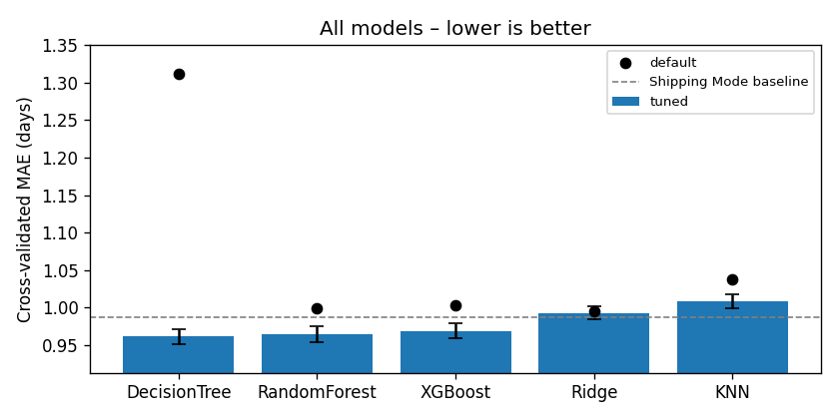
Figure 1: Tuned CV MAE per model (bars), default settings (dots), shipping-mode baseline (dashed)

4. Model comparison – classification (secondary)
Table 5: Cross-validated classification results
Model | Default AUC | Tuned AUC ± std | Precision | Recall | F1
Decision Tree | 0.6411 | 0.7761 ± 0.0033 | 0.894 | 0.585 | 0.707
XGBoost | 0.7691 | 0.7738 ± 0.0026 | 0.891 | 0.587 | 0.707
Random Forest | 0.7664 | 0.7725 ± 0.0046 | 0.894 | 0.585 | 0.707
KNN | 0.7523 | 0.7602 ± 0.0040 | 0.826 | 0.617 | 0.706
Logistic Regression | 0.7450 | 0.7450 ± 0.0038 | 0.885 | 0.575 | 0.697

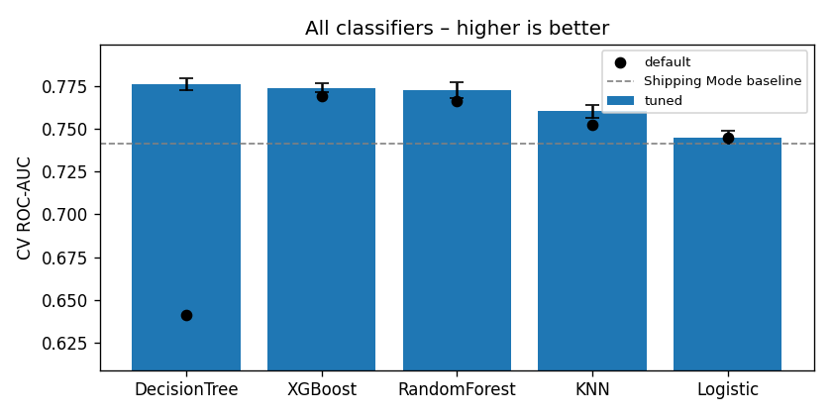
Figure 2: Classifier comparison (ROC-AUC)

5. Hyperparameter tuning
Table 6: Best parameters from RandomizedSearchCV
Model | Best regression parameters | Best classification parameters
Decision Tree | max_depth 3, min_samples_leaf 50, min_samples_split 2 | max_depth 5, min_samples_leaf 20, min_samples_split 10, balanced
Random Forest | 300 trees, max_depth 8, min_samples_leaf 20, max_features 1.0 | 100 trees, max_depth 8, min_samples_leaf 50, max_features 0.5, balanced
XGBoost | 200 trees, lr 0.05, max_depth 3, colsample 0.7, min_child_weight 10 | Same settings
Ridge / Logistic | alpha 157.4 | C 0.216
KNN | k 50, uniform, p 2 | k 100, distance, p 1

6. Final model selection and test
Rule: lowest CV error wins; models within one fold-std are tied; ties go to the simpler model. Regression tie zone (MAE ≤ 0.9720): Decision Tree, Random Forest, XGBoost → Decision Tree. Classification tie zone (AUC ≥ 0.7728): Decision Tree, XGBoost → Decision Tree.
Table 7: Final regression test (34,667 rows, 12,579 orders)
Metric | Regression CV | Regression TEST | Baseline TEST
MAE | 0.9617 | 0.9366 | 0.9633
RMSE | 1.2666 | 1.2482 | 1.2531
R² | 0.3930 | 0.4017 | 0.3970
Within ±1 day | 52.2 % | 53.6 % | 53.6 %

Table 8: Regression test error by shipping mode
Shipping mode | Test rows | Actual mean | Predicted mean | MAE
Same Day | 1,862 | 0.450 | 0.450 | 0.000
First Class | 5,312 | 2.000 | 2.000 | 0.000
Second Class | 6,884 | 4.017 | 3.995 | 1.175
Standard Class | 20,609 | 3.980 | 3.995 | 1.183

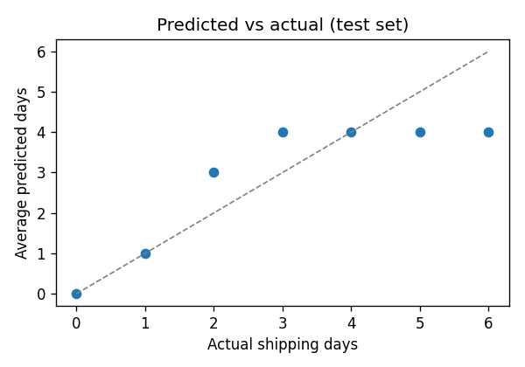
Figure 3: Average predicted vs actual days (test set)
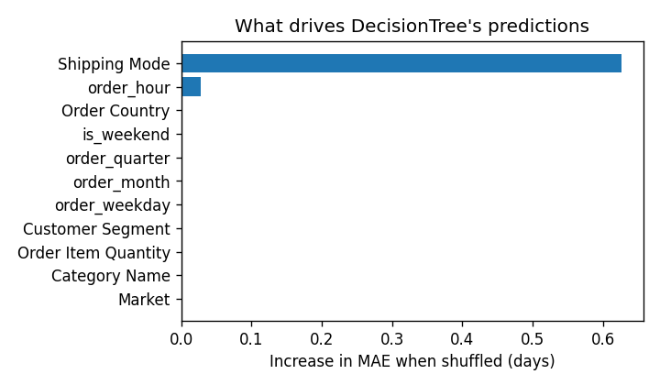
Figure 4: Permutation importance of the final regression model
Table 9: Final classification test (34,534 rows)
Metric | Classifier CV (0.5) | Classifier TEST (0.65) | Baseline TEST
ROC-AUC | 0.7761 | 0.7732 | 0.7432
Accuracy | 0.7228 | 0.7237 | 0.6993
Precision | 0.8937 | 0.8939 | 0.8879
Recall | 0.5847 | 0.5917 | 0.5485
F1 | 0.7069 | 0.7120 | 0.6781

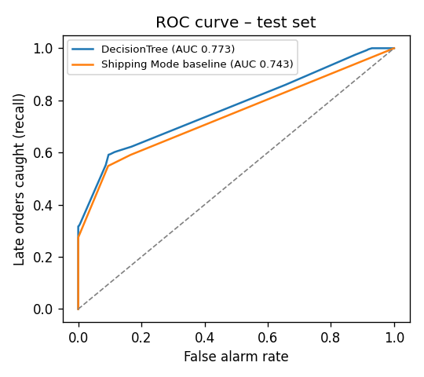
Figure 5: ROC curve of the final classifier (test set)

7. System testing
Table 10: System test results
ID | Test | Expected | Result
T1 | Order Id overlap train/test | 0 | 0 – Pass
T2 | Leakage columns in processed files | None | None – Pass
T3 | Final model beats baseline on test | Lower MAE | 0.937 vs 0.963 – Pass
T4 | Saved pipeline reload gives same predictions | True | True – Pass
T5 | GET /health | ok | ok – Pass
T6 | Combined prediction, 4 shipping modes | Valid output | 0 / 2 / 4 / 4 days; P(late) 0.00 / 1.00 / 0.75 / 0.34 – Pass
T7 | Invalid date format | HTTP 422 | 422 – Pass
T8 | Quantity 0 | Validation error | Rejected – Pass
T9 | Unseen country | No crash | Falls back to mean encoding – Pass
T10 | Latency after model load | < 1 s | ≈ 2.5–2.7 ms – Pass

Note: the automated pytest suite currently fails at import because it references a removed src/ package; checks T1–T2 were re-run manually.

8. Evidence files in this folder
Path | Contents
results/experiments.csv, results/clf_experiments.csv | Every experiment logged by every member
results/params_*.json, results/clf_params_*.json | Best parameters and CV scores per model
results/m3_*, results/clf_m3_* | Encoding and feature-selection decisions
results/m4_preprocessing.json, results/clf_m4_preprocessing.json | Scaler and validation decisions
figures/m2–m4, figures/clf_m2–clf_m4 | EDA, encoding, scaling charts
figures/models, figures/clf_models | Default vs tuned chart per model
figures/final, figures/clf_final | Final comparison, test errors, confusion matrix, ROC, importance

