Urban Flow Analytics
SLIIT Codefest Datathon 2026 — Technical Report
Scope: Section 1 (Data Quality) and Section 2.1 (Fare Amount Prediction)

This report covers the portions of the challenge implemented in the project notebooks to date. Section 2.2 (trip duration), Section 3.1 (demand forecasting) and Section 3.2 (hotspot / OD clustering) are not yet built and are listed under Future Work (Section 6).

Executive Summary
Urban Flow Analytics supplied twelve months of trip-level taxi records (April 2025 – March 2026) alongside a taxi-zone reference table. This report documents the work completed so far against the Datathon 2026 brief: (1) a systematic data-quality assessment and cleaning pass applied independently to each of the twelve monthly files, and (2) a first predictive pipeline for base_fare — the core fare-prediction task behind the city's proposed “No-Surprises Upfront Pricing” feature.
The twelve cleaned monthly files were integrated into a single 46.3M-row dataset, joined with the zone reference table, and split 70/15/15 into train/validation/test sets. On the validation set, a Linear Regression baseline reached RMSE 11.22 / MAE 6.90 / R² 0.61, while a default (untuned) XGBoost regressor reached RMSE 13.78 / MAE 3.95 / R² 0.42. The two models disagree on which is “better” depending on the metric — this discrepancy, and what it implies for model selection and next steps, is discussed in Section 4.
- 5 anomaly checks specified in the brief were quantified and treated (drop / impute / filter), each with a stated justification.
- 12 monthly files (~4M rows each) were cleaned independently, then integrated into df_integrated.csv (46,301,701 rows).
- A 70/15/15 train/validation/test split (32.4M / 6.9M / 6.9M rows) was produced for modelling.
- Two regression models were trained for base_fare prediction; results and a metric-selection rationale are reported per the brief's evaluation guidance.
- The default XGBoost model, saved as the deliverable .pkl, is not yet hyperparameter-tuned — flagged as the top priority next step.

1. Data Understanding
Two datasets were provided, matching the Field Reference Guide in the challenge brief:
Dataset | Grain | Notes
Urban Flow Analytics Taxi Dataset | 1 row per trip | 12 monthly CSVs (2025-04 through 2026-03), ~4M rows/month, 20 raw columns (timestamps, origin/dest zone IDs, distance, fare components, rate class, provider code, settlement method).
Urban Flow Analytics Zone Dataset | 1 row per taxi zone | loc_id, borough_name, zone_name, service_zone — joined to the taxi dataset on origin_loc_id / dest_loc_id.

Representative diagnostics below are drawn from the December 2025 file (4,305,006 raw rows, 20 columns), the month worked through cell-by-cell in notebooks/data_quality.ipynb; the same pipeline (scripts/01_data_quality.py and the per-month notebook runs) was applied independently to all twelve months before integration.

1.1 Missing Values
Five columns — rider_count, rate_class_id, offline_record_flag, zone_congestion_fee and Airport_fee — were missing on the same 1,195,482 rows (27.77% of the month). The overlap across exactly these columns points to a systematic gap tied to provider_code (some providers do not transmit these fields), not random noise.
Column | Missing (rows) | Missing % | Treatment
rider_count | 1,195,482 | 27.77% | Impute (mode) + _missing flag
rate_class_id | 1,195,482 | 27.77% | Impute (mode)
offline_record_flag | 1,195,482 | 27.77% | Impute ('N')
zone_congestion_fee | 1,195,482 | 27.77% | Impute (0 — no fee reported)
Airport_fee | 1,195,482 | 27.77% | Impute (0 — no fee reported)

Fee columns were imputed with 0 (absence of a reported fee is treated as no fee charged); categorical/count fields were imputed with the column mode. A rider_count_missing flag was retained so downstream models can still use missingness as a signal.

2. Data Quality — Anomaly Detection & Cleaning
Per the brief, five anomaly types were checked, each quantified as a percentage of total rows before deciding whether to drop, impute, or filter.
# | Anomaly | Rows Affected | % of Total | Decision
1 | Negative total charge (charge_total < 0) | 48,869 | 1.14% | Drop
2 | distance_miles = 0 with base_fare > 0 | 148,528 | 3.45% | Drop
3 | rider_count = 0 | 18,144 | 0.42% | Impute (mode = 1)
4 | dropoff_timestamp ≤ pickup_timestamp | 55,994 | 1.30% | Drop
5 | Implied speed > 80 mph | 1,127 | 0.03% | Drop (filter)

2.1 Negative Fares / Charges
48,869 rows (1.14%) had charge_total < 0 (48,175 rows, 1.12%, on base_fare alone). A calculated_charge field was reconstructed by summing base_fare, surcharge_misc, transit_tax, driver_tip_payment, toll_total, service_improvement_fee, zone_congestion_fee, Airport_fee and congestion_relief_fee, confirming the negative totals were internally consistent negative records (refunds/adjustments), not sum errors.
Decision — Drop: A negative charge on a completed trip cannot represent a real fare and cannot be repaired by imputation without fabricating values, so these rows were dropped.

2.2 Zero Distance With a Nonzero Fare
148,528 rows (3.45%) — the largest single anomaly category — recorded distance_miles = 0 while base_fare > 0 (mean charged fare on these rows: $31.87, up to $999).
Decision — Drop: A charged trip with zero recorded distance indicates a meter/GPS logging failure. There is no reliable way to impute the true distance, and fabricating it would bias every distance-based feature (including the fare and duration targets), so these rows were dropped.

2.3 Zero Passenger Count
18,144 rows (0.42%) recorded rider_count = 0, despite being charged trips.
Decision — Impute: A charged trip implies at least one rider, so 0 is treated as a data-entry error rather than a real empty trip. Since rider_count is not a primary predictor for the fare/duration/demand tasks, the 0 values were imputed with the dataset mode (1 rider) rather than dropping otherwise-valid trips; a rider_count_was_zero flag preserves the original signal.

2.4 Drop-off At or Before Pickup
The brief calls out drop-off strictly before pickup; the check was extended to dropoff ≤ pickup, since a zero-duration trip is equally invalid for a trip that covered real distance. 1 row had dropoff strictly before pickup (~0.00%); 55,993 rows (1.30%) had dropoff exactly equal to pickup — combined, 55,994 rows (1.30%).
Decision — Drop: A non-positive duration is physically impossible for a metered trip and cannot be repaired without knowing the true timestamps. This also matters directly for the upcoming trip-duration model (Section 2.2 of the brief), where a duration target of 0 or negative would corrupt training.

2.5 Unrealistic Implied Speed
Implied speed (distance_miles ÷ duration) exceeded an 80 mph threshold on 1,127 rows (0.03%) — a generous bound given highway runs to JFK, Newark, Nassau and Westchester under the rate-class schema. The worst offenders implied speeds in the hundreds of thousands of mph, traced back to distance_miles values in the hundreds of thousands — clear sensor/unit errors, not borderline cases.
Decision — Filter (drop): These are unambiguous sensor errors concentrated in a handful of extreme distance values; imputation is not meaningful here, and the volume affected is negligible, so the rows were filtered out.

2.6 Net Cleaning Impact
Applied sequentially to the December 2025 file: 4,305,006 raw rows → 4,106,224 rows retained after all five checks — a combined 4.63% of rows removed (checks are not mutually exclusive, so the net drop is smaller than the sum of the individual percentages above).

3. Data Integration & Train/Validation/Test Split
The same cleaning pipeline was applied independently to each of the twelve monthly files (notebooks/data_quality.ipynb / scripts/01_data_quality.py), producing df_cleaned_1.csv … df_cleaned_12.csv. Files were sorted numerically (not alphabetically) before concatenation, since an alphabetical sort would scramble the chronological order the later time-based split relies on.
Month file | Cleaned rows
df_cleaned_1.csv | 3,561,388
df_cleaned_2.csv | 3,250,954
df_cleaned_3.csv | 3,811,060
df_cleaned_4.csv | 3,810,503
df_cleaned_5.csv | 4,347,294
df_cleaned_6.csv | 4,117,575
df_cleaned_7.csv | 3,702,899
df_cleaned_8.csv | 3,385,830
df_cleaned_9.csv | 4,052,538
df_cleaned_10.csv | 4,202,857
df_cleaned_11.csv | 3,952,579
df_cleaned_12.csv (Dec 2025, detailed above) | 4,106,224

The twelve cleaned files were concatenated (46,301,701 rows) and left-joined twice against the zone reference table — once on origin_loc_id (pickup borough/zone/service_zone) and once on dest_loc_id (dropoff borough/zone/service_zone) — with row count unchanged after the join (46,301,701 rows, 29 columns), confirming a clean one-to-one zone lookup. The result was saved as data/processed/df_integrated.csv.
A 70/15/15 train/validation/test split (scikit-learn train_test_split, random_state=42) was then produced:
Split | Rows | % of Total
Train | 32,411,190 | 70.0%
Validation | 6,945,255 | 15.0%
Test | 6,945,256 | 15.0%

Note: The split is a random row-level split rather than a time-based split (e.g. train on earlier months, test on later ones). For a fare/duration model this is reasonable, but it lets information from every month leak into training, which would understate error for any future time-series demand model (Section 3.1 of the brief) that needs to forecast forward in time. This is flagged in Section 6.

4. Fare Amount Prediction (Challenge Section 2.1)
Objective: predict base_fare prior to trip start, to power a real-time “No-Surprises Upfront Pricing” quote — i.e. using only information available before or at pickup (time, locations, rate class, rider count, distance), not post-trip fields.

4.1 Feature Engineering
- Datetime features from pickup_timestamp: pickup_hour, pickup_dayofweek, pickup_month, pickup_day, is_weekend.
- is_rush_hour flag (7-9am, 4-6pm) and is_night flag (10pm-5am).
- Rate-class flags derived from rate_class_id: is_airport_rate (JFK/Newark), is_negotiated_fare, is_group_ride.
- same_zone_trip flag (origin_loc_id == dest_loc_id).
- Target encoding of origin_loc_id and dest_loc_id (mean base_fare per zone, fit on train only, with the train's global mean used to fill unseen zones in validation/test — avoiding leakage).
- One-hot encoding of low-cardinality categoricals: pickup_borough, dropoff_borough, provider_code (train/val/test columns aligned post-encoding).
- distance_miles and rider_count carried through directly.
Cardinality was checked before choosing an encoding strategy: 262 unique origin/destination zones (too high for one-hot → target encoding), versus 7 boroughs and 7 rate classes (one-hot encoded directly). This produced 29 features over the full 32.4M-row training set.

4.2 Models & Results
Two regressors were trained on the training split and evaluated on the held-out validation split:
Model | RMSE | MAE | R²
Linear Regression (baseline) | 11.216 | 6.899 | 0.612
XGBoost (default hyperparameters: n_estimators=300, max_depth=6, learning_rate=0.1) | 13.779 | 3.948 | 0.415

The trained XGBoost model was serialized to xgboost_base_fare_model.pkl as the submission deliverable.

4.3 Reading the Result: RMSE vs. MAE Disagreement
The two metrics disagree on which model is better: XGBoost's MAE is 43% lower than Linear Regression's (typical errors are smaller), but its RMSE is 23% higher and its R² is lower (large errors are worse). This pattern — good median-case performance, poor worst-case performance — is the signature of a model that fits the bulk of trips well but is pulled off on a subset of high-fare or outlier trips (e.g. negotiated fares, long airport runs, the residual extreme fares noted in Section 2.2). Because the default XGBoost was not hyperparameter-tuned or regularized against this, and no log-transform or outlier cap was applied to the skewed base_fare target, the RMSE gap most likely reflects under-tuning rather than a genuine limit of tree models on this problem — addressed as the top item in Section 6 (Future Work).

4.4 Rationale for Evaluation Metrics
Metric | Why it was used
RMSE | Penalizes large errors quadratically — the right lens for a pricing engine, where one badly wrong quote (e.g. a $40 miss on an airport run) is more damaging to rider trust than several small misses.
MAE | Reports typical dollar error in the same units as the fare, giving a directly interpretable “on average, how far off is the upfront quote” figure for stakeholders.
R² | Standardizes performance against a mean-fare baseline, making it easy to compare model configurations during iteration independent of the fare scale.

Used together, RMSE and MAE bound the problem from both sides — MAE shows typical-case accuracy, RMSE exposes how badly the model fails on its worst predictions — while R² gives a single comparable number across model iterations, which is how the RMSE/MAE disagreement in Section 4.3 was surfaced in the first place.

5. Solution Architecture
The diagram below reflects the pipeline as implemented: monthly raw data → per-month cleaning → integration with the zone table → split → feature engineering → model training → evaluation → serialized model.
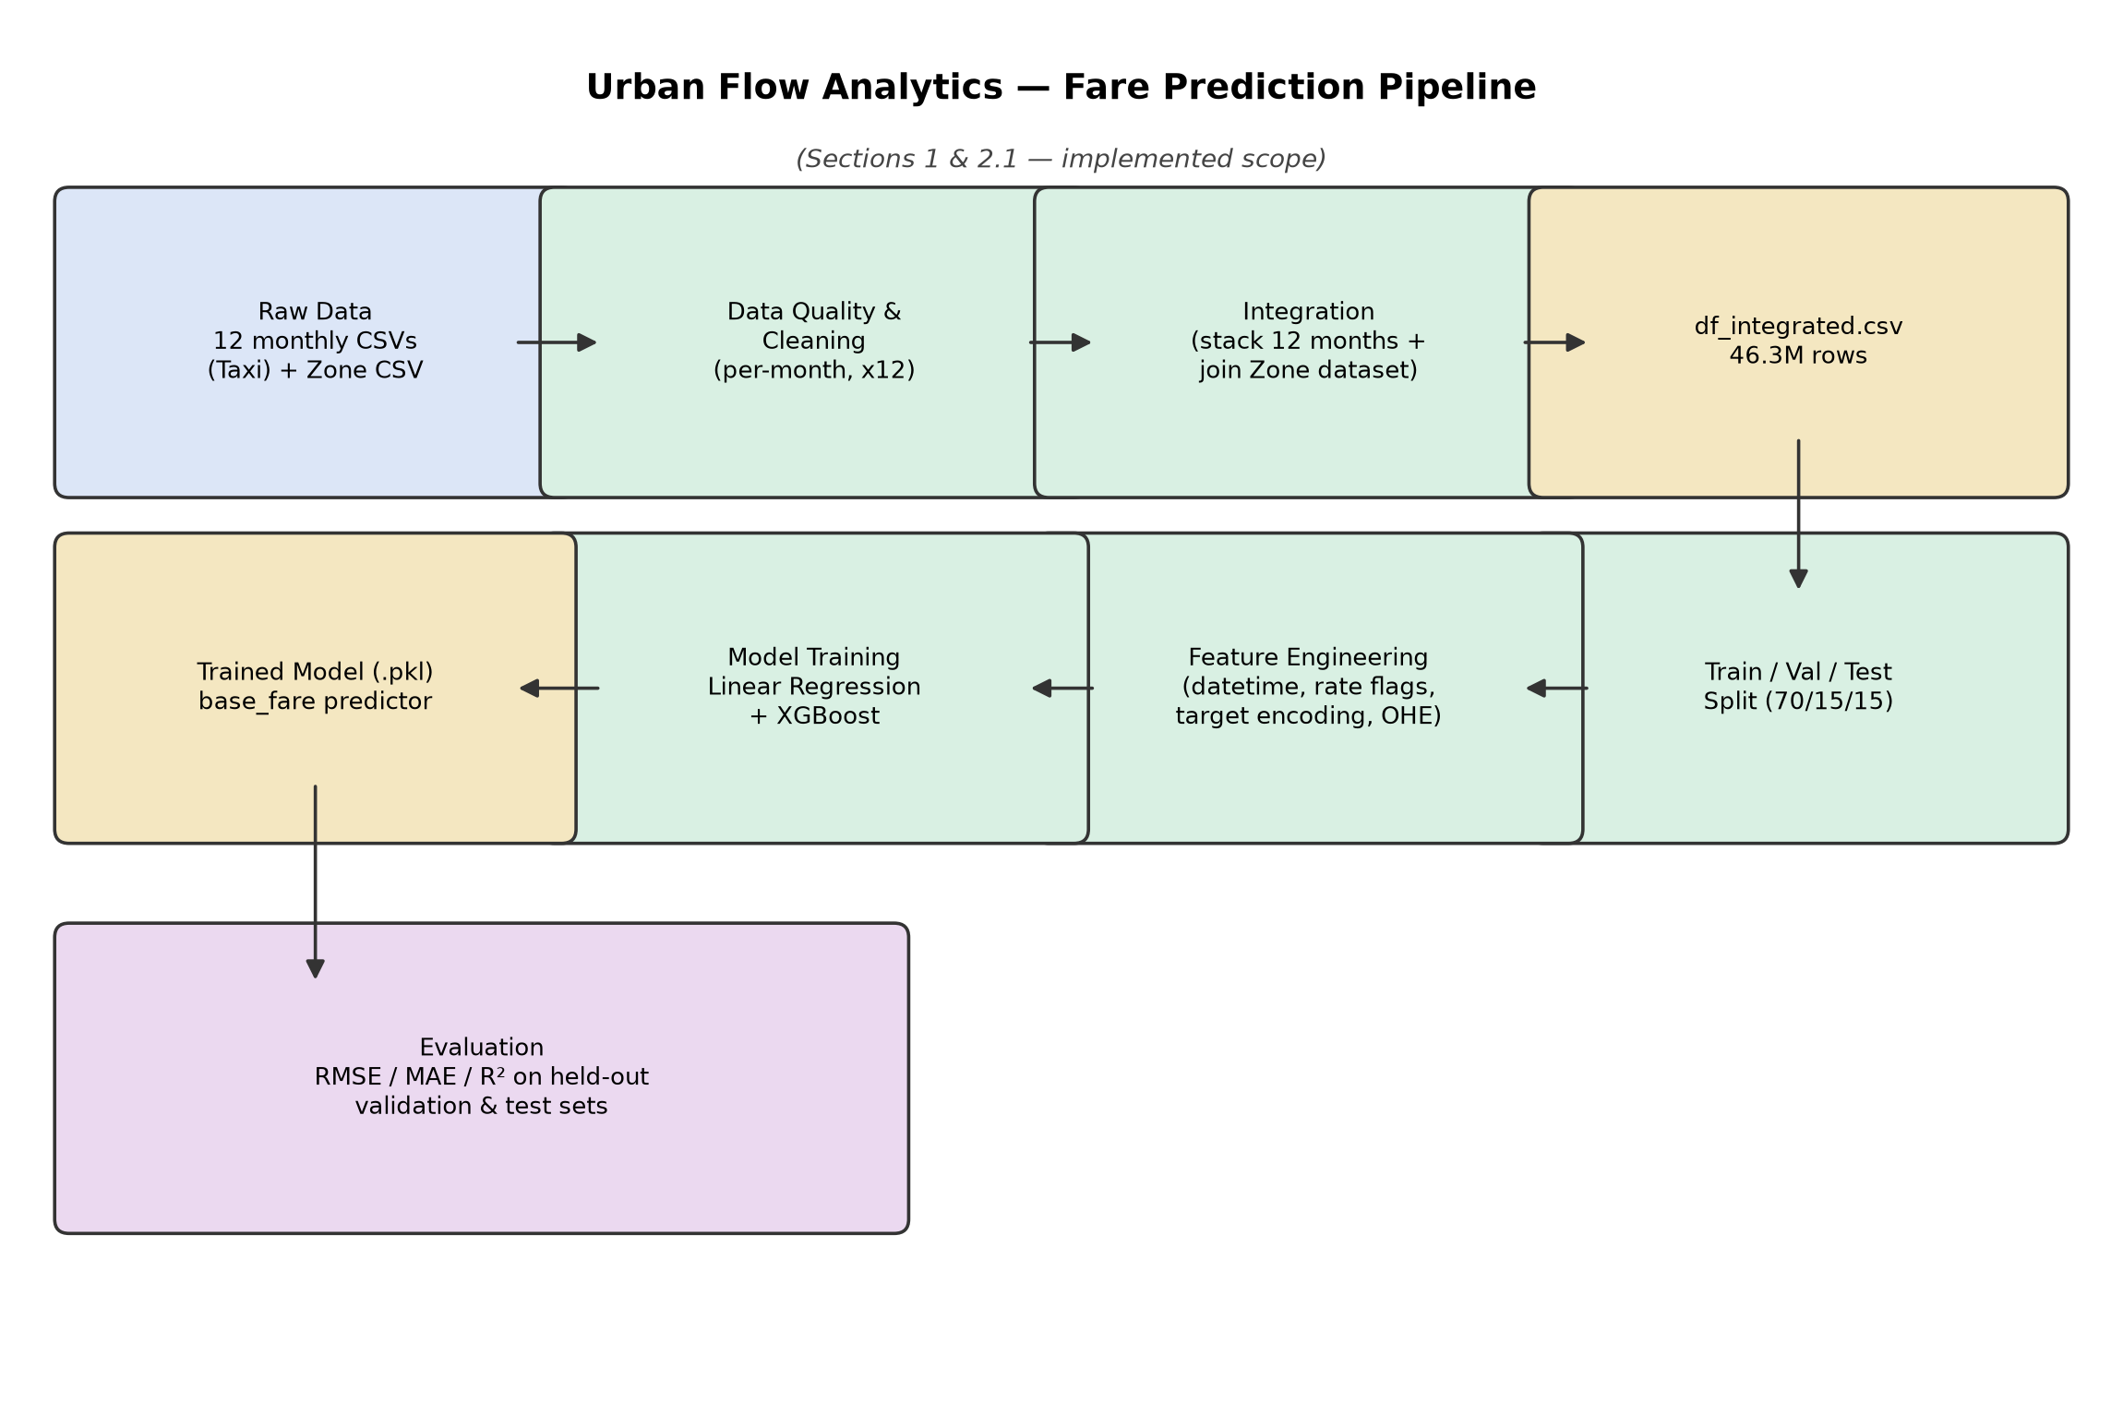
Figure 1. End-to-end pipeline for the implemented scope (Sections 1 and 2.1).

6. Key Findings, Limitations & Future Work

6.1 Key Findings
- Data quality issues are concentrated, not scattered: five anomaly checks combined touch roughly 4.6% of rows in a representative month, with zero-distance/nonzero-fare records the single largest category (3.45%) — pointing at meter/GPS logging as the primary data-quality risk area, more than fare entry errors.
- Missingness in rider_count, rate_class_id, offline_record_flag and the two fee columns is systematic (tied to provider_code) and affects over a quarter of rows — worth surfacing to operations, since it suggests specific provider integrations are not transmitting complete records.
- A simple, fully interpretable Linear Regression baseline currently gives the more trustworthy fare estimate by RMSE/R², while default XGBoost wins on typical-case error (MAE) — neither is yet a clear production choice without further tuning.
- distance_miles, rate-class flags (airport/negotiated/group) and zone-level target encodings are the intuitively dominant fare drivers; feature importances from the trained XGBoost model should be pulled into the next iteration of this report to confirm this quantitatively.

6.2 Business Implications
- A no-surprises upfront quote built on the current default-XGBoost model risks under-pricing outlier trips (airport runs, negotiated fares) — exactly the trips where a wrong quote is most visible to a rider. This should be resolved before the pricing feature is treated as launch-ready.
- The scale of the zero-distance-with-fare anomaly (3.45% of trips) is large enough to warrant a conversation with the meter/telematics vendor(s), rather than treating it purely as a modelling-side cleaning step.
- Provider-linked missingness (Section 1.1) suggests a data-completeness SLA gap with at least one upstream provider that operations may want to address independent of this modelling work.

6.3 Limitations of This Report
- Detailed anomaly diagnostics are shown for one representative month (December 2025); the other eleven months were cleaned with the identical pipeline but their individual diagnostic outputs were not captured for this report.
- The XGBoost model is untuned (default hyperparameters) and was evaluated only on the validation split in the current notebook — test-set numbers and a tuned comparison are not yet available.
- The train/validation/test split is a random row-level split, not time-based — adequate for fare prediction, but not directly reusable for the demand-forecasting task below without re-splitting by date.

6.4 Future Work (Remaining Brief Sections)
Brief Section | Status | Next Step
2.2 On-Time Arrival Estimator (trip duration) | Not started (notebooks/02_trip_duration.ipynb is empty) | Reuse the cleaned/integrated dataset; engineer duration-relevant features (distance, zone pair, time-of-day/traffic proxies); the dropoff≤pickup cleaning in Section 2.4 already protects this target.
3.1 Fleet Dispatcher (demand forecasting) | Not started | Aggregate pickups by zone/hour; requires a time-based (not random) split; time-series or gradient-boosted models for 24-72h pickup volume forecasts.
3.2 Hotspot & OD Flow Clustering | Not started | Cluster pickup/dropoff coordinates or zone pairs by time-of-day segment (e.g. K-means or DBSCAN on zone centroids/flow matrices).
Hyperparameter tuning of the fare model | Not started | Grid/Bayesian search on XGBoost (depth, learning rate, n_estimators, regularization); consider a log-transform of base_fare given the RMSE/MAE gap in Section 4.3.
Track 5 / Track 6 (bonus) | Not started | Out of scope for this report; open-ended bonus tracks.

7. Data & Deliverable Locations
Artifact | Path
Raw monthly taxi data | data/raw/Urban_Flow_Analytics_Taxi_Dataset_*.csv
Zone reference data | data/raw/Urban_Flow_Analytics_Zone_Dataset.csv
Cleaned monthly data | data/processed/df_cleaned_1.csv … df_cleaned_12.csv
Integrated dataset | data/processed/df_integrated.csv
Train/val/test splits | data/splits/{train,val,test}.csv
Data quality notebook | notebooks/data_quality.ipynb (+ scripts/01_data_quality.py)
Integration notebook | notebooks/integration.ipynb
Split notebook | notebooks/split.ipynb
Fare model notebook | notebooks/01_base_fare.ipynb
Trained model | models/xgboost_base_fare_model.pkl

