# Writing Image Files

* 1. For writing images to disks, “Win32 Disk Imager” (for Windows) and “dd” tool (for Linux) are used. Any other similar tool can be used as the alternative to the aforementioned tools. Insert the SD card to the SD Card reader of the PC.
  2. Open the terminal.
  3. Run “sudo umount /dev/sdX”; where “X” being the drive letter of the SD Card reader.
  4. Run “sudo dd if=/path/to/sd.img of=/dev/sdX”; where “X” being the drive letter and the “/path/to/sd.img” being the actual path to “sd.img”
  5. Wait till the operation is completed. It may take a while for this to complete.

## Write ‘sd.img’ to the SD Card

* + - Using “Win32 Disk Imager” (for Windows)
      1. Insert the SD card to the SD Card reader of the PC.
      2. Open Win32 Disk Imager.
      3. Select the image file of the SD Card (i.e. “sd.img”).
      4. Select the SD Card reader as the target.
      5. Click the “Write” button.

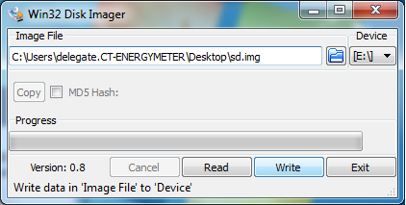

Step 5

Step 3

Step 4

* + - 1. Confirm overwrite when prompted.

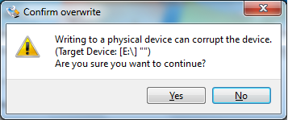

Step 6

* + - 1. A message will be shown upon successful completion. Click “OK”.



Step 7

* Using “dd” command (for Linux)
  1. Insert the SD card to the SD Card reader of the PC.
  2. Open the terminal.
  3. Run “sudo umount /dev/sdX”; where “X” being the drive letter of the SD Card reader.
  4. Run “sudo dd if=/path/to/sd.img of=/dev/sdX”; where “X” being the drive letter and the “/path/to/sd.img” being the actual path to “sd.img”
  5. Wait till the operation is completed. It may take a while for this to complete.

## Write ‘pen.img’ on the Pen Drive

* + - Using “Win32 Disk Imager”
      1. Insert the pen drive to the PC.
      2. Open Win32 Disk Imager.
      3. Select the image file of the pen drive (i.e. “pen.img”).
      4. Select the pen drive as the target.
      5. Click the “Write” button.

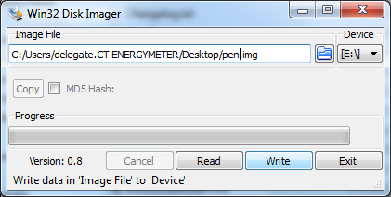

Step 5

Step 4

Step 3

* + - 1. Confirm overwrite when prompted.



Step 6

* + - 1. A message will be shown upon successful completion.
    - Using “dd” command (for Linux)
      1. Insert the pen drive to the PC.
      2. Open the terminal.
      3. Run “sudo umount /dev/sdX”; where “X” being the drive letter of the pen drive.
      4. Run “sudo dd if=/path/to/pen.img of=/dev/sdX”; where “X” being the drive letter and the “/path/to/sd.img” being the actual path to “pen.img”
      5. Wait till the operation is completed. It may take a while for this to complete.

# Server and Raspberry Pi Configuration

Linux partitions are not shown when the Pen Drive or the SD Card is connected to a Windows PC. Therefore for windows PCs a tool “Ext2Fsd” can be used to edit thee file in the Raspberry SD Card and the Pen Drive.

Following settings will only work for static IP configurations. For DHCP configurations refer to Raspberry Pi documentation. However make sure that the IP of the Raspberry Pi does not change over time.

Original files can be found with the extension “.orig” in the same directory of the file that is being modified. For example “home/pi/server.cfg.orig” has the original server setting of “server.cfg”.

## Server Configuration

### Plug in the Pen Drive to the PC

### Configure the server IP and Port in home/pi/server.cfg

#### The Server IP and the Server Port are in home/pi/server.cfg. Open this file using any text editor. The first line of the file is the server IP and the second line is the Server Port. Modify server.cfg appropriately. Then save the file.

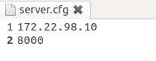

Server Port

Server IP

## Raspberry Pi Configuration

### Plug in the Pen Drive to the PC

### Configure the IP Address, Network Mask and Default Gateway in etc/network/interfaces

#### The Client IP and the Client Port are in etc/network/interfaces. Open this file using any text editor. Modify the file appropriately. Save the file.

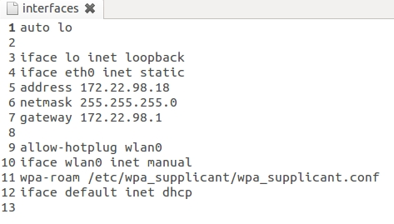

Client Default Gateway

Client IP

Client Network Mask

### Configure the Name Server in etc/resolv.conf

#### The Name Servers are in etc/resolv.conf. Open this file using any text editor. Modify the file appropriately. Save the file.

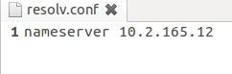

Name Server

# Final Setup

## Insert the SD Card and the Pen Drive.

## Plug in the Television set via HDMI cable.

## Plug in micro USB power supply. Most HDMI Television sets have USB ports. These ports can be used to power up the Raspberry Client.

If properly configured the Raspberry Pi Client will play the default playlist and will appear in the Client List Window of the server.