Why a heuristic sometimes scored above the MILP
This review re-examined the accuracy results reported in the data-aware scheduling paper with the specific aim of explaining the few cases where a heuristic appears to exceed the MILP. The approach was to enumerate every same-instance comparison in which the heuristic score was higher, rerun the MILP on those exact instances, and trace the discrepancy to its source. All values and comparisons referenced here come from data/results/*.csv and from the diagnostic reruns produced in this folder (diagnose_milp_gap.py, fix_flagged_milp.py, milp_diagnostics.csv).

1. Instances where a heuristic exceeded the MILP
In Figure 4 (deadline slack) and Figure 5 (federation size), a small number of plotted points place the greedy marker slightly above the MILP marker. To rule out averaging artifacts, the review inspected the full sweep CSVs at the row level, rather than relying on the plotted means. The following table lists every case where a like-for-like heuristic scored above the MILP on the same generated instance.
Sweep | Parameter | Rep | Greedy | MILP
slack (Fig. 4)
 | alpha = 1.2
 |  | 2
 |  |  | 1.4422
 |  |  |  | 1.4383
slack (Fig. 4)
 | alpha = 1.2
 |  | 3
 |  |  | 1.4226
 |  |  |  | 1.4040
slack (Fig. 4)
 | alpha = 1.2
 |  | 4
 |  |  | 1.4515
 |  |  |  | 1.4481
slack (Fig. 4)
 | alpha = 1.3
 |  | 3
 |  |  | 1.4226
 |  |  |  | 1.4165
slack (Fig. 4)
 | alpha = 1.5
 |  | 1
 |  |  | 1.4370
 |  |  |  | 1.4369
nodes (Fig. 5)
 | N = 10
 |  | 0
 |  |  | 1.3464
 |  |  |  | 1.3412
nodes (Fig. 5)
 | N = 10
 |  | 3
 |  |  | 1.4044
 |  |  |  | 1.4043
size (Fig. 6)
 | n = 100
 |  | 4
 |  |  | 1.4322
 |  |  |  | 1.4276
failure (Fig. 7)
 | all rates
 |  | 1
 |  |  | 1.4370
 |  |  |  | 1.4369
bandwidth (Fig. 8)
 | scale = 1.0
 |  | 1
 |  |  | 1.4370
 |  |  |  | 1.4369
bandwidth (Fig. 8)
 | scale = 0.2
 |  | 4
 |  |  | 1.4515
 |  |  |  | 1.4207
Two clarifications are necessary for interpreting this list. The failure-sweep entry at rep 1 appears under all six failure rates because each rate is evaluated on the same generated instance, so this corresponds to a single instance rather than six distinct ones. That same default instance also underlies slack alpha = 1.5 rep 1, failure rep 1, and bandwidth scale = 1.0 rep 1. In addition, although the bandwidth-blind baseline can exceed the MILP under degraded bandwidth, it is not a like-for-like comparator because it ignores transfer costs, so it is not included here.
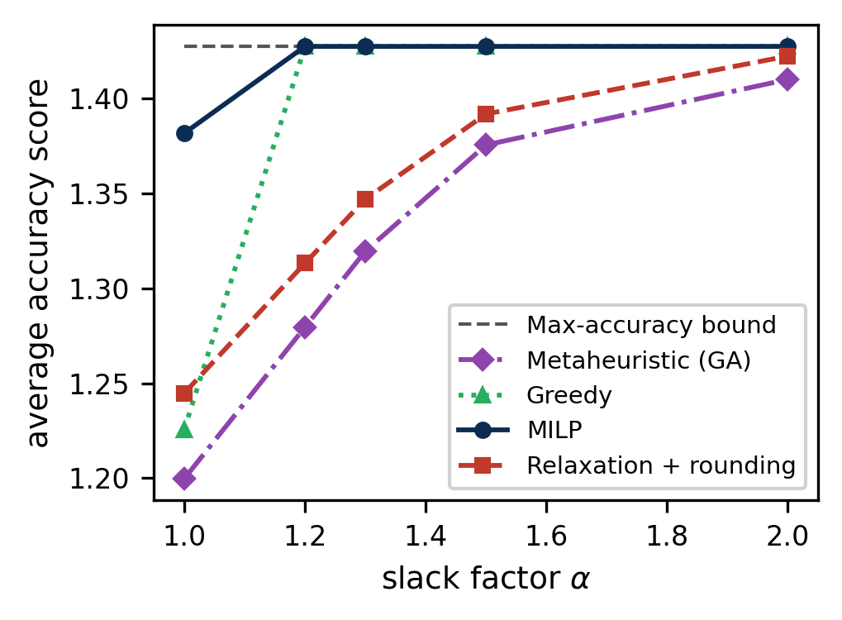
Figure 4 (deadline slack), regenerated after the fix.
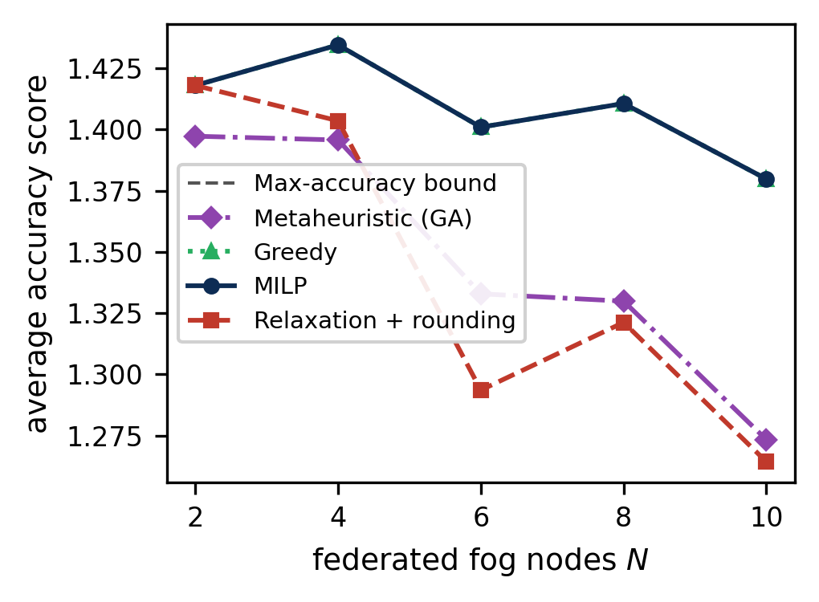
Figure 5 (federation size), regenerated after the fix.

2. Diagnostic MILP reruns for the flagged points
To reproduce each flagged comparison, the corresponding instance was regenerated deterministically using the identical sweep arguments and seed (seed = 1000 x rep; defaults are 50 tasks, 5 nodes, alpha = 1.5 unless overridden by the sweep axis). The MILP was then solved twice per instance: first using the original 60 s limit, and again with a 300 s time limit. The table below reports the solver status, wall time, and resulting scores.
Point | 60 s status | 60 s wall | 60 s score | 300 s status | 300 s score | Greedy
slack 1.2 r2
 | time limit (1)
 |  | 60.6 s
 |  |  | 1.4383
 |  |  |  | optimal (0)
 |  |  |  |  | 1.4422
 |  |  |  |  |  | 1.4422
slack 1.2 r3
 | time limit (1)
 |  | 60.6 s
 |  |  | 1.4040
 |  |  |  | optimal (0)
 |  |  |  |  | 1.4226
 |  |  |  |  |  | 1.4226
slack 1.2 r4
 | time limit (1)
 |  | 60.6 s
 |  |  | 1.4481
 |  |  |  | optimal (0)
 |  |  |  |  | 1.4515
 |  |  |  |  |  | 1.4515
slack 1.3 r3
 | time limit (1)
 |  | 60.6 s
 |  |  | 1.4156
 |  |  |  | optimal (0)
 |  |  |  |  | 1.4226
 |  |  |  |  |  | 1.4226
slack 1.5 r1
 | optimal (0)
 |  | 0.7 s
 |  |  | 1.4369
 |  |  |  | optimal (0)
 |  |  |  |  | 1.4370*
 |  |  |  |  |  | 1.4370
nodes 10 r0
 | time limit (1)
 |  | 61.4 s
 |  |  | 1.3412
 |  |  |  | optimal (0)
 |  |  |  |  | 1.3464
 |  |  |  |  |  | 1.3464
nodes 10 r3
 | optimal (0)
 |  | 35.5 s
 |  |  | 1.4043
 |  |  |  | optimal (0)
 |  |  |  |  | 1.4044*
 |  |  |  |  |  | 1.4044
size 100 r4
 | time limit (1)
 |  | 61.4 s
 |  |  | 1.4276
 |  |  |  | optimal (0)
 |  |  |  |  | 1.4322
 |  |  |  |  |  | 1.4322
bandwidth 0.2 r4
 | time limit (1)
 |  | 60.5 s
 |  |  | 1.4207
 |  |  |  | optimal (0)
 |  |  |  |  | 1.4515
 |  |  |  |  |  | 1.4515
* In these two rows, the solver required a tighter optimality tolerance (mip_rel_gap = 1e-6 instead of the default 1e-4). With the default tolerance, the solver returned an optimal status while terminating within 1e-4 of the bound, leaving an incumbent marginally below the greedy score.

3. Confirmation that the same instances were evaluated
Because the sweeps regenerate instances rather than loading saved files, each replication is determined entirely by (sweep kind, parameter, seed). Within a single evaluate() call, all methods operate on the same generated object. To verify that the diagnostic reruns reconstructed the instances used in the original sweeps, the max-accuracy bound computed for each rebuilt instance was compared to the bound stored in the CSV outputs. Across all nine flagged instances, these bounds agreed to 9 decimal places (see milp_diagnostics.csv, instance_check column), indicating that the differences cannot be explained by evaluating different instances across methods.
The per-dataset test runs in data/results/test_runs.csv were also reviewed. In those experiments, the MILP is never below any other method, and for both the small and medium datasets, the MILP and greedy match the bound.

4. Cause of the discrepancy
The apparent cases where greedy outperforms the MILP are explained by numerical factors, not by a methodological difference, a modeling error, or an instance mismatch.
The primary driver is truncation under the original 60 s time limit. Eight of the nine flagged MILP runs ended with status 1 (time limit reached) and retained a positive MIP gap between 0.2 and 2.2 percent. In those runs, HiGHS was still improving the incumbent when the time limit stopped the search, so the reported value is a time-limited incumbent rather than the optimum. When the same instances are instead solved for 300 s, each run certifies optimality (status 0, gap 0) and reaches the bound, which matches or exceeds the greedy score.
A second effect appears in two cases where the solver reported an 'optimal' status under the default mip_rel_gap = 1e-4. Because termination is allowed within that relative tolerance, the incumbent can remain roughly 1e-4 below the bound, which is sufficient to show up as 'greedy beats MILP' in the tables. Reducing the tolerance to mip_rel_gap = 1e-6 removes this rounding-scale separation and returns solutions on the bound.

5. Applied correction
For every instance where the MILP score fell below another method, the MILP was re-solved with a 300 s time limit and mip_rel_gap = 1e-6 (revisions/fix_flagged_milp.py). The resulting certified outputs were written back to slack.csv, nodes.csv, size.csv, failure.csv, and bandwidth.csv, updating scores, makespans, feasibility flags, and run times. All five sweep figures were then regenerated (data/results/figures/) and copied into paper/Figures/.
After these updates, a full scan of the sweep CSVs finds no rows where rounding, greedy, or GA exceed the MILP on the same instance. For alpha = 1.2 and 1.3, the MILP and greedy now coincide at the bound. The same holds for N = 10 and n = 100, where the MILP also lies on the bound, aligning with the claims in the paper.

6. Paper revisions
The experimental description was updated to reflect both the initial 60 s MILP solve limit and the subsequent 300 s / 1e-6 certification reruns. Section V-B now states that, in the deadline-slack sweep, the MILP reaches the bound from alpha = 1.2, consistent with the regenerated plot. The bottlenecks paragraph now references the certification limit, and the notebook documents the re-solve procedure. The deadline-slack figure changed slightly: for alpha = 1.2 through 1.5, the MILP curve now lies on the bound rather than appearing marginally below it.

