# Objective

To understand the impact of marketing spends (google and meta),app installs, rain, weekend, online traffic on footfall (pspd).

# Variables

The variables which are used for analysis are as follows:

| Business Buckets | Variable Name |
| --- | --- |
| **Performance Spend** | performance_spend_google, performance_spend_meta |
| **App Install** | app_installs |
| **Weekend Effect** | weekend_flag (binary variable containing values 0 and 1) |
| **Holiday Effect** | sg_holiday_details (binary variable containing values 0 and 1 where 0 means not a holiday and 1 means holiday) |
| **Rain Effect** | rain_mm |
| **Online Traffic** | online_traffic (including web and app) |
| **Footfall** | pspd |

# Descriptive Statistics of Variables

Data Granurality - daily

Data Duration - 2023-11-01 to 2024-11-30

### **Numerical Variables**

|  | **online_traffic** | **app_installs** | **performance_spend_google ($)** | **performance_spend_meta ($)** | **rain_mm** | **pspd** |
| --- | --- | --- | --- | --- | --- | --- |
| **count** | 396 | 396 | 396 | 396 | 396 | 396 |
| **mean** | 4492.77 | 41.85 | 1291.29 | 1185.13 | 7.85 | 72.86 |
| **std** | 1923.72 | 27.19 | 803.13 | 918.05 | 13.74 | 27.20 |
| **min** | 2431.00 | 5.00 | 0.00 | 49.57 | 0.00 | 15.54 |
| **1%** | 2729.45 | 8.00 | 262.67 | 123.09 | 0.00 | 36.89 |
| **5%** | 3214.25 | 10.00 | 492.15 | 225.79 | 0.00 | 43.75 |
| **10%** | 3301.50 | 15.00 | 636.97 | 318.09 | 0.00 | 47.68 |
| **25%** | 3593.00 | 22.00 | 837.72 | 558.57 | 0.00 | 52.64 |
| **50%** | 3953.50 | 36.00 | 1079.53 | 916.53 | 1.20 | 65.00 |
| **75%** | 4825.25 | 55.25 | 1483.66 | 1384.88 | 9.20 | 89.47 |
| **90%** | 6014.00 | 74.50 | 2182.91 | 2680.42 | 25.40 | 112.43 |
| **95%** | 6712.75 | 94.00 | 2986.73 | 3239.43 | 37.30 | 128.41 |
| **99%** | 12911.45 | 139.25 | 4010.28 | 4327.00 | 64.09 | 150.64 |
| **max** | 26339.00 | 177.00 | 6894.33 | 4671.02 | 85.80 | 192.75 |

### **Categorical Variables**

|  | **sg_holiday_details** | **weekend_flag** |
| --- | --- | --- |
| **count** | 396 | 396 |
| **mean** | 0.0303 | 0.2854 |
| **std** | 0.1716 | 0.4522 |
| **min** | 0 | 0 |
| **25%** | 0 | 0 |
| **50%** | 0 | 0 |
| **75%** | 0 | 1 |
| **max** | 1 | 1 |

# Adstock Transformation of Variables

In marketing analytics, it is critical to account for the delayed and diminishing effects of marketing activities. Advertising spend does not always impact footfall immediately; instead, its influence may persist over time and gradually decay. To capture this effect, we apply the Adstock Transformation to relevant variables.

In this analysis, we have applied this transformation to variables performance_spend_meta, performance_spend_google, app_installs and online_traffic.

The **Adstock Transformation** smooths the data, accounting for how past data continues to drive footfall over time.

**Formula:**

**Xt* = Xt + λ* Xt-1\***

Where:

* Xt = Current period's ad spend
* Xt*​ = Adstocked spend
* λ = Decay rate (0 < λ < 1), capturing how quickly the ad effect diminishes.Greater the value of lambda less gradual the decay i.e. the effect remains for longer duration.

The optimal value of lambda is often estimated during model training.

# Correlation Heatmap

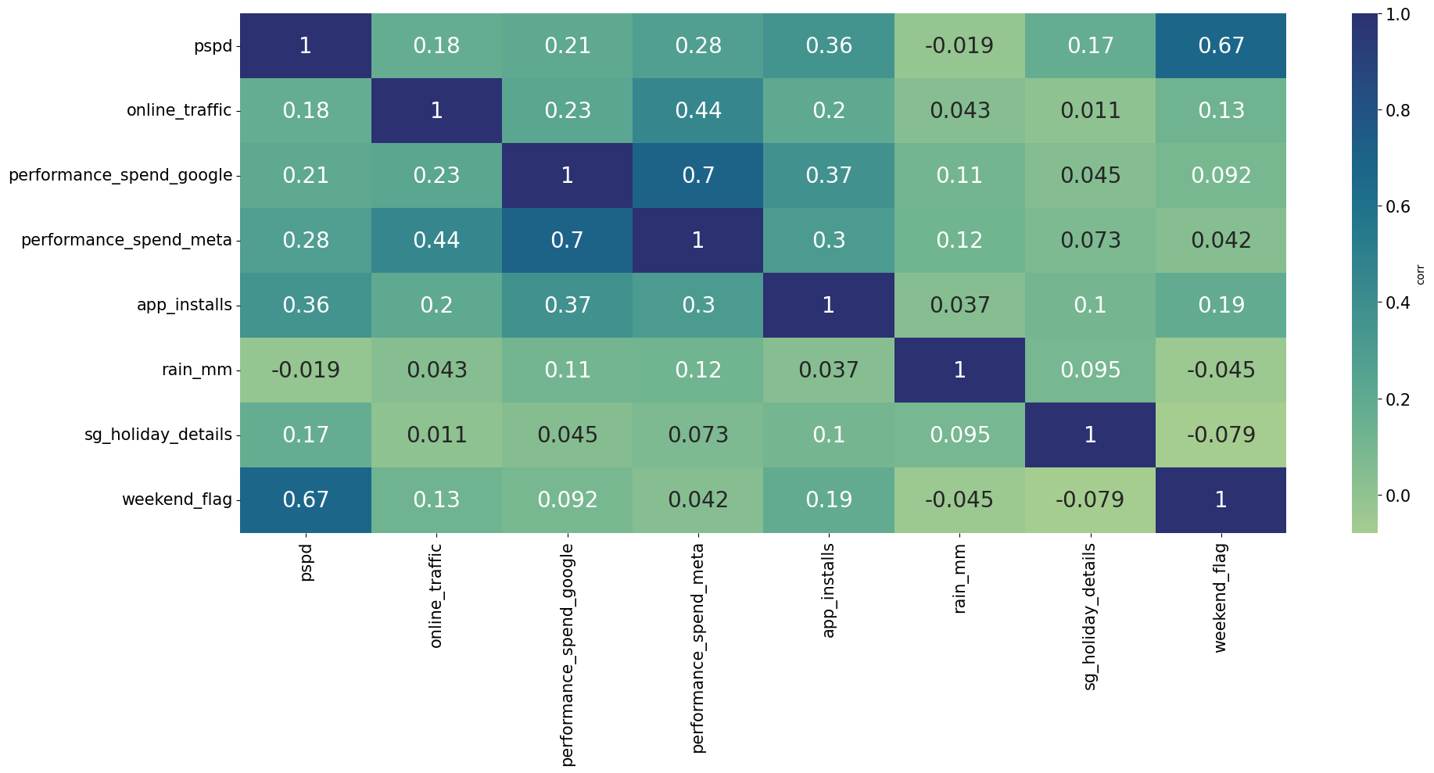

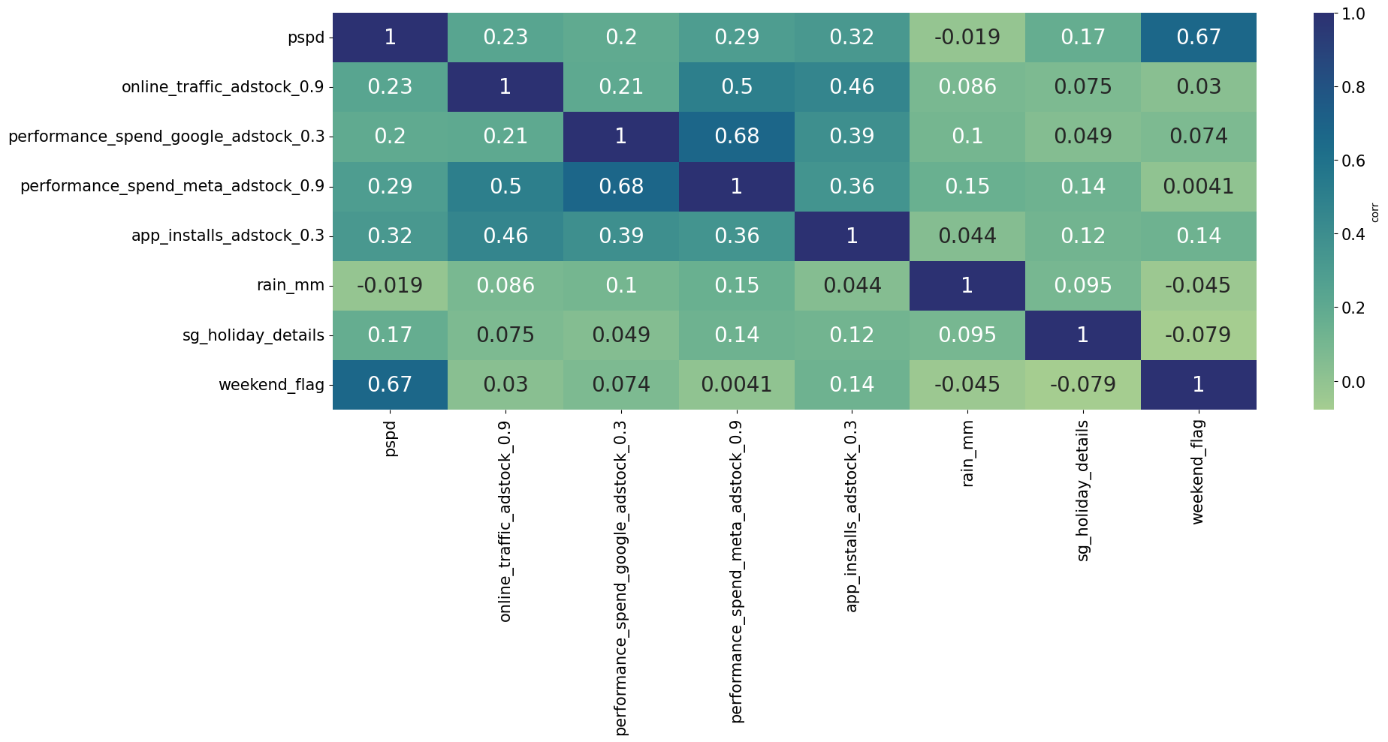Observations

* Correlation of pspd with weekend_flag is high.
* pspd is weakly correlated with performance_spend_meta, performance_spend_google,

online_traffic and app_installs.

* There is no correlation between pspd and rain_mm.
* High correlation between performance_spend_google and performance_spend_meta.

# EDA

**Categorical Variables**

* Bar graph of pspd vs sg_holiday_details and weekend_flag is shown below. It clearly shows that the footfall is increased significantly over weekends and also over festival holidays.

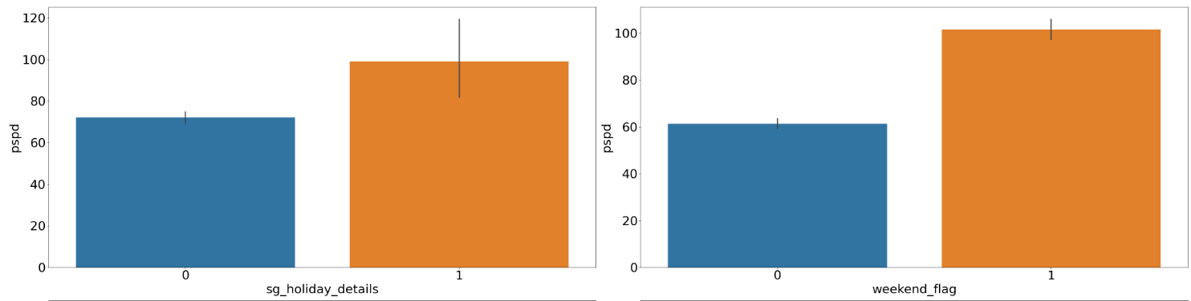

* To analyze the impact of rainfall on store footfall, two categorical variables were created:
* **Rain Indicator:** A binary variable indicating whether it rained on a particular day (rain or no rain).
* **Rain Intensity:** A categorical variable segmenting rainy days into three categories based on intensity:
  + **Light Rain**
  + **Moderate Rain**
  + **Heavy Rain**
  + **Extremely Heavy Rain**
* Upon analyzing the relationship between these variables and daily footfall, no significant trend or slope was observed.
* This suggests that footfall remains relatively consistent regardless of whether it rained or the intensity of the rain.
* Therefore, rainfall does not appear to have a measurable impact on customer footfall.

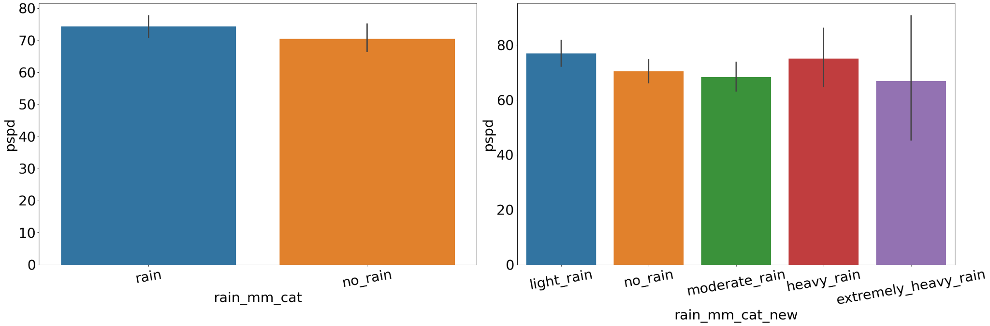

**Numerical Variables**

The scatterplots of numerical variables with pspd are shown below.

* It clearly indicates that app installs, performance_spend_meta, performance_spend_google have some impact over pspd these observations align with correlation heatmap shown above.
* Online Traffic doesn't have much impact over pspd

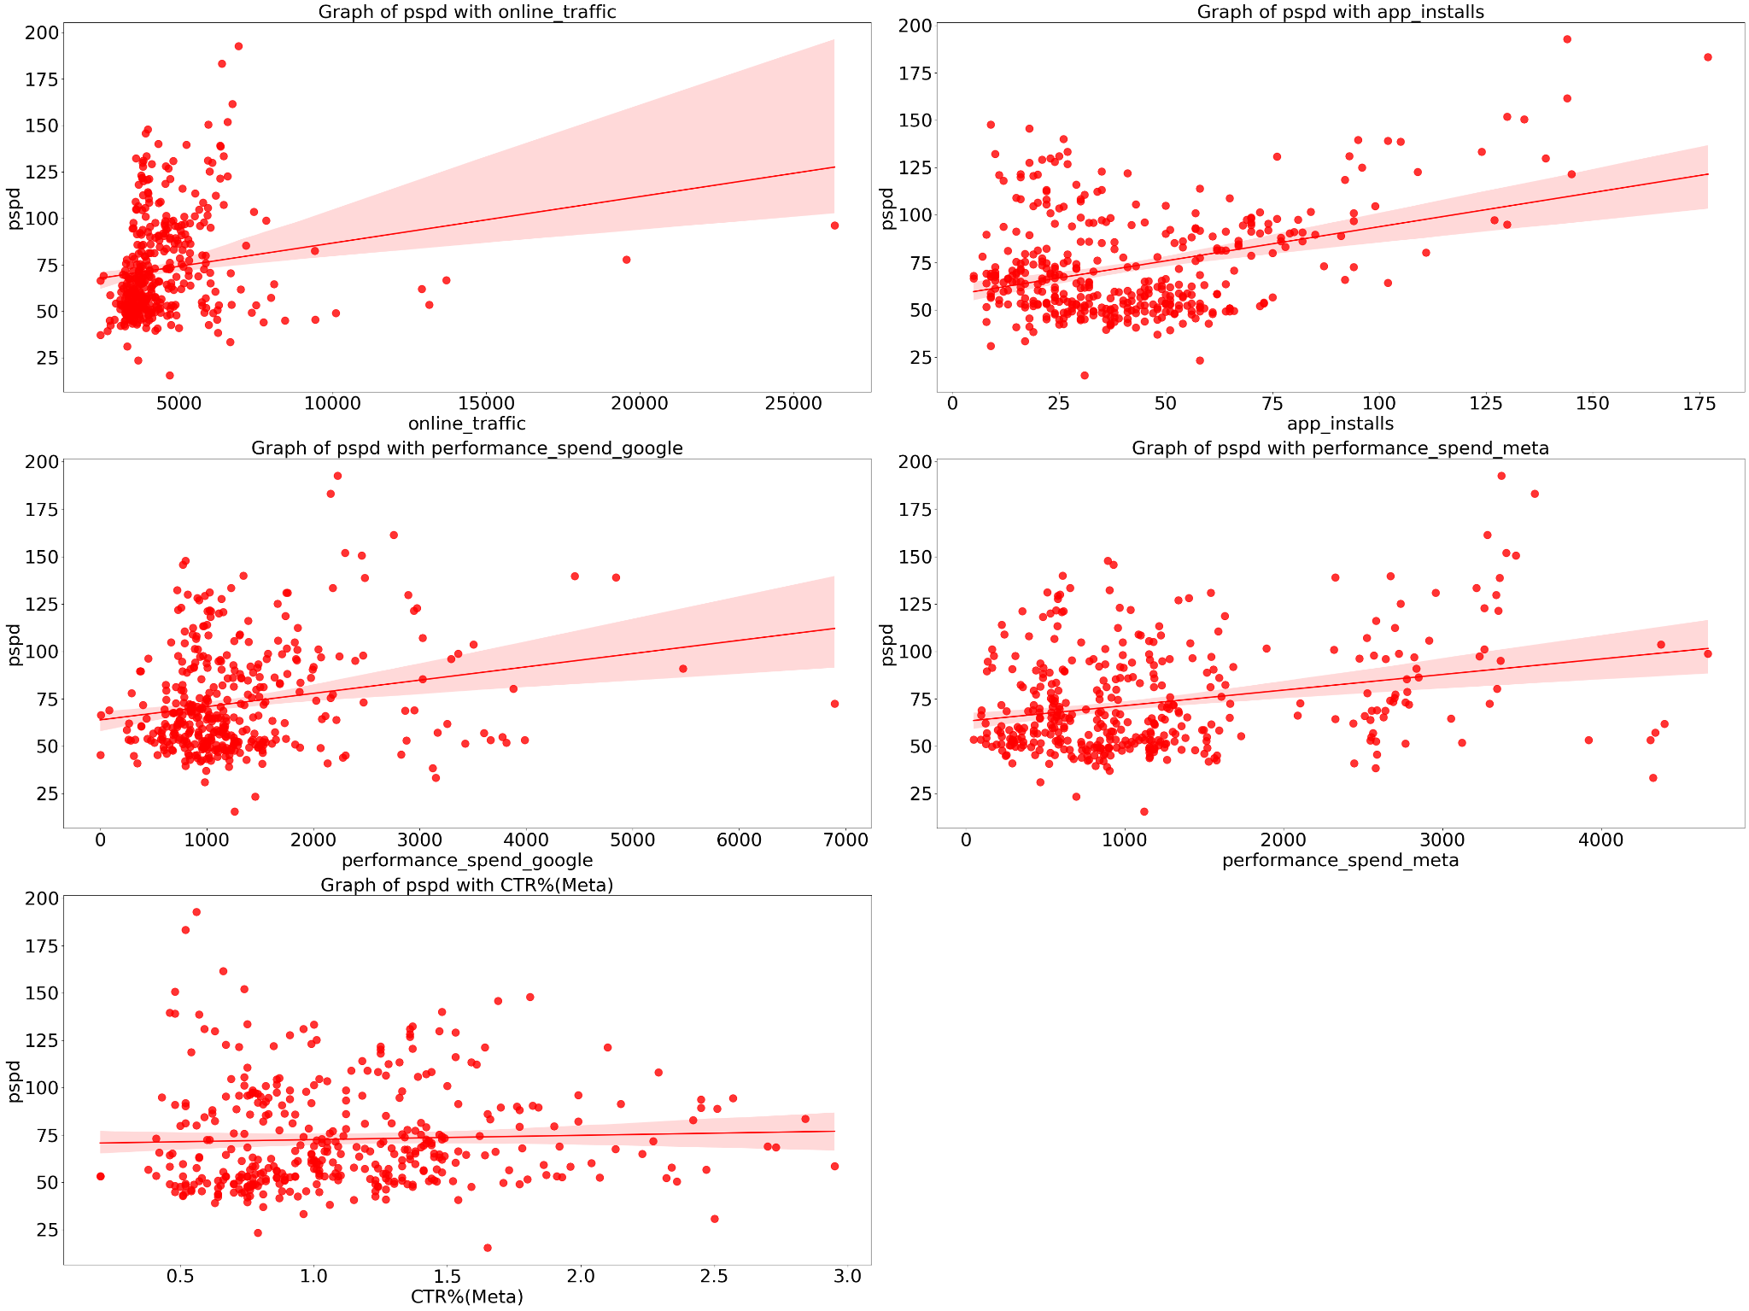

# Regression Model

To quantify the impact of adstock-transformed numerical variables and categorical variables on footfall, a regression model was implemented.

* The adstock transformation was applied to marketing spend variables (e.g., performance spend on Meta and Google, app installs, and online traffic) to account for the delayed and diminishing effects of marketing efforts.
* The decay factor (λ), which controls how past marketing activities influence the present, was optimized by iterating over multiple λ values.
* The λ value that exhibited the highest correlation with the target variable (pspd/footfall) was selected for the regression model to best capture the effect of marketing efforts.

Results

1. Regression Model with all the variables included.

| feature | Statistical Significant | Elasticity | Insights |
| --- | --- | --- | --- |
| const |  |  | **Coefficient:** 52.19  This represents the baseline footfall when all independent variables are zero. |
| online_traffic_adstock_0.9 | No | -0.031 | The negative coefficient suggests that an increase in online traffic slightly reduces footfall, though the result is **statistically insignificant**. |
| performance_spend_google_adstock_0.3 | Yes | -0.088 | Increased Google performance spend is negatively associated with footfall.This result is counterintuitive and could be attributed to **multicollinearity** with Meta spend, causing distorted effects. |
| performance_spend_meta_adstock_0.9 | Yes | 0.15 | Meta spending has a **positive impact** on footfall. A **1%** increase in adstock adjusted Meta spend is expected to increase footfall by **0.15%**. The **high decay factor (0.9)** suggests that Meta's marketing impact is **long-lasting** |
| app_installs_adstock_0.3 | Yes | 0.08 | A 1% increase in the **adstock-adjusted app installs** leads to an **0.08% increase** in footfall.  The **lower decay factor (0.3)** indicates that app installs have a **short-term impact**. |
| rain_mm_cat | No | 0.2 | Rain shows **no significant impact** on footfall. |
| sg_holiday_details | Yes | 44.28 | Holidays **positively impact footfall**, increasing visits by **44.28%**. |
| weekend_flag | Yes | 53.87 | Weekends significantly **boost footfall** by **53.87%** |

1. Regression Model after removing multicollinearity (removing performance_spend_google) and non-statistically significant variables.

| feature | Statistical Significant | Elasticity | Insights |
| --- | --- | --- | --- |
| const |  |  | **Coefficient:** 47.83  This represents the baseline footfall when all independent variables are zero. |
| performance_spend_meta_adstock_0.9 | Yes | 0.11 | Meta spending has a **positive impact** on footfall. A **1%** increase in **adstock adjusted Meta spend** is expected to increase footfall by **0.11%**. The **high decay factor (0.9)** suggests that Meta's marketing impact is **long-lasting** |
| app_installs_adstock_0.3 | Yes | 0.08 | A 1% increase in the **adstock adjusted app installs** leads to an **0.08% increase** in footfall.  The **lower decay factor (0.3)** indicates that app installs have a **short-term impact**. |
| sg_holiday_details | Yes | 45.53 | Holidays **positively impact footfall**, increasing visits by **45.53%**. |
| weekend_flag | Yes | 58.48 | Weekends significantly **boost footfall** by **58.48%.** Rain on weekend will reduce the footfall by **8.86%** |

Detailed regression report is attached [here](https://docs.google.com/spreadsheets/d/1q0Hi16DLKicbdWFlDv7kiRf6EYKnbGKjVinrfc6GMuE/edit?gid=0#gid=0)