MULTI-AGENT WAREHOUSE ROBOT COORDINATOR
Case Study Documentation
Team Members:
Vijay Krishna CB.SC.U4CSE23112
Gayas Sheik CB.SC.U4CSE23118
Sai Jeevan CB.SC.U4CSE23124
Manish CB.SC.U4CSE23125

1. Introduction
The Multi-Agent Warehouse Robot Coordinator is a simulation-based artificial intelligence system designed to demonstrate how multiple autonomous agents can coordinate warehouse package-delivery tasks. The system models a warehouse as a grid environment containing obstacles, packages, and multiple robots. It combines task allocation, A* pathfinding, obstacle avoidance, multi-agent coordination, and failure recovery.
1.1 Motivation
A warehouse with multiple autonomous robots requires agents to select tasks, navigate shared spaces, and continue operations when individual robots become unavailable. The project provides a controlled environment for demonstrating these multi-agent concepts using a visual simulation.
1.2 Scope
The implemented system contains five robots and ten packages in a 25 × 25 grid-based warehouse. It supports automatic task assignment, A* navigation, package pickup and delivery, robot failure handling, package recovery and reassignment, pause/resume, and simulation reset.

2. Problem Statement
Warehouse environments may contain multiple tasks and multiple autonomous robots operating simultaneously. Without coordination, robots may be assigned inefficiently, encounter obstacles, or become unable to complete their tasks when a robot fails. This project addresses these challenges through a multi-agent warehouse simulation with automatic task allocation, A* navigation, multi-robot coordination, and failure recovery.

3. Objectives
Develop a multi-agent warehouse robot simulation.
Automatically allocate package delivery tasks to available robots.
Use A* search for grid-based pathfinding.
Enable robots to navigate around warehouse obstacles.
Prevent robots from moving into cells occupied by other active robots.
Support package recovery and reassignment following robot failure.
Allow continued operation when up to three robots fail.
Provide a visual dashboard for monitoring robot and package activity.

4. PEAS Formulation
Component | Project Specification
Performance Measure | Successful package delivery, task completion, safe navigation, continued operation after robot failures, and package recovery/reassignment.
Environment | A 25 × 25 grid-based warehouse containing free cells, shelves/obstacles, pickup locations, and delivery locations.
Actuators | Robot movement between adjacent valid grid cells and task actions such as pickup and delivery.
Sensors / State Information | Robot position/state, package position/status, warehouse obstacle/grid information, and positions of other active robots available to the simulation.

5. Environment and Agent Analysis
5.1 Environment
The warehouse is represented as a 25 × 25 grid. Free cells represent traversable warehouse floor areas, while blocked cells represent shelves or other obstacles. Packages have pickup and delivery coordinates and can exist in states including Waiting, Assigned, Picked Up, Dropped, and Delivered.
5.2 Agents
The simulation contains five robot agents. Each robot has a position, current task, path, operational state, completed-task count, travel distance, replanning count, and failure state. Robots operate concurrently and receive tasks through the coordinator.
5.3 Package States
Waiting – Assigned - Picked Up – Dropped – Delivered
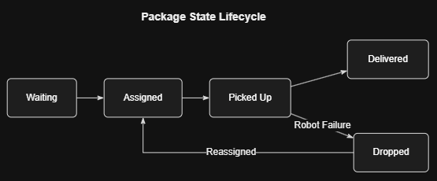
5.4 Agent Interaction
The coordinator assigns available tasks to active robots. Each Robot calculates and follows a path to its current target. The Recovery component handles failed robots and makes affected packages available for reassignment. The Environment provides the warehouse grid, obstacles, package definitions, and visualization.
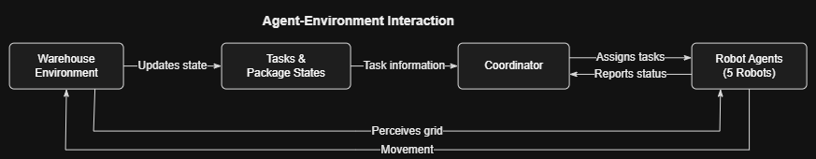

6. System Architecture and Design
The system follows a modular architecture in which environment modelling, robot behavior, coordination, failure recovery, and application integration are separated into dedicated Python modules.
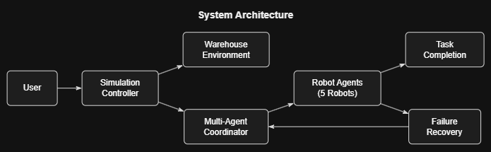
Module | Primary Responsibility | Role in System
environment.py | Warehouse grid, obstacles, packages, visualization | Defines the simulated warehouse environment and package information.
robot.py | Robot state, movement, A* pathfinding, collision avoidance, replanning | Implements autonomous robot behavior.
coordinator.py | Task allocation and robot selection | Assigns available packages to suitable active robots.
recovery.py | Failure handling, package recovery, reassignment, statistics/UI | Handles robot failures and recovery.
main.py | Integration and simulation loop | Initializes, updates, controls and renders the simulation.
6.1 System Workflow
The workflow begins with initialization of the warehouse, robots, and packages. The coordinator automatically assigns available packages. Robots calculate paths using A* and navigate through valid cells. Packages are picked up and transported to their delivery locations. When a robot fails, the Recovery component handles the affected package and the coordinator can reassign it to another active robot.
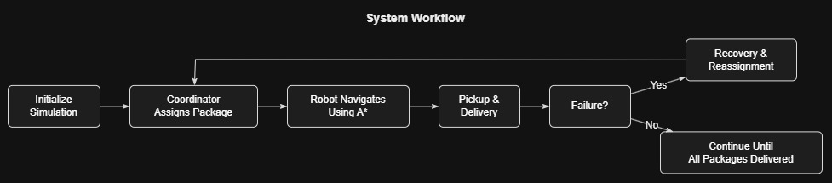

7. Algorithmic Modelling and Search Strategy
7.1 A* Pathfinding
A* search is used to calculate paths between a robot's current position and its target position. The implementation uses Manhattan distance as the heuristic because movement is restricted to four neighbouring grid directions.
The algorithm combines the accumulated path cost with a heuristic estimate of the remaining distance. Obstacle cells are excluded from normal movement. Temporarily occupied robot cells can also be supplied as blocked positions during path calculation.
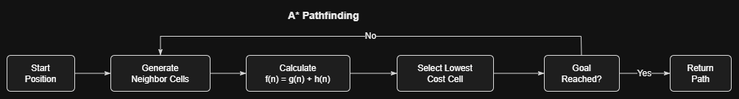
7.2 Task Allocation
The coordinator identifies idle and non-failed robots and selects an available robot using Manhattan distance to the relevant package location. Dropped-package recovery tasks are prioritized before normal waiting packages.

7.3 Multi-Agent Collision Handling
Before a robot moves to its next cell, the current positions of other active robots are considered. If the intended next cell is occupied, the robot does not enter that cell and can recalculate a path around the temporary blockage.
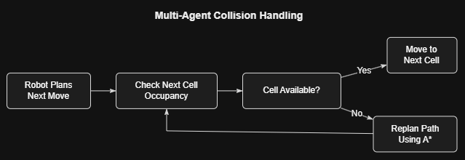
7.4 Failure Recovery
When a robot fails, it is marked as FAILED and becomes inactive. If it was carrying a package, the package becomes Dropped at the failure location used by the recovery mechanism. If the robot had not picked up its package, the package returns to a recoverable Waiting state at its pickup location. The coordinator can then assign the affected package to another active robot.
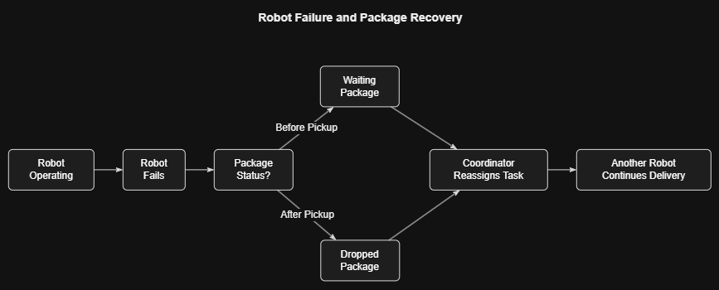
7.5 Failure Scope
The implementation supports a maximum of three robot failures during a simulation. A fourth simultaneous robot failure is outside the defined project scope.

8. Tools, Technologies and Packages
Technology / Tool | Purpose | Use in Project
Python 3.10 | Programming language | Core simulation implementation
Pygame 2.6.1 | Simulation and visualization | Rendering, controls and dashboard
A* Search | Pathfinding algorithm | Robot navigation
VS Code | Development environment | Development and code editing
Conda environment | Python environment management | Development environment setup

9. Implementation Details
The implementation is organized into modular Python files so that environment modelling, robot behavior, coordination, recovery, and application integration remain separated.
environment.py — Warehouse grid, obstacles, packages, visualization
robot.py — Robot state, movement, A* pathfinding, collision avoidance, replanning
coordinator.py — Task allocation and robot selection
recovery.py — Failure handling, package recovery, reassignment, statistics/UI
main.py — Integration and simulation loop
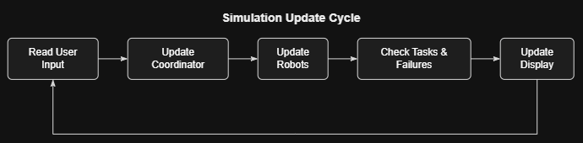

9.1 User Controls
Control | Function
1 | Fail Robot 1
2 | Fail Robot 2
3 | Fail Robot 3
4 | Fail Robot 4
5 | Fail Robot 5
SPACE | Pause / Resume
R | Reset simulation
9.2 Source Code Structure
main.py — entry point and simulation loop
environment.py — warehouse and package environment
robot.py — robot behavior and A* navigation
coordinator.py — task allocation and coordination
recovery.py — failure recovery, reassignment and dashboard
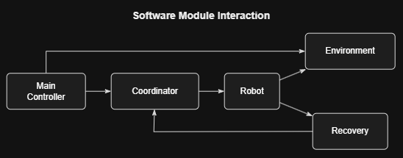

10. Results and Discussion
The completed simulation demonstrates coordinated operation of five warehouse robots across a 25 × 25 grid with ten packages, automatic task allocation, obstacle-aware navigation, package delivery, and failure recovery. The dashboard provides live information about robot status, task counts, distance travelled, assignments, replanning, package states, and robot failures.
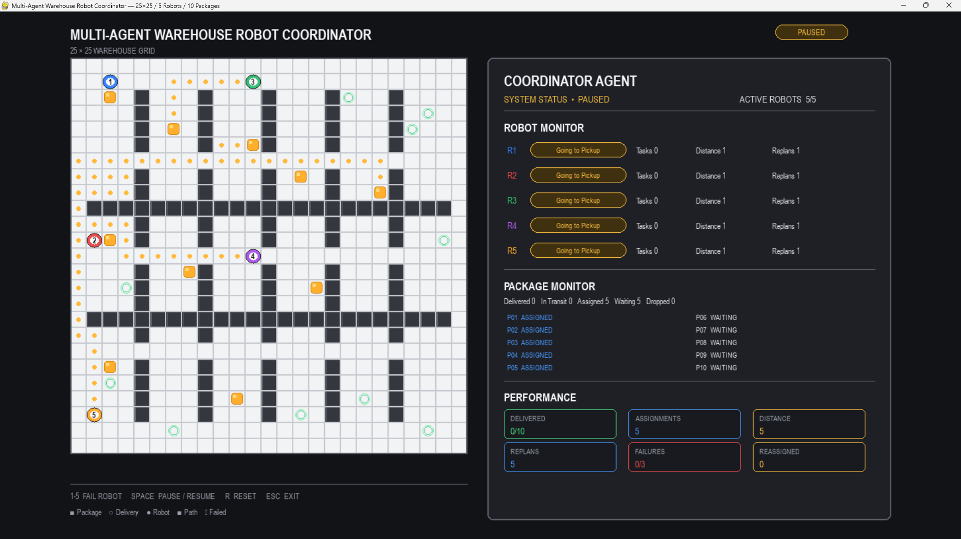
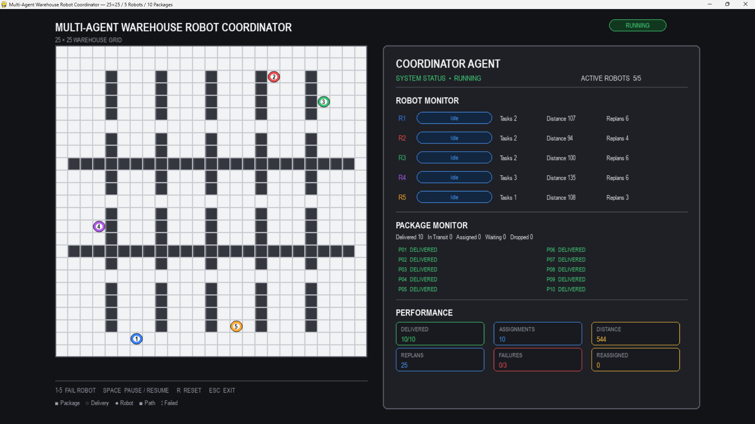

11. Limitations
The warehouse environment is simulated on a fixed grid rather than a physical warehouse.
Robot movement is modelled as discrete grid-cell movement.
The system supports a maximum of three robot failures as defined by the implementation.
Physical sensors, real robot hardware, wireless communication, and real-world localization are not included.
An actual collision-triggered dynamic-replanning event was not specifically observed during testing.

12. Conclusion
The Multi-Agent Warehouse Robot Coordinator demonstrates a modular multi-agent approach to warehouse task execution. The system combines autonomous task allocation, A* pathfinding, obstacle avoidance, package delivery, multi-robot operation, and failure recovery within a visual simulation.
The project provides a practical demonstration of multi-agent coordination and search-based navigation in a controlled warehouse environment. The implementation and separate validation activities establish the functional behavior of the developed system.

