INFORMATION DIFFUSION IN SOCIAL NETWORKS
SNA Case Study Final Report - INFORMATION DIFFUSION
Research Question
How does information spread across social networks, and what factors determine how far, how fast, and through whom it spreads?
Team Members
Vijay Krishna CB.SC.U4CSE23112
Gayas Sheik CB.SC.U4CSE23118
Manish S CB.SC.U4CSE23125

1. Introduction and Context
This case study analyzes information diffusion in a controlled synthetic social network. The study focuses on how network structure, user influence, communities, platforms, and time relate to the propagation of information. Social Network Analysis is used to move from individual interactions to network-level and cascade-level observations.
The locked problem statement is: “To analyze how information spreads through social networks and identify how user influence, network structure, communities, and time affect the propagation of information.”

2. Dataset and Network Model
The final dataset contains 50,000 interaction records, 10,000 users, 1,000 information items, 25 communities, five platforms, and 1,876 identified information cascades. The simulated platforms are Instagram, Facebook, Reddit, YouTube, and X.
Interaction types are Like, Comment, Share, and Cross Platform Share. Likes and comments represent engagement, while shares and cross-platform transfers are used as propagation-oriented interactions.

Data source and generation
Source: project-generated controlled synthetic dataset. The dataset was created specifically for this case study so that the analysis could contain consistent users, communities, platforms, information items, timestamps, and linked diffusion events across the full six-month observation period.
Generation and validation: the generator produced 50,000 interaction records with 10,000 users, 1,000 information items, 25 communities, and five platforms. Before analysis, the dataset was checked for duplicate interaction IDs and records, valid parent references, same-cascade and same-information relationships, chronological parent-child ordering, correct cascade depth, valid roots, and cross-platform/cross-community consistency. All final validation checks passed.

3. Methodology
- Construct a directed interaction network with users as nodes and user-to-user interactions as edges.
- Construct a propagation network from propagation-oriented interactions.
- Measure degree, PageRank, betweenness, closeness, and eigenvector centrality.
- Compare Regular, Active, Bridge, and Influential user types.
- Analyze information cascades using size, depth, duration, unique users, platforms, communities, and propagation events.
- Measure cross-platform and cross-community diffusion.
- Analyze monthly, daily/hourly, weekday, interaction-type, platform, and propagation-rate patterns.

3.1 Method Selection Rationale
- Degree centrality: used to measure direct connectivity and identify users with many incoming or outgoing interactions.
- PageRank: used to capture structural importance influenced by connections from other users, making it useful for assessing network-level influence.
- Betweenness centrality: used to identify users positioned on paths between other users and therefore potentially important as bridges.
- Closeness centrality: used to assess how efficiently a user can reach other users through the network.
- Eigenvector centrality: used to distinguish users connected to other well-connected users.
- Cascade metrics: used to measure how far, how deep, and how long simulated information propagation continues.
- Cross-platform and cross-community analysis: used to determine whether diffusion remains within a platform/community or crosses structural boundaries.
- Temporal analysis: used to examine how interaction and propagation activity varies over the observation period and across time-of-day/week.

3.2 Analysis Validation
The analysis scripts were run only after the generated dataset passed structural validation. Phase-level outputs were then cross-checked against the source data so that the reported network, centrality, cascade, cross-platform, cross-community, temporal, and integrated findings use consistent totals and definitions.
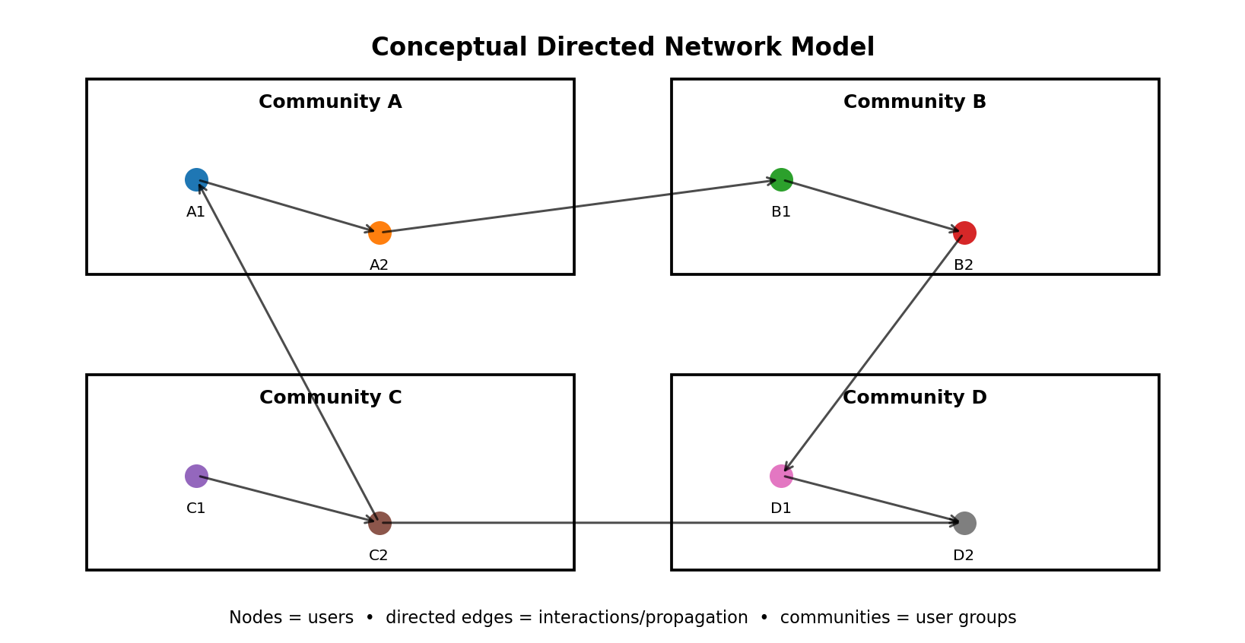
Figure 1. Conceptual directed network model used to represent users, communities, and diffusion links.

4. Network Structure and User Influence
The full interaction network contains 10,000 users and 48,463 unique interaction edges. The network density is approximately 0.000485, indicating a sparse network. The largest weakly connected component contains 9,421 users, showing that most users belong to one large connected region.
Influential users have the highest mean influence score (0.805) and mean activity score (0.778). The final centrality analysis also shows a positive association between influence and PageRank (r = 0.7014). This is an association in the synthetic network and should not be interpreted as causation.

5. Information Cascades
The analysis identifies 1,876 information cascades. Average cascade size is 26.65 interactions, median size is 28, and maximum size is 75. Average cascade depth is 26.65 and maximum depth is 75. Average cascade duration is approximately 249.55 hours.
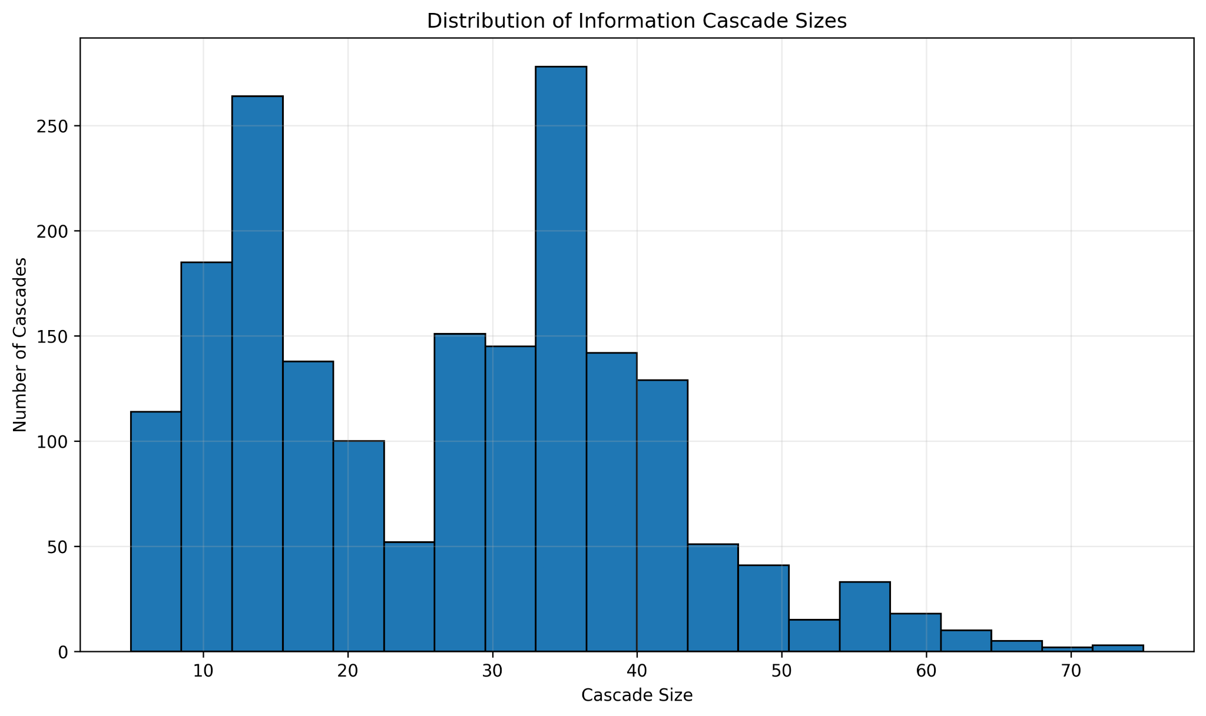
Figure 2. Distribution of Information Cascade Sizes
The distribution shows the range of simulated cascade sizes, with most cascades concentrated in the lower-to-middle size range and a smaller number extending toward the maximum of 75.
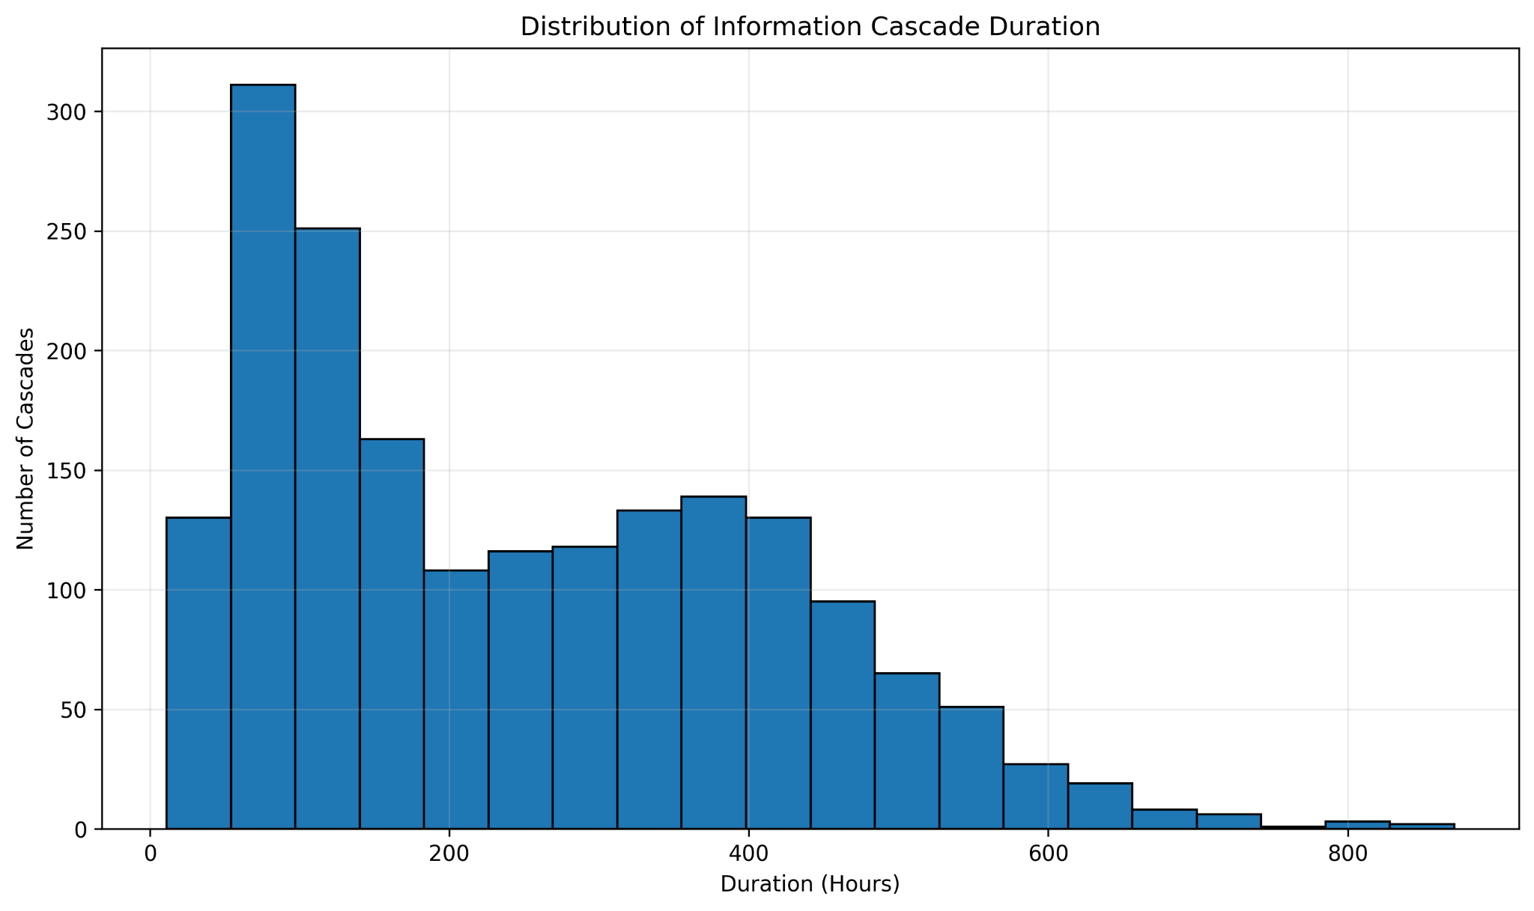
Figure 3. Distribution of Information Cascade Duration
Cascade durations vary substantially, with many cascades concentrated at shorter durations and a longer tail extending to several hundred hours.

6. Cross-Platform Diffusion
Cross-platform diffusion occurs in 1,729 of 1,876 cascades (92.16%). These cascades have an average size of 27.54 interactions, compared with 16.26 for cascades without cross-platform diffusion. All 20 directed source-to-target platform pairs are represented.
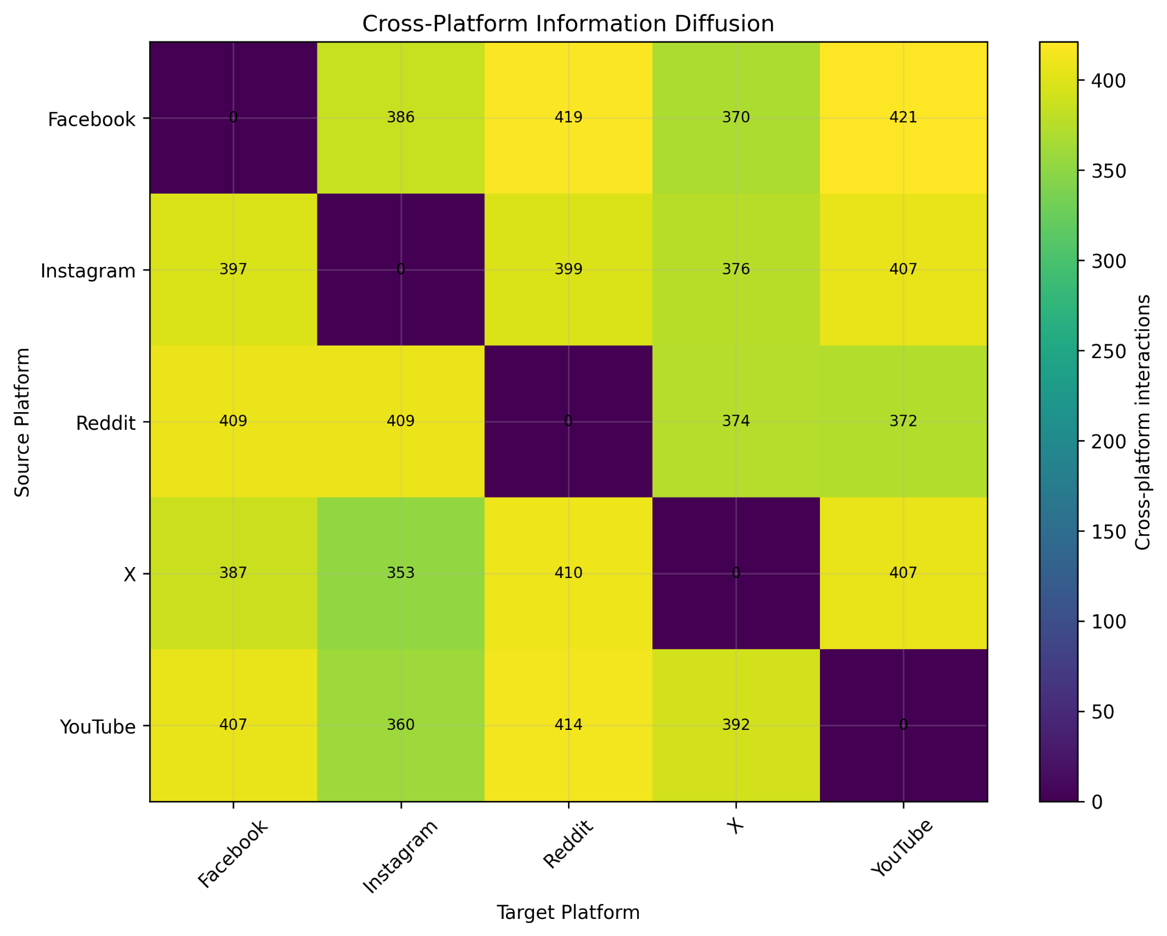
Figure 4. Cross-Platform Information Diffusion Matrix
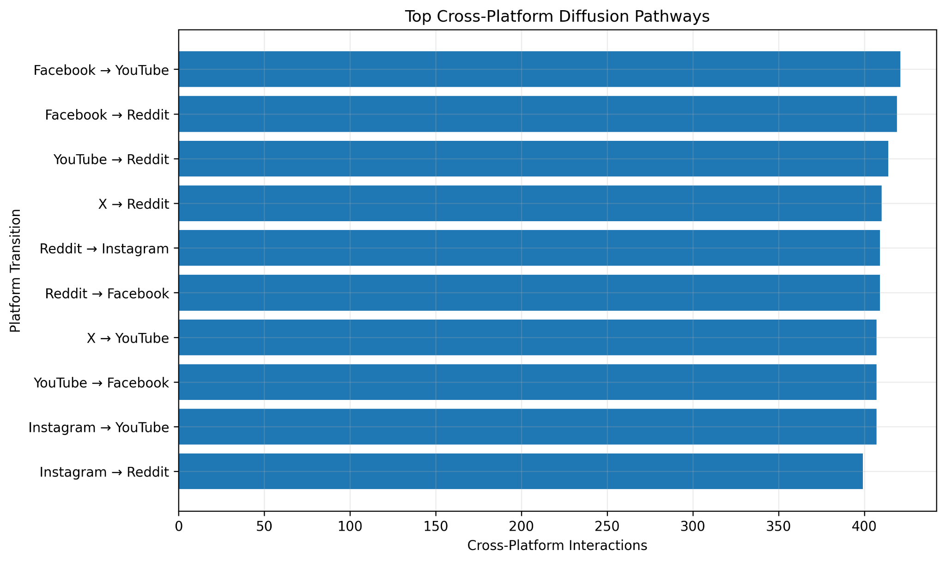
Figure 5. Top Cross-Platform Diffusion Pathways
The largest observed transition is Facebook → YouTube (421 events), followed by Facebook → Reddit (419) and YouTube → Reddit (414).

7. Cross-Community Diffusion
Cross-community diffusion occurs in 1,822 of 1,876 cascades (97.12%). These cascades average 27.13 interactions, compared with 10.63 for cascades without cross-community diffusion. This indicates that simulated information propagation is frequently not restricted to one community.
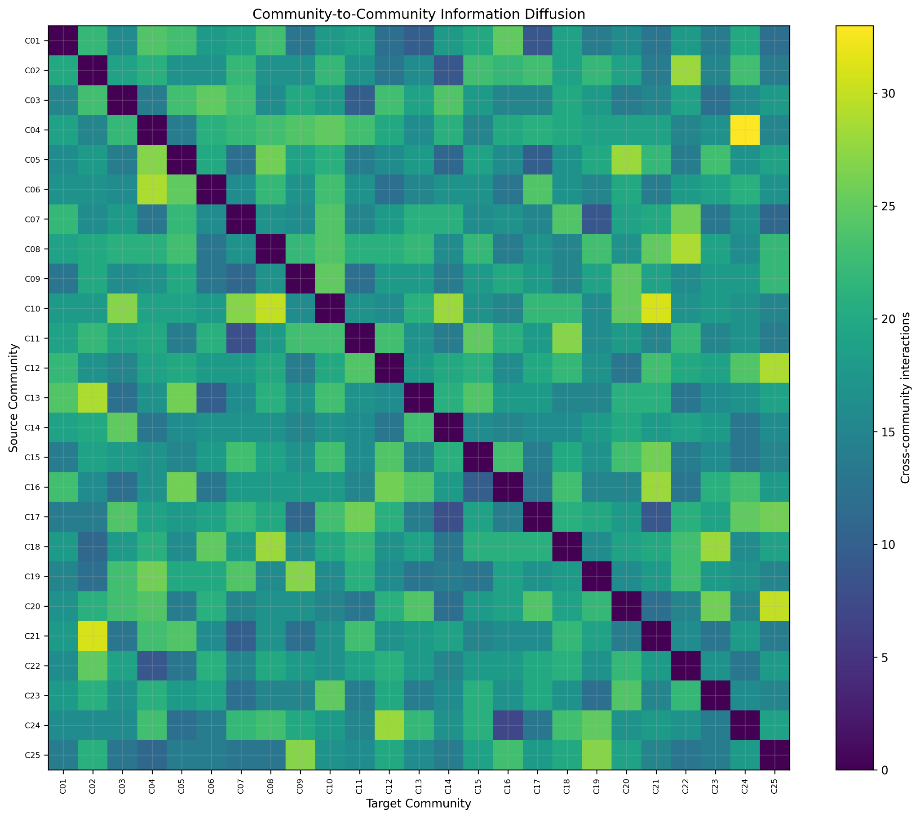
Figure 6. Community-to-Community Information Diffusion

8. Temporal Diffusion
Monthly interaction volume ranges from 6,570 in January 2026 to 9,463 in June 2026. The highest simulated activity occurs at 23:00 with 2,568 interactions, and Tuesday has the highest simulated weekday volume with 8,564 interactions.
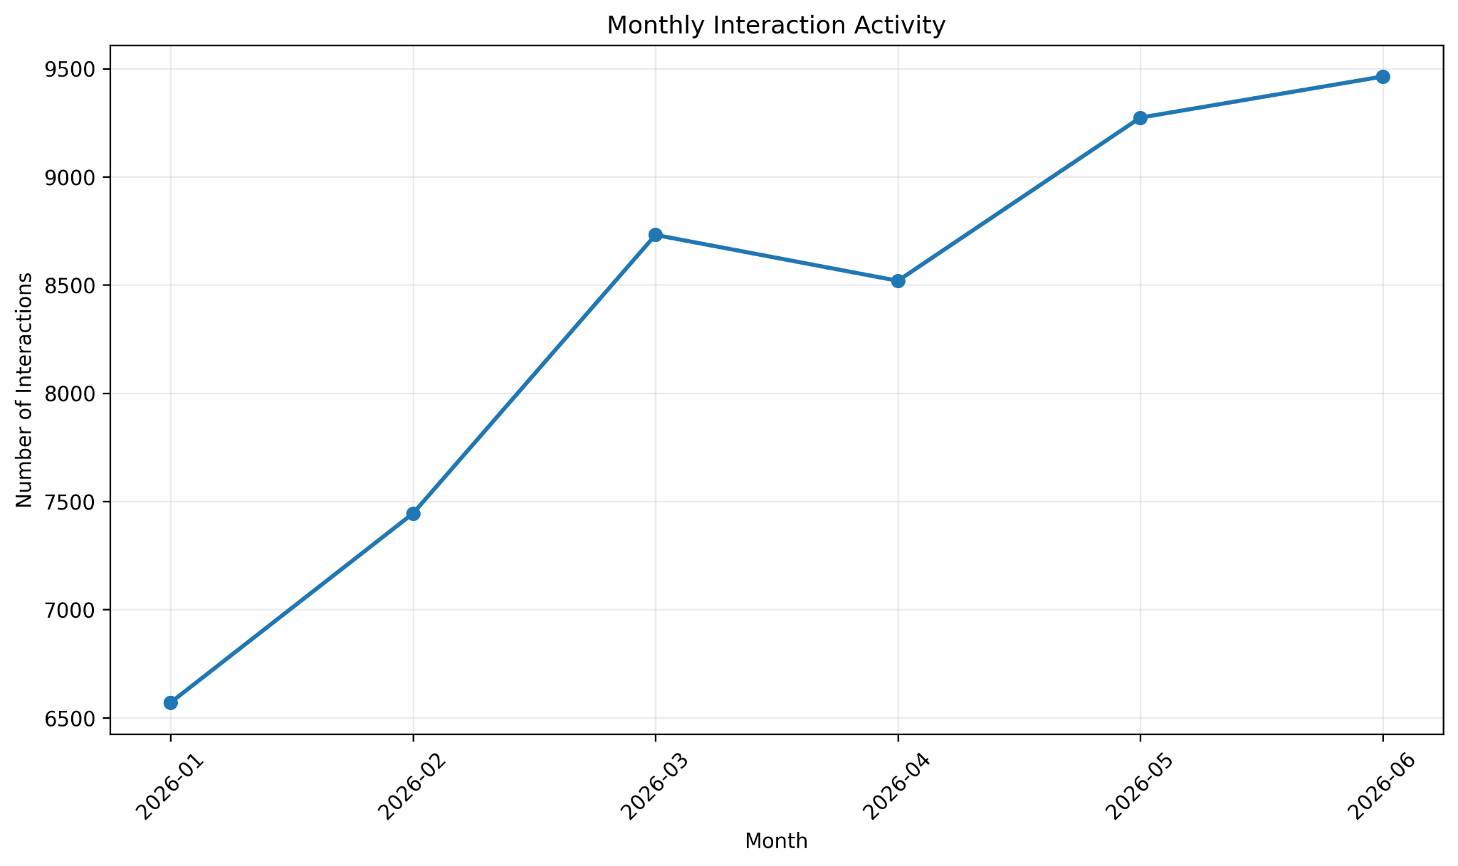
Figure 7. Monthly Interaction Activity
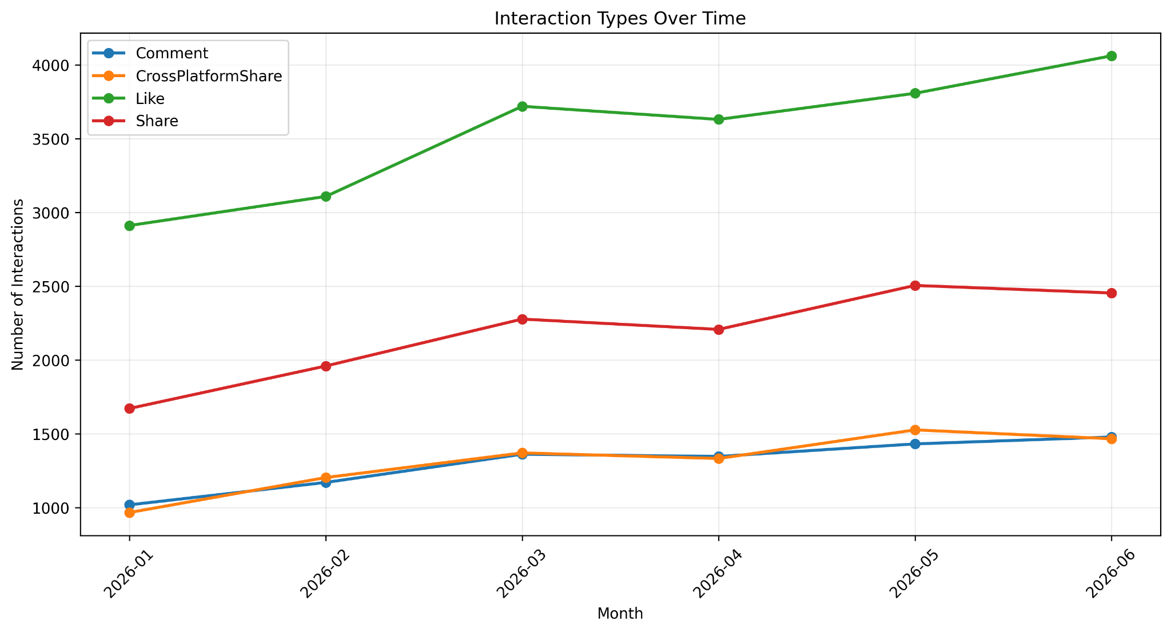
Figure 8. Interaction Types Over Time
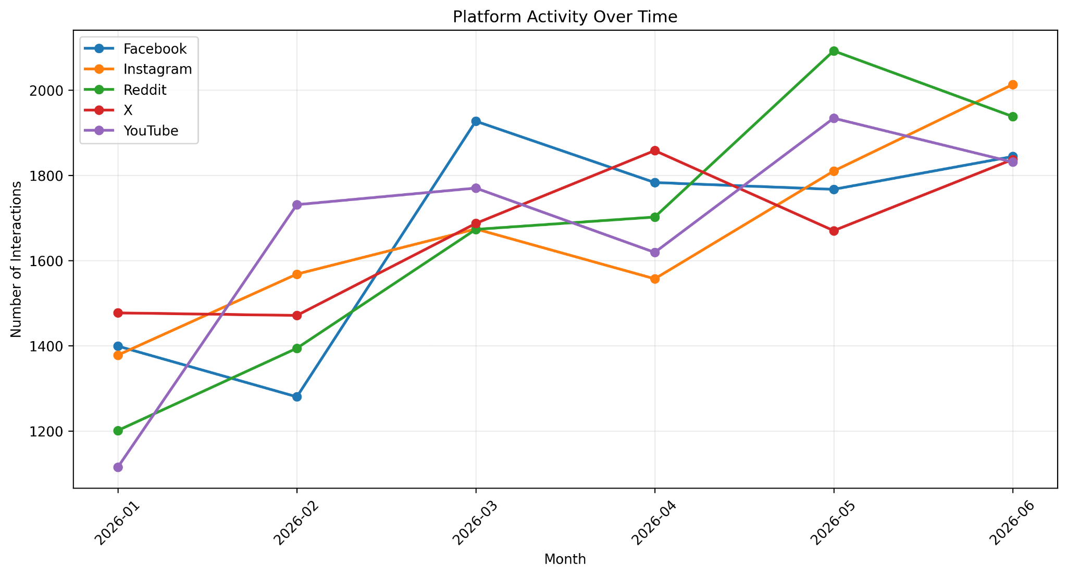
Figure 9. Platform Activity Over Time
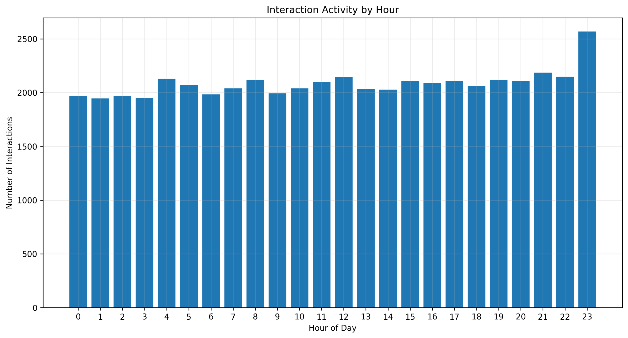
Figure 10. Interaction Activity by Hour
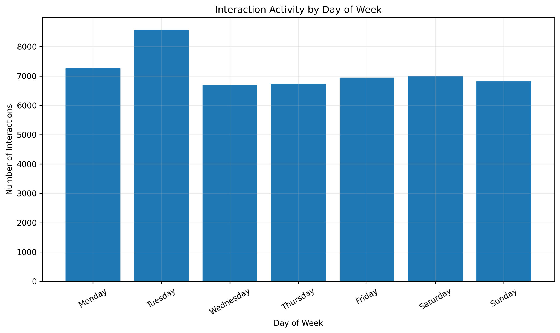
Figure 11. Interaction Activity by Day of Week
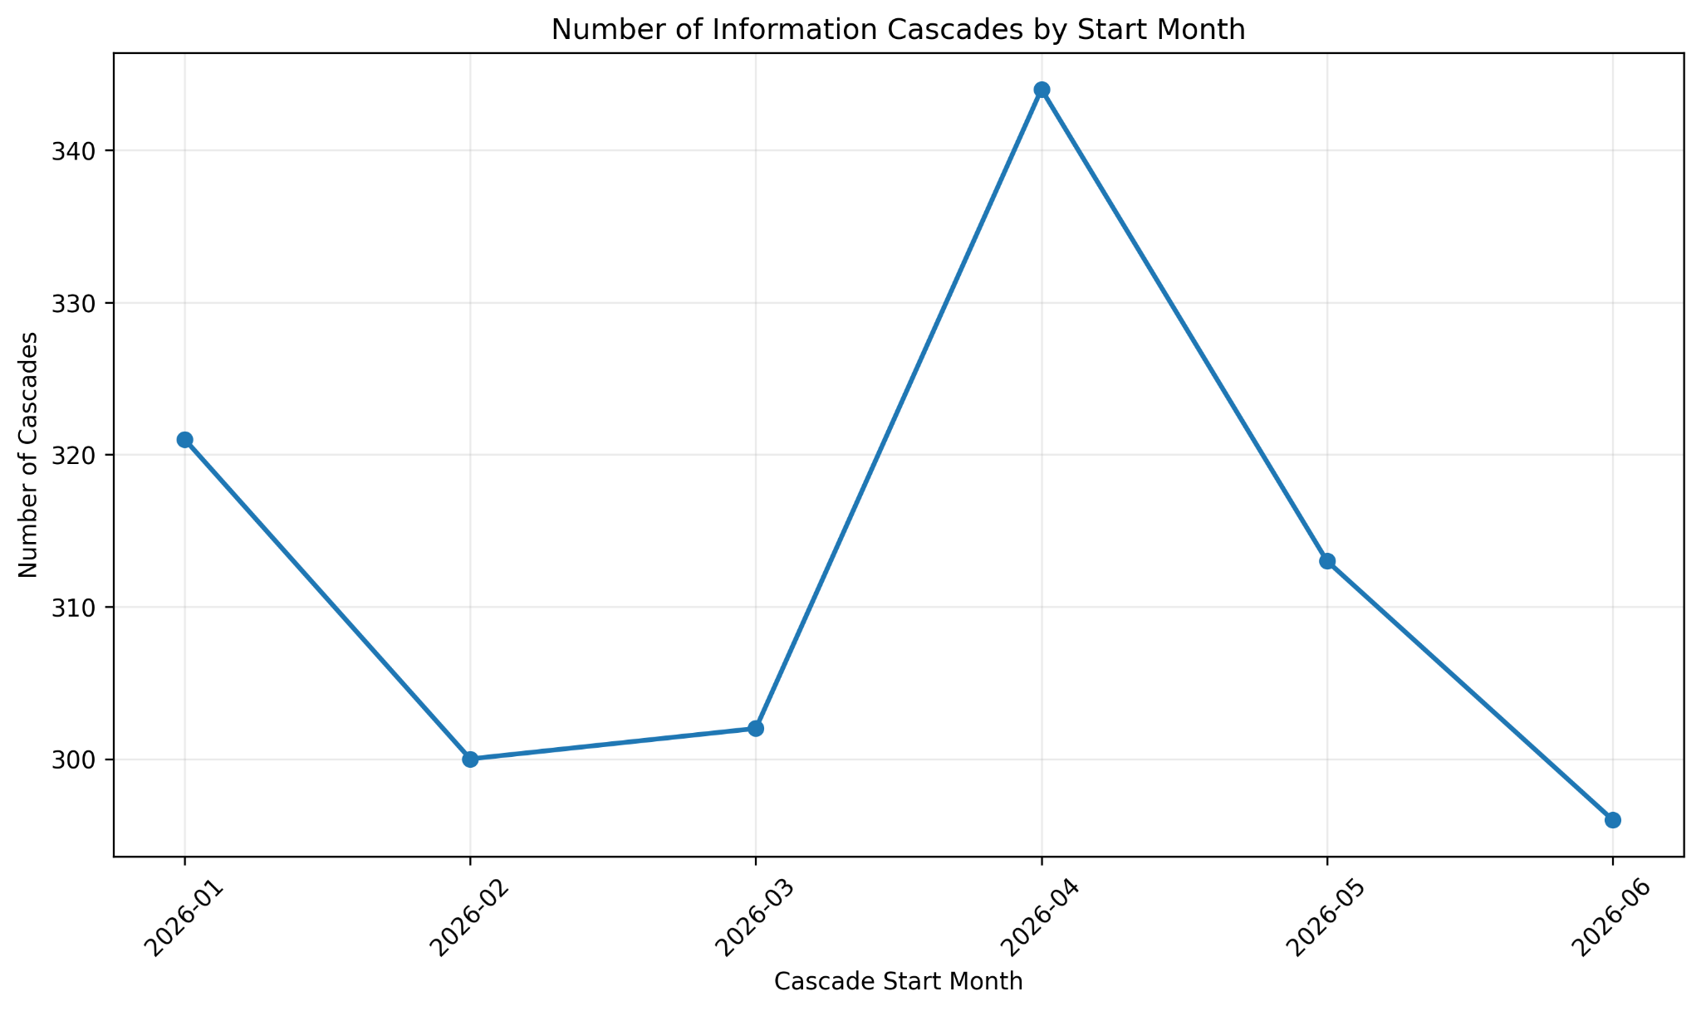
Figure 12. Number of Information Cascades by Start Month

9. Propagation and Engagement
The monthly propagation rate remains comparatively stable, averaging 41.83%, with a maximum of 43.49% in May 2026. The propagation-versus-engagement view separates propagation-oriented activity from engagement-oriented activity.
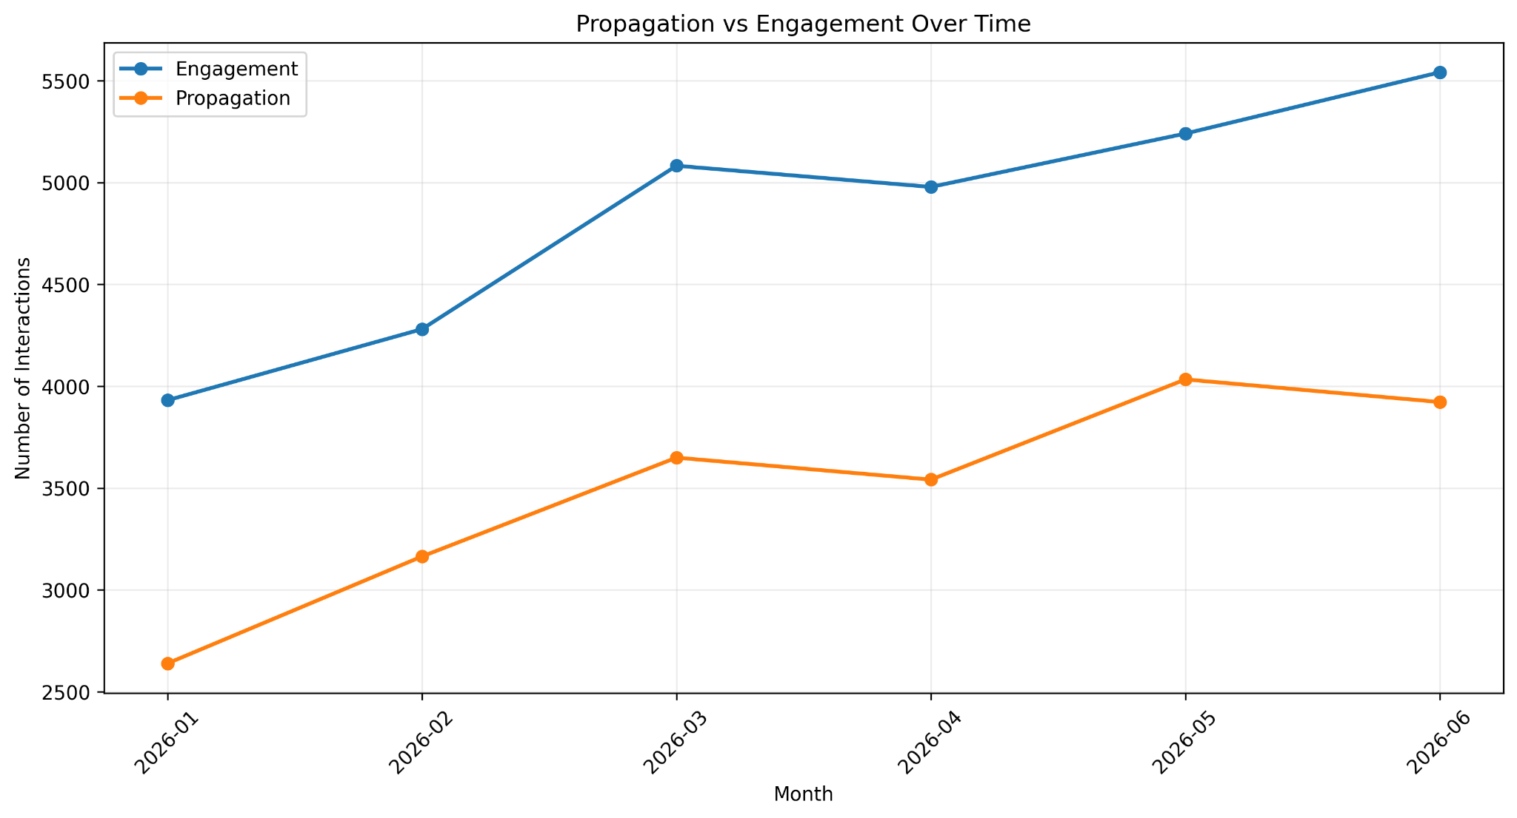
Figure 13. Propagation vs Engagement Over Time
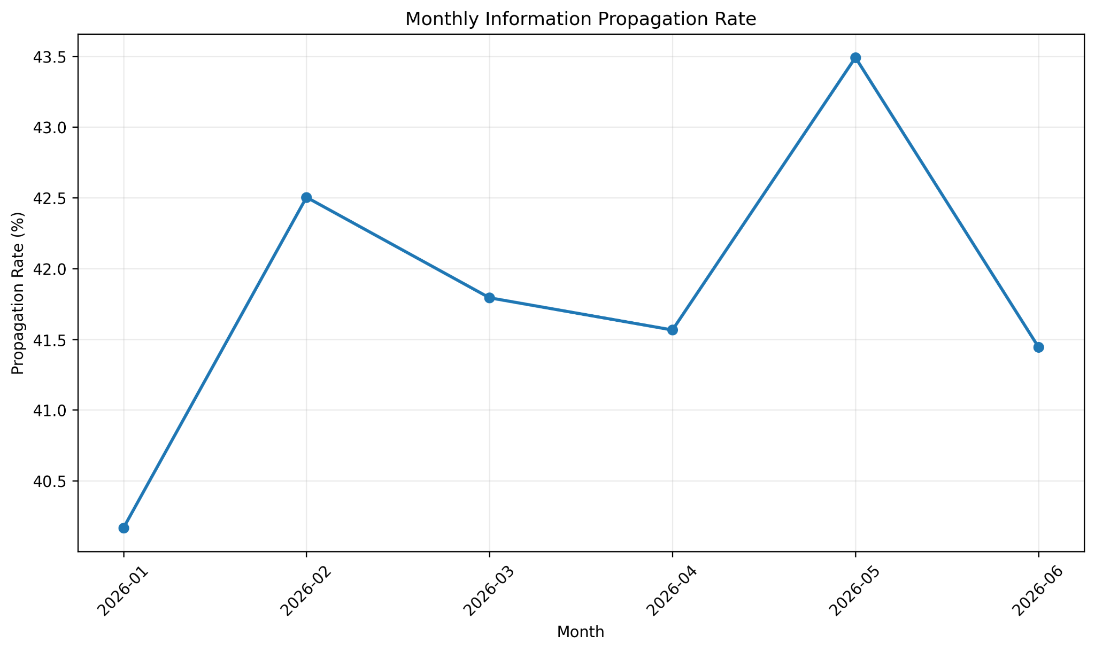
Figure 14. Monthly Information Propagation Rate

10. Additional Platform and Community Visualization
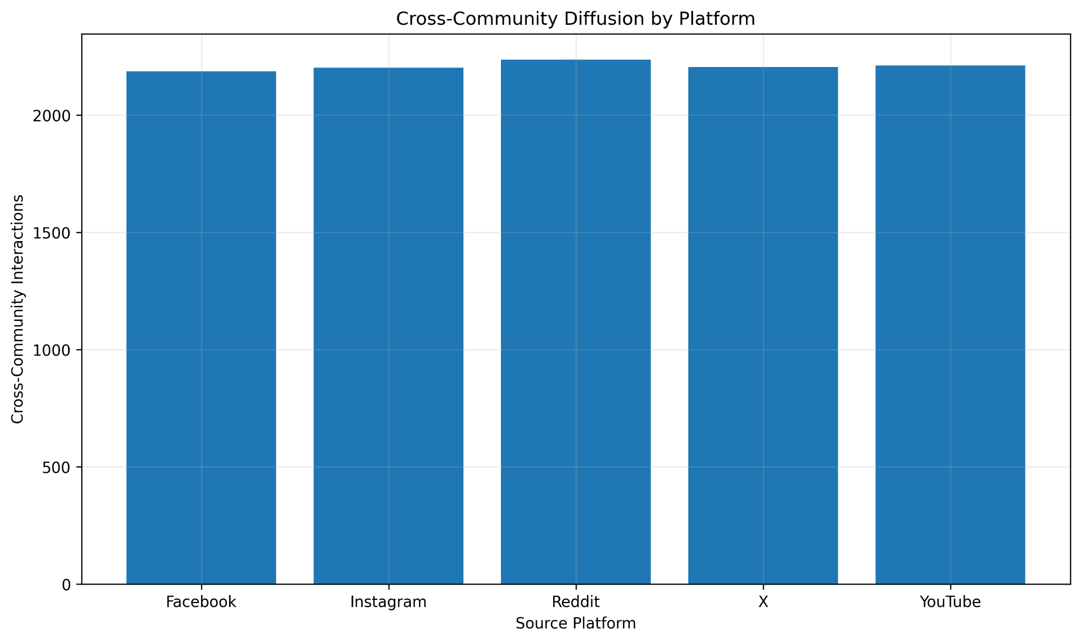
Figure 15. Cross-Community Diffusion by Platform
The platform-level cross-community bars are intentionally close because the underlying synthetic generation is controlled and balanced. They therefore support the observation that cross-community diffusion is widespread, but they should not be presented as evidence that one real-world platform is inherently more cross-community than another.

11. Integrated Findings
- The network is sparse but contains a very large connected region.
- Influential users occupy stronger structural positions and have higher average influence and activity.
- Influence is positively associated with PageRank (r = 0.7014).
- The dataset contains 1,876 cascades with an average size of 26.65 interactions.
- Cross-platform diffusion appears in 92.16% of cascades.
- Cross-community diffusion appears in 97.12% of cascades.
- Temporal activity varies over the six-month observation period while the propagation rate remains comparatively stable.

12. Discussion and Implications
The combined results indicate that information diffusion is shaped by multiple interacting dimensions. Network position is associated with influence, while information frequently crosses platform and community boundaries in the simulation. Temporal variation provides an additional dimension for understanding when interactions and propagation occur.
Potential applications include identifying structurally important users, monitoring cross-platform propagation pathways, studying community-to-community movement, and selecting strategic points for information monitoring or dissemination. These are implications of the modeling framework rather than validated claims about real social-media populations.
Real-world relevance: although the numerical findings are limited to the synthetic setting, the analytical workflow is applicable to real information-diffusion studies such as misinformation monitoring, viral-content tracking, influencer identification, emergency-information propagation, marketing diffusion, and community-to-community information movement. Real-world datasets would be required to validate whether the patterns observed here hold outside the controlled simulation.

13. Limitations
- The dataset is controlled and synthetic; findings are simulation-based.
- Generated cascades are predominantly chain-like, which limits interpretation of branching cascade topology.
- Platform and community distributions are controlled by the synthetic generation process.
- The 23:00 and Tuesday peaks are simulation outputs and should not receive real-world causal explanations.
- Observed relationships are associations and do not establish causality.

14. Future Work
- Validate the findings using real-world information-diffusion datasets.
- Use branching cascade structures to study richer cascade topology.
- Compare detected communities with known community assignments.
- Apply Independent Cascade or Linear Threshold diffusion models.
- Use time-to-event methods to study cascade speed and duration.

15. Conclusion
The case study demonstrates how Social Network Analysis can be used to examine information diffusion across a multi-platform synthetic social network. The results show a sparse but broadly connected network, differences between user types, a positive influence–PageRank association, frequent cross-platform and cross-community diffusion, and temporal variation. Together, these results answer the research question by showing that simulated information spread is shaped by network structure, user position, diffusion boundaries, and time. The conclusions are explicitly limited to the controlled synthetic setting.

