GreenPath : Tracking Your Carbon Footprint and Beyond

|  |  |
| --- | --- |
| **Name** | **Student ID** |
| Subasinghe Mudiyanselage Indika Gayashan Upasena | 300362878 |

Project Repo Path : <https://github.com/gayashanacd/CSIS_4495_Project_ISu878.git>

**CSIS-4495-001**

**How to run frontend VueJs app**

* Copy project file to a location and open terminal / command prompt in inside root folder.
* Run “**npm install**” to install all modules needed
* Execute “**npm run serve**” to run the application.
* Open web browser and navigate to <http://localhost:8080/> to view.

**How to run backend NodeJs app**

* Copy project file to a location and open terminal / command prompt in inside root folder.
* Run “**npm install**” to install all modules needed
* Execute “**node server**” to run the application.
* Open web browser and navigate to <http://localhost:5000/api/getusers> to see all users from mongo DB cloud

## Overview

The **GreenPath** project is progressing as scheduled, with key milestones from both the **Requirement Analysis** and **Design & Development** phases being completed successfully. Below is an overview of the completed tasks, challenges faced, and adjustments made.

### Completed Tasks

* **Phase 1: Requirement Analysis** completed, with finalized functional and non-functional requirements and the selection of the technology stack.
* **Phase 2: Design & Development** progressed, with wireframes and mockups completed. Front-end and back-end development are partially completed.

### Challenges Faced

* **UI Design Iterations**: Several rounds of feedback were required to finalize the UI to ensure it was user-friendly and aligned with sustainability tracking goals.
* **User Experience Complexity:** One of the key challenges was designing a simple yet comprehensive user interface (UI) that caters to a wide range of users with varying levels of tech-savviness. Ensuring that users can easily log their data for carbon footprint, water usage, and waste management required several rounds of feedback and testing.
* **Sustainability Data Accuracy**: It was difficult to balance between providing accurate environmental impact calculations and making the input process simple for users. Not all users know specific details like the exact fuel efficiency of their car or the amount of water used per activity, which led to the need for automatic estimation features.

### Assumptions & Actions Taken

* **Assumed User Interest in Detailed Tracking**: The project assumed that users would be engaged enough to input detailed information about their carbon emissions, water usage, and waste management. Based on this assumption, features like **daily input forms** and **personalized goals** were developed to encourage long-term interaction.
* The choice of the back-end infrastructure assumed steady scaling of user data, given the global potential of the app.

### Changes in Direction

* The **initial UI design** needed revisions to simplify the onboarding experience after testing early wireframes.
* **Expanded Waste Tracking Functionality**: Based on more research, the waste tracking feature was expanded to include more detailed categories (e.g., paper, plastic, glass, electronics) rather than just generic recyclable/non-recyclable divisions. This allows users to track their waste more granularly and receive more targeted recommendations on reducing their waste footprint.

## Detail

### Phase 1: Requirement Analysis (10-09-2024 to 16-09-2024)

**Milestone 1: Finalize Functional and Non-Functional Requirements**

* **Deliverable**: The requirements document was completed, outlining the core features:
  + **Carbon Tracking**: Users can log transportation, energy use, and other activities to track their carbon footprint.
  + **Water Usage Tracking**: Users can record household water usage from activities like showers, laundry, and outdoor watering.
  + **Waste Tracking**: Users can log their recyclable and non-recyclable waste, helping them understand and reduce waste generation.

Non-functional requirements such as scalability, security, and performance were also defined to ensure the system can handle increasing user numbers while remaining efficient.

**Milestone 2: Technology Stack Selection**

* **Deliverable**: The project’s technology stack was finalized. The selected stack includes:
  + **Front-end**: VueJs for a responsive and dynamic user interface.
  + **Back-end**: Node.js and Express for handling API requests and database interactions.
  + **Database**: MongoDB for a scalable, NoSQL solution to store user data.
  + **Hosting & DevOps**: Vercel with GitHub integration for hosting the application with CI/CD pipelines to streamline future deployment.

### Phase 2: Design & Development (17-09-2024 to 20-10-2024)

**Milestone 3: UI/UX Design**

* **Deliverable**: Wireframes and mockups for the **GreenPath** app were completed and reviewed. The UI/UX focuses on:
  + A **Dashboard** that provides an overview of the user’s carbon footprint, water usage, and waste management.
  + **Input Forms** for entering daily activities related to carbon emissions, water usage, and waste production.
  + **Community & Gamification** for users to interact with the society.

User feedback was incorporated into the design to ensure a smooth and intuitive experience, with a focus on accessibility and ease of use.

**Milestone 4: Front-End Development (20% Completed)**

* **Progress**:
  + Project structure was created to facilitate all screens with routing.
  + All initial screens were created without body data.
  + Generic utility class were created to support generic functions.
  + Vuex stores were created for application’s state management.

Next Steps:

* + Completing screens gradually and finalizing the input validation and integrating the forms with the back-end for data persistence.

**Milestone 5: Back-End Development (20% Completed)**

* **Progress**:
  + The back-end infrastructure is partially completed, including the setup of the API for handling user data and connecting to the **MongoDB database**.
  + Initial database structure is created with some dummy data.

Next Steps:

* + Complete the application API endpoints and integrate data analytics functionality to process and visualize user data.

### Screenshots – Frontend Implementations

Figure 1: Project Structure

Figure 2: Main Layout

Figure 3: Sidebar Navigation

Figure 4: Generic Util Class

Figure 5: Routing File

Figure 6: Web Application

### Screenshots – Backend Implementations

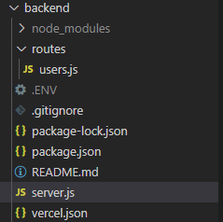

Figure 7: Project Structure

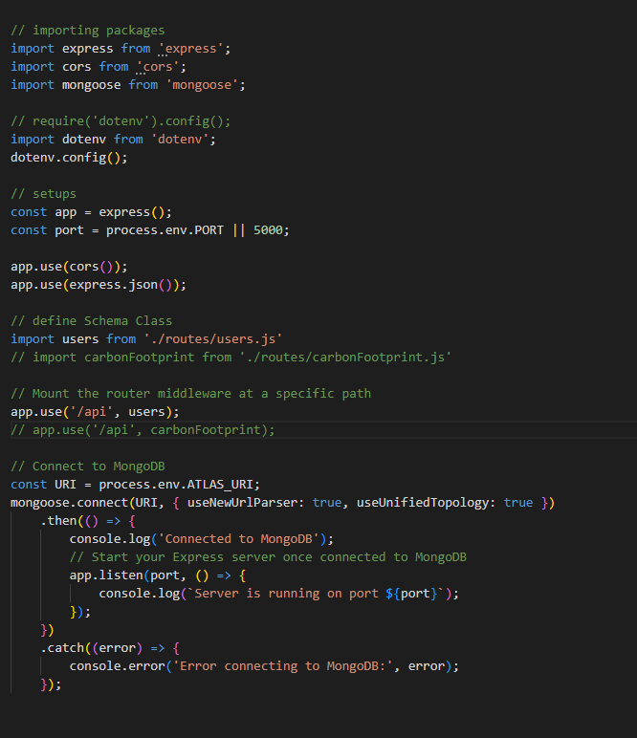

Figure 8: Server Js

Figure 9: User Api

Figure 10: Add User Api Test

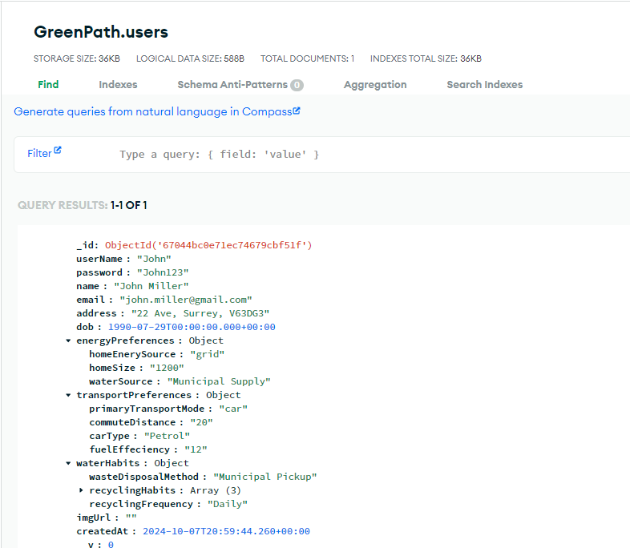

Figure 11: Added User in MongoDb

Figure 12: Get Users Api Test