GreenPath : Tracking Your Carbon Footprint and Beyond

|  |  |
| --- | --- |
| **Name** | **Student ID** |
| Subasinghe Mudiyanselage Indika Gayashan Upasena | 300362878 |

**CSIS-4495-001**

## Introduction

Sustainability has become a pressing global concern in recent decades, largely due to the impacts of climate change, resource depletion, and environmental damage. It highlights the importance of balancing economic growth, environmental protection, and social well-being to secure a sustainable future. Human activities, especially in areas like energy use, transportation, waste production, and food systems, play a significant role in environmental challenges such as carbon emissions, water scarcity, and pollution.

The GreenPath app focuses on environmental sustainability, providing users with tools to monitor, assess, and minimize their environmental footprint. By offering tailored suggestions based on individual habits, GreenPath helps users adopt more eco-friendly practices, contributing to the collective fight against climate change

### The Need for Personalized Sustainability Tools

Despite widespread awareness of environmental issues, many individuals struggle to understand the direct impact of their daily activities on the environment and how to reduce that impact effectively. Key questions arise:

* How can individuals track their carbon footprint, water usage, and waste production?
* What personalized, actionable steps can people take to make meaningful changes in their daily behaviours toward a more sustainable lifestyle?
* How can technology be leveraged to automate sustainability tracking and provide data-driven insights?

These questions are important because individual actions collectively have a significant influence on global environmental health. However, without clear, data-driven tools to measure personal impact and suggest actionable improvements, many people feel disconnected from the environmental consequences of their choices. By addressing this gap, the GreenPath app seeks to bridge the disconnect between awareness and action, providing users with the necessary information and guidance to make more sustainable decisions.

### Literature Review and Knowledge Gaps

Research on sustainability has been extensive, covering topics from carbon emissions tracking to waste reduction, renewable energy adoption, and individual behavioural changes toward sustainable living. Multiple studies have shown that tracking and awareness can significantly impact consumer behaviour. For example:

* **Carbon footprint calculators** like CoolClimate have been developed to estimate emissions based on various factors such as transportation and diet (Jones & Kammen, 2011).
* Studies on **behavioural nudges** have demonstrated that personalized feedback and goal-setting can lead to more sustainable consumer behaviour (Allcott & Rogers, 2014).
* **Gamification** and social features, as explored by Hamari et al. (2014), have proven effective in driving engagement and motivation toward eco-friendly practices.

However, existing research often highlights certain limitations and knowledge gaps:

* **Personalized insights**: Most carbon footprint calculators and sustainability tools provide static, generalized feedback, but lack the ability to offer dynamic, personalized recommendations based on user data.
* **Difficulty in maintaining user engagement**: Many sustainability apps and platforms struggle to retain users over the long term, largely because of limited interactivity and a lack of personalized goal setting.
* **Integration challenges**: Existing tools tend to address single dimensions of sustainability (e.g., energy consumption or waste) without offering a comprehensive approach that considers various aspects of environmental impact.

By building on these findings, GreenPath aims to address these gaps by providing a holistic platform that integrates multiple environmental factors, such as carbon emissions, water usage, and waste production tailored suggestions to users.

### Assumptions, Hypotheses, and Benefits of the Research

##### Assumptions

* Individuals are more likely to adopt sustainable behaviours if they can easily track their environmental impact and receive personalized, actionable recommendations.
* Gamification and community engagement features will motivate users to actively pursue sustainability goals.

##### Hypotheses

* Users who actively track their environmental impact through GreenPath and receive personalized recommendations will demonstrate a measurable reduction in their carbon footprint, water usage, and waste production over time.
* The introduction of gamified elements (e.g., challenges, badges) and social features (e.g., leaderboards, group activities) will lead to higher user engagement and a sustained commitment to eco-friendly practices.
* GreenPath users will show greater awareness and understanding of how their daily activities contribute to environmental issues, compared to users who do not use similar tracking tools.

##### Potential Benefits of the Research

The findings from this project could provide valuable insights into the role of personalized feedback and gamification in driving sustainable behavior. By helping individuals make more informed choices, the GreenPath app has the potential to:

* Reduce individual carbon footprints: Users will be more aware of how to lower their emissions through specific lifestyle changes (e.g., dietary adjustments, energy-saving practices).
* Promote water conservation: With detailed tracking and goal-setting features, users will be able to reduce unnecessary water usage in daily activities.
* Reduce waste production: By encouraging recycling, composting, and conscious consumption, users will produce less waste, contributing to waste reduction initiatives.

At a larger scale, GreenPath could serve as a model for future sustainability tools that integrate comprehensive and personalized recommendations to help society move toward a more sustainable future.

## Proposed Research Project

### Research Design and Objectives

The proposed research project involves the development and evaluation of the GreenPath app, a web-based platform and android mobile app (a companion app supports the main web-based application with a focus on adding data) that helps users track and reduce their environmental impact. The app will focus on key sustainability areas, such as carbon emissions (via transportation and energy usage), water consumption, and waste production. By providing users personalized recommendations and progress tracking, GreenPath aims to empower individuals to adopt more sustainable behaviours.

##### Objectives

* Develop a platform that allows users to input data related to their carbon footprint, water consumption, and waste production.
* Offer personalized, actionable recommendations based on user data to help them reduce their environmental impact.
* Provide intuitive visualizations of environmental data to help users understand their sustainability progress.
* Evaluate the effectiveness of the app in promoting sustainable behaviour by analyzing user engagement and environmental impact over time.

### Methodology and Justification

The research methodology combines data collection, analysis, and user engagement through the following components:

##### Data Collection

Users will manually input data for tracking of energy use, transportation, and waste habits. This allows the app to calculate environmental metrics.

**Justification**: Research (e.g., Allcott & Rogers, 2014) shows that personalized feedback can drive sustainable changes, which GreenPath builds upon by offering multi-domain tracking.

##### Personalized Recommendations

GreenPath will provide rule-based recommendations tailored to users’ specific habits. For example, if energy consumption is high, the app may suggest using energy-efficient appliances or lowering thermostat settings.

**Justification**: Studies like Abrahamse et al. (2005) support the use of tailored feedback for behaviour change, which GreenPath applies across carbon, water, and waste domains.

##### Data Visualization

The app will use charts and graphs to display trends in users' sustainability metrics, such as carbon emissions or water consumption, with goal indicators to motivate improvement.

**Justification**: Visual feedback and gamification are proven to engage users (Hamari et al., 2014), which can foster long-term behaviour change.

### Data Collection and Analytics

##### Data Collection

Data for the project will be collected through user inputs via web app and mobile app. Users will be able to input data about their daily habits (e.g., energy usage, transportation methods, water consumption, waste production).

To start the project, I will:

* Build the data input forms and API integration modules.
* Set up a backend system to store user data
* Ensure data privacy by securing sensitive user data.

##### Analytics and Recommendation Generation

Once data is collected, the app will:

* **Analyze Usage Patterns**: For each user, the app will track their daily activities and compare them to sustainable benchmarks (e.g., average carbon emissions for transportation).
* **Generate Personalized Recommendations**: Using rule-based algorithms, the app will generate recommendations like reducing energy consumption or adopting more sustainable food choices. These recommendations will be tailored to specific behaviours that deviate from sustainability goals.

##### Data Visualization

* The app will present user data visually through interactive charts and graphs. For instance, the user’s carbon footprint over time will be shown through line graphs, while water usage trends will be displayed in bar charts.
* Color-coded indicators will signal whether users are meeting their sustainability goals (e.g., green for improvement, red for exceeding limits).

### Technologies

**Platform**: Web based application which runs on browser and android mobile application

**Programming language**: JavaScript, Java

**Database**: MongoDb

**Front-end and backend:** ReactJs / VueJs and NodeJs

### Expected Results

The expected outcomes include:

* Reduced Carbon Footprint: Users will lower emissions by following personalized recommendations, such as adopting greener transport or reducing energy use.
* Water and Waste Reduction: Users will conserve water and manage waste more effectively through actionable advice on daily habits.
* Increased Engagement: Visual feedback and gamified elements will drive long-term engagement, fostering sustained behavioral change.

Practical Contributions:

* For Individuals: The GreenPath app will provide users with a tool to better understand and manage their environmental impact, empowering them to make data-driven choices that contribute to sustainability.
* For the Environment: On a larger scale, collective use of the GreenPath app could lead to meaningful reductions in carbon emissions, water usage, and waste production, contributing to broader environmental goals like mitigating climate change and preserving natural resources.

## Project Planning and Timeline

**Project Duration**:

* **Start Date**: 10-09-2024
* **End Date**: 30-11-2024
* **Total Duration**: 12 weeks

The project is divided into 5 key phases: Requirement Analysis, Design & Development, Data Collection & Integration, Testing & Refinement, and Final Delivery.

### Phase 1: Requirement Analysis (10-09-2024 to 16-09-2024)

**Duration**: 1 week  
**Key Milestones & Deliverables**:

* **Milestone 1**: Finalize functional and non-functional requirements.
  + Deliverable: Requirements document, outlining core features such as carbon tracking, water usage, waste tracking.
* **Milestone 2**: Technology stack selection.

### Phase 2: Design & Development (17-09-2024 to 20-10-2024)

**Duration**: 5 weeks  
**Key Milestones & Deliverables**:

* **Milestone 3**: User interface (UI) and user experience (UX) design.
  + Deliverable: Wireframes and mockups for the GreenPath app
* **Milestone 4**: Front-end development.
  + Deliverable: Functional UI for the app (dashboard, user input forms).
* **Milestone 5**: Android mobile app development.
  + Deliverable: Functional mobile UI.
* **Milestone 6**: Back-end development.
  + Deliverable: Back-end infrastructure with API integrations and database setup for storing user data.

### Phase 3: Integration (21-10-2024 to 04-11-2024)

**Duration**: 2 weeks  
**Key Milestones & Deliverables**:

* **Milestone 7**: API integration for carbon, water, and waste tracking with web and mobile applications.
  + Deliverable: Integrated web app and mobile app with API connections for transportation, energy, and water usage data.

### Phase 4: Testing & Refinement (05-11-2024 to 18-11-2024)

**Duration**: 2 weeks  
**Key Milestones & Deliverables**:

* **Milestone 8**: Unit testing and integration testing.
  + Deliverable: Test cases and reports ensuring the core functionalities (data input, API integration, recommendations) are working as expected.
* **Milestone 10**: Refinement and bug fixing.
  + Deliverable: Updated, refined version of the GreenPath app

### Phase 5: Final Delivery (19-11-2024 to 30-11-2024)

**Duration**: 2 weeks  
**Key Milestones & Deliverables**:

* **Milestone 11**: Final version of GreenPath app.
  + Deliverable: Fully functioning web app and mobile app with carbon, water, and waste tracking features, data visualization, and personalized recommendations.
* **Milestone 12**: Documentation and project report.
  + Deliverable: Final project report, including technical documentation, user guide

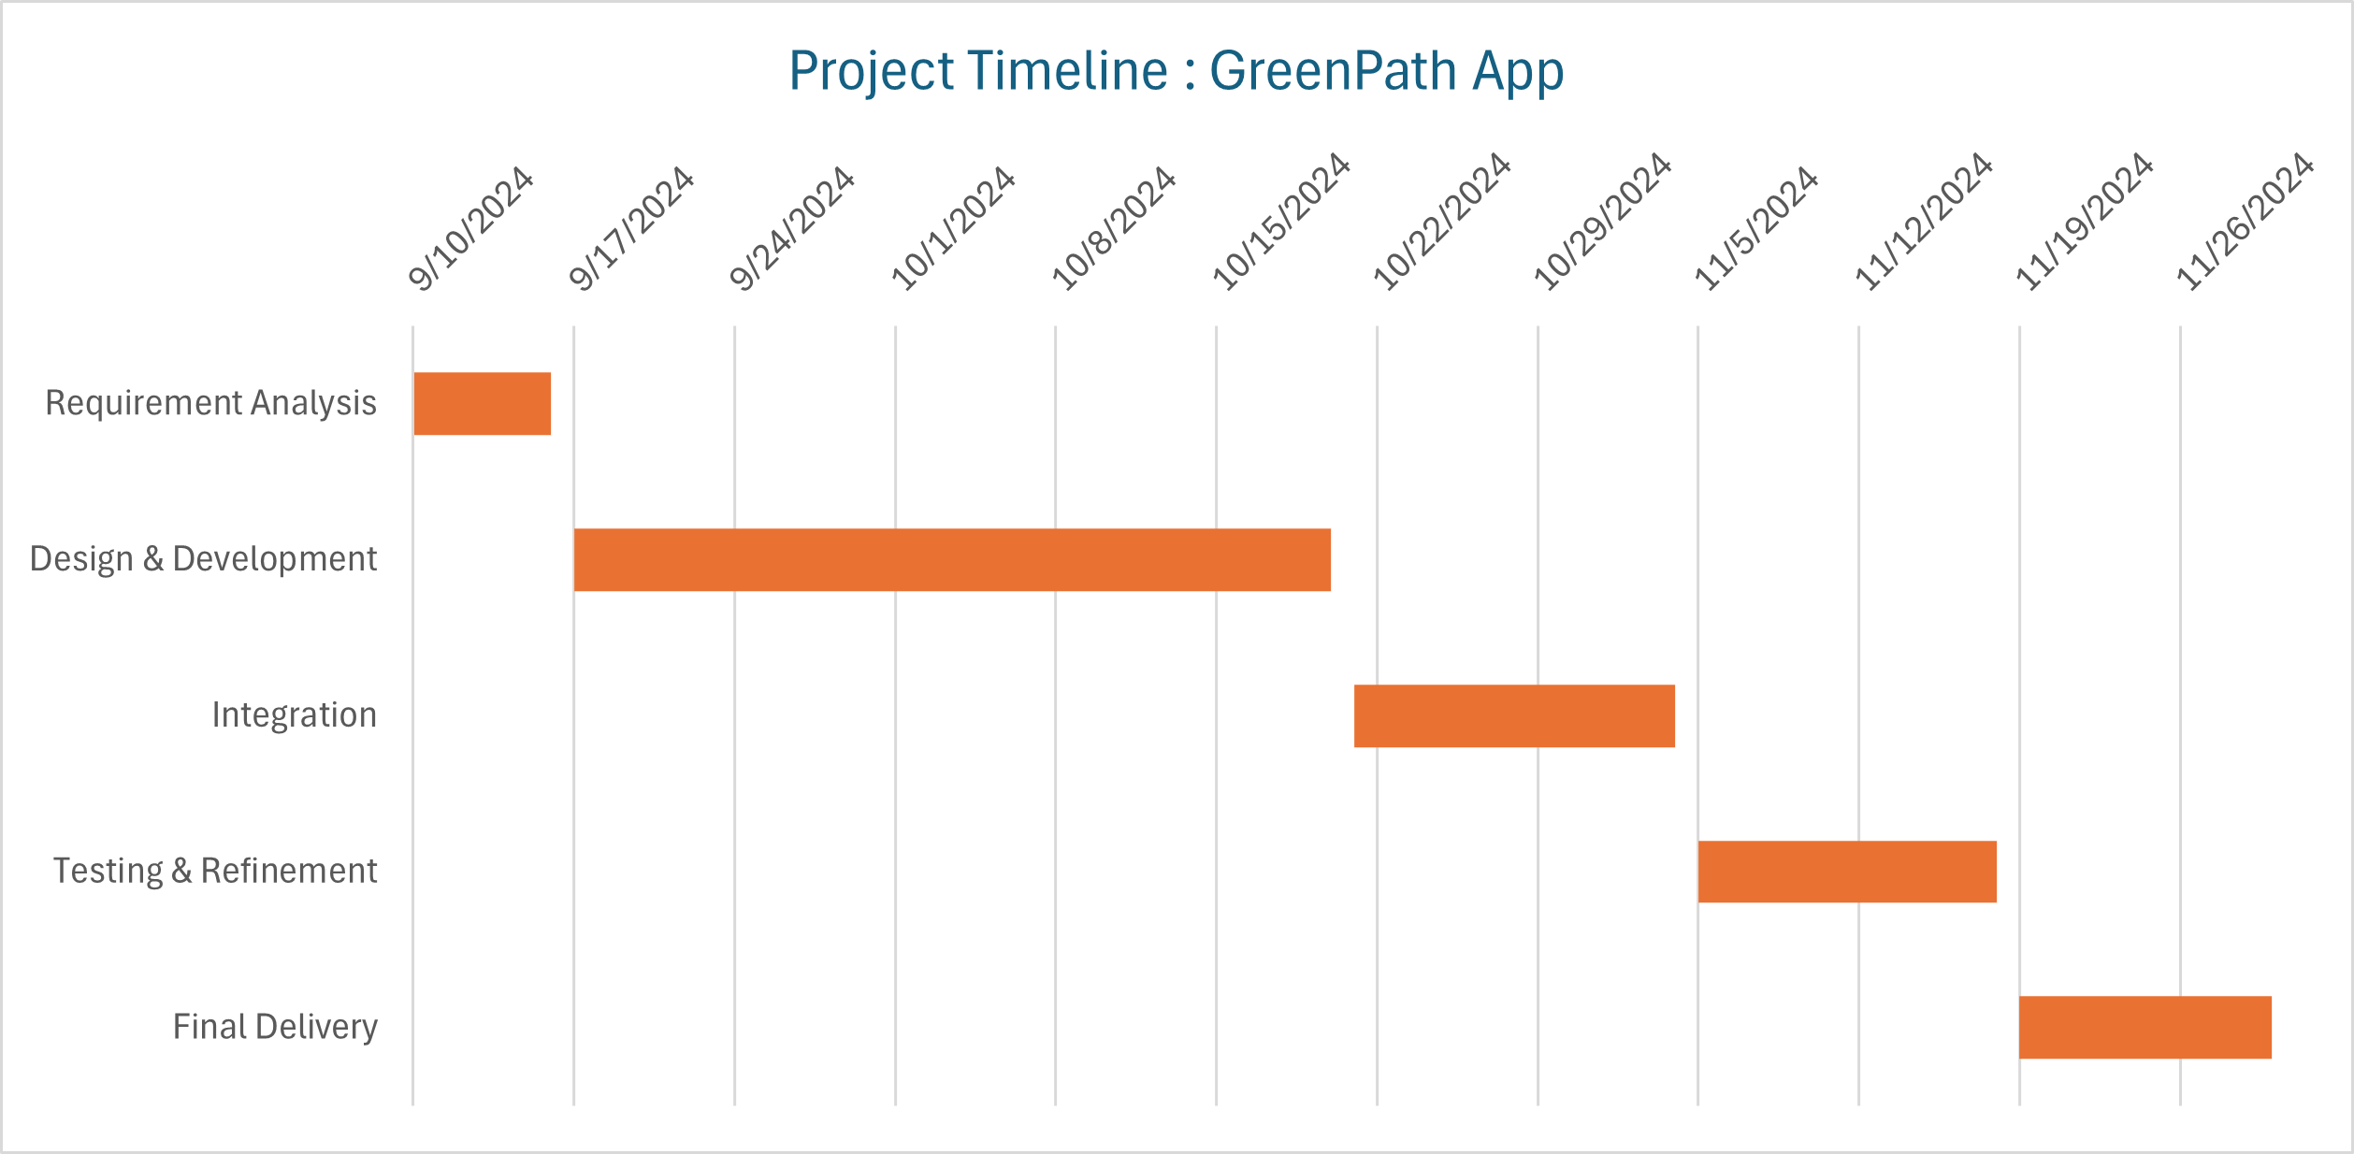

## References

1. **Allcott, H., & Rogers, T.** (2014). *The Short-Run and Long-Run Effects of Behavioural Interventions: Experimental Evidence from Energy Conservation*. American Economic Review, 104(10), 3003-3037.
2. **Abrahamse, W., Steg, L., Vlek, C., & Rothengatter, T.** (2005). *A review of intervention studies aimed at household energy conservation*. Journal of Environmental Psychology, 25(3), 273-291.
3. **Hamari, J., Koivisto, J., & Sarsa, H.** (2014). *Does Gamification Work? A Literature Review of Empirical Studies on Gamification*. 2014 47th Hawaii International Conference on System Sciences, 3025-3034.