The following are the frontend screen screenshots.

Cont…..

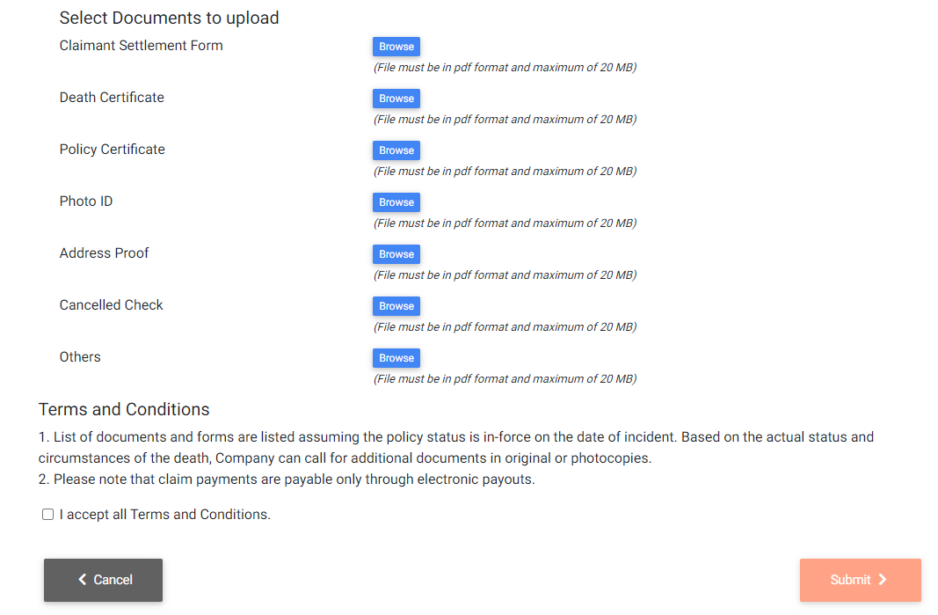

If this has to be the frontend, then create API end points which will facilitate the application.